A189 NORTH SEATON ROUNDABOUT
SAFETY IMPROVEMENT SCHEME
A189 North Seaton Roundabout has a history of personal injury accidents which have been difficult to address fully through the introduction of low-cost remedial measures. The Northumberland County Council 2015-16 Local Transport Plan programme has provided an additional level of funding to allow the introduction of more comprehensive measures targeted at reducing accident clusters which have been difficult to resolve through low cost measures.
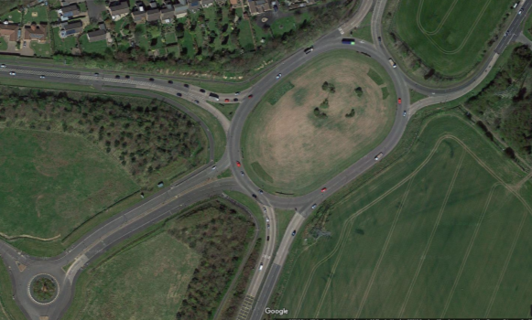
A189 North Seaton Roundabout © Google 2015
Data shows that 24 personal injury accidents occurred at the roundabout during the period 2012 to 2014. In the six month period January to June 2015 a further 9 injury accidents have occurred.
Analysis of accident data for the last three year period had identified the following safety problems:
- excessively high entry, circulatory and exit speeds often resulting in vehicle loss of control;
- “Weaving” accidents on the circulatory carriageway due to its wide nature and the lack of direction to road users provided by existing road markings and signs;
- Accident clusters at the B1334 approach to and entry onto the roundabout from North Seaton with the following probable causation factors:
  - Nose to tail accidents often due to approaching drivers looking right to identify gaps in traffic on the circulatory carriageway (visibility to the right significantly exceeds relevant Standards) and then failing to observe that the vehicle ahead had stopped to give way; and
  - Failure to give way type collisions between road users entering the roundabout and vehicles circulating the roundabout probably as a result of the misjudgement of high circulatory speeds, or drivers being unsure of the intended exit of circulating vehicles due to the close proximity of adjacent exits from the roundabout.

The scope of this scheme is therefore to build upon safety improvements already introduced (which will be mainly retained) but to provide significant complementary additional measures designed to target the above continuing accident clusters/types.
Present levels of funding do not allow the scope of this scheme to consider full traffic signalisation of the roundabout. However the proposed scheme is designed to take account that such a scheme may take place in the future, in terms of ensuring the new works would complement signalisation of the roundabout, and not result in ultimately abortive work.
The principles of the proposed scheme at A189 North Seaton Roundabout broadly follows the reduced speed limit, signing and roadmarking layouts to be found at the nearby A19(T)/A189 Moor Farm Roundabout the next main at-grade junction to the south on the A189. Although A19(T)/A189 Moor Farm Roundabout is signalised users of the A189 are now familiar of the need to approach and circulate that roundabout as directed by roadmarkings and signs at appropriate speeds. It is anticipated therefore that regular users of A189 North Seaton Roundabout will be familiar with a similar signing and roadmarking layout at A19(T)/A189 Moor Farm Roundabout.
The scheme proposals (which can be viewed by opening the attachments provided) are as follows:
- Site clearance of existing signs, roadmarkings and vegetation (to provide suitable visibility of new and existing signs);
- Introduction of a 50mph speed limit applicable to the approaches, exits and circulatory carriageway of the roundabout;
- Roadmarking improvements to provide a 3 lane spiral layout on the roundabout circulatory carriageway to replace an existing simple two lane concentric road marking layout. Lane destination roadmarkings are also proposed to direct road users into correct lanes when approaching, circulating and exiting the roundabout;
- Lengthening the existing two-lane approach to the roundabout on the B1334 arm (west) through amendments to existing roadmarkings;
- Introduction of new traffic signs (speed limit terminal/ repeater signs and lane destination signs are to be provided on each approach to the roundabout and also within the roundabout central island); and
- Passively safe traffic sign posts to be provided where justified; and
- 2.0m high willow panel fence screening to be provided to restrict visibility to the right at entry (for vehicles entering via the B1334 arm (west), in accordance with advice given in TD16/07 (Chapter 8, paragraph 8.8).
Works to install the scheme are programmed to commence on Monday 2nd November 2015 and, weather dependant, be complete within two weeks. In order to minimise disruption to traffic during this period night time working will take place between the hours of 8pm and 6am. Lane closures with a 30mph speed restriction are programmed to be in place from 2nd November 2015 for 5 nights. A full road closure of the roundabout is programmed to be in place for 5 nights from 9th November 2015 for 5 nights.
When full overnight closure of the roundabout is in place appropriate diversionary routes will be signed.
During the works period road users are reminded to proceed with care, drive at the reduced speed limit and be aware that full completion of the scheme (primarily signs, road markings and vegetation clearance) will be ongoing throughout the planned two week works programme, prior to the scheme becoming fully operational.
Technical Services – Design Team - Traffic
County Hall, Morpeth, Northumberland. NE61 2EF.

