NORTHUMBERLAND LOCAL AUTHORITY BUILDING CONTROL

APPLICATION FOR A REGULARISATION
The Building Act 1984
The Building Regulations 2010

Public Protection Building Control
E-Mail: buildingcontrol@northumberland.gov.uk Website: www.northumberland.gov.uk

This Regularistation Application conforms to the Building Regulations 2010
This form is to be filled in by owner or the agent. If the form is unfamiliar please read the notes which follow or consult your local Building Control office. Please submit completed form to the Building Control Office dealing with your application. Information regarding fees may be obtained from your Building Control Office.

Applicant’s details (see note 1)
1

2

3

4

5

6

7

8

9

Name:
Address:
Postcode: Tel: email:

Agent’s details (if applicable)
Name:
Address:
Postcode: Tel: email:

Location of building to which work relates
Address:
____________________________________________________________________________
Postcode:

Work carried out (see note 2)
Description:

Date work was carried out

What is present use?

What was previous use?

Is the completed building/s used as a use designated under the Regulatory Reform (Fire Safety) Order 2005 YES NO
I acknowledge that I have read my cancellation rights and I agree to works commencing on my
application within the 14 days cancellation period

Fees (see Guidance Note of Fees for information) Please indicate fee table and category of work. Table - Category - Cost of Work £ -
Normal fee £ plus 50% Total £

Additional Information:

Statement
This notice is given in relation to the building work as described, is submitted in accordance with Regulation 18(2) and is accompanied by the appropriate fee.

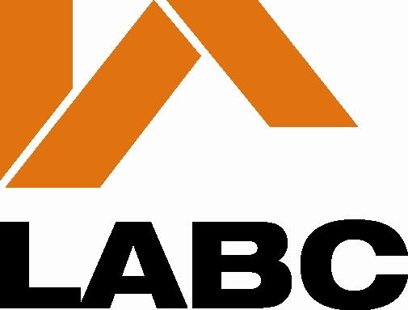 Name: Signature: Date:

Guidance Notes

1. The applicant is the building owner.

2. One copy of this notice should be completed and submitted with plans and particulars indicating the works carried out.

Where Part B (Fire Safety) imposes a requirement in relation to building work a further two copies of the plans should be submitted.

3. A regularisation application must be accompanied by the appropriate fee, which is charged at a rate of the normal fee payable had the works not otherwise already been carried out plus 50%, (VAT is not payable).

The appropriate fee is dependent upon the type of work carried out. Fee scales and methods of calculation are set out in the Guidance Notes on Fees, is available on request.

4. In accordance with Building Regulation 18 the Council may require an applicant to take such reasonable steps, including laying open the unauthorised work for inspection, making tests and taking samples as the authority think appropriate to ascertain what work, if any, is required to secure compliance with the relevant regulations.

5. These notes are for general guidance only, full particulars of a “Regularisation” request are contained in Regulation 18 of the Building Regulations 2010 and in respect of fees, in the Building (Local Authority Charges) Regulations 2010.

6. Persons who have carried out the building work or have made a material change of use of a building are reminded that permission may also have been required under the Town & Country Planning Act.

Contact Details;
E mail; buildingcontrol@northumberland.gov.uk;
Website; www.northumberland.gov.uk

North Northumberland
Berwick & Alnwick areas
Alnwick Community Fire Station/Depot, Blackthorn Close, Lionheart Ent Pk,
Alnwick, Northumberland NE66 2ER
Phone 01670 623838

South East Northumberland
Blyth, Cramlington, Bedlington, Ashington, Morpeth, Lynemouth, Ellington and Linton areas
Alnwick Community Fire Station/Depot, Blackthorn Close, Lionheart Ent Pk,
Alnwick, Northumberland NE66 2ER
Phone 01670 623729

West Northumberland
Hexham, Prudhoe and Ponteland areas
Hexham Community Fire Station, Maidens Walk, Hexham, Northumberland, NE46 1DR
Phone 01670 623820

Please Note - Fees can be made by ringing the appropriate office and making a card payment over the phone.

Building Control

Your Right to Cancel
You have the right to cancel this contract within 14 days without giving any reason.

The cancellation period will expire after 14 days from the date of your acknowledgment letter.

To exercise the right to cancel, you must inform us of your decision to cancel, by telephone, email or by using the attached form.

Effects of Cancellation
If you cancel this contract, we will reimburse all payment received from you, without undue delay We will make the reimbursement using the same means of payment for the initial transaction, unless you have expressly agreed otherwise.

If you have requested us to commence the service during the cancellation period, you shall pay us an amount which is in proportion to the work that has been carried out to that date.
--------------------------------------------------------------------------------------------------------------------
Cancellation Form
To: Northumberland County Council Building Control, Alnwick Community Fire Station, Blackthorn Close, Lionheart Enterprise Park, Alnwick NE66 2ER , or by emailing us at buildingcontrol@northumberland.gov.uk or by ringing us on 01670 623838 or 01670 623820

I/We give notice that I/We cancel my/our application for a Building Regulations service:

Please provide application reference or address to which the works relates to

…………………………………………………………………..

Name: …………………………………………………

Address: …………………………………………………

……………………………………………………………
……………………………………………………………
Signature: …………………………………………………

Date: …………………………………………………
