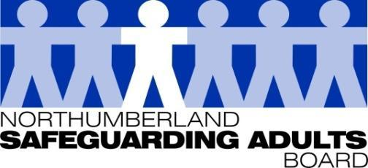
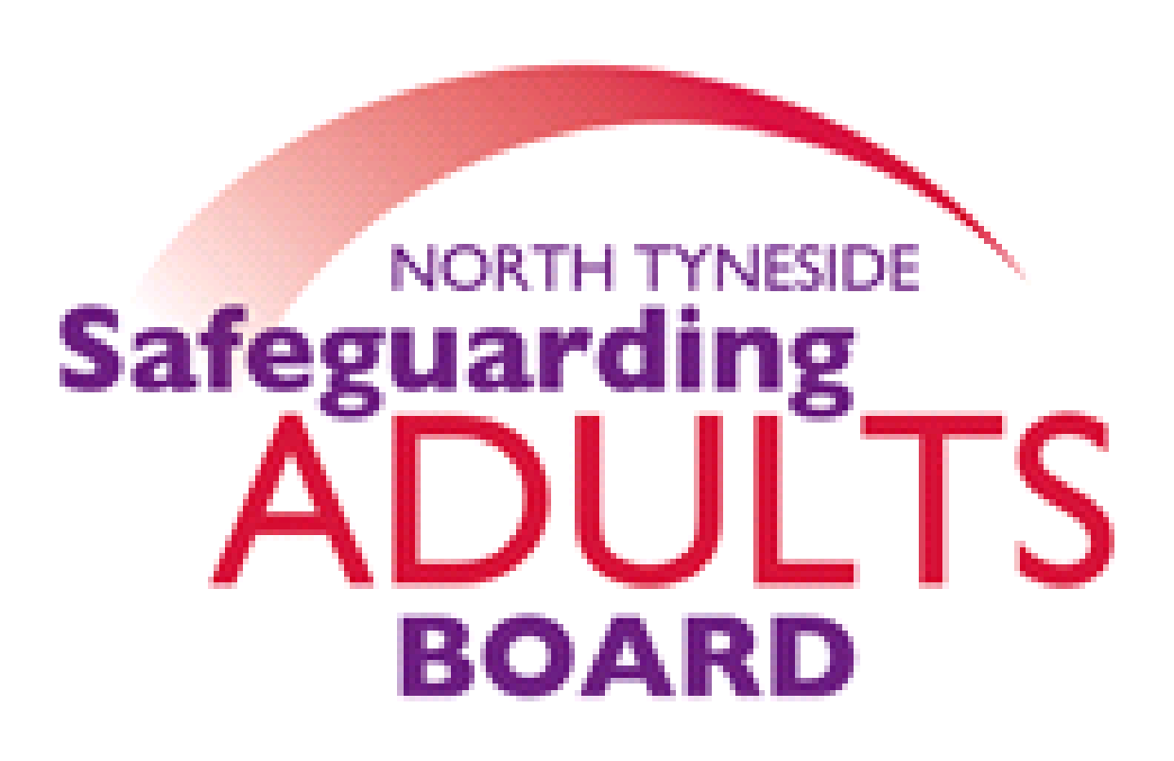

Summary Minutes

North Tyneside and Northumberland Safeguarding Adults Board (SAB) | Date: 22.09.20  Venue: via Teams

Please note these are not full Board minutes, but a summary of discussions, matters considered, and decisions made.

Suicide Prevention Action Plan briefing - North Tyneside Public Health
The Suicide Prevention Action Plan briefing was shared and opened for discussion. Suicide is a key Public Health priority; members were informed of progress made in reducing the rate of suicide for the population of North Tyneside. A multi-agency suicide prevention action plan has been produced, with agreed priorities, linked to the regional ICP suicide prevention programme. A national and regional strategic overview of suicide prevention was provided including the importance of both regional and national data in understanding suicide and those it affects. North Tyneside have a suicide prevention task group, formed in 2014. A Suicide Prevention Action Plan has been produced this includes a focus on providing bereavement support, suicide prevention and awareness training and monitoring high risk locations of suicide.

A new regional training hub will be available for all stakeholders to access different training to improve knowledge and awareness of mental health and details will be circulated once dates and training courses are confirmed, but will include:
- Introduction to Mental Health
- Suicide Awareness
- SOS – Support On Suicide
- SAS – Support After Suicide
- Mental Health First Aid

The SAB and NSSP have previously promoted and circulated the link to Zero tolerance Alliance free Suicide Awareness training.
Partner item - High Impact Patients/Frequent Attenders work at Northumbria Healthcare Trust
NHCFT provided a presentation to the SAB regarding the Frequent Attenders work. NHCFT hold a bi-monthly, multi-agency meeting to promote an integrated approach. The primary presentations for many frequent attenders include abdominal pain, chest pain, substance and or alcohol dependency and suicidal ideation/ attempts. Two of the main themes linked to attendance are social isolation and housing. The meetings are outcome focused.

There was a query about the process for patients frequently attending due to long term and serious health conditions that require frequent attendance. NHCFT confirmed a frequent attender health pathway is put in place. There is an MDT meeting approach to this work.
Draft SAB Annual Report 2019-20
The Draft Annual report has been circulated for comment to all SAB members. Comments have been requested to be returned by 30th September. The final report will then be published on the respective websites.
SAB Recovery/Strategic Plan
The final version of this plan has been circulated for discussion. Comments have been requested to be returned by 30th September, at which time the plan will then be published on both websites.

SAB Risk Register
The SAB risk register was reviewed.
For this quarter, most agencies are cautious due to the potential for a second wave of Covid. The Chair noted, the risks are owned by the agencies, and they are asked to provide controls and assurances to mitigate risks. The Risk Register will continue to be reviewed quarterly.
Subgroup reports/Updates:
Performance report
The Board reviewed and considered the performance report. This was positively received by meeting members, and a discussion took place regarding the key highlights referred to in the report.
Workforce Development sub-group
The Board were advised that most training is now up and running, and is being delivered virtually. The WFD sub-group meeting was held in July and the Terms of Reference were reviewed and a discussion took place about how the group should function in the future. There was an agreement to maintain the group on a virtual platform, and the Chairs will continue to meet with partner agencies as and when required.
Exploitation sub-group- Northumberland
The Board was advised that these meetings continue to take place via virtual mean. The remit of the sub- group now includes modern slavery and trafficking, and both the membership and governance arrangements have been reviewed.
The Exploitation strategy has been updated, and a task and finish group will review and produce the delivery plan. A funding bid to the VRU for APVA posts was successful, and there will be 2 staff based in the 14 plus team. A Northumberland Modern Day Slavery, Trafficking and Exploitation Concept of Operations has been agreed by the Safer Northumberland Partnership, and will be published on both the SAB and NSSP websites.
Safeguarding Adults Review Committee (SARC)
The Board were updated on the progress of the cases currently being overseen by the SARC. The lockdown has had some impact upon time frames and the progression of work, in relation to a small number of actions. SARC meetings are being scheduled for November, January and March and will be held virtually.
The following information was shared with the Board:

LGA/ADASS – Covid-19 and Safeguarding Adults Issues Grid (phase II) July 2020 ‘coming out of lockdown’
This has been updated and details a compilation of issues for SAB’s to consider during the easement of lockdown.

LPS timeline
The Board considered the revised timeline. The timescale for LPS has been extended with full implementation planned for 2022.

ACUK Safeguarding Vulnerable Dependent Drinkers Project update
The Board were advised that two workshops are scheduled for 1st & 8th October which are funded by Northumberland and North Tyneside Safeguarding Adults and Public Health. The focus of the workshops is to review and discuss the National briefing document produced. Local training sessions will follow early next year.

Northumberland DVA & SV Action Plan
For noting and information.

North Tyneside DVA & SV Action Plan
For noting and information.

Northumberland MDS, Trafficking and Exploitation Concept of Operations.
For noting and information. To be endorsed by the Board, and also the Northumberland Strategic Safeguarding Partnership, and Safer Northumberland Partnership.

Briefing for Safeguarding Adults Board – Past Cases Review 2
The Board received briefing outlining details of a second Past Cases Review being undertaken by the Diocese of Newcastle. This aim of this review is to address any shortcomings of the previous review and to include adult cases. The findings of the review will be presented to the SAB and other Boards in the area, at a future date.

SAB Members Induction Pack
This has been updated and will be circulated with the revised SAB Terms of Reference.

Northumbria Missing Adults Protocol
A regional Missing Adults protocol has been finalised. This is a joint protocol with Northumbria Police. The final protocol will be circulated to all 6 SAB areas for endorsement, with a view to launching the protocol in November during National Safeguarding week.

Revised SAB Terms of Reference
The SAB Terms of Reference have been revised. Once the Safeguarding Adults Review Committee Terms of Reference have been reviewed, the information will be circulated to SAB members. For noting and information. The final document will be made available on both websites.

Date of Next Meeting: 15/12/20

For further information about the Safeguarding Adults and the work of the Safeguarding Adults Board please see:
Northumberland:
https://www.northumberland.gov.uk/Care/Support/Safeguarding.aspx
North Tyneside:
https://my.northtyneside.gov.uk/category/1033/safeguarding-adults

Glossary of Abbreviations

ASC | Adult Social Care
BG | Business Group
BIA | Best Interest Assessor
CCG | Clinical Commissioning Group
CMHT | Community Mental Health Team
CQC | Care Quality Commission
CRC | Community Rehabilitation Company
CVS | Community Voluntary Sector
CYPL | Children, Young People and Learning
DASM | Designated Adults Safeguarding Manager
DoL | Deprivation of Liberty
GMC | General Medical Council
HWWB | Health Well Being Board
IMR | Independent Management Review
LADO | Local Authority Designated Officer
LD | Learning Disability
LSCB  NCC | Local Safeguarding Children’s Board  Northumberland County Council
NEPO | North East Purchasing Organisation
NHCFT | Northumbria Healthcare NHS Foundation Trust
NTC | North Tyneside Council
NTW | Northumberland, Tyne and Wear NHS Foundation Trust
NPS | National Probation Service
QAF  QSG | Quality Assessment Framework  Quality Surveillance Group
SAB | Safeguarding Adults Board
SAR | Safeguarding Adults Review
SARC | Safeguarding Adults Review Committee
SE | Sexual Exploitation
T&F | Task and Finish
WDG | Workforce Development Group

