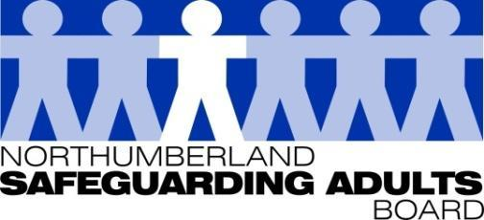
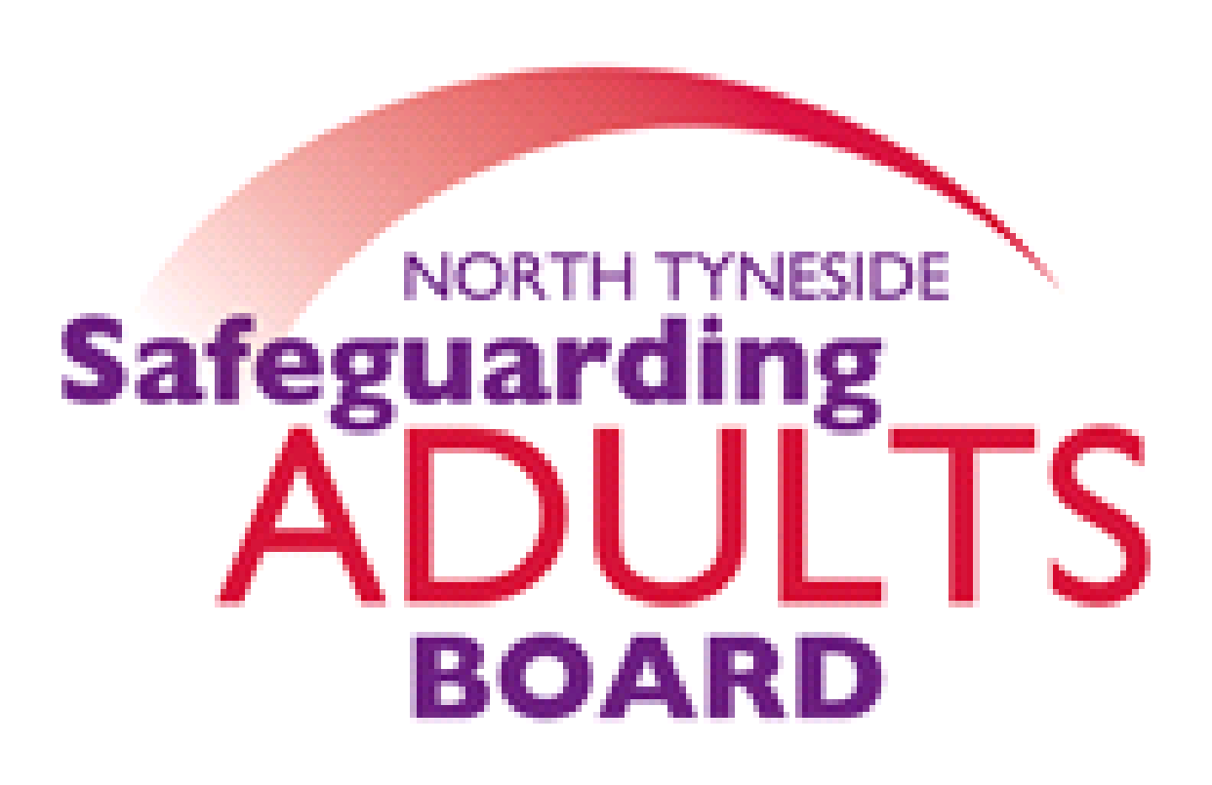

Summary Minutes

North Tyneside and Northumberland Safeguarding Adults Board | Date: 23.03.21  Venue: via Teams

Please note these are not full Board minutes, but a summary of discussions, matters considered, and decisions made.

SAR presentation of Adult AC to be known as Leigh
The Board considered the Safeguarding Adults Review report. The author described Adult AC and her life and outlined how the Review was undertaken, using virtual workshops during the pandemic. The author covered learning for the Board and partner agencies and the recommendations from the Review. The author summarised key areas for development, including the need for a Professional Curiosity Briefing and the need to develop an approach for the lifelong impact of Adverse Childhood Experiences.

The Chair thanked the author for the report and thought it was very thorough, although very sad. The Chair welcomed the Board to raise any questions or comments. The Chair acknowledged the SARC’s collaborative work to inform the recommendations; this is an important part of the process.

Domestic Abuse Partnership arrangements – North Tyneside and Northumberland

The Board received information from the Northumberland & North Tyneside Domestic Abuse & Sexual Violence Coordinator. The Domestic Abuse Bill is very much in the final stages. Royal assent is still expected in late April/ early May. The Bill (once it becomes an Act) will place the domestic abuse definition on a statutory footing and there is an expectation that Local Authorities have an established Domestic Abuse Board. There are plans to establish a new local Domestic Abuse Partnership Board in both areas, which will meet the required membership as set out in the draft statutory guidance. This will include representation from statutory and voluntary agencies and also for victims/survivors and their children.

Funding has been allocated for 2021/22; therefore there is an expectation that Boards will be set up and in place during this time. There is also a requirement to complete a needs assessment that informs a strategic commissioning strategy. It was noted it is a statutory duty to have the correct level of safe accommodation and support in place for victims, survivors and their children.

The Board were provided with a summary of local arrangements in Northumberland and North Tyneside and how work is progressing in line with the Bill. It was noted there has been good progress in both areas.

APVA/CPVA update - Northumberland & North Tyneside

The Board considered a briefing provided by the Northumberland & North Tyneside Domestic Abuse & Sexual Violence Coordinator regarding Adolescent / Child to Parent Violence and Abuse, now referred to as CPVA. Both Local Authorities have multi-agency steering groups that meet quarterly. This has been the case since a drive and funding from the PCC. There is a joint North Tyneside and Northumberland training strategy which was implemented in the early stages, and continues to be reviewed with the support of both workforce development leads and specialist programme deliverers. Multi-agency CPVA briefing and toolkit sessions continue to be delivered to ensure that staff have the required resources to support them. Virtual sessions have been well received and attended by staff. It was noted that the 6 LA areas have met with Northumbria Police and agreed that CPVA will now be defined as ‘any harmful act or behaviour by a child aged 10-18 years’ (it was previously 13 years +). Communications explaining this change are to be circulated. The seven-minute guide will be updated and shared within Northumberland. In North Tyneside it is hoped that a short film will be shared in team meetings.

Transitional Safeguarding Assurances – North Tyneside and Northumberland
The Board considered presentations from the North Tyneside and Northumberland SAB Business Managers, based on information presented to a regional Transitional Safeguarding workshop, alongside other Local Authorities in the region. In North Tyneside, development work has started in reviewing the transitions process. Northumberland have made good progress. The Adolescent service links closely with Adult Services and an adult representative has also attended MSET to pick up any transitional cases. A transitions policy and pathway has been developed, and transitions panels are now being piloted. A Joint Transitional Safeguarding Protocol has been developed and will be presented at the next meeting.

Channel Panel Assurances
North Tyneside:
The Board were advised that in North Tyneside, prior to Parsons Green, the Channel Panel sat within Community Safety, and Adult and Children’s services were part of the panel. However, following Parsons Green and the shift from Security to Safeguarding, it was decided that Panel chairs would sit within the Safeguarding teams within Adults and Children’s Services. A working group was set up to determine how this could be done, whilst this was underway the Government issued new guidance and as such some shift was necessary. As of 01/04/2021 there will be two Channel Chairs at the Children’s and Adult Front door, alongside the SPOCs. There is a full calendar of monthly Channel meetings. These will incorporate any learning. Governance currently sits under the Safety North Tyneside Partnership and a working group meet monthly to review the current arrangements.
Northumberland
The Northumberland SAB manager noted her role as Channel Chair for the last 18 months, alongside, a Co-Chair and Head of Children’s Services. The Board were provided with a briefing report which set out the current arrangements, which have recently been revised. The Channel Panel reports directly to the Safer Northumberland Partnership, for which a quarterly report is provided. The panel also reports annually to both the Children’s and Adult Boards. The Channel Panel membership and Terms of Reference have recently been reviewed, which include an escalation process. Nationally, revised Channel duty guidance was published in 2020, and a self-assessment was undertaken in Northumberland to ensure compliance with this. Meetings have taken place monthly for the past 18 months. The operational Prevent Channel pathway has also been recently revised. All Channel Panels need to provide an annual assurance statement to the Home Office in April 2021.
SAB Annual Strategic Plan
The Board reviewed the Strategic Plan, updated to March 2021. Most areas are either achieved or in progress. Some areas will need to be carried over to next year’s strategic plan, in line with the SAB’s ongoing priorities. This plan will now be finalised, and presented for endorsement at the next meeting. Work will now commence on the Strategic Plan 2021-22, including a review of the priorities and format.

SAB Risk Register
The Board considered and reviewed the updated Risk register. It was noted that some agencies have no risks identified now and these have been removed. The view was that were measures in place to mitigate risks and no new risks had been identified. Agencies and partners have adapted to a different way of working. Other agencies with risks highlighted, have expressed some caution around coming out of lockdown and the potential increase in safeguarding.

Subgroup reports/Updates:

Performance report
The Board considered the Performance report and highlights. Generally most partners are reporting a continued increase in safeguarding. There has been a significant increase in safeguarding activity: this demonstrates good information sharing by partners, and increased staff awareness. There are a number of safeguarding concerns, particularly in relation to self-neglect, that are associated with COVID and lockdown.
WFD sub-group
The Board were advised that the WFD group have now finalised a workforce strategy for the next 12 months. This includes internal and multi-agency training. Appreciative Enquiry training has now been arranged, and both areas have looked at ensuring messages have been circulated regarding the Northumbria Missing Adults protocol, and the importance of promoting the Herbert and Winnie protocols. Some work is being undertaken in relation to Making Safeguarding Personal and circulating briefings reminding people of all the available toolkits.
Exploitation sub-group- Northumberland
The Board were advised this group oversees sexual and criminal exploitation work. A revised strategy is in place and the delivery plan is currently being finalised by the group. The plan includes community engagement and awareness, training for professionals, victims and reachable moments, and data collection. Some of the positive work within the strategy and sub-group has focussed on partnership working, sharing of intelligence, raising awareness of signs and indicators, and early intervention and preventative measures.
SARC
The Board were updated on the progress of the cases currently being overseen by the SARC.
Items for information:
-NICE guidance – ‘Safeguarding adults in care homes’
-LGA/ADASS – ‘Understanding what constitutes a safeguarding concern and how to support effective outcomes’
-North Tyneside CCG Annual Safeguarding report
-Revised Prevent Pathway – Northumberland
-Revised Prevent Pathway – North Tyneside
-Falls Protocol – North Tyneside
-SAY App launch Northumberland – promotional materials

Date of Next Meeting:
Tuesday 22nd June 2021, 1:00pm, Microsoft Teams.

For further information about the Safeguarding Adults and the work of the Safeguarding Adults Board please see:
Northumberland:
https://www.northumberland.gov.uk/Care/Support/Safeguarding.aspx
North Tyneside:
https://my.northtyneside.gov.uk/category/1033/safeguarding-adults

Glossary of Abbreviations

ASC | Adult Social Care
BG | Business Group
BIA | Best Interest Assessor
CCG | Clinical Commissioning Group
CMHT | Community Mental Health Team
CQC | Care Quality Commission
CRC | Community Rehabilitation Company
CNTW | Cumbria, Northumberland, Tyne and Wear NHS Foundation Trust
CVS | Community Voluntary Sector
CYPL | Children, Young People and Learning
DASM | Designated Adults Safeguarding Manager
DoL | Deprivation of Liberty
GMC | General Medical Council
HWWB | Health Well Being Board
IMR | Independent Management Review
LADO | Local Authority Designated Officer
LD | Learning Disability
LSCB  NCC | Local Safeguarding Children’s Board  Northumberland County Council
NEPO | North East Purchasing Organisation
NHCFT | Northumbria Healthcare NHS Foundation Trust
NTC | North Tyneside Council
NPS | National Probation Service
QAF  QSG | Quality Assessment Framework  Quality Surveillance Group
SAB | Safeguarding Adults Board
SAR | Safeguarding Adults Review
SARC | Safeguarding Adults Review Committee
SE | Sexual Exploitation
T&F | Task and Finish
WDG | Workforce Development Group

