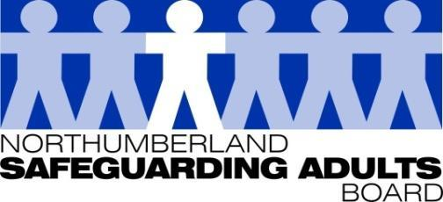
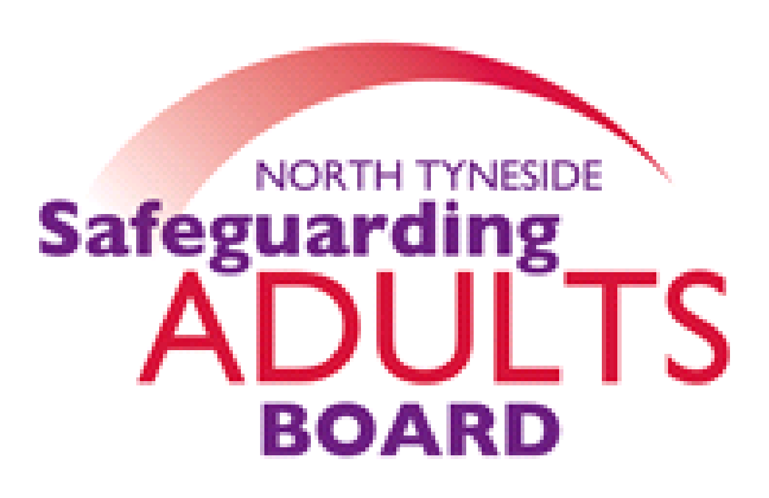

Summary Minutes

North Tyneside and Northumberland Safeguarding Adults Board | Date: 10.03.20  Venue: Northumberland Fire and Rescue Service HQ, West Hartford

Please note these are not full Board minutes, but a summary of discussions, matters considered, and decisions made.

Northumberland Suicide Prevention Strategy
A presentation was provided to the Board by Northumberland Public Health Consultant on the progress of suicide prevention work in Northumberland and at a sub-regional level. The briefing provided the key messages from national data on suicides, a local analysis of Northumberland data, National guidance, and the local response to suicide and prevention activities.

Suicide remains a local and national public health priority. It is one of the biggest contributors to years of life lost in men and has a significant impact on family, friends, work colleagues and the wider community. The patterns for deaths arising from suicide in Northumberland reflect the national pattern although the numbers are relatively small.

The Northumberland Suicide Prevention Strategy 2017-2022 (Refreshed in 2019) and
action plan, is based upon the national plan and Public Health England recommendations of local authority actions impacting on suicide. The priority areas are:
- Reduce the risk of suicide in key high-risk groups
- Tailor approaches to improve mental health in specific groups
- Reduce access to the means of suicide
- Provide better information and support to those bereaved or affected by suicide
- Support the media in delivering sensitive approaches to suicide and suicidal behaviour
- Support research, data collection and monitoring

Northumberland Joint Learning Review Report
Northumberland Strategic Safeguarding Manager presented the learning review report which made a number of recommendations to the NSSP and SAB. The report contents were discussed at length. A joint action plan would be produced to reflect this learning. It was noted that report will also be presented to the NSSP for endorsement.

Commissioning Update Reports
As outlined in the SAB Strategic Plan, Commissioning services are required to provide annual assurances to the Board in relation to the quality of commissioned services and safeguarding monitoring processes. Reports were provided to the Board by North Tyneside CCG, North Tyneside Local Authority and Northumberland CCG. It was noted that Northumberland Local Authority has provided a presentation to the Board earlier in the year.

LGA/ADASS Briefing on working with risk for Safeguarding Boards - in the context of MSP
An overview of the ADASS/LGA guidance document was provided, which is based on workshops in the context of MSP. The aim of this briefing document was to provide support to SABs and partner agencies in gaining a shared commitment to partnership guidance on effective working with risk, based on common principles.

The full document can be found at:
https://www.local.gov.uk/.../making-safeguarding-personal/working-risk

Making Safeguarding Personal toolkit
Building upon a range of MSP resources produced in 2017, ADASS have more recently (2020) published an updated MSP toolkit and a range of resources such as a myths and realities briefing, case studies and podcasts.
The full set of resources and toolkit can be found at:
https://www.local.gov.uk/our-support/our-improvement-offer/care-and-health-improvement/making-safeguarding-personal

It was agreed that work in relation to the MSP toolkit/resources would be added to the Strategic Plan for 2020-21.

ACUK’s Safeguarding Dependent Drinkers Initiative
Information was shared regarding a national initiative. This is a multi-agency partner project initiative to develop and deliver practice guidance and training on responding to vulnerable adults who are chronic and change resistant dependent drinkers. Local authorities, Safeguarding Adult Boards and other partners have been asked to participate to help improve local practice as well as challenging and informing national government about necessary changes.

Each participating area has been asked to purchase a package of training, consultation, feedback and development to enable both locally and nationally to develop the underpinning guidance and deliver cost-effective training through multi-partner funding. ACUK is working in partnership on this project with Professor Michael Preston-Shoot and it will be led by Mike Ward who heads the Blue Light project on complex drinkers, which has recently won both a Guardian Public Service Award and a Royal Society of Public Health Award.

ACUK’s recent report highlighted the role of alcohol is often not raised or picked up in safeguarding concerns, which has been highlighted in several safeguarding adults reviews.

The project will involve a review of all Safeguarding Adult Review material nationally and provide some scoping workshops. Each participating area will receive a 2 day training workshop, guidance and a presentation to local partners. Northumberland and North Tyneside (Safeguarding Adults and Public Health) have contributed funding to this project, and a local multi-agency scoping workshop is planned for 6 May.

Sub-group Reports:
- Performance sub-group – key data and findings from the Performance report were considered and discussed by the Board.
- Workforce Development sub-group – Findings from the Board’s Training Needs Analysis were discussed. It was agreed that the Induction pack and training for Board members would be reviewed. It was confirmed that Appreciative Inquiry training has been jointly commissioned.
- Sexual and Criminal Exploitation sub-group report – The Annual report was presented to the Board. It was highlighted that there are now Exploitation Champions in place across Adults and Children’s Services. Joint Sexual Exploitation training has also been developed and rolled out.

‘The Poor Relation – Police and CPS response to crimes against Older People’
Northumbria Police presented their local response to the ‘The Poor Relation’ report. An inspection was carried out in 2018/19 highlighting some of the challenges faced by the Police and the Crown Prosecution Service in keeping safe the ageing population. 13 recommendations were made and 10 areas for improvement were identified. This is a national issue. The Board discussed the local response, and expressed interest in the role of Victims First Northumbria (VFN). It was agreed that VFN would be approached to provide a future presentation to the Board.

The full report can be found at:
https://www.justiceinspectorates.gov.uk/hmicfrs/publications/crimes-against-older-people/

The following information was shared with the Board:

Changing Lives Liberty Project leaflet (information only)
Information relating to a new Changing Lives project which has funding for 3 years. The project will deliver trauma-responsive support to adults who are being exploited and are subject to modern slavery.

Leanne Patterson Safeguarding Adults Review
Following the publication of the Executive Summary report, a storyboard has been produced to highlight the learning from the review, which can be circulated by partners.
It was also confirmed that all partner agencies have completed their individual agency actions, though the multi-agency action plan remains ongoing.

Annual Report Easy Read version
An easy read version of the Annual Report has been produced by the Northumberland Central User Forum. The Board considered and agreed the content. This report would now be made available on both North Tyneside and Northumberland Safeguarding Adults websites. The Board and the Independent Chair expressed their gratitude to the forum, and this would be acknowledged at the beginning of the report.

Regional Missing Adults Protocol update
The APPG Inquiry into Safeguarding Vulnerable Missing Adults, and more recently a local Appreciative enquiry have highlighted the need for a protocol for missing adults. This would ensure that vulnerable adults receive a consistent response and an offer of help on their return, including mental health support if appropriate. Safeguarding Leads North/South of Tyne are working with Northumbria Police to develop a protocol.

Date of Next Meeting: 24/06/20

For further information about the Safeguarding Adults and the work of the Safeguarding Adults Board please see:
Northumberland:
https://www.northumberland.gov.uk/Care/Support/Safeguarding.aspx
North Tyneside:
https://my.northtyneside.gov.uk/category/1033/safeguarding-adults

