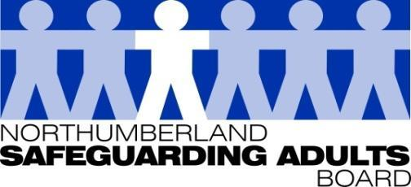
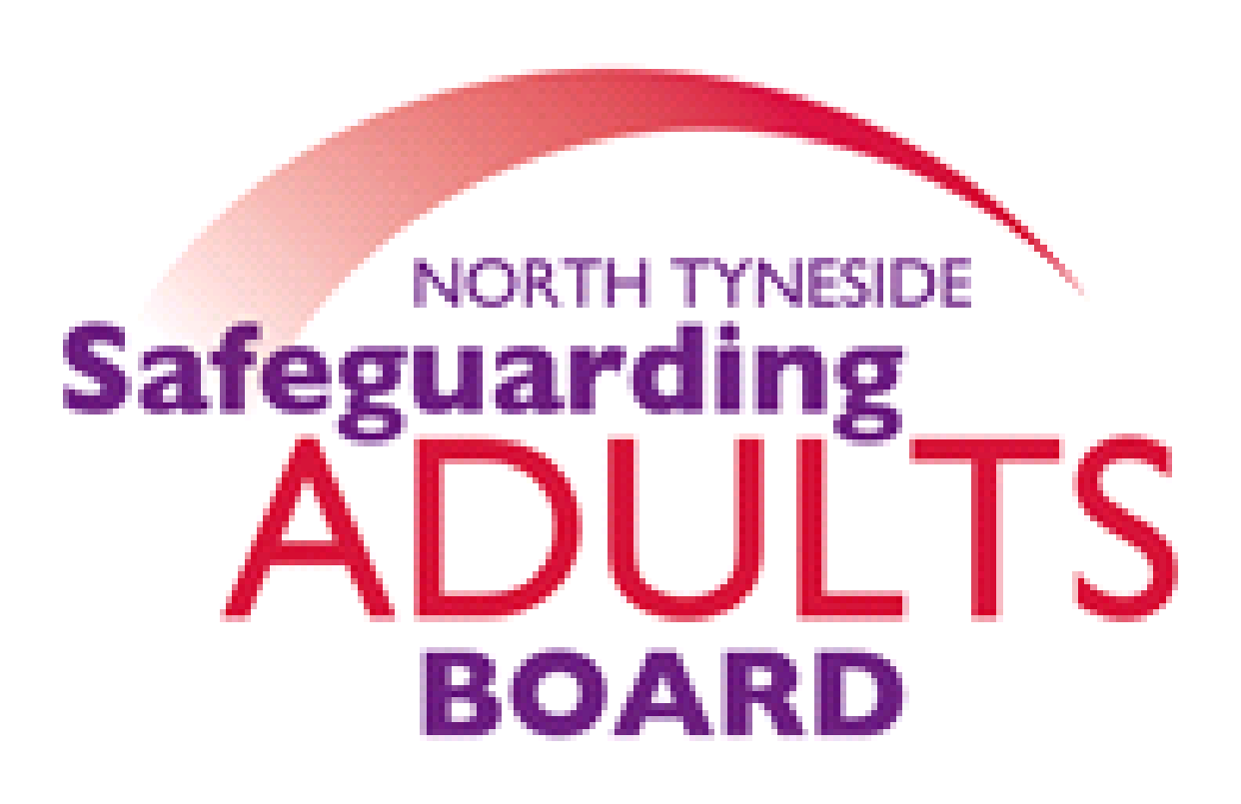

Summary Minutes

North Tyneside and Northumberland Safeguarding Adults Board | Date: 15.12. 20  Venue: via Teams

Please note these are not full Board minutes, but a summary of discussions, matters considered, and decisions made.

VRU Presentation
A presentation was provided by the Head of the Northumberland Violence Reduction Unit, Steven Hume. This included background information relating to the VRU team, the vision, and their delivery plan in relation to 4 key objectives: youth diversion, reducing offending, working with families and connecting communities.

The Northumbria Serious Violence Strategy was also shared with the Board.

Transitional Safeguarding Presentation
A presentation was provided by Steve Baguley from the National Working group. Some of the key messages highlighted included:

- Exploitation does not end at age 18, and the lessons from Operation Sanctuary are that perpetrators target vulnerability not age.
- We need to recognise the long-term impact of abuse and if young people receive better transitional services, then they are less likely to require input and services later.
- Awareness of language issues, which is often victim-blaming, dehumanising.
- There is a need to further develop a trauma informed approach when working with adults.
- SCRs and SARs have highlighted transition issues.
- A better understanding of adolescence is required, which does not fit with existing processes and structures.
- Consent to access services is an issue. The CPS guidance is very helpful. We should not be automatically closing cases due to the lack of consent. There needs to be a recognition regarding the impact of coercion and control upon consent.
- Nationally guidance is being developed for Safeguarding Adult Boards and Adult Social Care.
- Disruption of perpetrators is key.
- Across the county some good practice and alternative models are being developed. It is recognised that input from both adult and children’s social care better prepares young people for adulthood. CSC can learn from ASC in terms of a person-centred approach.

DWP Safeguarding Lead Presentation
A presentation was provided by the regional DWP Senior Safeguarding Leader, Lyndsey Thornton. Improving how they support the most vulnerable customers is a priority for DWP. The Senior Safeguarding Leader role is integral to this approach. A key aspect of this role is to link with local communities and build relationships with organisations that provide support to their customers.

The DWP are aware of potential safeguarding risks, such as those associated with large back payments, and are proactively identifying and supporting vulnerable individuals.

SAB Annual Strategic Plan
The updated Strategic plan was shared and discussed.

Most areas on the plan are now green or yellow. Yellow areas need to be monitored and reviewed by the SAB. There are no red or amber sections as progress is being made, and work needs to be finalised or carried over to 2021.

SAB Risk Register
The updated SAB risk register was shared and discussed. Partners are now in a position where they want to continue to monitor most risks due to a potential third Covid wave after the Christmas period.

This risk register is specific to the risks relating to Covid, and partners are responsible for identifying and updating their risks and mitigations.

Subgroup reports/Updates:

Performance report
The Board reviewed and considered the performance report, and a discussion took place regarding the key highlights referred to in the report.

WFD sub-group
WFD have continued to offer a range of training, though slightly reduced due to Covid.

They are starting to look at a new training directory for the next financial year and are linking in with sub-groups to identify themes going forward.

Exploitation sub-group- Northumberland

There is a new Chairperson and Deputy Chair provided by Northumbria Police, and the strategy and delivery plan has been reviewed and is being finalised.

The Regional Missing Adults protocol and the exploitation toolkit have been discussed in detail and have been circulated across agencies. Criminal exploitation training has been developed by Adult Social Care and the Learning and Development team and the Police have circulated this across the force area to increase awareness. The Police have also produced and circulated a 12- minute awareness raising video.

SARC
The Board were updated on the progress of the cases currently being overseen by the SARC.
For information:
The following information items were considered by the Board:

- Revised SAB Terms of Reference
- Final SAB Members Induction Pack
- National Covid Data Insights Report
- Final Northumbria Missing Adults Protocol
- SAY Project/App Update
- NHCFT – Safeguarding Children and Adults at risk – Annual Report 2019-20, Q2 Safeguarding Report 2020-21
- Northumberland CCG Annual Safeguarding report
- CNTW Safeguarding Annual Report
- National SAR Analysis Report – Draft report, Executive Summary
- Northumberland Adolescent to Parent Violence and Abuse Pathway

Date of Next Meeting: 23/03/21 @1-4.00pm via Teams

For further information about the Safeguarding Adults and the work of the Safeguarding Adults Board please see:
Northumberland:
https://www.northumberland.gov.uk/Care/Support/Safeguarding.aspx
North Tyneside:
https://my.northtyneside.gov.uk/category/1033/safeguarding-adults

Glossary of Abbreviations

ASC | Adult Social Care
BG | Business Group
BIA | Best Interest Assessor
CCG | Clinical Commissioning Group
CMHT | Community Mental Health Team
CQC | Care Quality Commission
CRC | Community Rehabilitation Company
CNTW | Cumbria, Northumberland, Tyne and Wear NHS Foundation Trust
CVS | Community Voluntary Sector
CYPL | Children, Young People and Learning
DASM | Designated Adults Safeguarding Manager
DoL | Deprivation of Liberty
GMC | General Medical Council
HWWB | Health Well Being Board
IMR | Independent Management Review
LADO | Local Authority Designated Officer
LD | Learning Disability
LSCB  NCC | Local Safeguarding Children’s Board  Northumberland County Council
NEPO | North East Purchasing Organisation
NHCFT | Northumbria Healthcare NHS Foundation Trust
NTC | North Tyneside Council
NPS | National Probation Service
QAF  QSG | Quality Assessment Framework  Quality Surveillance Group
SAB | Safeguarding Adults Board
SAR | Safeguarding Adults Review
SARC | Safeguarding Adults Review Committee
SE | Sexual Exploitation
T&F | Task and Finish
WDG | Workforce Development Group

