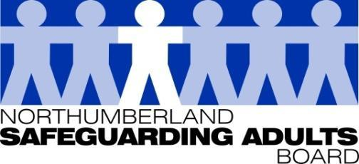
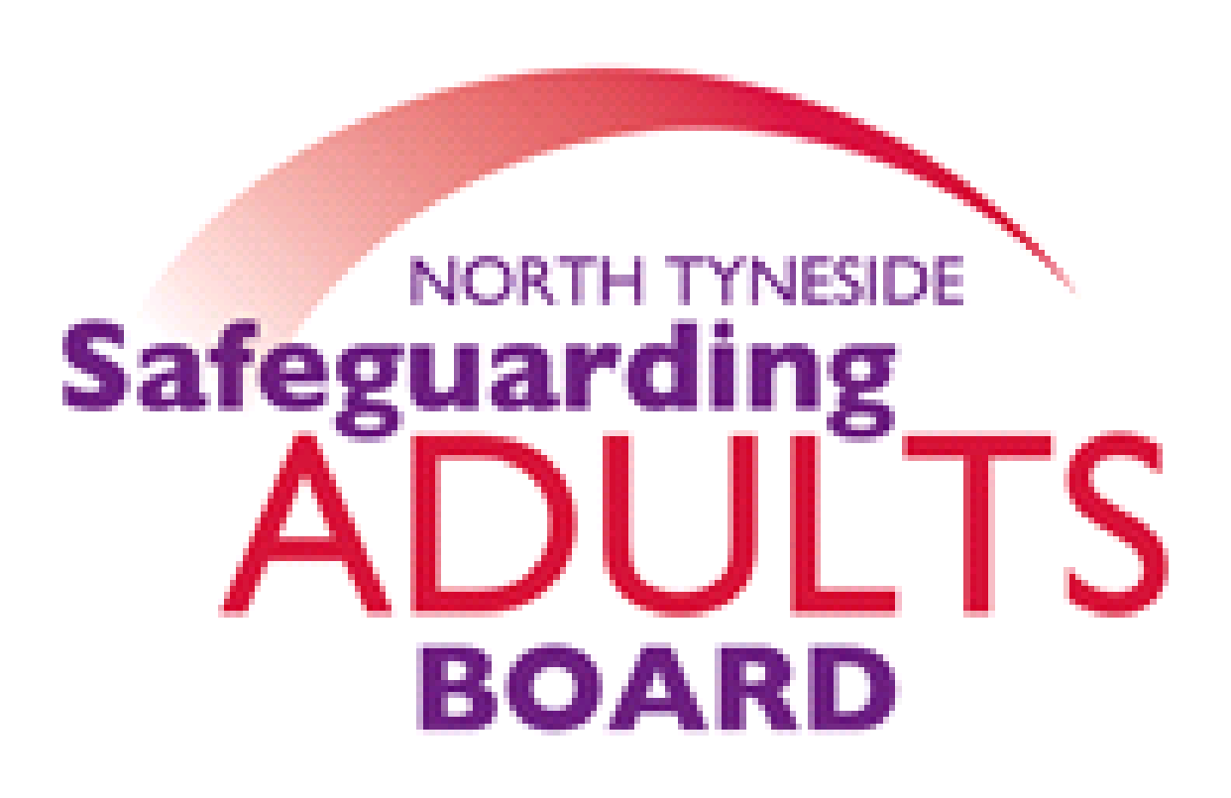

Summary Minutes

North Tyneside and Northumberland Safeguarding Adults Board | Date: 14/09/21  Venue: via Teams

Please note these are not full Board minutes, but a summary of discussions, matters considered, and decisions made.

Northumbria Police – Diversity, Equality, and Inclusivity Strategy
The Northumbria police lead for the Diversity, Quality, and Inclusivity partnership, delivered a presentation. The main objective of the Equality Act 2010 was to eliminate discrimination, harassment and victimisation, and advance equal opportunities. To try to address inequality the Police Chief Council developed the strategy which consists of three toolkits (Organisational, Communities and Partnership). The purpose of the Partnership toolkit is to bring partners together to better understand our partnership landscape, to understand disparity in regional communities and ensure we have provision in place for those suffering from disparity. All six local authority Chief Executives have signed up. The vision is to collectively understand the diversity in communities and to promote the benefits of diversity. An agreed outcome following the presentation was to determine what data core sab agencies collate on protective characteristics.
SAB Peer Review Proposal/Options
Both North Tyneside and Northumberland are reviewing future Board arrangements and considering moving to single Boards, updates will be provided at the Board in December.
Closed Cultures
During the pandemic, there was significantly reduced contact with individuals in receipt of care and support, from friends, families, and professionals; this was due to the need to mitigate the risk of the spread of COVID and adhere to Government guidance. ADASS published guidance highlighting the risks of closed environments, as did CQC, for providers. In response to this, it was agreed assurance was required from commissioning partners and CQC and a task and finish group was convened, and an assurance document collated. This included responses from both LA Commissioning teams, CCGs and CQC. Six questions were asked based on ADASS guidance to gather assurance: and they were asked about what existing mechanisms/forums are in place. There were similar responses from both Local authority Commissioning teams; there are regular meetings with CQC, Provider Forums, Quality & Safety Committees that both CCGs attend, as well as Quality Review Groups where information is shared.
An agreed action was for assurances to be sought from CCG’s in relation to placements, following recommendations from the recent Norfolk SAR.
Public Health – Mental Health post Covid – Regional update
A presentation and overview was provided in relation to a regional piece of work undertaken through the Public Mental Health network. It is representative of all twelve LAs in the North-East.
SAB work plan updates
A draft SAB Strategic Plan has been circulated and feedback requested on the proposal, which is a three-year plan with an annual Business Plan underneath. This allows for the new Board arrangements in terms of placed-based approaches, and priorities have been agreed across both areas for three years. The annual Business Plan will change depending on local arrangements and demands.
Annual Report 2020-21 to be circulated once finalised.
Subgroup reports/Updates:
Performance report
The report was shared, it sets out key trends of safeguarding referrals and activity across all partners represented within the Board, as well as reporting types of abuse, location, Making Safeguarding Personal measures, and criminal exploitation. The report explores data trends as well as actions and assurances put in place by partner agencies to meet the changing demand brought about by the pandemic.
WFD sub-group
There has been a request for more classroom training as people return to the workplace. There is new trauma-informed training course which has been circulated to all partners (Caring about Adversity, Resilience and Empowerment) which is being delivered jointly. This is a programme for anyone working with individuals who have experienced some form of trauma in their life and provides a baseline of awareness across all areas. There are some briefings to commence on 18/10/2021 with regards to the learning from the recently published Leigh SAR: six multi-agency sessions are planned, and information will be circulated to partners next week. There is also some long-term health condition awareness training available: as a result of Leigh’s SAR, there is a need to gain an understanding of HIV and Aids, and also to consider other health conditions also. In both LAs there has been a real need to look at what we are providing in terms of Level 3 Safeguarding Adults provider training, following the pandemic.
Exploitation sub-groups
An exploitation delivery plan has been developed which presented to the Board today for approval. The core objectives being progressed focus on data and intelligence sharing, community engagement and awareness, training, and victims. The Violence Reduction Unit (VRU) bid to the Home Office was successful and the project will commence in custody suites within and across the force. North-East mentors will be in custody to engage with children and young people up to the age of 21 years who are suspected of being criminally exploited or involved in gangs, serious youth violence etc. Adult Safeguarding has been joined up with Missing Coordinators and now monthly data is shared around the top missing adult cases and locations, to ensure the safeguarding response is maximised. The Missing from Home Coordinator is also now linked in with the Mental Health hospitals in relation to missing patients.
Safeguarding Adults Review Committee (SARC)
The Board were updated on the progress of the cases currently being overseen by the SARC.
National SAR Analysis SARC Assurance document and action plan
It was noted that following on from the national SAR analysis led by Michael Preston-Shoot, a number of recommendations were made that Boards and SARC groups were asked to consider. These were across five areas. Initially the SARC benchmarked recommendations against our current practice, policies and procedures and identified areas of improvement. This analysis report was presented to the Board. An action plan was also shared with the Board, which has been collated to look at next steps and timescales. In summary, the actions include reviewing the current SAR policies and procedures and ensuring some of the recommendations around timescales and feedback to individuals and families are considered. There is also a need to review the Board Quality Assurance Framework to ensure the learning and challenge from the analysis is incorporated. A SARC development session will be arranged in 2022, to look at how learning from previous SARs is followed up and revisited, to ensure any learning has been embedded. The North-East Quality Markers quick guide will also be implemented, and will be reviewed annually.
North East SAR Quality Markers quick guide
The North East SAR Champions have developed a Quality Markers quick guide which is more accessible than the full Quality Markers and will assist the role of the SARC. With the SAB’s approval, this will be implemented by the SARC and inform future decisions and commissions.
NHCFT/CCG Diabetes Management plan/pathway
Following on from the previously published Adult W SAR, one of the main recommendations was to develop a multi-agency diabetic pathway. This plan has now been developed by NHCFT and Northumberland CCG and has been published and shared with Adult W’s family. The pathway was presented to the Board for information.
National Safeguarding Adults Week 15-21 November 2021
https://www.anncrafttrust.org/events/national-safeguarding-adults-week-2021/
Refer to link for information. A National Safeguarding week plan is current being developed, and more information will follow.

Adversity and Resilience Communications/Training
The National Safeguarding week plan will include communications and training events in relation to Adversity and Resilience.
The following items were presented for endorsement:
Leanne Patterson SAR – Finalised action plan
Safeguarding and Housing Partnership Terms of Reference
Bobby Joint Learning Review – Finalised action plan
The following items were presented for information:
Past Cases Review 2 update – Diocese of Newcastle Safeguarding Advisory Group
Final SAB Risk Register
Northumberland 7- minute briefings – Language, Child to Parent Violence and Abuse, Professional Curiosity
NHCFT Annual Safeguarding Children and Adults at risk Annual Report 2020-21/Q1 Safeguarding report
Safeguarding Vulnerable Drinkers Project – Final guidance/report
Date of Next Meeting:
Tuesday 14th December, 1.00-3pm via Microsoft Teams.

For further information about the Safeguarding Adults and the work of the Safeguarding Adults Board please see:
Northumberland:
https://www.northumberland.gov.uk/Care/Support/Safeguarding.aspx
North Tyneside:
https://my.northtyneside.gov.uk/category/1033/safeguarding-adults

Glossary of Abbreviations

ASC | Adult Social Care
BG | Business Group
BIA | Best Interest Assessor
CCG | Clinical Commissioning Group
CMHT | Community Mental Health Team
CQC | Care Quality Commission
CRC | Community Rehabilitation Company
CNTW | Cumbria, Northumberland, Tyne and Wear NHS Foundation Trust
CVS | Community Voluntary Sector
CYPL | Children, Young People and Learning
DASM | Designated Adults Safeguarding Manager
DoL | Deprivation of Liberty
GMC | General Medical Council
HWWB | Health Well Being Board
IMR | Independent Management Review
LADO | Local Authority Designated Officer
LD | Learning Disability
LSCB  NCC | Local Safeguarding Children’s Board  Northumberland County Council
NEPO | North East Purchasing Organisation
NHCFT | Northumbria Healthcare NHS Foundation Trust
NTC | North Tyneside Council
NPS | National Probation Service
QAF  QSG | Quality Assessment Framework  Quality Surveillance Group
SAB | Safeguarding Adults Board
SAR | Safeguarding Adults Review
SARC | Safeguarding Adults Review Committee
SE | Sexual Exploitation
T&F | Task and Finish
WDG | Workforce Development Group

