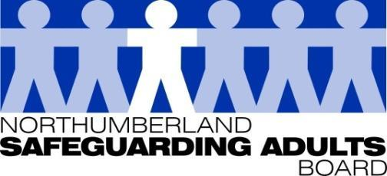
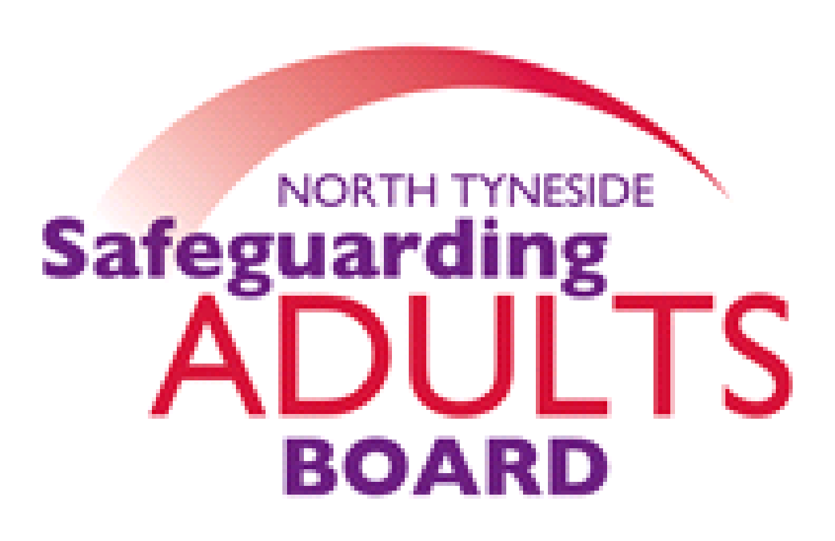

Summary Minutes

North Tyneside and Northumberland Safeguarding Adults Board | Date: 08/03/22  Venue: via Teams

Please note these are not full Board minutes, but a summary of discussions, matters considered, and decisions made.

The Chair confirmed this is the final Joint Board meeting between North Tyneside and Northumberland Safeguarding Adults Board.

Future SAB Arrangements
North Tyneside have established an Executive Board and initial meetings have been held where the strategic plan, Terms of Reference and delivery plan has been agreed, these will be working documents. Draft membership for the Partnership Board has been produced and is waiting to be signed off by the Executive Board. The Partnership launch is planned for Monday 9th May, this coincides with Mental Health Awareness Week, which is important and has been an area of focus for the Board, following discussions and evidence from the COVID Pandemic. North Tyneside are also looking to improve the multi-agency approach and pathway for complex cases, which it is hoped a broad Partner membership can help achieve.

Northumberland will have a Joint Safeguarding Partnership with Children’s, an Executive group is in place, and the new Partnership will be launched on 4 May. There is a project plan in place to review all sub-groups, Terms of References, and memberships over the next 12 months.

Updates on Partnership/Sub-Group Arrangements
It has been agreed for the first 12 months, the SARC and Performance Group will remain combined across the two areas. Lay members have confirmed they are happy to continue their role in their respective authorities. It was agreed correspondence would be sent to all co-opted members to update them regarding the new Partnership arrangements.
SAB Annual Report 2021-2022

- Partner Contribution Reports – May 2022
- Request for partner spotlights/case studies
The Chair reminded Board members that the Annual report will look back on the preceding year (21-22) and will be the last report as a joint board. It will include information from each area about their new Board arrangements. Evidence and information will be collated from partners to be included in the report. As always, support is requested from partners to highlight any case studies or work to feature in the report.

Report to SAB – Northumberland S42 Safeguarding Data
The Chair reminded the Board that at the last meeting the Covid Insights report was looked at in more detail, and it was noted that Northumberland was an outlier in relation to the number of S42 enquiries reported, though there were a high number of Adult Concern Notifications recorded. It was noted the report presented to the Board today provided a helpful and detailed analysis. A summary of the report findings were shared and assurance provided that whilst some recording issues had been highlighted, adults at risk in Northumberland, are being appropriately safeguarded.

Subgroup reports/Updates:
Performance report
The performance data was shared, and an overview of the key headlines was provided. There is a still a decrease in domestic, emotional, and financial abuse but high numbers are still being seen in neglect and acts of omission, there is also an increase in organisational abuse.

Report to Performance Group – Northumberland Meeting Attendance Analysis
An audit of multi-agency meeting attendance is completed annually in Northumberland, and a full Audit report is provided for partner agencies information.

WFD sub-group
An update to the board was provided in relation to the joint work which has been undertaken. Adversity Awareness training continues to be offered across both Local Authority areas which will continue to be delivered jointly. To date approximately 400 people have received the training across both areas. A number of briefings, webinars and 7-Minute guides have been produced such as professional curiously, hate/mate crime, Think-family, Safeguarding Adult Review briefings. WFD leads will continue with both Boards, support development sessions, and work with the SARC to ensure lessons learned are being shared. They will also continue to develop and strengthen the domestic abuse offer across both areas.

Exploitation sub-groups
The Board were advised there has been really good buy-in from partnership agencies across both LA’s.

Northumberland Exploitation sub-group
An update was provided, the last meeting was held on 9th Feb, where a presentation was provided in relation to Operation Eclipse, a multi-agency operation in Berwick in relation to county lines activity. This is to be shared with other Strategic Exploitation groups in the Northumbria Police area. There has also been a presentation in relation to the Exploitation hub, and the use of the vulnerability tracker to map exploitation. Introducing Exploitation champions in all agencies has been discussed and this is being taken forward as part of the delivery plan. Changing Lives have also provided an update in relation to the stage tool kit. A 7- minute guide in relation to exploitation language has been produced. The IICSA report has also been considered by the group in relation to organised CSE, and protected characteristics data has been explored.

North Tyneside Exploitation sub-group
An update was provided, the last meeting was 8th Feb. It was noted the agenda was very child focused and it does need to be steered back slightly. Missing adult data was looked at and it was noted and discussed that there were a low number of missing people in North Tyneside compared to other areas.

SARC Sub-Group
A comprehensive overview report was provided, the last meeting was 1st March: updates on all action plans and new referrals was provided. Under the new Partner arrangements the Chair of the SARC confirmed that she would now provide separate reports to the Chair of North Tyneside SAB, and Chair of Northumberland Children and Adults Partnership.

CNTW Annual Report for Safeguarding & Public Protection 2021-2022
A comprehensive report was shared with partners.

For information
LGA Carers & Safeguarding: A briefing for people who work with carers
https://www.local.gov.uk/parliament/briefings-and-responses/carers-and-safeguarding-briefing-people-who-work-carers

Northumberland Falls Guidance for Care Providers
Shared for endorsement from the Board and will then be uploaded to the website and shared with practitioners and care providers.

Date of Next Meeting: This was the final Joint Board meeting.
Single Board arrangements are in place from April 2022 and Board dates will be shared and confirmed via the new Board arrangements for North Tyneside and Northumberland.

For further information about the Safeguarding Adults and the work of the Safeguarding Adults Board please see:
Northumberland:
https://www.northumberland.gov.uk/Care/Support/Safeguarding.aspx
North Tyneside:
https://my.northtyneside.gov.uk/category/1033/safeguarding-adults

Glossary of Abbreviations

ASC | Adult Social Care
BG | Business Group
BIA | Best Interest Assessor
CCG | Clinical Commissioning Group
CMHT | Community Mental Health Team
CQC | Care Quality Commission
CRC | Community Rehabilitation Company
CNTW | Cumbria, Northumberland, Tyne and Wear NHS Foundation Trust
CVS | Community Voluntary Sector
CYPL | Children, Young People and Learning
DASM | Designated Adults Safeguarding Manager
DoL | Deprivation of Liberty
GMC | General Medical Council
HWWB | Health Well Being Board
IMR | Independent Management Review
LADO | Local Authority Designated Officer
LD | Learning Disability
LSCB  NCC | Local Safeguarding Children’s Board  Northumberland County Council
NEPO | North East Purchasing Organisation
NHCFT | Northumbria Healthcare NHS Foundation Trust
NTC | North Tyneside Council
NPS | National Probation Service
QAF  QSG | Quality Assessment Framework  Quality Surveillance Group
SAB | Safeguarding Adults Board
SAR | Safeguarding Adults Review
SARC | Safeguarding Adults Review Committee
SE | Sexual Exploitation
T&F | Task and Finish
WDG | Workforce Development Group

