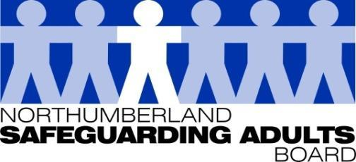
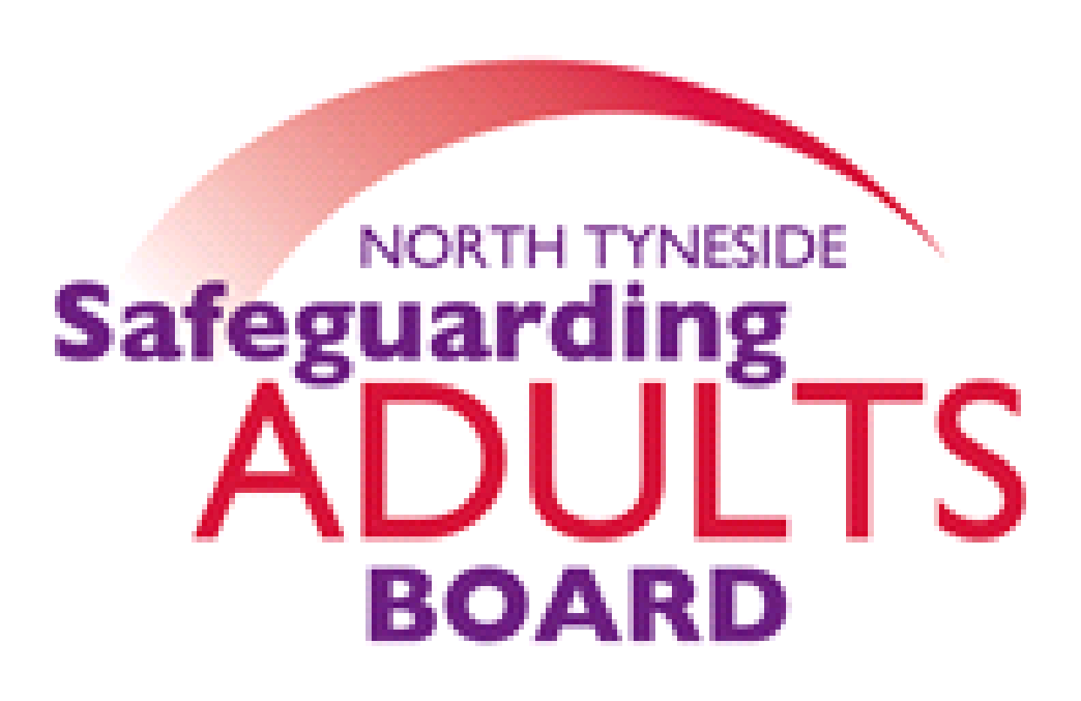

Summary Minutes

North Tyneside and Northumberland Safeguarding Adults Board | Date: 22/06/21  Venue: via Teams

Please note these are not full Board minutes, but a summary of discussions, matters considered, and decisions made.

SAB Peer Review
The Chair summarised the outcome of the Review: the author identified the Board was an excellent forum for sharing information, learning and good practice, and has worked well together, in terms of a joint approach to emerging safeguarding themes such as criminal and sexual exploitation. The Reviewer suggested that we may now want to focus on place-based arrangements and identify if there are any opportunities to link with Children’s and Community Partnerships. It was noted that we have learned through Covid, that sense of place is important. Going forward we should consider local need whilst building on the strong foundations we have.
Transitional Safeguarding Presentation
An overview was provided of a recent publication, ‘Bridging the Gap’ relating to transitional safeguarding, with a particular focus on criminal and sexual exploitation. It is relevant to all those involved with safeguarding and draws upon best practice, research, and knowledge from local areas. Examples of innovative practice were shared, from a number of areas. It was noted the briefing is a DHSC publication, and collaboration between ADASS, LGA, NWG, BASW and includes input from the Police.
NICE Guidelines – Safeguarding in Care Homes
Assurance reports were provided to the Board, by North Tyneside and Northumberland Local Authority and CCG Commissioners.
Northumberland CCG noted that there have been significant increases in safeguarding with the easing of lockdown, as places are opening up and families are going in care homes and raising concerns. The NICE guidance covers keeping adults in care homes safe from abuse and neglect, and identifies the potential indicators of abuse and safeguarding processes. It was acknowledged that there is a need to understand the difference between safeguarding issues and poor practice as well as when/how to make safeguarding referrals to the Local Authority. Northumberland, the CCG have a partnership agreement with the Council which promotes close working. Overall monitoring responsibility is undertaken by the Council’s contracts and commissioning and the safeguarding team, however Northumberland CCG work closely with these teams, and attend regular information sharing meetings.

In North Tyneside there is a joint contract with the Local Authority for care homes. This includes issues such as safe systems of recruitment, training and education for staff, policy, and procedures. There are also joint assurance monitoring visits. The CCG attend individual safeguarding meetings alongside organisational meetings. In respect of learning from safeguarding Community of Practice meetings are held with nursing home managers. The CCG work closely with Local Authority colleagues; weekly telephone calls took place during the pandemic, and face to face visits took place wherever there was a serious concern.

Feedback from Northumberland Local Authority Commissioners noted that during the pandemic they have been regularly communicating with providers, and have been sending out information on a daily basis but this has largely been in relation to urgent issues. It is acknowledged that many of the usual routes of receiving safeguarding concerns (families, visiting professionals) have reduced, and they are looking to reinstate compliance visits as soon as possible. In terms of the content of the guidance they can provide assurance that the requirements are already covered in existing contracts. When appropriate to do so, compliance visits will restart, and safeguarding will be an important focus within these visits. The guidance and closed cultures information will be included in safeguarding adults training, and will also be presented at provider forums for older persons and specialist providers, which will be followed up by Commissioning in individual compliance visits.

Closed Cultures Assurances
ADASS Advice Note – Safeguarding during the Covid Pandemic
A briefing was provided in relation to the ADASS Advice Note regarding safeguarding adults during Covid. The advice note was developed for ADASS members, to assist those with legal responsibility as the Directors of Adult Social Services and other senior staff members, in highlighting and responding to the safeguarding issues that have emerged during the pandemic. Closed cultures/ environments refers to environments that have been closed to visitors and professionals. It is recognised that the majority of organisations have worked hard to accommodate contact between residents and visitors, whilst preventing the spread of COVID; however, it is recognised some agencies have not managed as well and some have required, or will require, additional support during this very challenging period. It was agreed an assurance template for Commissioners should be developed, with a view to collating this information in a closed environments assurance plan.
SAB Annual Strategic Plan
Strategic plan 2020-21 – Year end sign off
It was noted that last year’s strategic plan has been updated, finalised, and circulated for information. Any outstanding areas that need to be carried over to the next strategic plan have been highlighted.

Strategic plan 2021-22 proposal
A proposal was shared regarding next year’s strategic plan. The current plan is very lengthy and is difficult to maintain. It is proposed that the current priorities are reviewed, and the format of next year’s plan is revised. Other models have been circulated for consideration. It has also been suggested that it should be a three-year plan with a Business plan which sits underneath and can be updated annually. Volunteers from the Board were requested to assist with a re-design.
SAB Development day – presentations
- Safeguarding Vulnerable Dependent Drinkers briefing
- MSP toolkit / resources
- Safeguarding Concerns and S42 Enquiries frameworks
It was noted that presentations have been circulated for information, particularly for those Board members who were not able to attend. We are looking to record the MSP and Safeguarding Concerns presentations, exploring platforms to have these available online, as well as circulate to co-opted members. The Chair thanked the presenters; it was a useful session with a good turnout.
SAB Annual report 2020-21 – Partner contributions
It was confirmed the template and request for contributions from partner agencies has been circulated. It was noted that partner case studies or work highlights have made a valuable contribution to previous Annual reports. A feature regarding the Northumbria Missing Adults Protocol was suggested.
Subgroup reports/Updates:
Performance report
The Board considered the Performance report and highlights. All partners have seen an increase in safeguarding concerns and the complexity of these, particularly domestic abuse, self-neglect, physical harm, and neglect. Partners feel there is very strong multi-agency working. There has been an increase in welfare concerns, mental health issues and alcohol issues.
WFD sub-group
It was noted there has been a drive around trauma informed practice, including producing a consistent package across both LA’s that will be suitable for all multi-agency partners. One baseline course across the Board would be useful. Each organisational partner may then need to do some specific training, depending upon the needs of their service. It is hoped this can be developed and delivered from September. Work with the Disclosure Barring Service has been undertaken, to create workshops for partner agencies, these dates will be advertised imminently. Workforce Leads have ensured that Making Safeguarding Personal (MSP) is embedded in all training. A session around the tools that are available will be recorded and uploaded to learning platforms and Safeguarding websites. The Safeguarding Vulnerable Dependent Drinkers workshops have come to an end, and the next steps being considered. There is an opportunity for Blue Light training to continue to be available.
Exploitation sub-groups
Northumbria Police are now chairing all six exploitation sub-groups, this will promote consistency across LA areas. This has been positive in terms of having regional oversight around sharing good practice and building on exploitation via a regional approach. The challenge is understanding all of the data from agencies. There has been some progress around this, the Victims Hubs has been in development, which is being led by the Crime Department. The Department have the lead on modern day slavery, County Lines, human trafficking, and sexual exploitation in the Northumbria area.
Safeguarding Adults Review Committee (SARC)
The Board were updated on the progress of the cases currently being overseen by the SARC.
Regional SAR Champions presentation
It was shared there is a regional SAR champions group which has representation from all the North and South of Tyne Board Managers. A peer review process has been developed which means when an area undertakes a discretionary review, they can reach out to other SAR champions to peer review. This group have also produced a SAR Quality markers quick guide. There has been some interest nationally in relation to sharing the final document. A North East SAR Library has also been developed, which is hosted on the Gateshead TEAMS site: this has attracted some national interest and has been presented to the ADASS Policy network. It has also been presented to the National Board Managers meeting and the North East SAB Chairs meeting. This is a good piece of work that both areas are involved in.
Items for information/endorsement:

Northumberland Transitional Safeguarding Protocol
The Board reviewed and endorsed the Protocol.

Covid-19 Adult Safeguarding Insight Project 2nd Report (April 2021)-
The Board considered the content and findings of this national report.

Date of Next Meeting:
Tuesday 14th September, 1.00-3pm via Microsoft Teams.

For further information about the Safeguarding Adults and the work of the Safeguarding Adults Board please see:
Northumberland:
https://www.northumberland.gov.uk/Care/Support/Safeguarding.aspx
North Tyneside:
https://my.northtyneside.gov.uk/category/1033/safeguarding-adults

Glossary of Abbreviations

ASC | Adult Social Care
BG | Business Group
BIA | Best Interest Assessor
CCG | Clinical Commissioning Group
CMHT | Community Mental Health Team
CQC | Care Quality Commission
CRC | Community Rehabilitation Company
CNTW | Cumbria, Northumberland, Tyne and Wear NHS Foundation Trust
CVS | Community Voluntary Sector
CYPL | Children, Young People and Learning
DASM | Designated Adults Safeguarding Manager
DoL | Deprivation of Liberty
GMC | General Medical Council
HWWB | Health Well Being Board
IMR | Independent Management Review
LADO | Local Authority Designated Officer
LD | Learning Disability
LSCB  NCC | Local Safeguarding Children’s Board  Northumberland County Council
NEPO | North East Purchasing Organisation
NHCFT | Northumbria Healthcare NHS Foundation Trust
NTC | North Tyneside Council
NPS | National Probation Service
QAF  QSG | Quality Assessment Framework  Quality Surveillance Group
SAB | Safeguarding Adults Board
SAR | Safeguarding Adults Review
SARC | Safeguarding Adults Review Committee
SE | Sexual Exploitation
T&F | Task and Finish
WDG | Workforce Development Group

