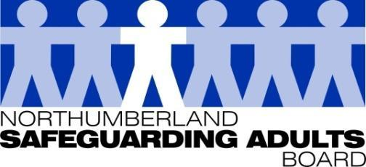
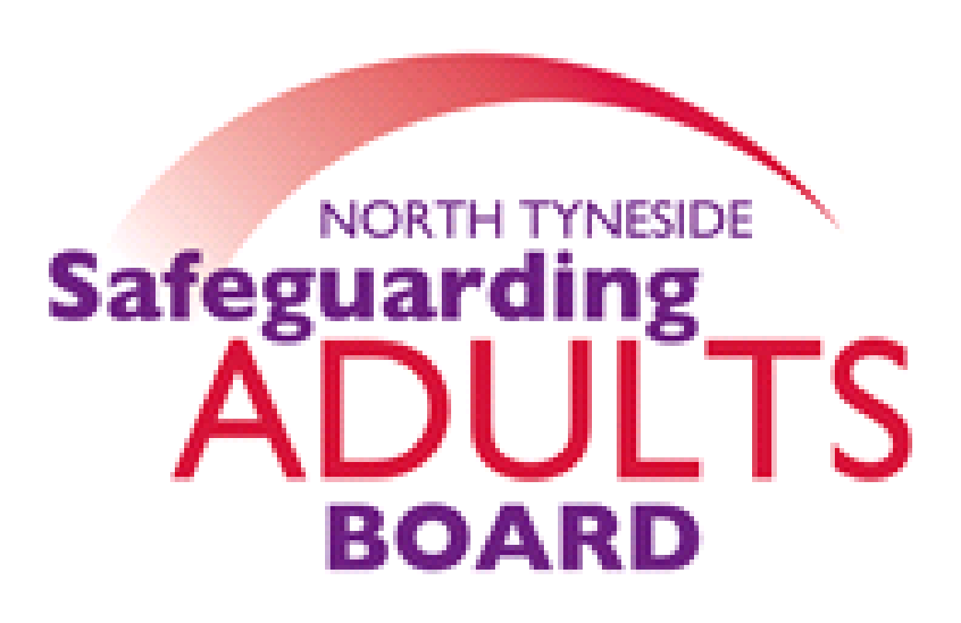

Summary Minutes

North Tyneside and Northumberland Safeguarding Adults Board | Date: 14/12/21  Venue: via Teams

Please note these are not full Board minutes, but a summary of discussions, matters considered, and decisions made.

Domestic Abuse Partnership Boards - Update
An overview of the Domestic Abuse Partnership Board arrangements in both areas was provided by the Domestic Abuse & Sexual Violence Coordinator.

The Domestic Abuse Act received royal assent at the end of April so there is now a legal definition of domestic abuse, which brings with it additional protections for victims of abuse and strengthens measures to tackle offenders. It was noted this is a landmark act, as it recognises children as domestic abuse victims in their own right. LA’s have increased responsibility following this Act becoming law, these include, providing support/services for victim survivors, creating a Domestic Abuse Board, and undertaking a domestic abuse needs assessment and producing a strategy. There is a duty to provide support to victim survivors and their children in safe accommodation; the LA must assess the accommodation needs and have a strategy to meet those needs. A further focus for LA’s is that domestic abuse victims and their children are recognised as having automatic priority for homelessness assistance.

There is a new Domestic Abuse commissioner, and their statutory duties commenced on the 5 November. The Domestic Abuse Commissioner will provide public leadership, play a key role in monitoring provision of services, and encourage good practice in protecting and supporting people affected by domestic abuse, particularly children. The Commissioner will also hold local authorities to account for their strategies and services. Both LA’s, are on target to meet their statutory requirements.
Future Boards Arrangement April 2022 – Update
An overview of the arrangements planned for North Tyneside was provided. Board members were reminded that following the peer review of the joint SAB arrangements, it was agreed to separate and put LA specific Board arrangements in place from April 2022. In North Tyneside, there will be a focus on safeguarding and safety in general, and alignment with other strategic partnerships in North Tyneside, including Children, Domestic Abuse and Community Safety.

An overview of the progress made in Northumberland was also provided. A recent development session has been held with Children and Adult partners, which was very positive. The aim of the development session was to gain an understanding of partners views in relation to the new arrangements and agree some key principles and priorities. It was noted that in Northumberland it has been agreed in principle, there will be a joint Children and Adults Board from April 2022. There is further work to do around the model and the sub-groups, and it is likely to be an evolving process.
Mental Health Post Covid Update – Northumberland Public Health
It was noted that Covid has caused some delays in reporting and recording suicides. The reason for this is that Covid impacted on the coroner’s court, and there has been a delay in holding inquests to confirm deaths by suicide. In Northumberland, there is a zero-suicide ambition, and there has been a lot of work and progress in safeguarding the population from suicide. However, it was noted that it will now be impossible to compare what progress has been made with pre-covid figures. it is unknown how long it will take for the coroner’s court to catch up or what impact covid will have longer term. Any current suicides may not show up in reports for a long time, as the impact of this could take years to manifest. A vast amount of work that has been completed by Public Health and the team was thanked for all of their hard work.
Northumbria Police – Multi-Agency Victim Hub Update/Key Messages
It was advised that the multi-agency Victim Hub has evolved from the hub that was set up after Operation Sanctuary in 2014, which was a wide scale child sexual exploitation operation. Since then, there has been a hub both North and South of Tyne. Following a recent review of the arrangements, it was agreed it would be more beneficial to have one hub that serves the whole Northumbria Police force area. This is where the Multi Agency Hub vision developed. The Hub is currently based at Freeman House, which is a non-police building, and includes video interview suites, informal relaxed rooms, and conference and refreshments facilities. Partner agencies are encouraged to make use of the hot desk space and work from the hub when joint working a case that involves exploitation. The hub now covers all forms of exploitation and is not limited to sexual exploitation. Exploitation occurs across children and adults, and victims are targeted because of their vulnerability and not because of their age. Therefore, the hub looks to support victims with a range of vulnerabilities.
SAB work plan updates
Final published Annual report 2020-21
The Board received the report for information purposes as it has been previously approved via email circulation. The report will now be presented to the respective Overview and Scrutiny Committees and Health and Wellbeing Boards.
Strategic Plan 2021-23
The strategic plan was presented to the board: the plan sets out the vision of the board, what the core priorities are and what needs to be achieved. It was noted it had been agreed that a 3-year plan would be produced, even though each LA would be moving to place-based partnership arrangements, as both areas agreed the core priorities were relevant. However, how they are achieved and delivered in each LA may differ. The plan will be available on both websites.
Subgroup reports/Updates:
Performance report
The performance data was shared, and an overview was provided. It was noted that across all organisational safeguarding concerns are still increasing but are stabilising slightly. In Northumberland it has continued to increase. A summary was provided in relation to activity reported by a number of other partner agencies.
Local Covid Insights Analysis Report
The Board were advised this is the 3rd and final report published, and the aim of the project has been to gain insight and an understanding of the impact of the pandemic on safeguarding activity both locally and nationally. The report covers data up to June 2021 and involved 106 LA’s. Both LA’s have also received individual reports. Within the Performance sub-group summary report there are the key highlights and a link to the full publication, which is a useful source of information for anyone involved with safeguarding. The main areas explored were safeguarding concerns, section 42 enquiries, location/types of abuse and outcome of enquiries, much of which is highlighted in the SAB’s quarterly Performance reports. The information compares LA’s both nationally and across the North- East and identifies any trends. The key messages were highlighted within the report.
WFD sub-group
An update to the board was provided in relation to the joint work which has been undertaken in relation to Adversity Awareness sessions. These continue to be delivered and have been extremely well received. Across both LA’s there has been over 200 multi-agency attendees, and the course evaluation has very positive. These sessions will continue into 2022. The 3 levels of Domestic Abuse training offered is continuing and are still very well attended. It was noted that Northumberland are finalising a programme of Transitional Safeguarding workshops for children’s and adult’s workforces. Initially these will be delivered single agency then it will be extended to multi-agency. There is currently a significant amount of training being undertaken around Criminal Exploitation with housing colleagues, and also safeguarding briefings for private landlords as part of their accreditation framework by Northumberland. It was noted there had recently been the white ribbon ambassadors and champions event, which was hosted by both LA’s. Excellent feedback was received from this. In North Tyneside there has also been a focus on training for the Housing and Environmental teams in relation to safeguarding and vulnerabilities.
Exploitation sub-groups
The Board were advised there has been really good buy-in from partnership agencies across both LA’s.
Northumberland sub-group
They have reviewed data around missing adults and had input from Foetal Alcohol Spectrum Charity, which was really insightful in terms of how many residents are living in the community with the disorder, with a range of vulnerabilities. There has also been good input from Changing Lives who provided a regional and national update around Modern-Day Slavery. Lynne added there is currently a custody pilot underway, which the Violence Reduction Unit (VRU) are running, which focuses on intervening with young people up to the age of 21 in custody and assigning them a mentor from Edge North- East Family Gateway.
North Tyneside sub-group
There has been good input from the regional county lines co-ordinator who gave an update in relation to local and national pictures. There was a discussion about the student population who are being exploited and brought into county lines, and the different marketing tools used. Changing lives also gave an update on the Stage Tool Kit around sexually exploited victims involved in sex work, which gave some key points for front line practitioners to consider.
SARC Sub-Group
A comprehensive overview report was provided from the SARC meeting on 14th October, where updates were provided on all action plans and cases. It was suggested that a benchmarking exercise should be undertaken in relation to the Norfolk SAR (Joanna, Ben & Jon) to determine the key learning points: this will be discussed in further detail at the next SARC meeting.
LGA/ADASS Updated Adult Safeguarding and Homelessness Briefing
A presentation was shared with the Board, it was explained that there is a large amount of learning for Board’s. The key issues were highlighted, and it was agreed for this to be added to each local authorities Forward Plan, to consider further.
National SAR Library Update
The national SAR library is now being hosted by the SAB Chairs network. All SAB’s have been asked to submit any SARs published after April 2019, to be included in the library.
Date of Next Meeting:
Tuesday 8th March 2022, 1.00-3pm via Microsoft Teams.

For further information about the Safeguarding Adults and the work of the Safeguarding Adults Board please see:
Northumberland:
https://www.northumberland.gov.uk/Care/Support/Safeguarding.aspx
North Tyneside:
https://my.northtyneside.gov.uk/category/1033/safeguarding-adults

Glossary of Abbreviations

ASC | Adult Social Care
BG | Business Group
BIA | Best Interest Assessor
CCG | Clinical Commissioning Group
CMHT | Community Mental Health Team
CQC | Care Quality Commission
CRC | Community Rehabilitation Company
CNTW | Cumbria, Northumberland, Tyne and Wear NHS Foundation Trust
CVS | Community Voluntary Sector
CYPL | Children, Young People and Learning
DASM | Designated Adults Safeguarding Manager
DoL | Deprivation of Liberty
GMC | General Medical Council
HWWB | Health Well Being Board
IMR | Independent Management Review
LADO | Local Authority Designated Officer
LD | Learning Disability
LSCB  NCC | Local Safeguarding Children’s Board  Northumberland County Council
NEPO | North East Purchasing Organisation
NHCFT | Northumbria Healthcare NHS Foundation Trust
NTC | North Tyneside Council
NPS | National Probation Service
QAF  QSG | Quality Assessment Framework  Quality Surveillance Group
SAB | Safeguarding Adults Board
SAR | Safeguarding Adults Review
SARC | Safeguarding Adults Review Committee
SE | Sexual Exploitation
T&F | Task and Finish
WDG | Workforce Development Group

