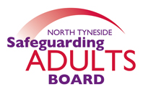

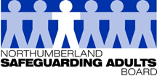

**North Tyneside and Northumberland**

**Safeguarding Adults Board**

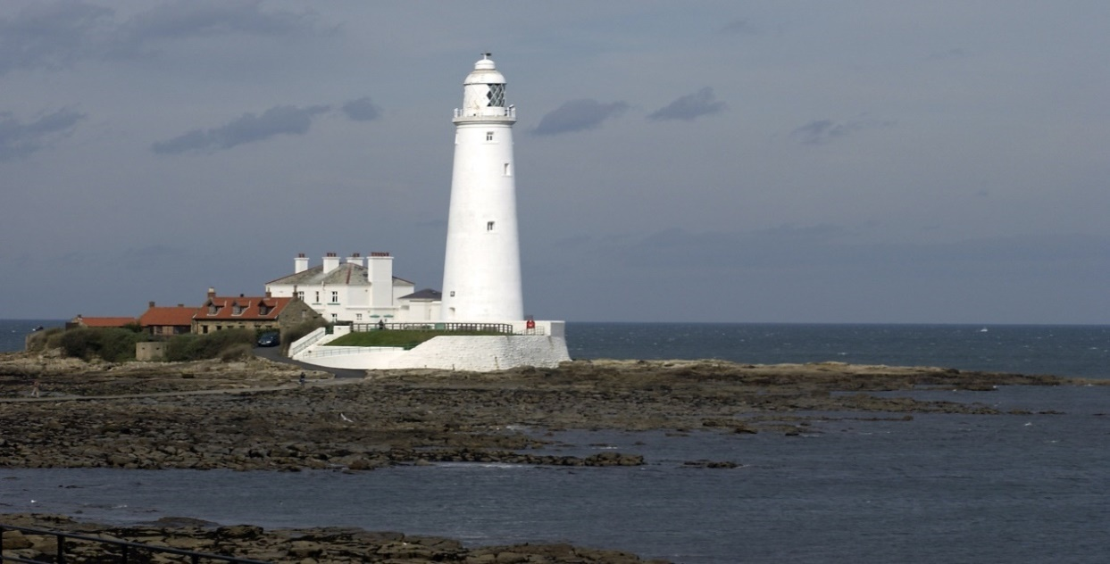

**Annual Report 2018 – 2019**



**CONTENTS**

|  |  |  |
| --- | --- | --- |
|  |  | **Page** |
|  | **Foreword by Independent Chair ………………..…………………………..** | **1** |
|  | **Our Vision ……………………………………………….………………………** | **2** |
|  | **North Tyneside and Northumberland Safeguarding Adults Board……** | **2-3** |
|  | **Local Safeguarding Data ……………………………………………………..** | **4-6** |
|  | **Key achievements 2018-2019 ……………………………………………….** | **7-15** |
|  | **Lessons learnt ……….…………………………………………………………** | **16-17** |
|  | **What training have we delivered? ……….…………………………………** | **18-19** |
|  | **Looking forward to next year……………………………………………….** | **20** |
|  | **Working with our partners ……………………………..…………………….** | **21-22** |
|  |  |  |

**Appendix 1. Glossary of terms 23**

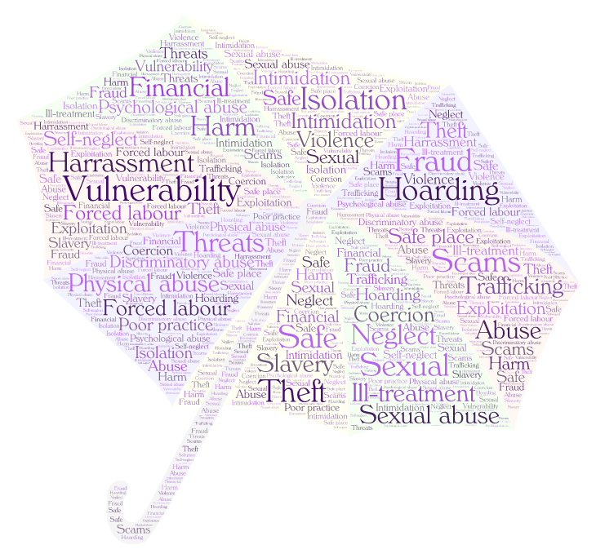

**Foreword by Independent Chair**

It has been my privilege to Chair the North Tyneside and Northumberland Safeguarding Adults Board (SAB) since the two boards became one in December 2016.

It is the Board’s responsibility to ensure that all the potentially vulnerable people living in North Tyneside and Northumberland are kept as safe as possible from abuse or neglect, whether they are a hospital patient, a care home resident or living in their own home. The work of the Board, through its various sub groups and with local and regional partners, promotes robust safeguarding services across the multi-agency partnership.

This annual report provides local people with an account of the Board’s work over the past year to improve the safeguarding and wellbeing of adults at risk. The Board continues to review our performance and provide high levels of scrutiny and constructive challenge on how effectively we work together to ensure strong safeguarding arrangements. I would like to take this opportunity to thank the Central User Forum who have agreed to assist the Board to produce an easy read version of this report, which will serve to increase awareness of Safeguarding Adults to a wider audience.

The SAB remains committed to the Making Safeguarding Personal agenda, and seeks assurance that these principles are embedded in practice. The ongoing development of Multi-Agency Safeguarding Hubs in both areas has strengthened safeguarding arrangements and working relationships with our partners, which directly impacts upon the safety of adults at risk of abuse and neglect. Our local data clearly demonstrates the impact of these developments. We remain committed to working together to develop these arrangements, to ensure we achieve personalised front line practice, and the best possible outcomes for individuals.

The Board continues to identify emerging areas of risk identified locally and nationally, and promotes a preventative approach. This year the SAB has focused upon self-neglect and hoarding, poverty, domestic abuse, sexual exploitation and modern day slavery.

Again it has been a busy year for the SAB, who have completed and published one Safeguarding Adults Review, and have commenced another. I would like to offer my condolences to the families of the individuals at the heart of these reviews, and offer an assurance that the Board will work in partnership to ensure that the learning from these reviews is embedded.

My thanks and appreciation goes to all partners for their dedication during a time of huge demand and whose commitment and motivation deliver our shared priorities. I would also like to thank and recognise the ongoing contribution of the Lay members, who continue to provide valuable scrutiny and perspective. We continue to learn and improve.

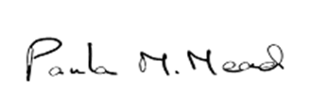

**Paula Mead**

North Tyneside and Northumberland SAB Independent Chair

1. **Our Vision**

“To promote the individual’s human rights, their capacity for independence, ensuring each person is treated with dignity and respect and able to enjoy a sustained quality of life and improved wellbeing. That at all times people are afforded protection from abuse, neglect, discrimination or poor treatment and that their carers whether paid or unpaid, are safe”.

In addition, we agree to adhere to the Care Act principles which underpin all adult safeguarding work;

Page 4 of 33

1. **North Tyneside and Northumberland Safeguarding Adults Board [SAB]**

The SAB has three core duties, in accordance with the Care Act (2014):

* develop and publish a strategic plan setting out how they will meet their objectives and how their member and partner agencies will contribute.
* publish an annual report detailing how effective their work has been.
* commission safeguarding adults reviews (SARs) for any cases which meet the criteria for these.

The main objective of the SAB is to improve local safeguarding arrangements to ensure partners act to help and protect adults experiencing, or at risk of neglect and abuse.

**SAB members**

As specified in the Care Act, the SAB includes three core members; the Local Authority, Clinical Commissioning Group, and the Police. However our membership is also made up of nominated lead representatives from a wide range of partner agencies.

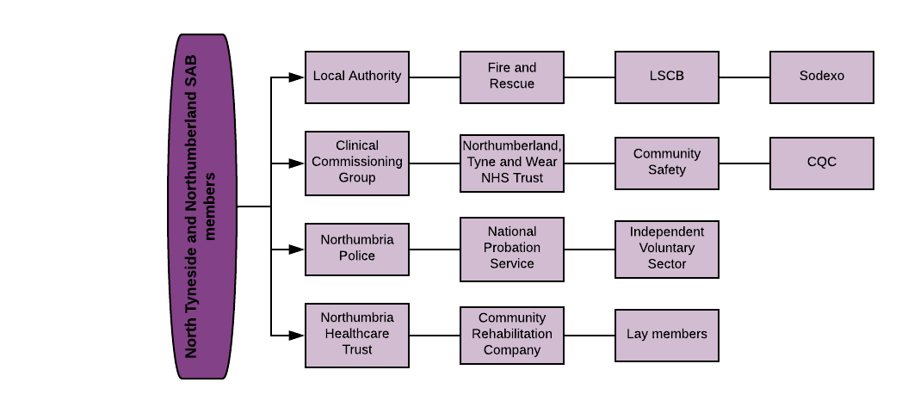

**SAB structure**

The SAB is supported by a number of sub-groups that contribute to the work of the Board. Three of the sub-groups are partnerships between Northumberland and North Tyneside and have representation from both areas. We have continued to have separate Sexual Exploitation sub-groups, with Northumberland and North Tyneside each having had a group consisting of members from their respective Local Safeguarding Children Board and Community Safety Partnerships.

The SAB reports to the Overview Scrutiny Committees and also shares the Annual report with the Health and Wellbeing strategic boards at North Tyneside and Northumberland.

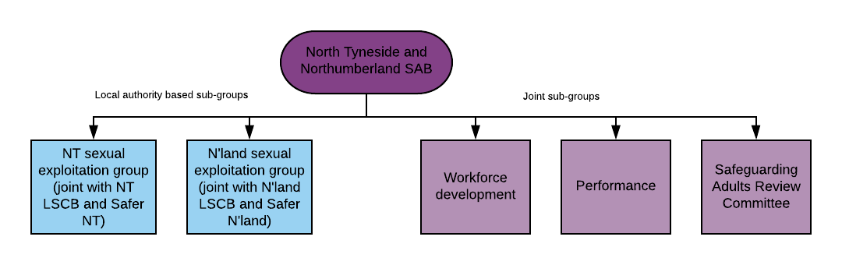

Page 6 of 33

1. **Local Safeguarding Data 2018 -2019**



**North Tyneside Data**

Performance Source: Safeguarding Adults Return

**Location of abuse**



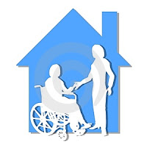

49% of concluded enquires were about abuse in people’s own home.

**Safeguarding Concerns and Enquiries**

28% of enquiries were in Nursing or Care homes

**Source of Risk**

There has been an increase in concerns and enquiries from the previous year. This reflects a change in recording where safeguarding concerns received are reported without a pre-screening. They are then triaged prior to commencing an enquiry.

**78%** of enquiries had risk identified and action taken.

**4%** of enquiries ceased at individual’s request.

**84%** of enquiries involved a source of risk known to the individual.



**j**

**Type of Abuse**

0 Safeguarding Adult Reviews were carried out

**\*Adult Concern** – this is a referral into Adult Social Care by any person or agency who believes that an adult may be experiencing abuse or neglect.

**\*S.42 Enquiry/ Safeguarding referral** – an enquiry is any action that is taken or instigated by the Local Authority under Section 42 of the Care Act 2014. Please see full [Care Act guidance](mailto:http://www.legislation.gov.uk/ukpga/2014/23/section/42/enacted).



**Northumberland Data**

(Performance Source: Local Performance Monitoring Report)

!**100% of referrals from the police led to an enquiry**

The introduction of a formal Multi-agency Safeguarding Hub (MASH) has seen the number of concerns drop by 25% from the previous year. A triage system has similarly impacted on the number of enquiries which is 44% lower than 2017/18.

**Safeguarding Concerns and Enquiries**

The introduction of a formal Multi-Agency Safeguarding Hub (MASH) has seen the number of concerns significantly reduce by 25% from the previous year. A triage system has similarly impacted on the number of enquiries, which is 44% lower than 2017/18. This demonstrates more appropriate concerns are being reported.

**Location of abuse**





43% of concluded enquires were about abuse in people’s own home

29% of enquiries were in Nursing or Care homes

**Source of Risk**



**76%** of enquiries had risk identified and action taken.

**4%** of enquiries ceased at individual’s request.

**65%** of enquiries involved a source of risk known to the individual.

**Type of Abuse**

1 Safeguarding Adult Review was concluded and 1 was commenced

**Making Safeguarding Personal**



% of clients involved in enquiries who lacked capacity

**North Tyneside – 38%**

**Northumberland – 47%**

% of individuals involved in enquiries who were asked what their desired outcomes were

**North Tyneside – 67%**

**Northumberland – 56%**

% of individuals who had their outcomes fully or partially met (where outcomes were expressed)

**North Tyneside – 93%**

**Northumberland – 91%**



The SAB remains committed to the Making Safeguarding Personal agenda, which is always a central focus for the Board. We remain committed to working together to develop these arrangements, to ensure we achieve personalised front line practice, and the best possible outcomes for individuals. Moving forward in 2019/2020 the Board will be undertaking multi-agency MSP audits to seek assurance that this approach is embedded across all partner agencies.

1. **Key achievements 2018-2019**

**Continued Development of the MASH**



Both North Tyneside and Northumberland have developed Multi-Agency Safeguarding Hubs (MASH) as part of their front door services. A MASH brings together professionals from a range of agencies and is designed to facilitate timely information sharing and decision making on a multi-agency basis, which is key to meeting the SAB objectives. MASH arrangements across ensure consistent thresholds are applied, to facilitate effective risk assessment and intervention, and a family approach towards safeguarding.

**North Tyneside**

The Adult Social Care MASH continues to sit at the front door alongside children services and other partners which include the Police, Harbour, Probation and Housing. This has improved partnership working, especially around MARAC as the co-ordinators are co-located.

We have been part of the MASH since September 2017. We meet with the police every day to screen police concerns and this allows for effective triaging. The majority of referrals come from other professionals and we access the MASH partners to discuss these when required. The Adult MASH is also part of the Adult Gateway Team and this can allow for a positive customer journey.

Being co-located with children’s services has allowed for a sharing of information but also gives us the opportunity to be able to give clarity around Adult Social Care and the Care Act. We are part of strategy meetings for children’s cases when the police have determined that a case is APVA (Adolescent to Parent Violence), allowing for a think family approach and enables us to identify if the adult involved has any Care Act eligible needs.

**Northumberland**

The Northumberland MASH was launched in February 2018, and since this time has extended its membership from Police, Adult Safeguarding and Children’s Services, to include representatives from Education, Health and Early Help Services. Single Point of Contacts have been identified within other partner agencies including NTW, Fire and Rescue Service, Probation, Department of Working Pensions, Housing, Public Protection and Community Safety. The information provided by partner agencies not only improves decision making, but also supports in the planning and intervention required, resulting in appropriate responses to both adults and children

The MASH has progressed to joint Adult and Children’s strategy meetings focussing on cases involving Adolescent to Parent Violence (APVA), Exploitation and County Lines.  This has evidenced robust safety planning and intervention, and feedback within the MASH highlights the quality of these meetings. The implementation of daily Triage meetings to consider all Police concerns also ensures appropriate and timely interventions are provided to both adults and children.

Staffing within the MASH has remained consistent and working relationships have strengthened, resulting in one team as opposed to partner agencies located together.  Multi-agency themed audits continue to identify good practice and areas for development and training. To date audits have considered key areas such as fire setting, neglect, exploitation, and missing children/adults.

Moving forwards Northumberland continues to review and develop the MASH, and has identified future areas of development which include; regular quality and performance workshops, continuing to develop the joint strategy model, and further improving partnership working.

**Strengthened our Response to Sexual Exploitation**



Both North Tyneside and Northumberland have had joint sub groups with Children’s Safeguarding Boards and Community Safety Partnerships, which have continued to drive the SAB’s work in relation to sexual exploitation, and moving forward our understanding of and responses to criminal exploitation.

**North Tyneside**

Following the publication of the Newcastle Joint Serious Case Review [JSCR] into sexual exploitation, the North Tyneside Sub group undertook briefings and an analysis of the locality’s multi agency position against the recommendations. An all age multi agency audit was also undertaken against the key lines of enquiry in the sexual exploitation Joint Targeted Area Inspection framework.

North Tyneside has drafted operational guidelines in relation to Modern Day Slavery and has tested a pathway for managing vulnerable victims of County Lines operations successfully. Building on the work of the MSET (Missing, Sexually Exploited and Trafficked) panel in Children’s services, North Tyneside have launched an Adult MSET which facilitates multi-agency working and risk management for some of our most vulnerable adults.

**Northumberland**

In Northumberland the Sexual and Criminal Exploitation strategy (2019-2022) was launched this year, and the implementation of the multi-agency delivery plan to support this commenced. The sub group has also undertaken a significant amount of work in response to the JSCR into sexual exploitation, which has included multi-agency benchmarking, circulating a 7 minute guide, and delivering Information events across the County. A number of Sexual Exploitation masterclasses have also been delivered, and further sessions are planned for 2019-20. The learning from this Review remains central to Northumberland’s strategy and priorities moving forward.

MSET arrangements have been rolled out across Children’s services in Northumberland, which include representation from Adult Social Care, to support the early identification of vulnerable young people who may require transitional support and planning. Adult Social Care are also exploring other regional models, and adapting the screening tool and guidance for use with adults at risk. Work is also underway in Northumberland to raise awareness of criminal exploitation across the partnership, and to develop local arrangements to respond to County Lines. A 7 minute guide has been circulated to all partner agencies, and briefing sessions are planned. Further development is required in this area moving forward.

Northumberland benefitted from a multi-agency Joint Targeted Area Inspection (JTAI) earlier in the year which was focused on Child Sexual Exploitation and Child Exploitation which has helped to further inform the strategy and action plan.

Looking ahead to next year, the sub group will continue to monitor the multi-agency strategy and delivery plan. The group will be focusing upon criminal exploitation, data analysis and mapping of hot spots, developing the Sexual Exploitation Champion role, and rolling out a Joint Sexual Exploitation training programme across Adults and Children’s services. We will also be working with our Regional partners to develop a consistent approach to missing adults.

**Communication**

The communication sub-group was disbanded in 2018/19 and in its place there is now a communication protocol, which outlines a range of community groups and organisations with whom the SAB regularly share information with. Links have also been established with a number of church and faith groups, and there is now SAB representation on the Diocesan Safeguarding Advisory Group. This was an action identified in a learning review held in 2017-18. In the next year we aim to extend our communication with faith groups by engaging with non-Christian groups.

**Quality Assurance**

The SAB, in collaboration with Newcastle SAB, has updated their Quality Assurance Framework which was circulated to all partner agencies in December 2018. A self- assessment and challenge session was then held in May to evaluate the work of the SAB partner agencies, and identify and inform the priorities set out in the Annual Plan for 2019-20.

Both local authorities have robust audit procedures in place to monitor the quality and effectiveness of operational safeguarding arrangements. These are reported to and scrutinised by the Board and the sub groups on a quarterly basis.

**Focus on specific topics**

This year the Board has focused upon, and invited speakers in relation to a range of Specialist topics. These presentations have informed future areas of work, and are included in a number of sub-group work plans.

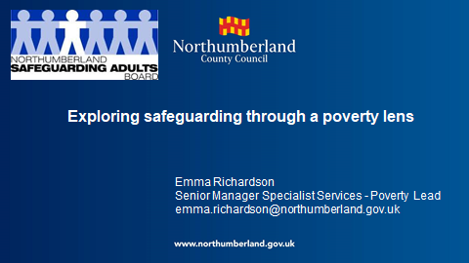

**Development sessions**

**Exploring safeguarding through a poverty lens**

Explored the prevalence of Poverty in the North East, and the impact upon health and wellbeing in our communities. Poverty increases risk to individuals with toxic multipliers such as addiction and mental health issues. There is a significant correlation between Poverty, Disability and Mental Health, which has implications for safeguarding children and adults at risk. The SAB were asked to consider universal messages, partnership working, prevention and service planning through a poverty lens.

**Self-Neglect and Hoarding**

Explored the cumulative risks associated with self-neglect and hoarding, and the impact on services and more importantly vulnerable adults. The interface with Safeguarding Adults and the provisions of the Care Act were considered, alongside learning identified from Safeguarding Adult Reviews. The SAB were asked to consider the importance of balancing the law, early and effective interventions, and fundamentally adopting a trauma based approach to working with individuals.

Moving forward a multi-agency task group has been established to develop a Hoarding protocol and training resources.

**E**

**Modern Day Slavery**

The Care Act (2014) defines Modern Day Slavery as a form of abuse, falling within the remit of the Safeguarding Adults procedures. The Modern Slavery Act (2015) consolidated and simplified existing offences into a single act.

Modern Day Slavery (MDS) continues to be an area for development for all agencies. Building upon the Regional North of Tyne guidance for staff produced in 2016, an operational response to the challenge of MDS has been developed and is awaiting endorsement from the Board. This will be implemented across both areas in 2019-20.

**Northumberland Housing Services case**

A Police investigation commenced in October 2017 as a result of an incident highlighted by the Gypsy Roma Traveller Liaison Officer, regarding concerns at an unauthorised encampment. This resulted in the safeguarding of an Eastern European vulnerable male adult, who was being held in domestic servitude. A number of defendants have been charged with offences under the Modern Day Slavery Act.

This is an example of effective training and awareness raising across Housing services.

**Policies and Procedures**

The SAB has a Multi-agency Safeguarding Policy in place which covers both Northumberland and North Tyneside.

This year we have updated and published the SAB information sharing agreement and the SAB terms of reference. The SAB also endorsed the publication of SAB meeting minutes. All these documents can be found on [North Tyneside](https://my.northtyneside.gov.uk/category/1033/safeguarding-adults) and [Northumberland](https://www.northumberland.gov.uk/Care/Support/Safeguarding.aspx) Safeguarding Adults websites. During this year, the Northumberland Safeguarding Adults website has been redesigned and relaunched.

**Raising Awareness of Safeguarding during ‘SAFE week’**

**SAFE (S**afeguarding **A**wareness **F**or **E**veryone) **week**

In September 2018 the fifth annual SAFE week took place across North Tyneside and Newcastle. The campaign seeks to raise awareness of protecting vulnerable adults and children.

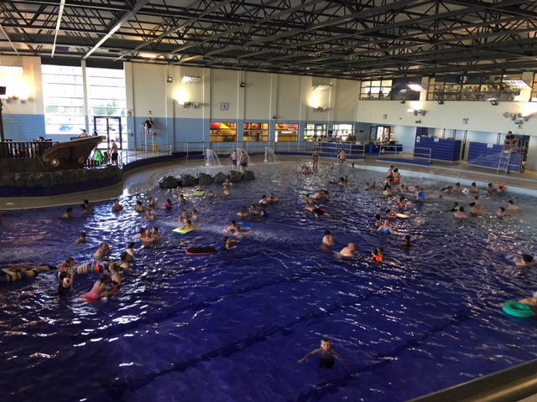FILE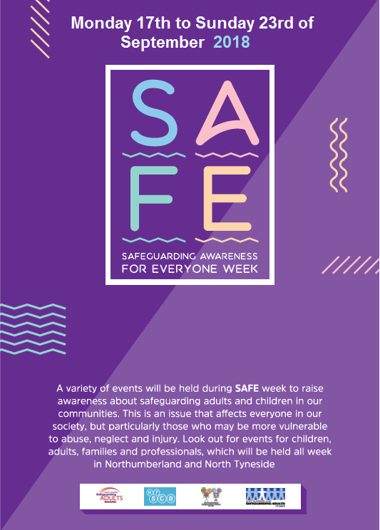

The lighthouse was turned purple……

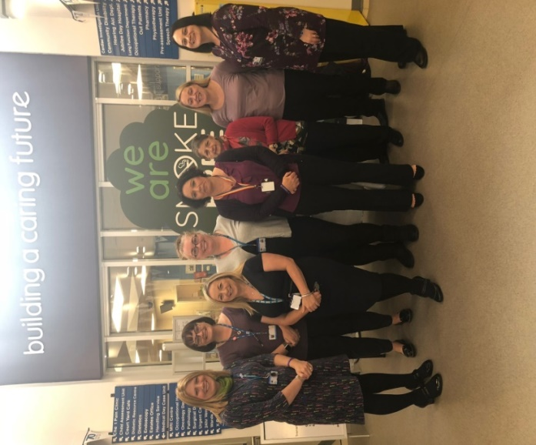

So was Waves swimming pool………

People also wore purple and there were purple cakes!



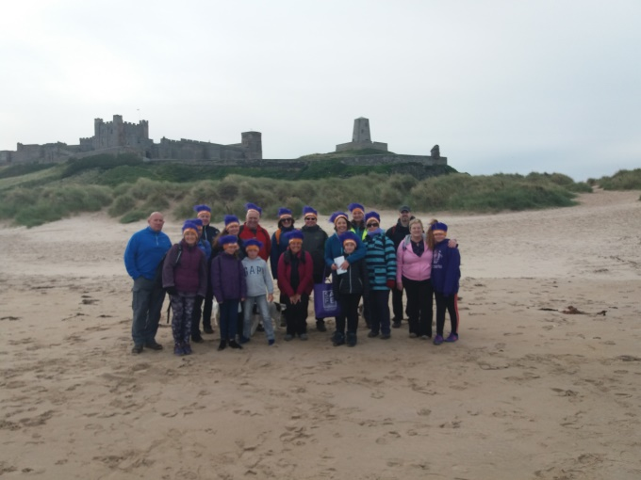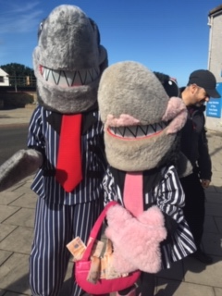

There was an awareness raising walk from Bamburgh to Seahouses, in partnership with Active Northumberland. This event was also supported by [Stop Loan Sharks](http://www.stoploansharks.co.uk/)

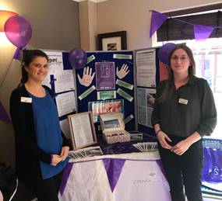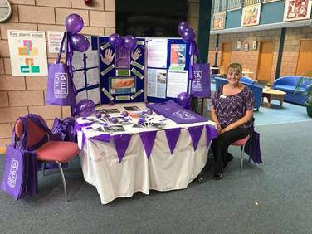

Information stalls were held at various locations across both boroughs

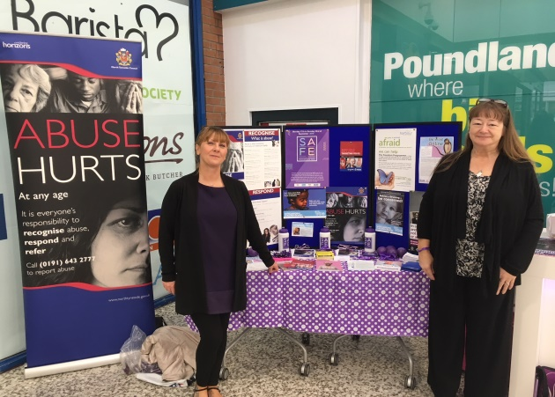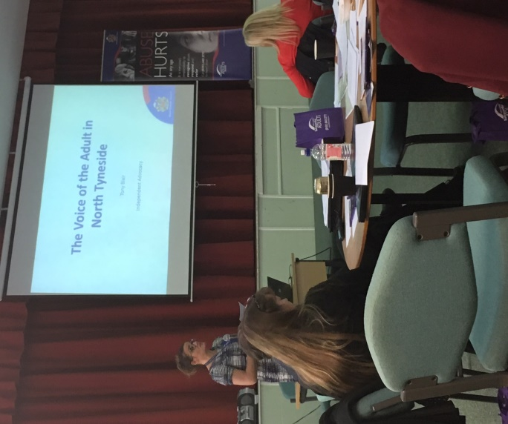

North Tyneside held a conference entitled ‘The Voice of the Adult’

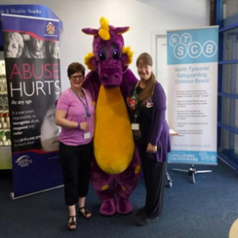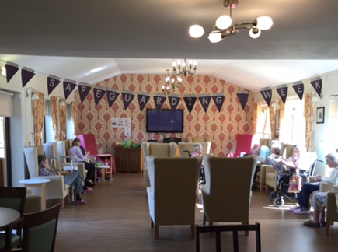**Contribution from Lay members**

Page 16 of 33

The SAB continues to be committed to engaging communities in safeguarding, and promoting the welfare and wellbeing of adults. In March 2018 we were delighted to recruit two lay members to the Board; one representing Northumberland and one for North Tyneside. One year on, and their role and contribution to the SAB has been invaluable, and continues to provide a community perspective to the work of the Board. Both lay members have contributed positively to meetings and development sessions, and have provided oversight and scrutiny of the decisions and policies endorsed by the Board.

We continue to welcome their contribution and perspective, which can only enhance safeguarding within our local communities.

*“ A year in and the real benefit I feel of being a lay member is having the independence of the role, giving me the freedom to ask questions that often other people may be thinking but not saying because of the constraints of their role. This has been my main contribution.*

*Also it is vital to call out on the use of organisational jargon in SAB meetings and publications.*

*Hopefully the involvement of lay members has helped to further promote greater awareness that every member of our society is entitled to feel safe and protected from abuse and neglect.*

***North Tyneside Lay Member***

*“ My first year as lay person has been a productive one in helping me in my community role improve the interface between the SAB and the community organisations I am involved with. Bringing key safeguarding information into communities is very important. I have been able to help spread key information such as SAFE week and the Herbert protocol across local community networks. Being part of the SAB has also given me easy access to senior officers in agencies which has fast tracked community action. An example of this was as a result of speaking to several colleagues on the SAB my local community then hosted an Ageing Well Fair which was highly successful. Lots of new links have since been made with key agencies at a local level which will only enhance the safeguarding message at community level. ”*

***Northumberland Lay Member***

**Support from the Central User Forum**

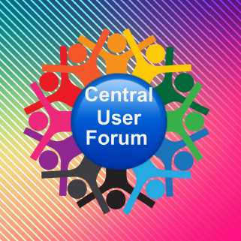

The Central User Forum is a self-advocacy group for Adults with Learning disabilities in Northumberland. They work in partnership with Northumberland County Council’s Learning disability Partnership board and other self-advocacy groups in the area.

Their main goal is to increase the involvement of people with Learning disabilities and autism, enabling them to have a voice in the development of social care.

This year the Forum are supporting the Safeguarding Adults Board to produce an easy-read version of their Annual Report, to ensure the information is accessible to a range of people, including those with Learning disabilities.

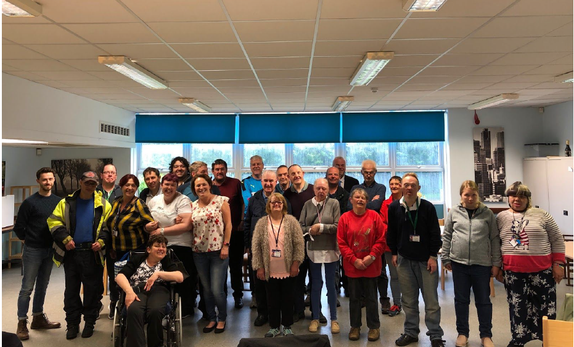

1. **Lessons Learnt**

**Safeguarding Adults Reviews (SARs)**

In accordance with the Care Act 2014 Safeguarding Adult Boards have a statutory duty to carry out Safeguarding Adults Reviews. The SAB is required to undertake reviews when an adult in its area has died as a result of abuse or neglect, and there is a concern about how the partner agencies have worked together to safeguard the adult.

In the year for this Annual report one Safeguarding Adults Review (SAR) has been completed in Northumberland, which commenced in 2017-18, and was published on behalf of the SAB in December 2018. Further details of the learning from this review can be found below. Looking ahead to next year a key priority for the Safeguarding Adults Review Committee (SARC) will be to oversee the action plan from this review, reporting progress to the SAB and ensuring that all recommendations have been completed in full.

In 2018-19 the SARC also recommended to the Board that one SAR be undertaken in Northumberland. This review has commenced, and will be concluded and reported in the 2019-20 Annual report. The themes within this review relate to domestic violence, homelessness, substance misuse, and difficulties sustaining engagement.

**Peer Review**

The SAB would like to thank and acknowledge the contribution of the Sunderland Safeguarding Adults Board, who this year undertook a peer review of the decisions made by the SARC. The Chair of the Sunderland SAB and the Chair of the Learning and Improvement in Practice sub group reviewed referrals to the SARC dating back to 2014, and in particular the decisions reached. This independent review supported all the final decisions taken by the SARC, about whether the criteria to undertake a SAR had been met. The review did make some observations in relation to procedures and processes, all of these learning points have been taken on board by the Committee, and appropriate revisions have been made. This independent review has been valuable in scrutinising and developing our local arrangements, and providing assurances regarding the Committee’s decision making and governance.

**Learning Reviews**

In 2018-2019 the SARC considered 6 new case referrals. The SARC has continued to monitor the action plans from a number of previously completed learning reviews. These reviews had not met the statutory criteria for a SAR but partners had agreed that there were lessons to be learned about multi-agency collaboration. The SARC also continues to consider and benchmark learning from other reviews, both locally and nationally. Looking ahead to next year, SAR champions will be looking to develop and cascade this learning further.

Both the Northumberland SAB Manager and the Chair of the SARC have become two of seven regional SAR champions. Research in Practice for Adults (RiPfA) were commissioned in partnership with SCIE, to develop a national Safeguarding Adults Review Champions network. It is the role of SAR Champions to support SABs in their region by raising awareness of the SAR quality markers and national SAR library. Also, in response

to a number of learning reviews which have been overseen by the Safeguarding Adults Review Committee, bespoke training has been developed for both SAB partners and staff

in Northumberland and North Tyneside. This training seeks to cascade the key learning from local reviews and SAR’s, and is being rolled out in 2019-20.

**Safeguarding Adults Review – Adult W**

In December 2018 the SAB published a SAR relating to Adult W. The full report can be found on [Northumberland’s Safeguarding Adults website](https://www.northumberland.gov.uk/Care/Support/Safeguarding.aspx)

Adult W was 90 years old, with Type 1 diabetes and a number of other medical conditions. Adult W died in a nursing home after his condition deteriorated, and the severity of the situation was not recognised or escalated. Adult W’s bespoke diabetes care plan had not been updated and communicated across all relevant agencies, which led to a poor level of understanding of Adult W’s diabetic and holistic care needs in the week leading up to his death.

**Key learning identified:**

* There was poor management of Adult W’s deteriorating condition by Nursing home staff. There was no clear care plan of sick day rules.
* There was a lack of review, communication and accountability in relation to Adult W’s diabetes plan.
* Communication and Integration of the care pathway was not effective.
* Diabetes education and training is required for staff appropriate to their role.

**What have we done as a result?**

* Reviewed available diabetes/physical deterioration training, and staff compliance.
* Multi agency Diabetic Patient Pathway is being developed which reflects good practice and clear lines of accountability.
* Adult Social Care staff briefed on the need for good multi-disciplinary working, written assessment, robust carers’ assessments, and ensuring appropriate information/equipment is transferred between care settings.

**Ongoing work:**

* Finalise and implement Multi agency Diabetic pathway.
* Multi-agency audit to review compliance to the revised pathway.
* Organisational policies to be reviewed and updated.

1. **What training have we delivered**

The Safeguarding Adults training programme offered across both local authority areas continues to provide high quality learning and development opportunities for a diverse workforce, and is regularly reviewed to ensure it remains ‘fit for purpose’.

Multi agency and interagency initiatives have continued to develop and the joint approach to learning events across both adult and children’s social care continues to expand. The diagram below shows the number of attendees at a number of the courses available.

There is a significant difference in the numbers trained across both areas. However this is reflected in the fact that Northumberland has a larger geographical area. In addition Northumberland data includes Northumbria Healthcare Trust training, which will include Health and Social care staff employed in the Community Services Business Unit.

**Training Highlights:**

* **New ‘Social Care Training Team’ established in Northumberland**

Following a significant restructure of the previous LDU Community training team we have now established a dedicated Team for Adults and Children’s Social Care Training. The Team co-ordinates, commissions and delivers a wide range of training and other learning events across Northumberland and in partnership with a range of statutory and non-statutory agencies.



* **Learning Events to support SAB priorities**

Specialist learning events have included a Sexual Exploitation Masterclass: Trauma Based Approach, a self-neglect and Hoarding Masterclass, Domestic Abuse (L2) Ask and Act train the trainer and the Josephine and Jack Programme.

* **Quality Assurance Process – Provider SA Training Programmes**

During this year the Workforce Development Group undertook a Quality Assurance Audit of Independent provider Safeguarding Training, to ensure it met both local and national requirements in accordance with policy and legislation.

The audit has led to the addition of a contractual clause for commissioned providers in North Tyneside. This includes a requirement to access the Northumberland and North Tyneside SAB Safeguarding Adult training programme or to submit all in-house training programmes to the sub group for quality assurance. Any concerns identified will be raised directly with the relevant provider. Moving forward Northumberland are looking to adopt the same approach.

**Our Workforce Plan for 2019-20**

* Raising the profile of Domestic Abuse using the newly developed Level 2 training programme.
* Working with housing partners to achieve accreditation under the Domestic Abuse Housing Alliance.
* To develop a Level 3 Safeguarding Adult programme for Health services in response to the Intercollegiate document.
* To develop a multi-agency approach to learning lessons from SAR’s and other reviews.
* To review existing CSE Training and develop an all age Sexual Exploitation training programme.
* To develop a multi-agency hoarding protocol and toolkit for practitioners.

1. **Looking forward to next year**

We have a strategic plan in place for 2019-20, which has been informed by local

Safeguarding data; experiences and feedback; partner self-assessments; and regional priorities.

The plan can be found [here](../Annual%20plan%202019-20/Annual%20plan%202019-20%20July%2019.docx) or on the Safeguarding Adults pages at;

[www.northtyneside.gov.uk](http://www.northtyneside.gov.uk)

[www.northumberland.gov.uk/Care/Support/Safeguarding.aspx](http://www.northumberland.gov.uk/Care/Support/Safeguarding.aspx)

The key Strategic Priorities for the SAB for 2019-20 are;

Page 24 of 33



1. [](https://www.google.co.uk/url?sa=i&rct=j&q=&esrc=s&source=images&cd=&cad=rja&uact=8&ved=2ahUKEwjz9cKEw4jlAhUQ3uAKHcrQC10QjRx6BAgBEAQ&url=https://www.arthritisaction.org.uk/mhdirectory/north-tyneside-talking-therapies/northumbria-healthcare-nhs-foundation-trust-logo-use-for-north-tyneside-talking-therapies/&psig=AOvVaw3X6dMyV09d3PuOl4C-QRHM&ust=1570481823239269)**Working with our partners**

**Partner spotlight – Northumbria Healthcare Trust**

**The Domestic Abuse Health Advocate Role in Northumbria Healthcare Trust**

In early 2017 a proposal for funding was made to the then Police Crime Commissioner (PCC) Vera Baird to pilot a Domestic Abuse Health Advocate (DAHA) for each health provider in the Northumbria Police area. This was in partnership with the local authorities and CCG’s within those areas. Northumbria Health Care Trust (NHCT) in conjunction with North Tyneside and Northumberland LA and CCG’s decided to look at the DAHA role from an acute perspective. Funding was granted for 3 years starting in April 2017- March 2020.

The DAHA pilot was specifically to support victims and upskill staff in three main areas; A&E, Gynaecology and Maternity. Pathways and training was set up to not only support high risk victims of domestic abuse, but to empower and enable staff to support those who attend NHCT and do not identify, via the Dash Risk Assessment, as high risk. Incorporating safety planning, the role has been evaluated by both victims and staff to be exceptionally beneficial. Resources have been developed to enable staff to support victims, in the form of a pocket slider that staff can carry to help them have quick access to pathways, plans and support services. Other resources have been provided from domestic abuse agencies for staff to give to victims.

**Case Study from DAHA pilot**

**Background**

* Patient A was brought to NSECH emergency department by police following an assault by her partner.
* Patient A was isolated from family and dependent upon her partner financially. Patient A disclosed controlling and coercive behaviours from her partner.

**Actions**

* A referral was made to the DAHA who saw Patient A in A&E.
* A DASH RIC (domestic violence screening tool) was completed and a MARAC referral submitted.
* Patient A was supplied with a Pay as you go mobile phone.
* The DAHA secured a space in the refuge and negotiated for patient A to be able to take her dog for the weekend.
* The dog was then fostered temporarily via the Dogs Trust Freedom Project.

**Outcome**

* Patient A was provided with specialist domestic abuse support through Harbour Support Services.
* Patient A has now been rehoused and is safe.

**Partner updates**

**Partner updates**

Our partners have been invited to contribute to this report. Their individual reports have been complied into a separate document which can be found [here](https://www.northumberland.gov.uk/NorthumberlandCountyCouncil/media/Health-and-social-care/Care%20support%20for%20adults/safeguarding%20adults/Partner-report-2018-19.pdf).

Below are some brief highlights of what our partners have told us about Safeguarding in their organisations this year.

|  |
| --- |
| Following the learning identified in two local DHR’s we have improved the Domestic Abuse Pathway and Coding – **North Tyneside CCG** |
| Procurement of a comprehensive single agency training package for primary care staff in relation to safeguarding adults, mental capacity act, deprivation of liberty, prevent and domestic abuse – **Northumberland CCG** |
| Referrals submitted for adults who are of concern to the police for reasons under the wider definition of Vulnerability as well as those meeting the Safeguarding threshold, are now all subject to multi-agency triage within the Multi agency safeguarding hub (MASH) arrangements for adults - **Northumbria Police** |
| A series of leaflets have been devised by the Learning Disability Liaison nurses along with people with learning disabilities for patients coming into hospital – **Northumbria Healthcare Trust** |
| We have had a particular focus on combatting domestic abuse, working with the perpetrators of sexual offending, modern day slavery and human trafficking and meeting the needs of service users with learning difficulties/disabilities – **National Probation Service** |
| We have recruited a dedicated Partner Link Worker resource and developed a relationship with Victims First – **Community Rehabilitation Company** |
| The Safeguarding and Public Protection (SAPP) Team aims to support all trust staff to keep children, young people and adults at risk safe, and to meet statutory obligations – **NTW** |
| We have delivered tailored safeguarding training to all supervisory and middle managers (delivered by Adult Safeguarding Team) – **Northumberland Fire and Rescue** |
| We have refreshed and streamlined the Safeguarding Adults procedure to make it as easy as possible for front line staff to report concerns – **Tyne and Wear Fire and Rescue** |
| We are progressing the action plan required to achieve Domestic Abuse Housing Alliance (DAHA) accreditation, working closely with colleagues in Strategic Housing to ensure that a consistent approach to support for vulnerable tenants is achieved – **Housing Services Northumberland** |
| We launched our SSKIN (pressure ulcer prevention) campaign in conjunction with/adapted from the National Patient Safety Agency – **Northumberland Age UK** |

**Appendix 1**

**Glossary of terms**

|  |  |
| --- | --- |
| APVA | **Adolescent to Parent Violence** |
| CCG | **Clinical Commissioning Group** |
| DHR | **Domestic Homicide Review** |
| DoLS | **Deprivation of Liberty Safeguards** |
| JSCR | **Joint Serious Case Review** |
| JTAI | **Joint Targeted Area Inspection** |
| LA | **Local Authority** |
| MARAC | **Multi-Agency Risk Assessment Conference** |
| MATAC | **Multi-agency Tasking and Coordination** |
| MASH | **Multi-Agency Safeguarding Hub** |
| MDS | **Modern Day Slavery** |
| MSP | **Making Safeguarding Personal** |
| MSET | **Missing, Sexually Exploited and Trafficked** |
| NHCFT | **Northumbria Healthcare Foundation Trust** |
| NTW | **Northumberland, Tyne and Wear NHS Foundation Trust** |
| NSCB | **Northumberland Safeguarding Children Board** |
| SAB | **Safeguarding Adults Board** |
| SAR | **Safeguarding Adults Review (under s.44 of the Care Act)**  See full [Care Act guidance](mailto:http://www.legislation.gov.uk/ukpga/2014/23/part/1/crossheading/safeguarding-adults-at-risk-of-abuse-or-neglect/enacted). |
| SARC | **Safeguarding Adults Review Committee** |
| SCIE | **Social Care Institute for Excellence** |
| SE/ CSE | **Sexual Exploitation/ Child Sexual Exploitation** |
| S.42 Enquiry | The Care Act 2014 (**Section 42**) requires that each local authority must make **enquiries**, or cause others to do so, if it believes an adult is experiencing, or is at risk of, abuse or neglect.  See full [Care Act guidance](mailto:http://www.legislation.gov.uk/ukpga/2014/23/section/42/enacted). |