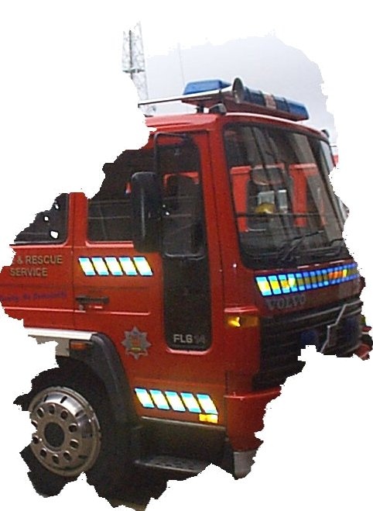

Northumberland Fire & Rescue Service
West Hartford Business Park
West Hartford
Cramlington
Northumberland
NE23 3JP

IDENTIFYING FIRE HAZARDS
NOTES ON TEST PROCEDURES AND FREQUENCIES ETC.

If a fire certificate is in force for the premises it should be checked as the following procedures and frequencies may differ.
* Indicates an entry should be made in the log book.
It is strongly recommended that a maintenance contract is taken out with a reputable company in respect of each of the installations below, if provided.

HOSE REELS (For further information see B.S. 5306 : Part I)
Regular inspections for leaks and correct operation.
* Annual test when the hose should be completely run out and subjected to operational water pressure to ensure that the hose is in good condition and that all couplings are water tight. A flow test should be carried out to ensure that a discharge of at least 30 litres/minute is achieved.

FIRE EXTINGUISHERS (For further information see B.S. 5306: Part 3)
* Monthly inspection to ensure that they are in their proper position and have not been discharged, or lost pressure (those fitted with pressure indicator) or suffered obvious damage.
* Annual inspection. No guidance is given as this should be done preferably by a representative of the manufacturer, or at least by a competent person following the manufacturer's recommended procedures and using the tools etc., specified therein.

* At intervals not exceeding those given below test discharge the extinguishers.
(a) Water/Foam (All Types), Powder (Gas Cartridge and Stored Pressure - other than Primary Sealed types - every 5 years.
(b) Carbon Dioxide, Powder (Stored Pressure Primary Sealed) - Every 10 years (20 years where the Annual Inspection has been followed) and subsequently after a further 10 years and thereafter at 5 year intervals.

FIRE ALARM (For further information see B.S. 5839 : Part I)
It is important that the operations of testing do not result in a false signal of fire.
Daily inspect the panel for normal operation of the system. Where provided, check that the connection to the remote manned centre is functioning correctly.
* Weekly test and examination to ensure that the system is capable of operating under alarm conditions, namely (a) Operate trigger device (manual call point or detector) or end of line switch on a zone circuit. Zones should be tested in strict rotation, each zone being tested at least quarterly for a monitored system and weekly for an unmonitored system. Each time a zone is tested a different trigger device should be used. (b) Examination of batteries and connections, including electrolyte level.
* Quarterly and Annual inspection and test. No guidance is given as these should be done by the installer, or by an employee who has received special training from the installer.
* Record all actuations of the fire alarm system and any remedial action taken to prevent any false alarms.

FIRE DETECTORS (For further information see B.S. 5839 : Part 1)
Regular visual inspection of detectors for damage, unusual accumulations of dirt, heavy coats of paint and other conditions likely to interfere with the correct operation of the detector.
* Annual test of at least 2% of installed heat detectors by application of a heat source as a check on reliability. Detectors other than heat should be checked for correct operation and sensitivity in accordance with the manufacturer's instruction and carried out by the installer.
AUTOMATIC DOOR RELEASES CONNECTED TO FIRE ALARM SYSTEM
*Weekly in conjunction with the fire alarm test, check that all doors are being released and closing fully onto the door rebates.

EMERGENCY LIGHTING (For further information see B.S. 5266: Part I)
Because of possible failure, all tests should be undertaken at times of least risk.
Regularly inspect the system for cleanliness, particularly luminaires. Battery banks and generators should be checked following the manufacturer's instructions.
* Monthly test of self contained luminaires, by simulation of a failure of the normal lighting supply, for sufficient time to allow all luminaires to be checked for proper function.
* Six monthly test of self contained and central battery systems, by simulation of a failure of the normal lighting supply, for a continuous period of one hour. During test check all luminaires for proper function. * Three yearly test for full duration of self contained and central battery systems which have a specified duration category in excess of one hour. During test check all luminaires for proper function. * For self contained luminaires with sealed batteries, after the first three yearly test the three yearly test should be carried out annually.

FIRE INSTRUCTIONS
* At intervals shown below instructions should be given in respect of the action, purpose etc., of the following:- discovering a fire, hearing the fire alarm, the assembly point, calling the fire brigade, making safe power supplies etc., use of fire alarms and fire extinguishers, and the means of escape routes.
First month of employment two instruction periods.
Three monthly for staff on night duties.
Six monthly for staff on day duties.

FIRE DRILLS
* At intervals shown below drills should be conducted to simulate fire conditions i.e. one escape route obstructed, no advance warning given other than to specific staff for the purposes of safety, the fire alarm should be operated on instructions of management. Do not call the fire brigade for the purposes of a drill, it is an offence.
Six monthly for residential premises, places of public entertainment, large shops and departmental stores. Yearly for industrial and commercial premises.

DOOR MAINTENANCE
*Fire Doors - Monthly inspection to ensure all fire doors are closing fully against their rebates and that the doors and frames are in a good condition (including glazing).
Any doors fitted with a self closing device should be checked to ensure the door closes effectively. Ensure all fire doors are suitably indicated by appropriate signs (excluding doors to bedrooms).

*Exit Doors - Monthly inspection to ensure all exit doors are easily openable and open fully.
Doors fitted with permitted security devices should have these removed and the door opened. Ensure all exit doors are suitably indicated by appropriate signs.

FIRE ALARM SYSTEM - RECORD OF TESTS

DATE | FIRE ALARM |  | AUTOMATIC DOOR RELEASES | AUTOMATIC DETECTORS |  | REMEDIAL ACTION TAKEN | SIGNATURE
 | Call Point Location or  Number | Satisfactory Yes/No | Satisfactory Yes/No | Location or Number | Satisfactory  Yes/No
EMERGENCY LIGHTING SYSTEM - RECORD OF TESTS

DATE | SATISFACTORY  YES/NO | REMEDIAL ACTION | SIGNATURE

FIRE INSTRUCTIONS AND DRILLS – RECORD OF WHEN GIVEN

(It is recommended that all individuals participating in a fire drill or receiving instruction are named and signed to confirm receipt of training etc.)

Date | Instruction  Duration | Fire Drill  Evacuation Time | Person Receiving  Instruction/Participating  In Drill | Nature of Instruction/Overview of Drill | Observations of Instructor | Signature of Instructor &  Participant

