Northumberland County Council Admission Arrangements for Community and Voluntary Controlled Schools - 2024/25

Admission to Middle, High, Secondary schools (years 5, 7 and 9) and sixth forms (year 12 entry)

Introduction

These are part of the admission arrangements for community and voluntary controlled middle, high, secondary schools and sixth forms.

Co-ordinated Admission Arrangements

In line with current legislation, the Local Authority has drawn up a separate co-ordinated admissions scheme to coordinate admissions to maintained schools and Academies within Northumberland and neighbouring authorities for the main admissions round.

Published Admission Numbers

The admission number the Local Authority will publish for each community and voluntary controlled school is shown below

Please note proposed changes re: The Duchess’s Community High School

- Reduction of the Published Admission Number at The Duchess's Community High School from 250 to 240 in view of current and future pupil numbers.

School Name | Published Admission Number (PAN) (main school) | Published Admission Number (admission to sixth form – external (new) students only)
Astley Community High School | 150 | 10
Berwick Middle School | 114 | N/A
Corbridge Middle School | 90 | N/A
Glendale Middle School | 42 | N/A
James Calvert Spence College | 120 | 10
Seaton Sluice Middle School | 85 | N/A
The Duchess's Community High School | 240 (previously 250) | 10
Tweedmouth Community Middle School | 93 | N/A
Whytrig Middle School | 90 | N/A

The Local Authority Admissions Policy for 2024-2025

This admissions policy will be used to allocate places at those Local Authority schools which are oversubscribed. It is attached below for entry to Year 5, Year 7, Year 9 and Year 12.

Admission Policy for Community and Voluntary Controlled Schools – middle, high, secondary schools and sixth forms

This policy applies only to Local Authority maintained schools and voluntary controlled schools.

NB If you are applying for a school that manages their own admissions e.g academies, please review their admissions policy/arrangements via the school website.

The County Council is obliged to admit all applicants to a particular school provided these do not exceed the school’s Published Admission Number (PAN).

Children with Education Health and Care Plans where the school is named in the statement will be admitted.

Oversubscription Criteria

Where there are more applications than places available the following oversubscription criteria will be applied, strictly in order of priority:

- Children in Public Care (and as deemed under Section 22 of the Children Act 1989) including a child who was previously “looked after” but immediately after being “looked after” became subject to an adoption, residence, or special guardianship order. Children who appear to have been in state care outside of England and ceased to be in state care as a result of being adopted.

Note: A 'looked after child' is a child who is (a) in the care of a local authority, or (b) being provided with accommodation by a local authority in the exercise of their social services functions (see the definition in Section 22(1) of the Children Act 1989) at the time of making an application to a school. This includes children who were adopted under the Adoption Act 1976 (see section 12 adoption orders) and children who were adopted under the Adoption and Childrens Act 2002 (see section 46 adoption orders). Child arrangements orders are defined in s.8 of the Children Act 1989, as amended by s.12 of the Children and Families Act 2014. Child arrangements orders replace residence orders and any residence order in force prior to 22 April 2014 is deemed to be a child arrangements order. See Section 14A of the Children Act 1989 which defines a ‘special guardianship order’ as an order appointing one or more individuals to be a child’s special guardian (or special guardians).

- Children living within the catchment area of the school and those on whose behalf firm evidence is presented that they will be living in the catchment area by the appropriate admission date.

The following link provides information re: catchments relevant to the 2024/25 academic year: Digital catchment maps

- Children with an exceptional social or medical reason that means that they can only attend that specific school (for example, where the child or one or both parents has a disability that means that the child can only go to one school).

Strong supporting evidence must be provided from a professional body involved with the family or the child. The professional must be independent of both the family and the school.

The evidence must relate specifically to the school for which the application is being made and must demonstrate clearly why it is the only school that can meet the child’s needs. No assumptions should be made that the submission of the relevant evidence will, in itself be sufficient to allocate a place.

Note: You will not be allocated a place under this criterion if you omit to send to the School Admissions Team a written statement from a professional third party by 31 October 2023.

- Children resident in the greater catchment area of the school partnership who have a sibling* already in the school who is expected to be on roll at the school at the time of admission. Evidence must be presented to confirm that the child will be living in the greater catchment area by the appropriate admission date.

- Children resident in the greater catchment area of the school partnership. Evidence must be presented to confirm that the child will be living in the greater catchment area by the appropriate admission date.

NOTE: The greater catchment area for a school is the catchment area of the high or secondary school i.e all school in a partnership that feed into a particular high or secondary school. The Local Authority cannot determine catchment areas for Voluntary Aided and Foundation schools or Academies, however for the purpose of this criteria, the Council has determined a greater catchment for Community and Voluntary Controlled schools. Parents can find details of this using the digital catchment maps link above.

- Children who have a sibling* who already attends the school, including sixth form, and who is expected to be on roll at the school at the time of admission.

*For the purpose of admissions siblings are deemed to be brothers and sisters, stepsiblings, foster siblings, adopted siblings and other children who reside permanently in the household and are treated as siblings.

- Requests on behalf of children which are based on the need to maintain continuity of educational provision within the feeder pattern of Northumberland’s schools.

NOTE: Please see feeder schools below.
 | Feeder Schools
Astley Community High School | New Hartley, Seaton Sluice, Seghill, Holywell Village, Seaton Delaval First Schools  Seaton Sluice, Whytrig Community Middle Schools
Berwick Middle School | Holy Trinity CE, St Cuthbert’s RC VA (part), Berwick St Mary’s, Hugh Joicey CE. Holy Island CE, Lowick, Norham St Ceolwulfs CE, Scremerston First Schools
Corbridge Middle School | Broomhaugh CE, Corbridge CE, Slaley, Whittonstall First Schools
Glendale Middle School | Wooler First School
James Calvert Spence College | Amble, Amble Links, Broomhill, Red Row, Grange View First Schools  NCEA Warkworth CE Primary
Seaton Sluice Middle School | New Hartley, Seaton Sluice, Seghill First Schools
The Duchess's Community High School | Swansfield Park, Ellingham CE, Shilbottle, Swarland, Branton, Embleton Vincent Edward’s CE, Seahouses, Felton CE, Hipsburn, Longhoughton CE, St Paul’s RC VA , St Michael’s CE, Whittingham CE Primary Schools
Tweedmouth Community Middle School | Spittal, Tweedmouth Prior Park, Tweedmouth West, St Cuthbert’s First Schools
Whytrig Middle School | Holywell Village, Seaton Delaval First Schools
Important: This criterion does not apply to those children who have entered a school in the final year before transfer.

- Other children

Tie Breaker

Should it prove necessary, because places are limited, to distinguish between children in any given category priority will be given to those who live nearest to the school, measured in a direct line (‘as the crow flies’) using the LA’s computerised measuring system (GIS). Where two or more distances are found to be equal a system of random allocation will apply, independently administered.

Applicants refused admission are entitled to an appeal which is determined by an independent panel.

Applications for Year 12

All Northumberland schools offer sixth form of study for students. The majority of the sixth form students transfer from Year 11, but places are available for external students. The entry requirements for sixth forms are largely dependent on the course of study that a student wishes to access. They are the same for internal and external students. Details of specific entry requirements and courses available may be obtained from the school. The availability of courses is dependent upon the number of applicants and the financial sustainability of the course and the Governing Body of the school determines this.

Entry requirements and oversubscription criteria – Year 12

Students who have attended the school in the previous academic year (during Year 11) and who satisfy the school’s entry requirements* will be automatically allocated.

All other students will be allocted in accordance to the oversuvscription below:

a) Children in Public Care (and as deemed under Section 22 of the Children Act 1989) includ- ing a child who was previously “looked after” but immediately after being “looked after” became subject to an adoption, residence, or special guardianship order. Children who appear to have been in state care outside of England and ceased to be in state care as a result of being adopted.

b) All other students.

Tie Breaker

Should it prove necessary, because places are limited, to distinguish between children in any given category priority will be given to those who live nearest to the school, measured in a direct line (‘as the crow flies’) using the LA’s computerised measuring system (GIS). Where two or more distances are found to be equal a system of random allocation will apply, independently administered.

Applicants refused admission to a sixth form are entitled to an appeal which is determined by an independent panel.

*Details of the entry requirements are available from the individual Sixth Forms.

Catchment proposal

Broomhill, Felton, James Calvert Spence and The Duchess’ High

Having reviewed the catchment areas for Broomhill First School and Felton Primary School, it appears that the inclusion of the houses at the end of Mouldshaugh Lane in the Broomhill catchment could have been as a result of an anomaly or historical error. Therefore, this consultation presents an opportunity to review the Broomhill First and Felton Primary catchment areas, and we will consult on moving the western boundary of the Felton Primary and The Duchess's High Schools catchment areas to the natural border formed by the River Coquet. This consultation will ensure that all stakeholders that might be impacted by any change to the catchments, including Broomhill First and James Calvert Spence College, will have the opportunity to submit their views for consideration. A copy of the previous maps and the new proposed maps can be found below:

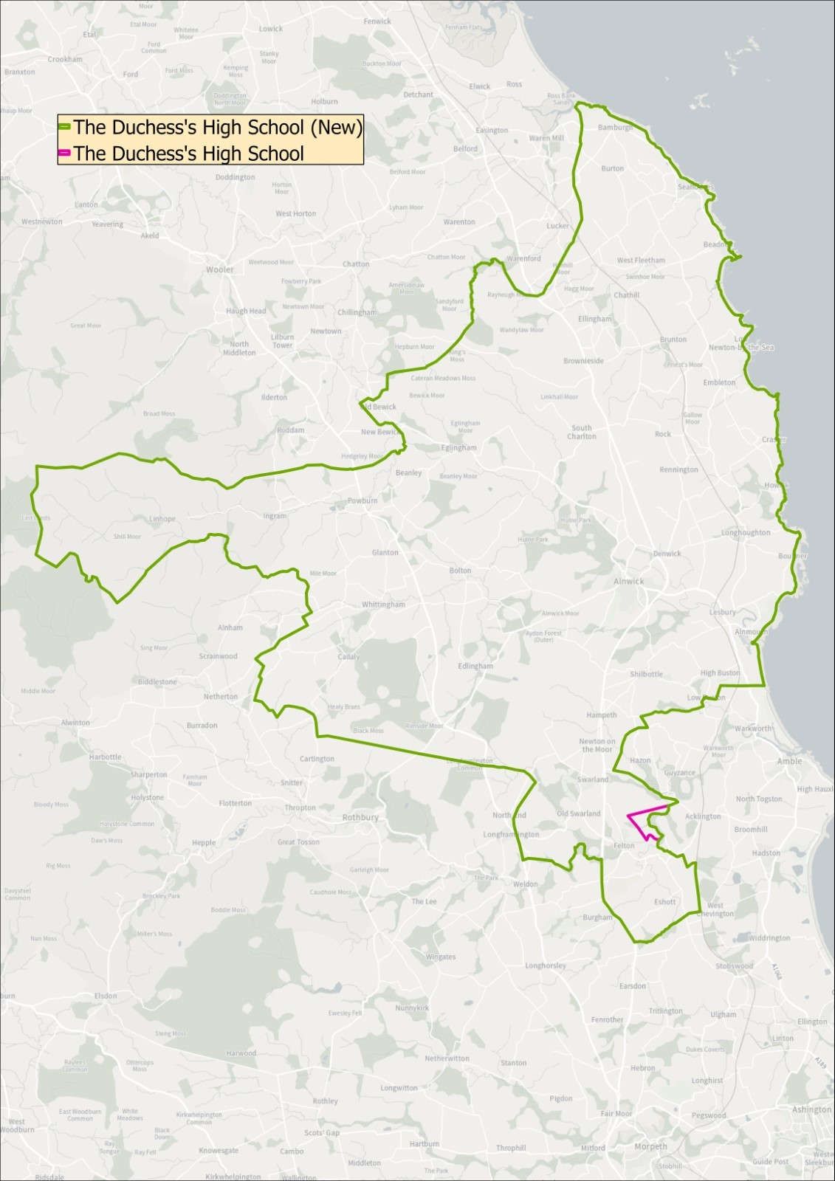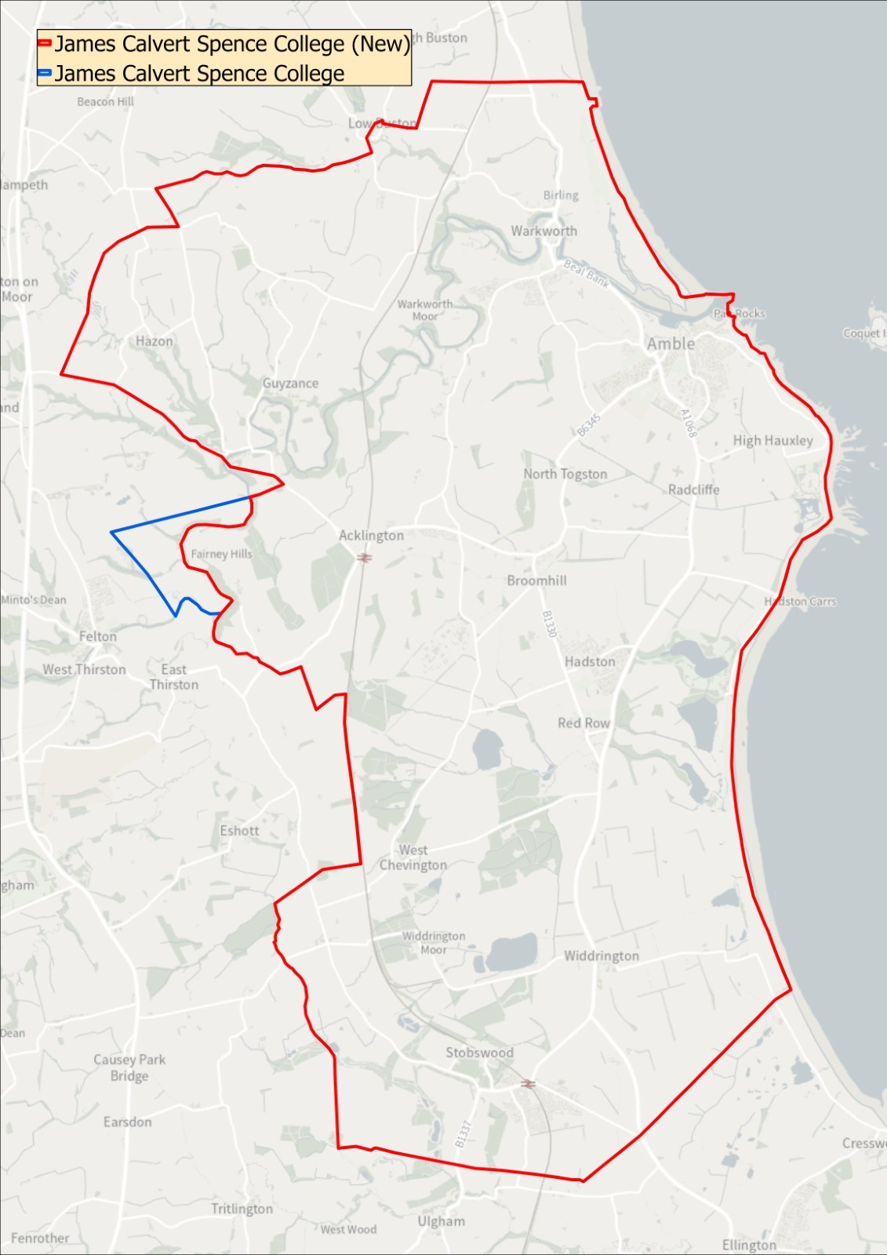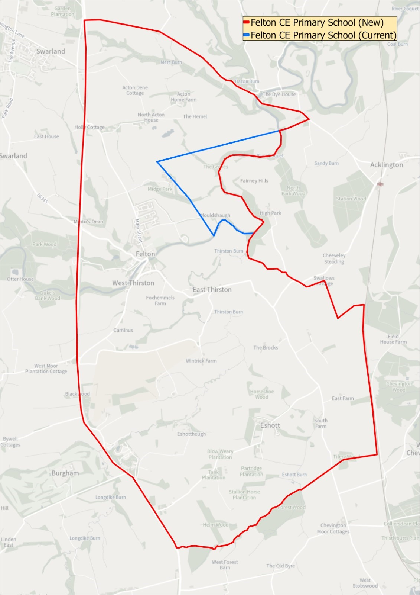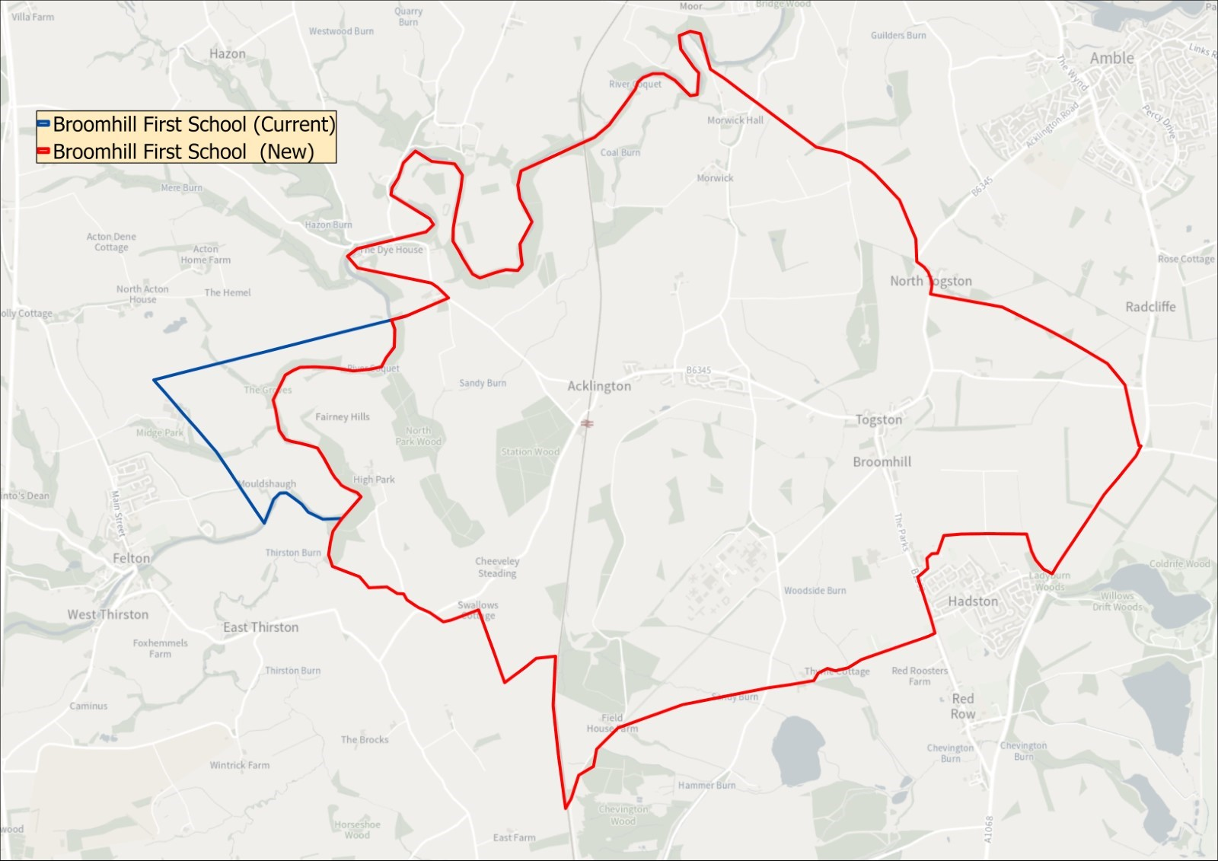

GENERAL

Parents may be asked to provide evidence of residency if the requested school is oversubscribed.

Applications on behalf of children who are resident in other Local Authority areas will be considered in the same way as applications from Northumberland residents.

Children with disabilities will be treated no less favourably than other applicants for admission. Schools are under a duty to make reasonable adjustments to ensure that children with disabilities are not placed at a substantial disadvantage, and no child will be refused a place on the grounds of disability. A pupil has a disability if he or she has a physical or mental impairment that has a substantial and long-term adverse effect on his or her ability to carry out normal day-to-day activities.

Those parents whose application to a school has been unsuccessful will be notified of their right of appeal to an Independent Appeal Panel. The School Standards and Framework Act 1998, gives this right to all parents whose application for a school has been unsuccessful. The decision of an Appeal Panel is binding on both the Admission Authority and the school. The School Admission Appeals Code can be found on the DfE website at: www.gov.uk/dfe.

Definitions used under the policy

‘Parents’ include all those people who have a parental responsibility* for a child as set out in the Children’s Act 1989. Where responsibility for a child is ‘shared’, the person deemed to be the person responsible for completing the application is the person receiving Child Benefit and whose address will be used for admission purposes.

*Parental Responsibility, unless otherwise determined by a court order:
- Mothers automatically have parental responsibility.
- Fathers also have parental responsibility if the father is married to the mother at the time of the child’s birth. This continues after any divorce/separation/remarriage even if the child lives apart from them.
- An unmarried father can obtain Parental Responsibility by:
- marrying the mother
- having his name registered or re-registered on the birth certificate if his name is not already registered**
- entering into a Parental Responsibility Agreement with the mother
- obtaining a Parental Responsibility Order from the court
- having obtained a Residence Order prior to 22.4.2014
- by being named as the resident parent under a Child Arrangements Order
- becoming the child’s guardian on the mother’s death

**The law has changed so that unmarried fathers who registered or re-registered their name on their child’s birth certificate after 1st December 2003 will have Parental Responsibility for their child.
Therefore:
- If an unmarried father has a child after 1st December 2003 and he is registered on the birth certificate he WILL have Parental Responsibility.
- If a child’s birth was registered before 1st December 2003 and the father was not named on the birth certificate, the birth can be re-registered to include the father’s name. Once this has been done, the father WILL have Parental Responsibility.*
- If an unmarried father’s name is already on the birth certificate and the child was registered before 1st December 2003, the law has not changed this situation so the father WILL NOT have Parental Responsibility. (Unless obtained by other means).

Same-sex parents

Civil partners
Same-sex partners will both have parental responsibility if they were civil partners at the time of the treatment, eg donor insemination or fertility treatment.
Non-civil partners
For same-sex partners who are not civil partners, the 2nd parent can get parental responsibility by either:
- applying for parental responsibility if a parental agreement was made
- becoming a civil partner of the other parent and making a parental responsibility agreement or jointly registering the birth
Details of catchment areas are available on request or by following the links on the County Council’s webpage to the interactive mapping system

Address to be Used in Determining Priority for Admission

The address of the parent or carer with whom the child is normally resident, Mondays to Fridays term time only, will be used in the allocation process.

In some cases, for example where shared parental living arrangements are in place, a child’s address may be difficult to determine. In these circumstances the address used for child benefit purposes will normally be used, i.e. the address of the parent claiming the benefit. If that is not available, then the address on the NHS medical card can be used.

Fraudulent Applications and Withdrawal of a School Place

The local authority will not withdraw the offer of a place unless it has been established that the offer was obtained through a fraudulent, or intentionally misleading application. Where an offer is withdrawn on the basis of fraudulent or misleading information, the application will be considered on the basis of correct information, and parents or carers will have the right of appeal where no place can be offered.

The local authority may seek to withdraw the offer of a school places if it is established that a fraudulent application was submitted.

Where parents or carers are found to have made a fraudulent application for a school place and the admission authority decides not to withdraw that place in the best interests of the child, should a school place be sought for any other sibling, or siblings, the sibling criterion will not be considered.

If a place is withdrawn it will be offered to those with a greater right to the place as of National Offers Day, ranked according to the school’s oversubscription criteria.

Parental disagreement

The management of school applications may be severely delayed during the main admissions round where separated parents* of the child each submit a separate application for different schools or one parent does not agree with the application made by the other parent. The School Admissions Code states that only one offer of a school place per child is made by the Local Authority. In this situation the Local Authority asks that parents and/or carers resolve matters between themselves before informing the Local Authority in writing of which application should be processed/their agreement to an application. In case of dispute between parents, where more than one parent has parental responsibility and they do not agree to an application being made to a particular school, a temporary school place will be offered until any dispute is resolved by both parents as a personal matter and this will be based on the address of the parent or carer with whom the child is normally resident, Mondays to Fridays term time only.

Late Applications

Normally applications submitted after the relevant published date will not be considered until after allocations for those parents who applied on time have been made unless in exceptional circumstances. If the LA considers your reasons are exceptional your application will be considered along with those received on time. Examples of what may be considered as exceptional circumstances are a family who have just moved into the area (proof of ownership or tenancy agreement will be required). Any evidence submitted after the relevant date to support a late application or change of preference will not be considered. Affected applicants will not receive an offer with other parents on National Offers Day, instead receiving one on ‘re-allocation day’.

Waiting Lists

Once places have been allocated, children refused a place will continue to be considered for any vacancies which become available. Vacancies will always be allocated by applying the admissions policy and oversubscription criteria of the school; length of time on the waiting list will not be considered. Each added child will require the list to be ranked again in line with the published oversubscription criteria. The LA will hold all waiting lists for Community and Voluntary Controlled Schools and where requested for VA, Trust and Academies. Waiting lists for the normal year of entry will be kept open until 31 December 2024.

Twins and Siblings of Multiple Births

Where places are available for some but not all children from multiple births (including twins) the Local Authority will exercise discretion offered by the School Admissions Code to offer all the children a place, even if this breaches the published admission number for the year group.

Catchment Areas

Catchment areas are a tool used to apply the over subscription criteria when a school has more applications than places. Catchment areas have no separate legal identity outside of the application of the admissions policy. Details of catchment areas are available on request or by following the links on the County Council’s webpage to the interactive mapping system (see above)

Distance Measures

Distance measures will be undertaken using the Local Authority’s computerised Geographical Information System (GIS). This measures a straight-line measure from the front door of the home to the main gate of the school. Distance checking is an integral function within the school admissions software ensuring consistency in measurement. Where two or more distances are found to be equal a system of random allocation will apply, independently administered.

Admission of Children outside their Normal Age Group

A request may be made for a child to be admitted outside of their normal age group, for example, if the child is gifted and talented or has experienced problems such as ill health.

Any such request should be made in writing to the head teacher of the school and to the local authority. The local authority will make its decision about the request based on the circumstances of each case and in the best interests of the child. In addition to taking into account the views of the head teacher who has statutory responsibility for the internal organisation, management and control of the school, the local authority will take into account the views of the parents and of appropriate medical and education professionals.

The Admissions Timetable

The timetable for the September 2024 application and allocation processes will be in line with the co-ordinated admissions schemes in accordance with the timetable detailed below

Admissions timetable (not sixth forms)

12 September 2023: | E-admissions portal opens.
12 September 2023: | Common application forms together with admissions information and school prospectuses are made available for parents.
31 October 2023: | Closing Date for Applications:  E-admission portal closes.
1 March 2024: | Parents notified of the outcome of their applications for school places
15 March 2024: | Last date for refusals by parents.

Publication of the Local Authorities Information for Parents (2024/25) Handbook

The Information for Parents publication for September 2024 entry will be available from the beginning of September 2023.

