**Northumberland County Council Admission Arrangements for Community and Voluntary Controlled Schools - 2024/25**

**Admission to First and Primary Schools (Reception)**

**Introduction**

These are part of the admission arrangements for community and voluntary controlled first and primary schools.

NB If you are applying for a school that manages their own admissions e.g academies, please review their admissions policy/arrangements via the school website.

**Co-ordinated Admission Arrangements**

In line with current legislation, the Local Authority has drawn up a co-ordinated admissions scheme to coordinate admissions to maintained schools and Academies within Northumberland and neighbouring authorities for the main admissions round.

**Published Admission Numbers**

The admission number the Local Authority will publish for each community and voluntary controlled school is shown below.

**Please note proposed changes re: Shilbottle Primary, Hipsburn Primary and Northburn Primary**

* Reduction of the Published Admission Number at Shilbottle Primary School from 30 to 15, in view of current and future pupil numbers.
* Reduction of the Published Admission Number at Hipsburn Primary School from 21 to 15 in view of current and future pupil numbers.
* Reduction of the Published Admission Number at Northburn Primary School from 45 to 30 in view of current and future pupil numbers.

|  |  |
| --- | --- |
| **School Name** | **Published Admission Number (PAN )** |
| Acomb First School | 15 |
| Allendale Primary School | 24 |
| Amble First School | 30 |
| Amble Links First | 30 |
| Beaconhill Community Primary School | 30 |
| Beaufront First School | 15 |
| Bedlington Station Primary School | 30 |
| Bedlington Stead Lane Primary School | 30 |
| Bedlington West End First School | 30 |
| Belford Primary School | 30 |
| Berwick St. Mary's C.E. First School | 30 |
| Branton Community Primary School | 6 |
| Broomhill First School | 15 |
| Burnside Primary School | 60 |
| Cambo First School | 8 |
| Cambois Primary School | 15 |
| Choppington Primary School | 15 |
| Cragside C of E Primary School | 60 |
| Cramlington Eastlea Primary School | 30 |
| Ellington Primary School | 30 |
| Felton C of E Primary School | 15 |
| Grange View CE First School | 30 |
| Greenhaugh County Primary School (as will be) | 8 |
| Guidepost Ringway Primary School | 30 |
| Hareside Primary School | 60 |
| Hexham First School | 30 |
| **Hipsburn Primary School** | **15 (previously 21)** |
| Holywell First School | 30 |
| Horton Grange Primary School | 90 |
| Kielder Community Primary School (as will be) | 8 |
| Linton Primary School | 8 |
| Longhoughton C of E Primary School | 30 |
| Lowick C of E VC First School | 10 |
| Morpeth First School | 60 |
| Mowbray Primary School | 30 |
| New Delaval County Primary School | 45 |
| New Hartley First School | 30 |
| Newsham Primary School | 60 |
| Norham St Ceolwulf's C of E First School | 10 |
| **Northburn Primary School** | **30 (previously 45)** |
| Otterburn Primary School | 10 |
| Pegswood County Primary School | 30 |
| Red Row Community First School | 29 |
| Rothbury First School | 20 |
| Scremerston First School | 18 |
| Seahouses Primary School | 21 |
| Seaton Delaval First School | 30 |
| Seaton Sluice First School | 30 |
| Seghill First School | 30 |
| Shanklea Primary School | 45 |
| **Shilbottle Primary School** | **15 (previoulsy 30)** |
| Slaley First School | 10 |
| Spittal Community First School | 40 |
| Stakeford Primary School | 30 |
| Stamfordham Primary School | 15 |
| Stannington First School | 20 |
| Swansfield Park Primary School | 45 |
| Swarland Primary School | 17 |
| The Sele First School, Hexham | 84 |
| Tweedmouth Prior Park First School | 30 |
| Tweedmouth West First School | 30 |
| Whittingham Primary School | 15 |
| Wooler First School | 27 |

**The Local Authority Admissions Policy for 2024-2025**

This admissions policy will be used to allocate places at those schools which are oversubscribed. It is attached below for entry to a Reception class.

**Admission Policy – first and primary schools**

This policy applies only to Local Authority maintained schools and Voluntary Controlled Schools.

The County Council is obliged to admit all applicants to a particular school provided these do not exceed the school’s Published Admission Number (PAN).

Children with an Education Health and Care Plan where the school is named in the statement will be admitted.

**Oversubscription Criteria**

Where there are more applications than places available the following oversubscription criteria will be applied, strictly in order of priority:

1. Children in Public Care (and as deemed under Section 22 of the Children Act 1989) includ- ing a child who was previously “looked after” but immediately after being “looked after” became subject to an adoption, residence, or special guardianship order. Children who appear to have been in state care outside of England and ceased to be in state care as a result of being adopted.

Note: A 'looked after child' is a child who is (a) in the care of a local authority, or (b) being provided with accommodation by a local authority in the exercise of their social services functions (see the definition in Section 22(1) of the Children Act 1989) at the time of making an application to a school. This includes children who were adopted under the Adoption Act 1976 (see section 12 adoption orders) and children who were adopted under the Adoption and Childrens Act 2002 (see section 46 adoption orders). Child arrangements orders are defined in s.8 of the Children Act 1989, as amended by s.12 of the Children and Families Act 2014. Child arrangements orders replace residence orders and any residence order in force prior to 22 April 2014 is deemed to be a child arrangements order. See Section 14A of the Children Act 1989 which defines a ‘special guardianship order’ as an order appointing one or more individuals to be a child’s special guardian (or special guardians).

1. Children living within the catchment area of the school and those on whose behalf firm evidence is presented that they will be living in the catchment area by the appropriate admission date.

The following link provides information re: catchments relevant to the 2024/25 academic year: [Digital catchment maps](https://northumberland.maps.arcgis.com/apps/webappviewer/index.html?id=8aa658f92b2a4237834519c4330fc07c)

1. Children with an exceptional social or medical reason that means that they can only

attend that specific school (for example, where the child or one or both parents has a disability that means that the child can only go to one school).

Strong supporting evidence must be provided from a professional body involved with the family or the child. The professional must be independent of both the family and the school. The evidence must relate specifically to the school for which the application is being made and must demonstrate clearly why it is the only school that can meet the child’s needs. No assumptions should be made that the submission of the relevant evidence will, in itself be sufficient to allocate a place.

NOTE: You will not be allocated a place under this criterion if you omit to send to School Admissions Team a written statement from a professional third party by 16 January 2024.

1. Children resident in the greater catchment area of the school partnership who have a sibling* already in the school who is expected to be on roll at the school at the time of admission. Evidence must be presented to confirm that the child will be living in the greater catchment area by the appropriate admission date.
2. Children resident in the greater catchment area of the school partnership. Evidence must be presented to confirm that the child will be living in the greater catchment area by the appropriate admission date.

NOTE:The greater catchment area for a school is the catchment area of the high or secondary school i.e all school in a partnership that feed into a particular high or secondary school. The Local Authority cannot determine catchment areas for Voluntary Aided and Foundation schools or Academies, however for the purpose of this criteria, the Council has determined a greater catchment for Community and Voluntary Controlled schools. Parents can find details of this using the digital catchment maps link above.

1. Children who have a sibling* who already attends the school and who is expected to be on roll at the school at the time of admission.

* For the purpose of admissions siblings are deemed to be brothers and sisters, stepsiblings, foster siblings, adopted siblings and other children who reside permanently in the household and are treated as siblings.

1. Other children

**Tie Breaker**

Should it prove necessary, because places are limited, to distinguish between children in any given category priority will be given to those who live nearest to the school, measured in a direct line (‘as the crow flies’) using the LA’s computerised measuring system (GIS). Where two or more distances are found to be equal a system of random allocation will apply, independently administered.

Applicants refused admission are entitled to an appeal which is determined by an independent panel.

**Catchment proposal**

**Broomhill, Felton, James Calvert Spence and The Duchess High**

Having reviewed the catchment areas for Broomhill First School and Felton Primary School, it appears that the inclusion of the houses at the end of Mouldshaugh Lane in the Broomhill catchment could have been as a result of an anomaly or historical error. Therefore, this consultation presents an opportunity to review the Broomhill First and Felton Primary catchment areas, and we will consult on moving the western boundary of the Felton Primary and The Duchess's High Schools catchment areas to the natural border formed by the River Coquet. This consultation will ensure that all stakeholders that might be impacted by any change to the catchments, including Broomhill First and James Calvert Spence College, will have the opportunity to submit their views for consideration. A copy of the previous maps and the new proposed maps can be found below:

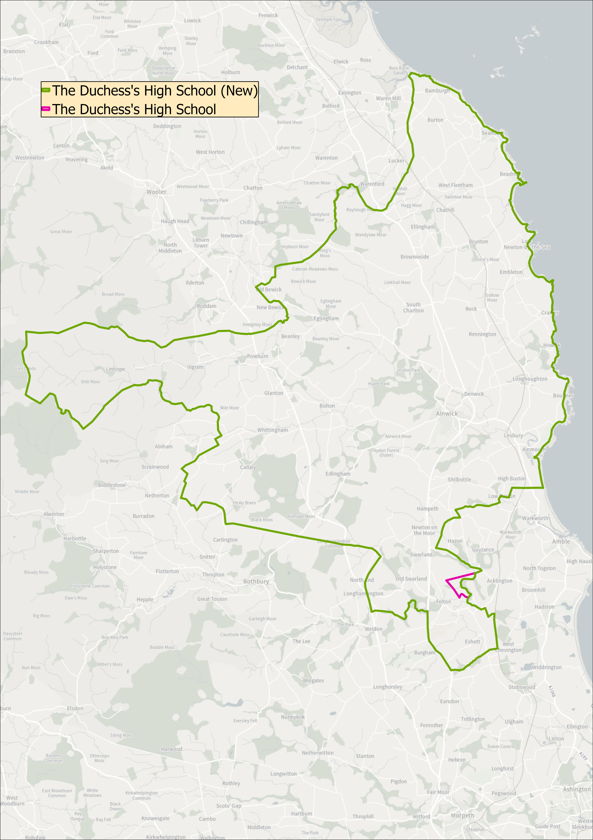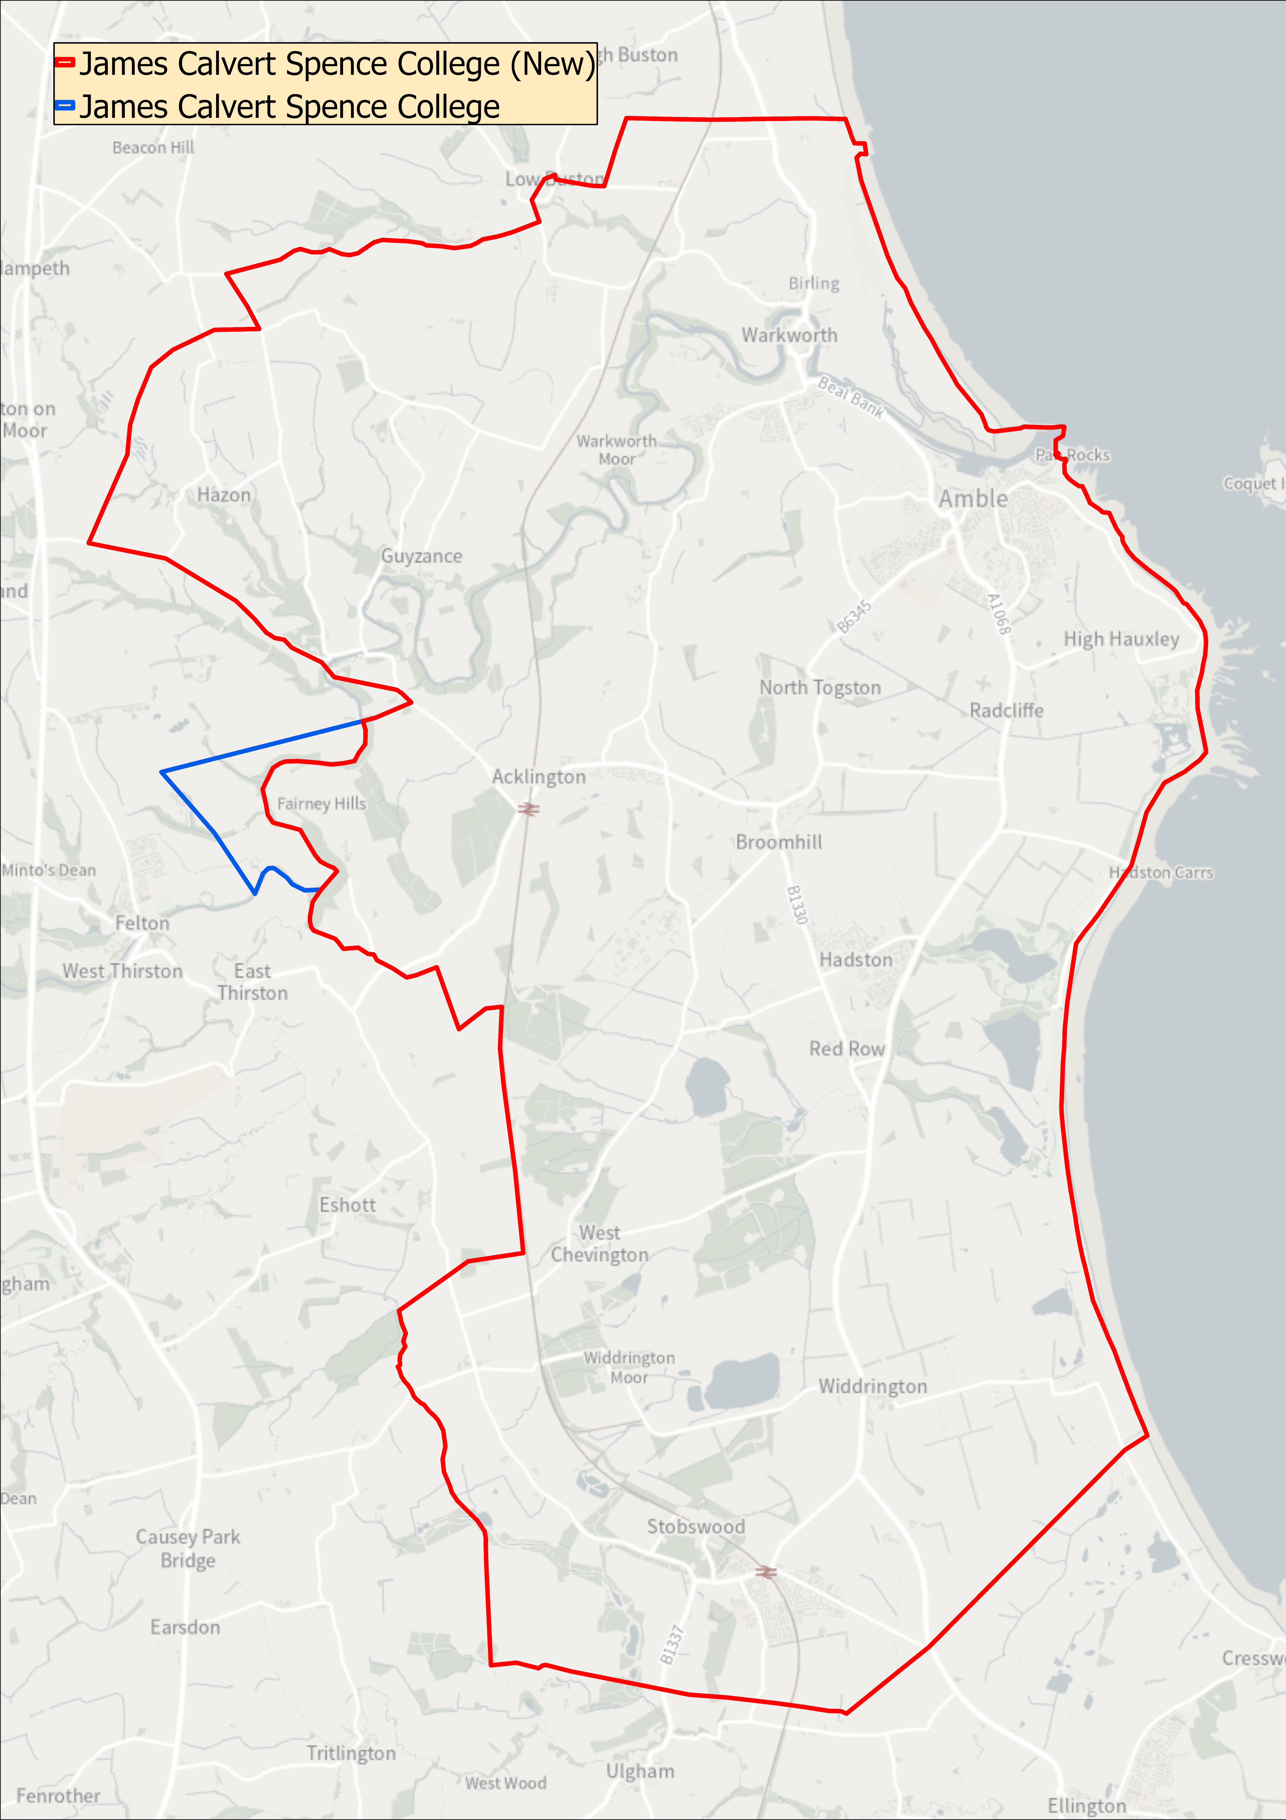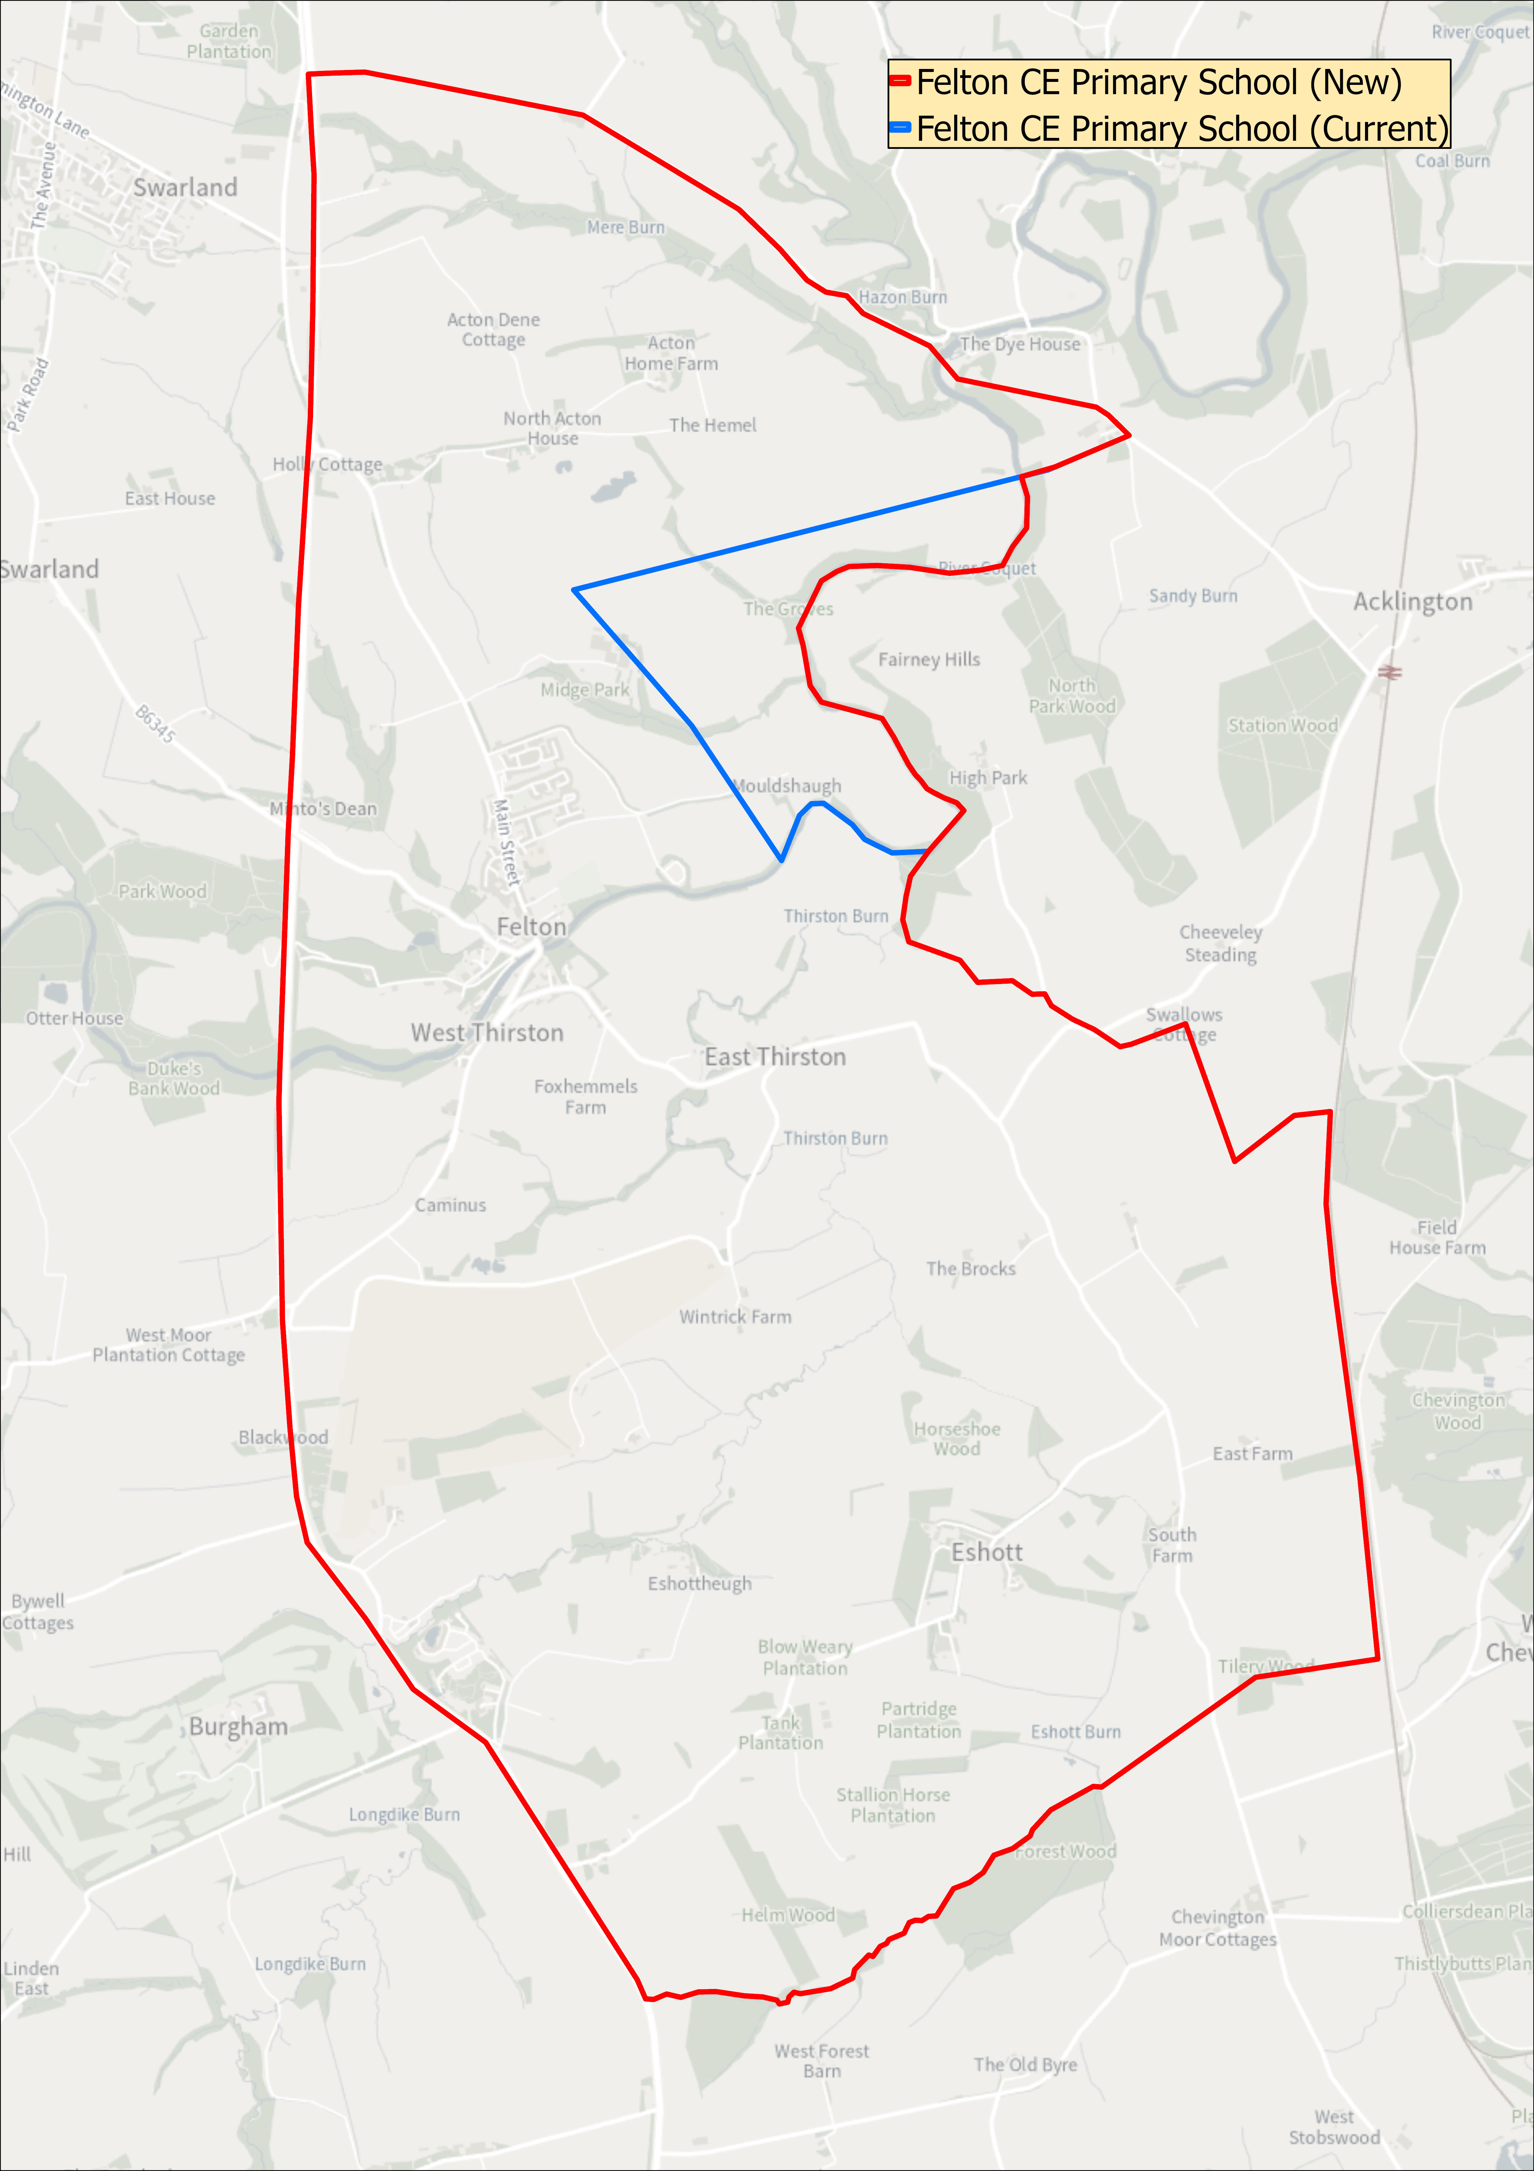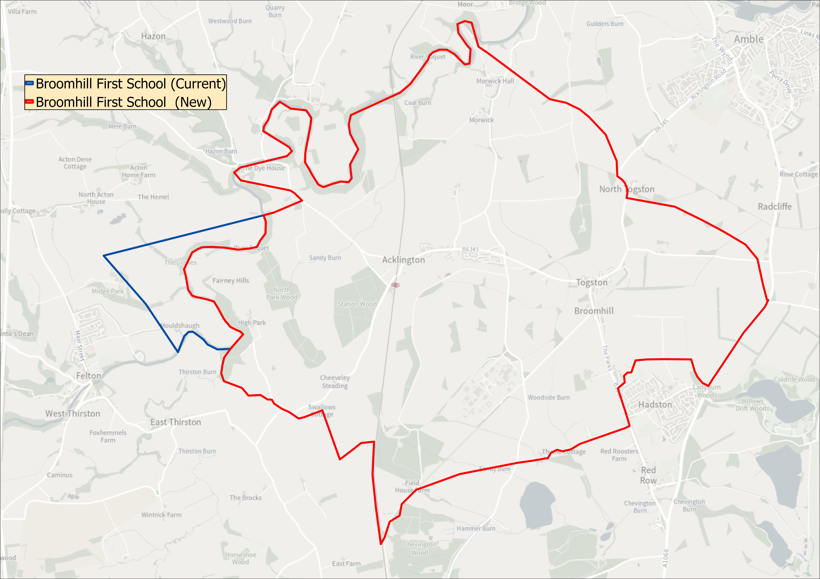

**GENERAL**

**Parents may be asked to provide evidence of residency if the requested school is oversubscribed.**

Applications on behalf of children who are resident in other Local Authority areas will be considered in the same way as applications from Northumberland residents.

Children with disabilities will be treated no less favourably than other applicants for admission. Schools are under a duty to make reasonable adjustments to ensure that children with disabilities are not placed at a substantial disadvantage, and no child will be refused a place on the grounds of disability. A pupil has a disability if he or she has a physical or mental impairment that has a substantial and long-term adverse effect on his or her ability to carry out normal day-to-day activities.

Those parents whose application to a school has been unsuccessful will be notified of their right of appeal to an Independent Appeal Panel. The School Standards and Framework Act 1998, gives this right to all parents whose application for a school has been unsuccessful. The decision of an Appeal Panel is binding on both the Admission Authority and the school. The School Admission Appeals Code can be found on the DfE website at: [**www.gov.uk/dfe**](http://www.gov.uk/dfe).

**Definitions used under the policy**

‘**Parents’** include all those people who have a parental responsibility* for a child as set out in the Children’s Act 1989. Where responsibility for a child is ‘shared’, the person deemed to be the person responsible for completing the application is the person receiving Child Benefit and whose address will be used for admission purposes.

*Parental Responsibility, unless otherwise determined by a court order:

* Mothers automatically have parental responsibility.
* Fathers also have parental responsibility if the father is married to the mother at the time of the child’s birth. This continues after any divorce/separation/remarriage even if the child lives apart from them.
* An unmarried father can obtain Parental Responsibility by:
* marrying the mother
* having his name registered or re-registered on the birth certificate if his name is not already registered**
* entering into a Parental Responsibility Agreement with the mother
* obtaining a Parental Responsibility Order from the court
* having obtained a Residence Order prior to 22.4.2014
* by being named as the resident parent under a Child Arrangements Order
* becoming the child’s guardian on the mother’s death

**The law has changed so that unmarried fathers who registered or re-registered their name on their child’s birth certificate *after* 1st December 2003 will have Parental Responsibility for their child.

Therefore:

* If an unmarried father has a child after 1st December 2003 and he is registered on the birth certificate he WILL have Parental Responsibility.
* If a child’s birth was registered before 1st December 2003 and the father was not named on the birth certificate, the birth can be re-registered to include the father’s name. Once this has been done, the father WILL have Parental Responsibility.**\***
* If an unmarried father’s name is already on the birth certificate and the child was registered before 1st December 2003, the law has not changed this situation so the father WILL NOT have Parental Responsibility. (Unless obtained by other means).

## **Same-sex parents**

### **Civil partners**

Same-sex partners will both have parental responsibility if they were civil partners at the time of the treatment, eg donor insemination or fertility treatment.

### **Non-civil partners**

For same-sex partners who are not civil partners, the 2nd parent can get parental responsibility by either:

* [applying for parental responsibility](https://www.gov.uk/parental-rights-responsibilities/apply-for-parental-responsibility) if a parental agreement was made
* becoming a civil partner of the other parent and making a parental responsibility agreement or jointly registering the birth

**Address to be Used in Determining Priority for Admission**

The address of the parent or carer with whom the child is normally resident, Mondays to Fridays term time only, will be used in the allocation process.

In some cases, for example where shared parental living arrangements are in place, a child’s address may be difficult to determine. In these circumstances the address used for child benefit purposes will normally be used, i.e. the address of the parent claiming the benefit. If that is not available, then the address on the NHS medical card can be used.

**Fraudulent Applications and Withdrawal of a School Place**

The Local Authority will not withdraw the offer of a place unless it has been established that the offer was obtained through a fraudulent or intentionally misleading application. Where an offer is withdrawn on the basis of fraudulent or misleading information, the application will be considered on the basis of correct information, and parents or carers will have the right of appeal where no place can be offered.

**The local authority may seek to withdraw the offer of a school places if it is established that a fraudulent application was submitted.**

Where parents or carers are found to have made a fraudulent application for a school place and the admission authority decides not to withdraw that place in the best interests of the child, should a school place be sought for any other sibling, or siblings, the sibling criterion will not be considered.

If a place is withdrawn it will be offered to those with a greater right to the place as of National Offers Day, ranked according to the school’s oversubscription criteria.

**Parental disagreement**

The management of school applications may be severely delayed during the main admissions round where separated parents* of the child each submit an application for different schools or one parent does not agree with the application made by the other parent. The School Admissions Code states that only one offer of a school place per child can be made by the Local Authority. In this situation the Local Authority asks that parents and/or carers resolve matters between themselves before informing the Local Authority in writing of which application should be processed/their agreement to an application. In case of dispute between parents, where more than one parent has parental responsibility and they do not agree to an application being made to a particular school, a temporary school place will be offered until any dispute is resolved by both parents as a personal matter and this will be based on the address of the parent or carer with whom the child is normally resident, Mondays to Fridays term-time only.

**Late Applications**

Normally applications submitted after the relevant published date will not be considered until after allocations for those parents who applied on time have been made unless in exceptional circumstances. If the LA considers your reasons are exceptional your application will be considered along with those received on time. Examples of what may be considered as exceptional circumstances are a family who have just moved into the area (proof of ownership or tenancy agreement will be required). Any evidence submitted after the relevant date to support a late application or change of preference will not be considered. Affected applicants will not receive an offer with other parents on National Offers Day, instead receiving one on ‘re-allocation day’.

**Waiting Lists**

Once places have been allocated, children refused a place will continue to be considered for any vacancies which become available. Vacancies will always be allocated by applying the admissions policy and oversubscription criteria of the school; length of time on the waiting list will not be considered. Each added child will require the list to be ranked again in line with the published oversubscription criteria. The LA will hold all waiting lists for Community and Voluntary Controlled Schools and where requested for VA, Trust and Academies. Waiting lists for the normal year of entry will be kept open until 31 December 2024.

**Twins and Siblings of Multiple Births**

Where places are available for some but not all children from multiple births (including twins) the Local Authority will exercise discretion offered by the School Admissions Code to offer all the children a place, even if this breaches the published admission number for the year group.

**Catchment Areas**

Catchment areas are a tool used to apply the over subscription criteria when a school has more applications than places. Catchment areas have no separate legal identity outside of the application of the admissions policy. Details of catchment areas are available on request or by following the links on the County Council’s webpage to the interactive mapping system (see above)

**Distance Measures**

Distance measures will be undertaken using the Local Authority’s computerised Geographical Information System (GIS). This measures a straight-line measure from the front door of the home to the main gate of the school. Distance checking is an integral function within the school admissions software ensuring consistency in measurement. Where two or more distances are found to be equal a system of random allocation will apply, independently administered.

**Admission of Children below Compulsory School Age and Deferred Entry**

Children are entitled to start school full time the September following their fourth birthday. This is when most children start school. However a parent does not have to send their to school until they reach compulsory school age. A child will reach compulsory school age on the prescribed day following their fifth birthday (or on their fifth birthday if it falls on a prescribed day). The prescribed days are 31 December, 31 March and 31 August. Children must receive full time education from this point. For children under compulsory school age, once a school place has been offered and accepted, parents may, if they wish, request that their child attends school part-time until later in the school year, or starts full time, later in the school year, but not later than the start of the summer term. If you would like your child to attend school part time or start school later in the school year, you must contact the local authority and school following receipt of your offer letter.

**Admission of Children outside their Normal Age Group**

A request may be made for a child to be admitted outside of their normal age group, for example, if the child is gifted and talented or has experienced problems such as ill health.

Any such request should be discussed with the head teacher of the school and made in writing to the local authority. The local authority will make its decision about the request based on the circumstances of each case and in the best interests of the child. In addition to taking into account the views of the head teacher who has statutory responsibility for the internal organisation, management and control of the school, the local authority will take into account the views of the parents and of appropriate medical and education professionals.

**Summer Born Children**

The parents of a summer born child, i.e. a child born between 1 April and 31 August can also choose to defer entry as above but they can also request that the child be admitted out of their normal age group, to the reception class in the September following their fifth birthday and that the child will remain in this cohort as they progress through school.

Parents who want to make this request should make an application for their child’s normal age group at the usual time. The application to the local authority should include this request. The local authority will liaise with the school and the relevant admission authority will make its decision about the request based on the circumstances of each case and in the best interests of the child. In addition to taking into account the views of the head teacher, who has statutory responsibility for the internal organisation, management and control of the school, the relevant admission authority will take into account the views of the parents and of appropriate medical and education professionals.

Parents will be informed of the outcome of the request before primary national offer day.

If the request is agreed, the application for the normal age group may be withdrawn before a place is offered. If the request is refused, the parent must decide whether to accept the offer of a place for the normal age group, or to refuse it and make an in year application for admission to year one for the September following the child’s fifth birthday.

Where a parent’s request is agreed, they must make a new application as part of the main admissions round the following year.

One admission authority cannot be required to honour a decision made by another admission authority on admission out of the normal age group. Parents, therefore, should consider whether to request admission out of the normal year group at all their preference schools, rather than just their first preference schools. If a child who has not reached compulsory school age has been allocated a Reception place and their parent or carer wishes to delay their child’s entry to school, the place will be held open. The place must be taken up in the term in which the child reaches compulsory school age.

**Admission to Nursery Schools and Infant/Primary Schools Offering Nursery Education**

These arrangements do not apply to the admission of nursery children. Nursery admission arrangements are determined separately. **Attendance at a school’s nursery does not guarantee admission to the school’s Reception group nor is it a factor in allocating places in most cases.**

**All parents must apply for a place in a Reception class.**

**The Admissions Timetable**

The timetable for the September 2024 application and allocation processes will be in line with the co-ordinated admissions schemes in accordance with the timetable detailed below.

**Admissions timetable**

|  |  |
| --- | --- |
| **1 November 2023:** | E-admissions portal opens. |
| **1 November 2023:** | Common application forms together with admissions information and school prospectuses are made available for parents. |
| **15 January 2024:** | Closing date for applications:  E-admission portal closes. |
| **16 April 2024:** | Parents notified of the outcome of their applications for school places |
| **2 May 2024:** | Last date for refusals by parents |

**Publication of the Local Authority’s Information for Parents (2024/25) Handbook**

The Information for Parents publication for September 2024 entry will be available from the beginning of September 2023.