Item 7

Wellbeing and Community Health

SCHOOLS’ FORUM

17 February 2017

Setting the High Needs Block for 2017-18

1. Purpose of the Report

To agree the detailed allocation of the High Needs Block within the DSG for 2017/18.

2. Recommendations

It is recommended that the Schools Forum agree to the specific recommendations set out below.

3 The High Needs Block

The High Needs budget that was set for 2016/17 was in excess of the High Needs allocation available

In the current financial year, 2016/17, the forecasted outturn for the High Need Block is £1.8 m more than the budget.

If we do not change our High Needs funding arrangements we will have to vire money from the Schools Block in 2018/19. This will mean much reduced funding for schools in 2018/19.

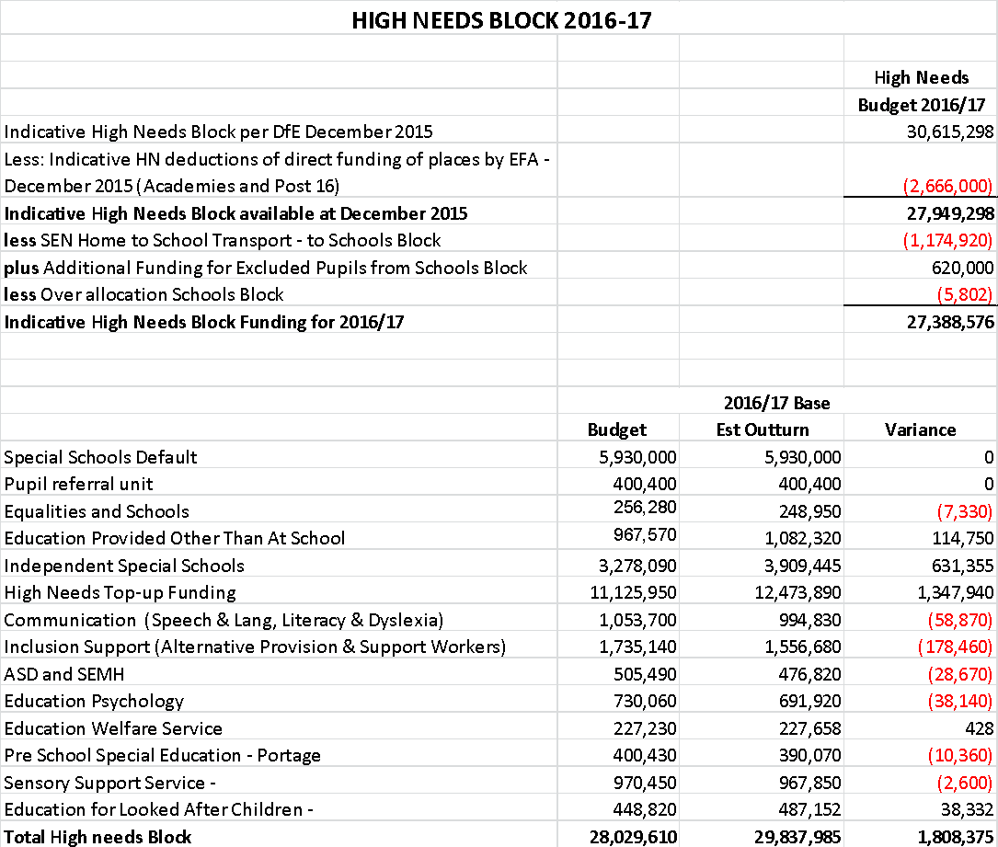

The 2016/17 projected deficit will be reduced by carrying forward the underspend from 2015/16 of £457k and other underspends of £300k. This gives a final projected outturn position of £1,051,375.

The DfE have given us an additional £1.6m in our High Needs allocation for 2017/18.

At its meeting on 18 January 2017, the Forum agreed to set the total for 2017/18 High Needs Block, after allowing for agreed virements to and from the Schools block, at the provisional figure of £27,818,548, subject to any subsequent adjustments from the EFA.

Action has already taken place or is being put in place order to reduce, or prevent altogether, further overspends as detailed below:

- A review of the Equalities and Schools budget is to be undertaken.
- Action has already been taken to make efficiency savings within the Education Provided Other than at School budget. The reason for the increase in this budget for 2016/17 is due to a re-alignment of transport within the budget from Inclusion Support.
- Independent Special Schools – this budget is as accurate as possible given the current predicted placements at April 2017.
- Inclusion Support - the reason for the decrease in this budget is due to a re-alignment of transport within the budget to Education Other than at School.
- ASD/SEMH – this budget has reduced due to efficiency services
- Education Psychology - this budget has reduced due to efficiency savings and the removal of a £30k budget for a Bereavement Service which is provided free of charge by the NHS.
- Education Welfare Service – this budget has increased due to the need to address specific attendance problems identified by Ofsted.
- A review of the Sensory Support budget is to be undertaken
- A review of the Education for Looked After Children is to be undertaken.

The proposed allocation of the £27,822,151, (£27,818,548 plus £3603 vired from the Schools Block) across the various budget heads is shown below.

HIGH NEEDS BLOCK 2017-18
Indicative High Needs Block per DfE December 2016 | 32,229,468
Less: indicative HN deductions of direct funding of places by EFA- Dec 2016 (academies and post 16) | (3,236,000)
Indicative high needs block available at Dec 2016. | 28,993,468
Less SEN home to School Transport - to schools block | (1,174,920)
Plus under allocation from the schools block | 3,603
Indicative High Needs Block Funding 2016/17 | 27,822,151

High Needs Spend | 2017/18 Base |  | 2018/19
 | do nothing option | SLA income 7mths | SLA income full year.
Special School Base budgets | 5,940,000 | 5,940,000 | 5,940,000
PRU | 400,400 | 400,400 | 400,400
Equalities and schools | 204,050 | 204,050 | 204,050
Education provided other than at school | 1,102,250 | 1,102,250 | 1,102,250
Independent special schools | 3,358,800 | 3,358,800 | 3,358,800
High Need Top up funding | 12,468,000 | 12,468,000 | 12,468,000
Communications | 1,039,000 | 1,039,000 | 1,039,000
Inclusion support | 1,479,620 | 1,152,620 | 917,620
ASD & SEMH | 414,750 | 414,750 | 414,750
Education Psychology | 645,170 | 645,170 | 645,170
Education welfare | 331,630 | 331,630 | 331,630
Pre school special education- Portage | 406,400 | 406,400 | 406,400
Sensory support | 985,990 | 985,990 | 985,990
Education for looked after children | 477,450 | 477,450 | 477,450
Total High Need commitment | 29,253,510 | 28,926,510 | 28,691,510
Carried forward 2016/17 2017/18 deficit | 1,051,375 | 1,051,375 | 1,103,587
Less projected SEND SLA Income | 0.00 | (1,052,147) | (1,803,680)
Projected in year expenditure | 30,304,885 | 29,252,411 | 27,991,417
Indicative High Needs Block Funding 2016/17 | (27,822,151) | (27,822,151) | (27,822,151)
High Needs Funding Gap | -2,482,734 | -1,103,587 | (169,266)

The High Needs funding gap at the end of 2017/18 if we do not take any action would result in an in year overspend of £1.4m, with a £2.4m accumulative deficit when the £1.051m from 2016/17 is taken in account. Implementation of the SEND SLA Bundle proposals from September 2017 ie 7/12ths of the financial year, would result in much reduced in year of overspend of £52k with the accumulative deficit of £1.1m for 2017/18.

The full year effect of the implementation of the SEND SLA Bundle income would result in an in year surplus of £934k which would give an accumulative surplus of £169K at the end of 2018/19. The above assumes that both expenditure and high needs funding block remains at 2017/18 funding levels.

Additional funding will be required in future years to enable growth for specialist places at any new proposed special schools or in mainstream. This funding will have to be found from an enhanced high needs block before 2020.

The Schools Forum is recommended to agree these provisional budget allocations.

