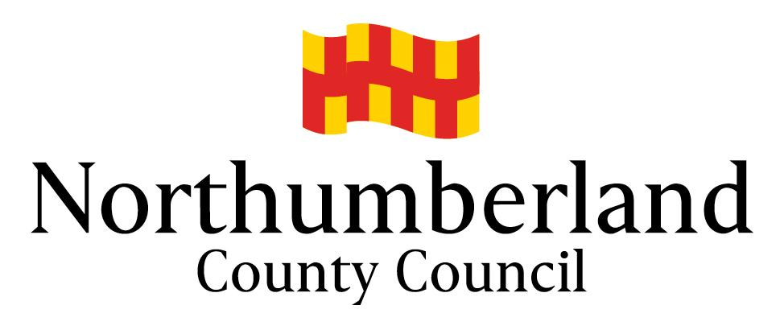
SCHOOLS’ FORUM
21st November 2018
DSG Budget update – October 2018
 | Annual budget before recoupment | Recoupment for acadmies | Current budget after recoupment | Year end forecast
 | £000 | £000 | £000 | £000
Schools Block | 178,010 | (77,445) | 100,565 | (345)
Central Schools Block | 3,289 |  | 3,289 | (56)
High Needs Block | 31,723 | (2,764) | 28,959 | 2,419
Early Years Block | 16,455 |  | 16,455 | (73)
Grant | (229,477) | 80,209 | (149,268) | (37)
Total | 0 | 0 | 0 | 1,908

The allocation of DSG for 2018-19 is £231.6m, of this £80m is deducted at source and passed on to Academies and for the direct funding of High Needs places and a further £2 million is used to meet the deficit brought forward from 2017-18, leaving £149.3 million which is received direct by the council.
Approval was given by the DfE and the Schools Forum to approve a 1% transfer of funding from the Schools block to the High Needs block which amounted to £1.8million and this transfer is included in the figures above.

As at October 2018, there is an overall forecast overspend of £1.9million and this is largely due to the following:

Schools Block
There is a forecast underspend on the schools block of £345k due to:
- Contingency Fund of £475k was created to fund the closing deficit budget across the schools that have closed during 2018-19 (Netherton Northside First School, Acklington First School and Belford St Mary’s Middle School). It is expected that the budget will underspend by around £361k. This is subject to change as the final costs are still coming in for those schools.
- An overspend of £13k is expected on the Behaviour Support team as SLA income has under-achieved by £25k offset by an underspend of £12k on staffing costs.

Central Schools Block
There is a forecast underspend on the central schools block of £56k due largely to:
- A refund of £125k for business rates was received when four schools converted to academy on 1st April 2018 as the rates allocations reduced to 20% for the full year.
- This is offset by an additional payment made to James Calvert Spence College for split site funding of £63k.

High Needs Block
There is a forecast overspend on the high needs block of £2.4 million due largely to:
- Alternative provision for excluded pupils is now expected to overspend by £670k. At the start of the 2017-18 academic year there was 70 permanent exclusions and this has almost doubled to 131 at the beginning of the 18-19 academic year. It is estimated that a further 10 exclusions will take place on average each month and whilst the service can recover funds for any new exclusions, they are unable to do so for the longer term exclusions.
- A forecast overspend of £758k on Independent Special Schools. This is following an increase in placements by 28 over the last academic year to 172 as at September 2018.
- SEN top-ups are currently predicted to overspend by around £930k. The vast majority of top ups are paid to children and young people with Education Health and Care Plan and these numbers have risen by 13.6% from 1679 to 1907 in Northumberland over the last 12 months, compared to 11.3% nationally. Latest national data is for the year to January 2018, but we have seen a continued increase in local Plan numbers since then, the figure currently stands at 2034. The forecast is subject to change and will be revised once the autumn term payments have been made, and final October School Census numbers are available.
Early Years Block
There is a forecast underspend on the early years block of £73k due largely to:
- An underspend on staffing of £18k due to vacant posts that have now been filled.
- Additional income received of £53k.

Grant
There is a forecast underspend on the grant of £37k due to:
- Early Years clawback for funded nursery hours in 2017-18 was less than expected. The additional grant received has not been allocated to a block so that it can be used to contribute to the overall pressures across the grant.

