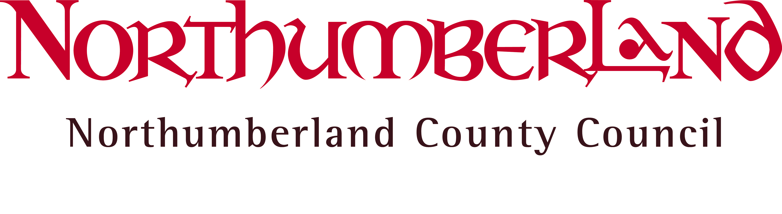

Rt Hon Nicky Morgan MP,  Secretary of State for Education,  House of Commons,  London,  SW1A 0AA | Your Ref:  Our Ref:  Enquiries to:  Direct Line:  E-mail:  Date: | LP  Mrs L Papaioannou, Clerk to Schools Forum  (01670) 622615  Linda.Papaioannou@northumberland.gov.uk  6 June 2016

Dear Nicky Morgan,

Inadequacy of Early Years Funding within Northumberland

Northumberland Schools’ Forum has asked me to contact you about the inadequacy of Early Years Funding within the County.

The matter has been raised with Forum by our Private, Voluntary and Independent (PVI) early years education providers but applies also to early years provision attached to schools. The problem has escalated with the increase from 15 to 30 hours in the free provision offer to some disadvantaged children and increases in minimum wage levels.

PVI providers are finding that their funding is not adequate to meet their basic costs; they report having to subsidise the free offer by raising charges for paying users, some of whom will be very close to qualifying for free provision for their own children.

Progress to National Funding Formulae offer some hope to us as a poorly funded Local Authority. Our Early Years providers are particularly concerned that there is further delay in working towards an Early Years National Funding Formula and that many of them will have been driven out of business before fair funding is offered. If this happens it may have a disproportionate impact in a rural county trying to maintain a sustainable rural population.

We would welcome your views on the timescale for developing an Early Years Formula and how the finances should be managed in the interim.

Yours sincerely,

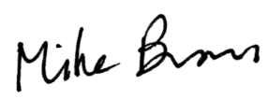

Mr J M Brown, Chairman, Northumberland Schools’ Forum

Copy to: Northumberland Schools’ Forum

