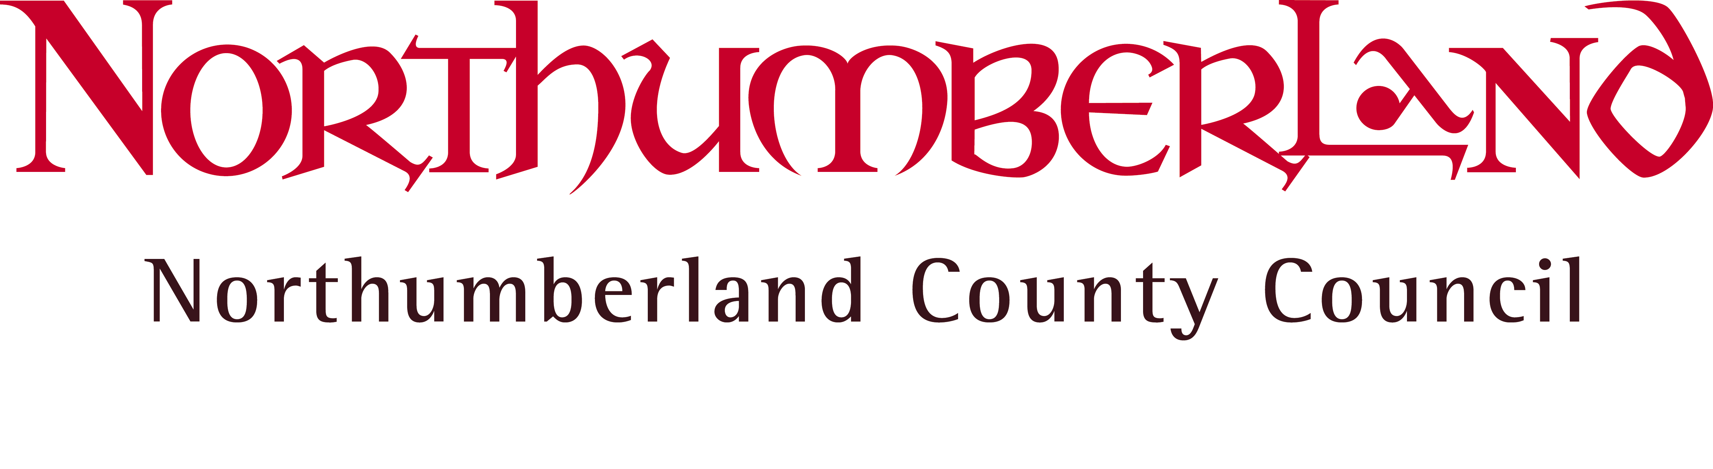

 | Your Ref:  Our Ref:  Enquiries to:  Direct Line:  E-mail:  Date: | LP  Mrs. L. Papaioannou  (01670) 622615  Linda.Papaioannou@northumberland.gov.uk  12 October 2015

Dear Sir or Madam,

A meeting of the SCHOOLS FORUM will be held in Committee Room 1, County Hall, Morpeth on Wednesday, 21 October 2015 at 9.30 a.m.

Refreshments will be available before the meeting.

Can I please stress the importance of attendance to enable decisions to be taken. May I remind you that if you are unable to attend, you are able to arrange for an appropriate substitute to attend on your behalf. For Headteachers, an appropriate substitute would be another Headteacher from the same phase. Likewise, for Governors, an appropriate substitute would be another Governor from the same phase.

Yours faithfully,

Linda Papaioannou
Clerk to the Forum

To the members of the Schools Forum

Copy to Mrs. D. Lally, Executive Director of Wellbeing and Community Health Services and Dr. A. Johnson, Director of Education and Skills

AGENDA

It is expected that the matters included in this part of the agenda
will be dealt with in public.

 |  | Decision/ Consultation/ Information
1. | APOLOGIES FOR ABSENCE
2. | DISCLOSURE OF INTERESTS
3. | MINUTES  Minutes of the meeting of the Schools Forum held on Wednesday 16 September 2015, as circulated, to be confirmed as a true record, and signed by the Chairman. | Decision
4. | MATTERS ARISING FROM THE MINUTES
5. | COMMUNICATION  a) Communication with Schools Forum  (b) Draft Minutes from the following Committee meetings:  - Formula Funding Committee – (no meeting held)  - Additional Needs Committee – 14 October 2015 (to be tabled) | Information  Decision
6. | SCHOOLS FORUM MISSION STATEMENT DOCUMENT  To consider the report from the Director of Education and Skills (copy attached), including:  - Current Membership of Schools Forum  - Current Membership of Committees  - Proposed Revised Terms of Reference | Information  Decision
7. | FINALISATION OF FORMULA FUNDING FOR 2016/17 AND OUTCOME OF CONSULTATION  To receive a verbal update on the report presented to Cabinet on 13 October 2015 in respect of the outcome of the school and early years funding for 2016/17. | Information
8. | EOTAS FUNDING FOR ALTERNATIVE PROVISION  To consider the report from the Director of Education and Skills (copy attached). | Information Decision
9. | SCHOOL BALANCES 2014/15  - To receive a verbal report from the Formula Funding Committee about possible clawback of school’s balances and to agree a way forward.  - To consider the report (copy attached) in respect of balances carried forward from 2014/15 into 2015/16. | Decision  Information
10. | DSG BUDGET 2015/16  To receive the DSG budget monitoring statement for August 2015. | Information
11. | URGENT BUSINESS (IF ANY)  To consider such other business as, in the opinion of the Chairman, should, by reason of special circumstances, be considered as a matter of urgency.
12. | DATE OF NEXT MEETING  The next meeting of the Schools Forum was previously agreed to be held on Thursday 14 January 2015 at 9.30 a.m. in the Council Chamber, County Hall, Morpeth.

Meetings for the remainder of the school year are:
- Tuesday, 23 February 2016 at 9.30 a.m. in the Council Chamber
- Wednesday, 18 May 2016 at 9.30 a.m. in CR1
- Wednesday, 6 July 2016 at 9.30 a.m. in CR1

