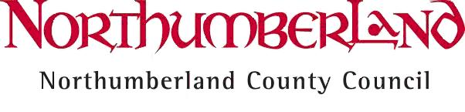
Education and Skills

SCHOOLS FORUM

14 January 2016

Outcome of Consultation on Changes to the Scheme for Financing Schools in Respect of Admission Appeals from April 2016

INTRODUCTION

In November 2015 the Department for Education consulted on a proposal to make a change to section 6.3 of the Scheme for Financing Schools Statutory guidance, to include admission appeals as one of the services for which a local authority can charge maintained school budgets for administering admission appeals, where the authority has included the funding for admission appeals in schools budget allocations. A consultation paper on this proposed change was issued to all schools on 1 December 2015 with responses required by 5 January 2016.

CONTEXT

Paragraph 1.14 of the School Admission Appeals Code states that: “Local authorities must allocate reasonable funds to governing bodies of maintained schools which are admission authorities to meet admission appeals costs.”

Therefore, local authorities currently have a duty to support maintained schools (Voluntary Aided, Foundation and Trust schools) which are admission authorities. This is in addition to authorities’ responsibilities where they as act as the admissions authority for maintained Community and Voluntary Controlled schools.

However, the 2013 to 2014 funding reforms removed the ability of local authorities to specifically allocate funding for own admissions authority schools and ended the separate grant paid to academies for admissions. The reforms also restricted local authorities’ ability to increase the amount of budget retained centrally for admissions, to ensure that as much money as possible was allocated to schools.

PROPOSED CHANGE FROM APRIL 2016

For schools for which the local authority is the admission authority, and for which the authority therefore must provide an appeals service, the additional flexibility the Scheme for Financing schools will allow local authorities to use their powers under the Financial Management Scheme to charge those schools. All other schools and academies would be responsible for their own admission appeals, with funding for this function included in their delegated budgets. No separate funding will be available to help cover the costs of providing this service. The local authority already offers a traded service, and schools and academies which are their own admissions authorities are free to decide whether to use it individually.

CONSULTATION RESPONSE

There was only one response to the local authority consultation from a first school. They did not agree with the principle of the proposed change unless there was specific identifiable funding against which to offset the charge. The expressed the opinion that any detriment to schools budgets by levying admission appeals charges would increase the incentive for schools to seek Academy status and be in control of their own admission procedures.

The DfE published the response to its consultation on 17 December. They received 49 responses to the consultation – 41% agreed with the change, 41% did not agree to the change and 5% were unsure. Those that agreed thought the change sensible and would ensure fair and equitable treatment between all types of schools. The DfE therefore intends to agree the proposed change to the Scheme for Financing Schools Statutory guidance to provide an alternative option and more flexibility for local authorities.

Therefore the County Council propose to implement the change from 1 April 2016 by adding the following text as item (u) to the end of paragraph 6.3 of the current Financing of Schools Scheme:

(u) Costs incurred by the authority in administering admissions appeals, where the local authority is the admissions authority and the funding for admission appeals has been delegated to all schools as part of their formula allocation.

