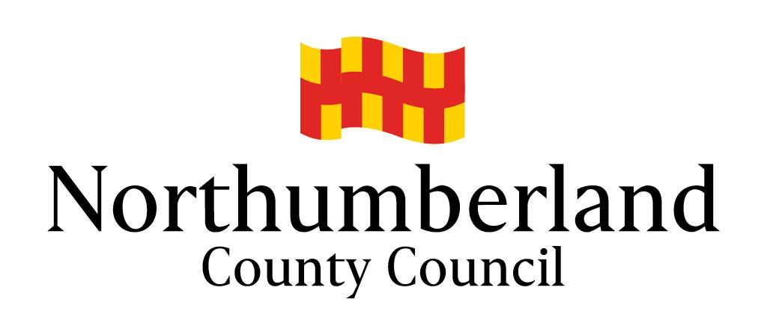

BECOMING A LOCAL COUNCILLOR

A guide about membership of community, parish and town councils in Northumberland

ELECTIONS OFFICE
UPDATED OCTOBER 2020

In this document, “local” and “local councillor” include community, parish and town councils, together with their councillors.

DESCRIPTION OF THE ROLE OF A LOCAL COUNCILLOR

Role | Local Councillor
Responsible to | All people resident within the parish, parish ward or town
Regular liaison with | Other councillors, County Council, residents
Period of service | 4 years before re-election
Salary | This is a voluntary position with some expenses able to be paid in certain circumstances

Main purpose:
- Representing the views of all residents within your parish, and parish ward.

Secondary purpose:
- As part of a local council you will have responsibility for running local services which may include open spaces, play areas, village halls, community car schemes and potentially much more, depending very much on individual local councils.
- Deciding on how much to raise through the council tax in order to deliver your council’s services.
- Influencing and shaping the long term development policy for the parish, and as part of the planning process, comment on planning applications in the parish.
- Improve the quality of life and the environment in the local area.
- Working to identify issues which are important to the lives of the residents you represent.
- Working to bring about improvements through local projects, lobbying other service providers and working in partnership with other parishes and agencies.

- What is a local council?
A local council is a local authority that makes decisions on behalf of the people in the community. There are local councils in most parts of Northumberland, although in some isolated areas no local council has been elected for some years. They are the most local level of local government, with Northumberland County Council above it in the hierarchy.

- The role of local councils
Local councils have limited powers to make decisions but they do have the ability to negotiate with, and the power to influence those other local organisations that do make the final decisions (such as the county council, health authority and police). In this respect local councils are extremely powerful. The organisations that make the final decisions know that a local council gives the best reflection of how a community feels about something and its views will be taken seriously.

Local councils must act within the law and must abide by a Code of Conduct which requires them to act impartially and fairly which does not bring the council into disrepute.

Councillors must disclose certain information about themselves, such as the address of any land holdings within the parish, their membership of any political parties or trade unions and the name of their employer for example.

- How much time does it take up?
Councils usually meet once a month, others only every 2 or 3 months for the council meeting to which members of the public are also invited. Meetings tend to be on weekday evenings and may last two or three hours, depending on what’s on the list of items to discuss. Some councils may also have sub-committees to deal with specific subjects, such as planning matters.

In addition to the regular meetings, councillors should be prepared to give time for ‘ad hoc’ meetings, for example with architects or agents to discuss planning applications that the council must give its opinions on.

- Do I get paid to be a local councillor?
Councillors are not paid for their work, but councils can choose to reimburse expenses such as telephone calls and postage.

- How long does a local councillor serve for?
Once elected, local councillors sit on the council for a maximum of four years. If they then want to stay in the post they can stand for re-election. This does not mean that you have to stay for four years. If you find it is not for you, or you can no longer meet the commitment, you can stand down.

- Becoming a local councillor
To become a local councillor, you are either elected or co-opted:

The ordinary elections of councillors (when all of the parish or town seats become vacant) in Northumberland are organised by the Returning Officer of the County Council and take place on the first Thursday in May every four years – 2013, 2017, 2021, 2025 etc. To stand for election you must be nominated by completing a nomination paper, supported by a proposer and a seconder. If there are more candidates than seats available, the election will proceed to a poll, if not, the Returning Officer may declare the candidates as duly elected unopposed.

If a seat becomes vacant (a casual vacancy) during the 4 year cycle, the council will either hold a by-election or co-opt members to the council.

- Am I eligible to be a local councillor?
To be qualified to be elected a member of a local council, you must be 18 years of age or over, and a Commonwealth citizen, a citizen of the Republic of Ireland or a citizen of another Member State of the European Community and either:
- be a registered local government elector for the area of the parish/town;
- for the whole of the previous 12 months have occupied as owner or tenant any land or other premises in the parish/town; or
- have your principal or only place of work for the whole of the previous 12 months in the parish/town;
- have resided in the parish/town or within 3 miles thereof during the whole of the previous 12 months.

- Training
Training for councillors may be available from (NALC) Northumberland Association of Local Councils, who represents the vast majority of local councils in Northumberland.

- Are you interested in becoming a local councillor?
The best way to find out what it is like to be a local councillor is to talk to someone who’s doing it now. Go along to a local council meeting and speak to one of the councillors and find out what they think of the job. With covid-19, nearly all local councils are using digital meetings. Contact the clerk of your local council to ask about observing one Use the website for your local council, you might be able to get the names and contact details of the current councillors, and the dates of their meetings.

Alternatively, for contact details and information on the work of local councils, visit the Northumberland Association of Local Councils – northumberlandalc.uk and click on the name of the parish you are interested in. Additional information on becoming a councillor can be found at the National Association of Local Councils – nalc.gov.uk

