HOW TO GUIDE… Using 3rd Party registration

Go to ncc.learningpool.com using Google Chrome. If you do not have the Google Chrome search engine, please install this to continue.
Click on ‘Create account (External users only)’.

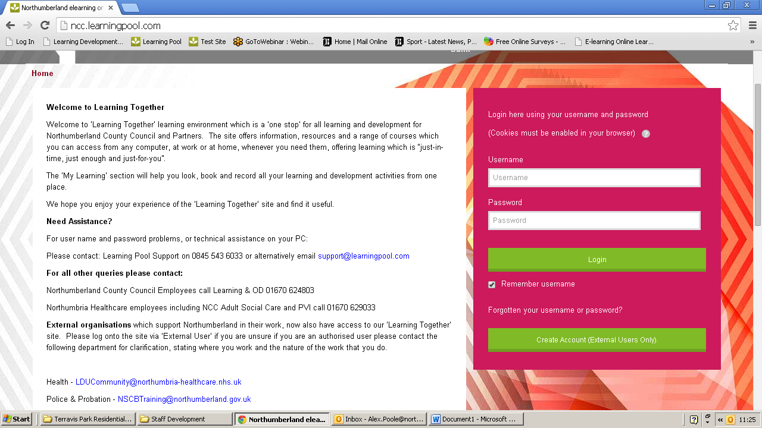

Boxes highlighted with a red astrix (*) are mandatory and must be completed.

Your username is your email address. If you do not have an email address, then you will need to create one.
Create your password; follow the instructions as to what your password needs to be made up of.
Complete the following fields: Email address, Email (again), First name, Surname, City/town and Country.
Select the ‘choose position’ tab.

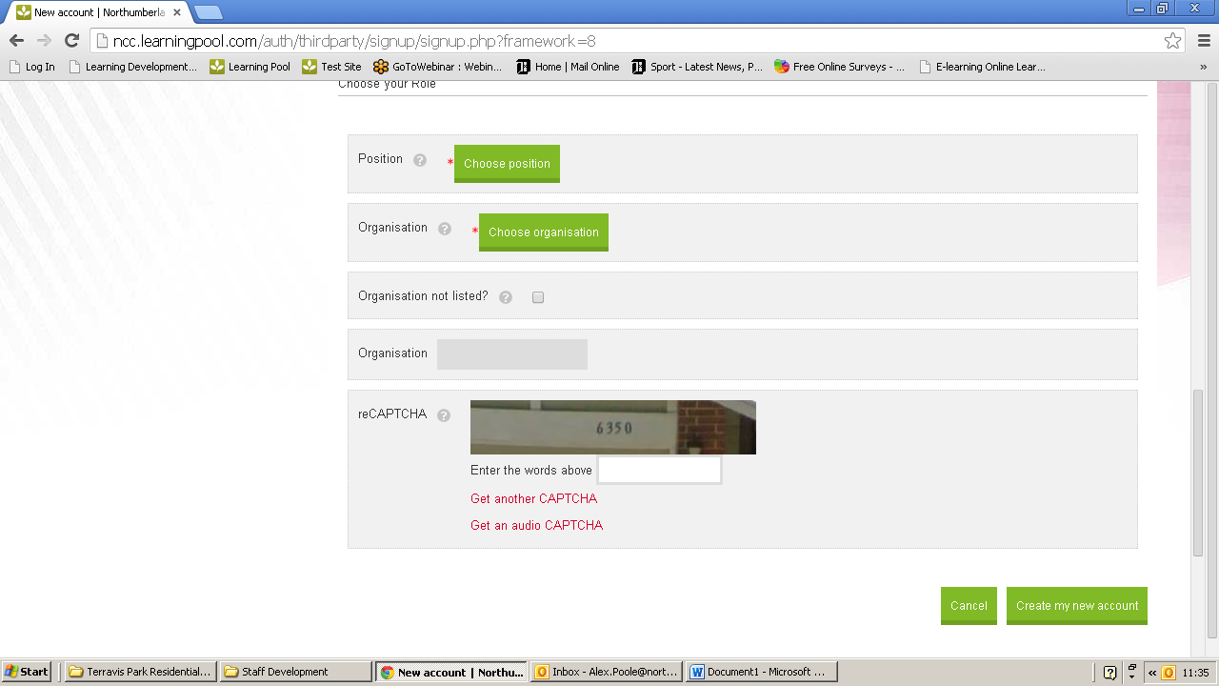

Expand the Social Care option by clicking on the + sign. Find and Select your position then click Ok.

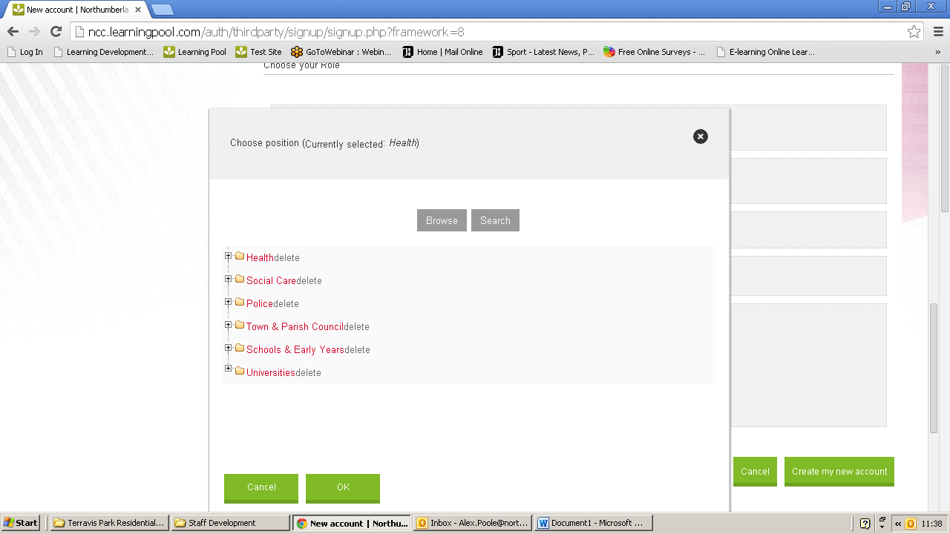

Click on organisation. Expand the ‘PVI – Social Care’ header by clicking on the + sign and locate and select your organisation. Make sure you click the plus button all the way to finding your organisation, which is when you will click the name itself.
If your organisation is not listed, click cancel and tick the ‘organisation not listed’ check box and type your organisation into the field.

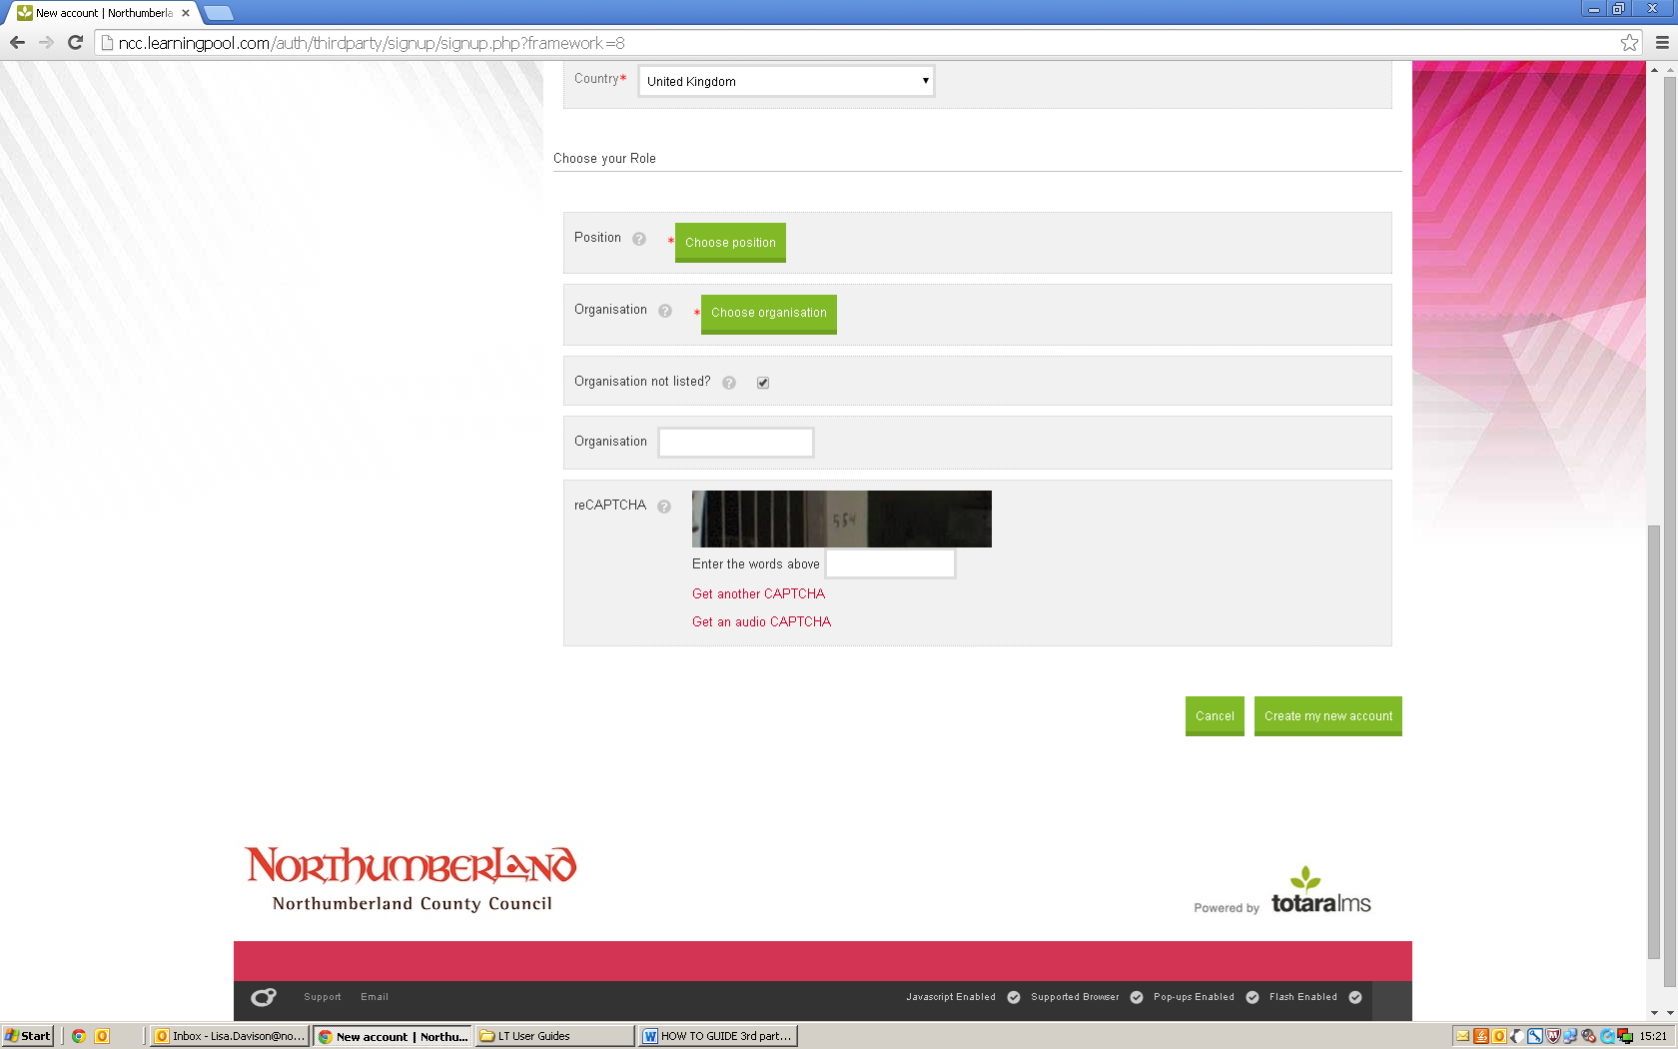

Complete the reCAPTCHA section by entering the code in the picture in the ‘Enter the words above’ box. Once you have completed this, click on the ‘create new user’ field.
As instructed on the next screen, please log in to your email and follow the link to complete your registration.

