Understanding the impact of COVID-19 on children, young people and their families with SEND in Northumberland

September 2020

Ju

Survey findings

Introduction

The survey and this report have been co-produced with the Northumberland Parent Carer Forum. The results will be used to:
- increase our understanding of what happened to families and their children during lockdown in Northumberland and,
- inform planning of what needs to happen moving forward, both now during the Autumn Term in 2020 and looking forward to the future.

This survey is based on the work carried out by the Disabled Children’s Partnership and their report ‘Left in Lockdown’ which looked at the impact of the coronavirus and lockdown on families with disabled children across the UK.

The survey was live between 6th July and the 14th August 2020 and was promoted through social media channels, direct contact with SEND groups within Northumberland, Northumberland Parent Carer Forum and professionals across education, health and social care. The survey covered the following areas:

- About you
- Health and wellbeing of your family
- Health and wellbeing of your child / children with SEND
- Health and social care support
- Education and learning
- Money and work
- What three things would you like to see happen now in Northumberland to support children and young people with SEND?

We would like to thank the parents and carers who took the time to carry out this survey. Thank you.

Summary of findings

What the survey found
Lockdown impacted negatively on the mental health and wellbeing of most parents and carers as well as that of their children with SEND. Over a third of families reported having to decrease their spending in order to manage and a quarter reported struggling financially.

Home-schooling was difficult for many families, particularly when combined with working from home. The nature of their child’s needs, a lack of routine, the number of children and adults in the household and the support the family received from school impacted significantly on a family’s ability to home school. The majority of children in this report did not attend school during the period of the survey. A small number of children did not receive any schooling at home and their physical and mental health became worse. Conversely, some children thrived away from the pressures of school.

For some families, school provided good support to families around their learning and support for their wellbeing. For others, parents reported a lack of communication and support, and work being sent home that their child found difficult to do.

Just over half of children and young people with SEND continued to receive more or the same level of health and social care support as before lockdown, while others reported they received less or no support. A quarter of children and young people reported their assessments went ahead, while for the remainder it was delayed or cancelled. Two thirds of children and young people undergoing an education assessment to determine if they needed additional support reported the communication was not enough.

Families remain worried and anxious about their children returning to school and how they will catch up on their learning, reintegrate back into school, manage social interactions, cope with transitions and stay safe from coronavirus.

Looking to the future, families wished for more staffing, training and funding for schools, increase support for mental health and plans for how their children will catch up on any missed learning. Families wanted improved communication with their schools, extra activities available for weekends and holidays and more advice and support if their child needed help at school.

Who completed the survey?
- 426 replies were received (highest return for any SEND survey carried out in Northumberland)
- 91% of the survey was completed by Mums
- ASD, Social emotional and mental health and learning disability were the most common difficulties of children

Health and Wellbeing of families
Overall, the impact of lockdown;
- negatively affected respondent’s mental health more than their physical health,
- positively affected partners physical health and had a mixed impact on mental health,
- negatively affected the mental health of non-disabled children and had a more positive impact on physical health.
Family and friends were the most common source of support, with school / college and mental health professionals coming second and third.

Top things that respondents found the hardest in lockdown were;
- Work and / or home-schooling
- Mental health becoming worse
- Lack of structure / routine
- Missing family / friends

Top things respondents found positive in lockdown were;
- Increased family time
- More time outdoors
- Less stress and pressure
Health and Wellbeing of children with SEND
Overall, the impact of lockdown had a negative impact on the mental health of children and young people with SEND and a more positive impact on physical health.

Top things reported that children and young people with SEND found hard during lockdown;
- Missing family & friends
- Lack of structure and routine
- Mental health decreased for some
- Not being able to go outside

Top things reported that children and young people with SEND found positive during lockdown;
- Family time
- Not going to school
- Less stress and pressure
- Mental health improved for some

Health and social care support
- 63% of children were receiving therapies or extra support from NCC, the NHS or school,
- of these, 57% received more or the same level of support while 41% received less or no support.

Top three impacts identified by those who were having support;
- Services were paused or reduced
- Missed access to specific services
- Provided support themselves
- Some treatments were delayed

41% of families needed to seek medical help during lockdown for their child with SEND (most), themselves or their partner (second most) or their non-disabled child (least).

For those waiting for a health or social care assessment;
- 45% had their assessment delayed
- 12% had their assessment cancelled
- assessment went ahead for 24%

Education and Learning
Level of support received;
- 40% had an EHCP
- 33% received support at SEN Support
- 20% reported they were not yet receiving any support at school

Where children attended school usually;
- 66% attended mainstream school
- 21% attended special school
- 6% attended Early Years

For children going through an assessment for additional support with learning, the communication was not enough for 66% and just right for 27%.

During lockdown;
- 79% of children and young people stayed at home
- 14% attended part time
- 6% attended full time
- 41% of respondents were key workers

Most common reasons, from most to least for staying at home;
- 34% had concern about their child’s health at school or because someone in the house was shielding
- 25% felt that school was unable to provide suitable provision
- 20% reported their children wanted to stay at home
- 18% reported their school had formally advised their child not to attend
- 2% reported their school had formally carried out a risk assessment which detailed their child should not attend
The percentage of children and young people who wanted to stay at home increased with age. The percentage of families who reported that school were not able to make suitable provision decreased with age.

Support received from school for those who were home schooled (most to least);
- 32% felt support offered was not relevant to their child’s needs
- 29% felt they had received good support for their child’s needs
- 24% received some specific home learning support but would have liked more
- 15% received specific home learning support

Amount of home-schooling families reported they were able to offer;
- 47% reported not enough
- 30% felt it was the right amount
- 11% were unable to home school at all
- 5% felt they did too much
- 12% did not respond

Top three feelings of those who filled in the survey about returning to school;
- Felt confident / positive about returning to school
- Had general worry and anxiety about it
- Were worried about their child’s health and safety

A mix of families reported receiving positive support from their child’s school while others reported infrequent contact and / or support from school.

Money and Work
For the majority of families, household income remained the same, though 38% of families experienced a decrease in income. For those receiving benefits, they stayed the same for the majority of families though a few increased or decreased.

126 families reported that an adult in the household had been furloughed, 11 had become unemployed and 7 had been made redundant during lockdown.

Families reported;
- 39% had decreased their spending
- 27% struggled financially
- 17% reported lockdown had impacted on their food shopping

Thinking about the future
Most common areas with 10 or more responses for the things that families feel need to happen now;
- Extra staffing, resources, support and funding for schools (49)
- Increase support for mental health, anxiety needs etc in schools, provide counselling services in schools (29)
- Children to have a plan with support about how to catch up (28)
- Better, frequent communication about what is happening in school (17)
- More training to mainstream staff and SENCo’s around SEND (15)
- Extra activities for the holidays, weekends available locally (12)
- More support and advice available for parents about the SEND system and what support is available (11)

Appendix

Detailed analysis of findings

Detailed analysis of findings

About You
We received 426 replies to the survey which is the largest response there has been to any survey around Special Educational Needs and Disability in Northumberland.

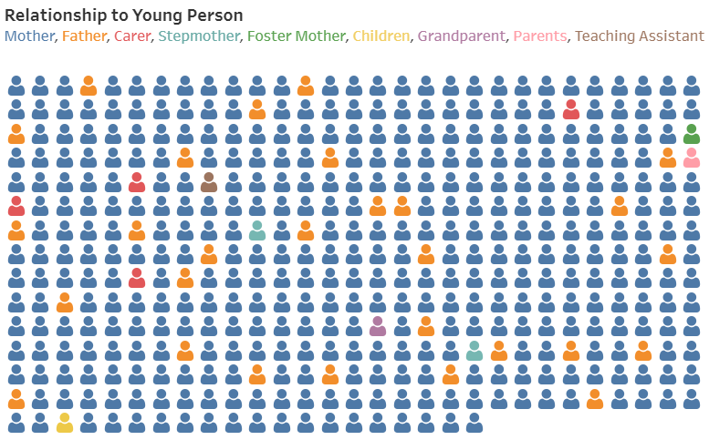

Mothers completed the survey 91%, with fathers the second highest at 6%.
73% came from two parent households and 24% were from single parent households.

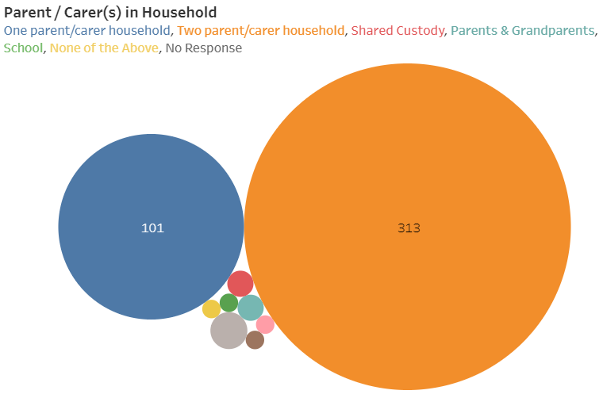
Respondents were asked to provide the first four letters of their postcode to enable an understanding of where respondents lived.

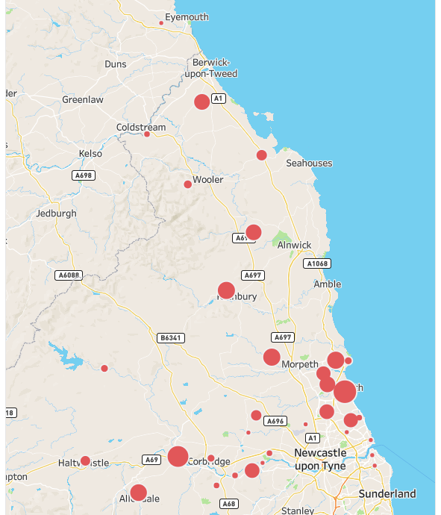
Of those that provided this information, the postcodes with more than 10 respondents were as follows

Postcode | Number of respondents | NB those with postcodes outside of the county attended schools in Northumberland
NE24 | 33
NE46 | 28
NE61 | 19
NE63 | 19
NE65 | 19
NE47 | 18
NE22 | 16
NE66 | 16
TD15 | 15
NE23 | 15
NE42 | 14
NE25 | 13
NE62 | 13

11-15 year olds were the largest age group of children with SEND within households with 19+years of age being the smallest group, with 12 respondents.

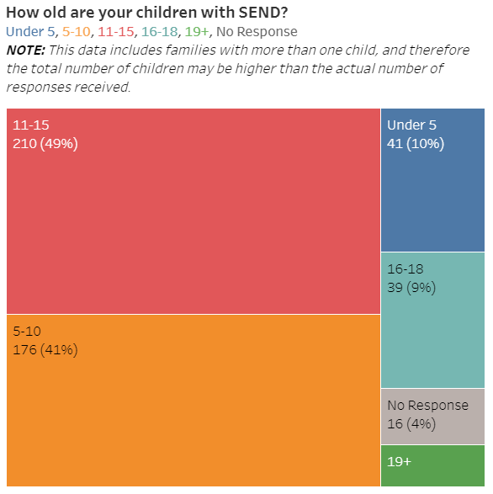 | No of C&YP in the household | With SEND | Non-disabled children in the household
 | 0 | - | 141
 | 1 | 289 | 155
 | 2 | 77 | 74
 | 3 | 9 | 20
 | 4+ | 5 | 7
 | No response | 36 | 29
(ACTION : Check tableau as %
don’t add up to 100)

Autism was the most prevalent need of children and young people with SEND completing this survey, with social, emotional and mental health needs being the second, followed by learning disability.

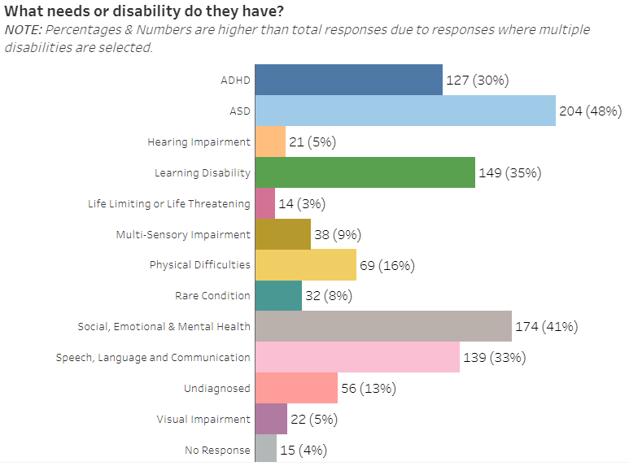
Health and Wellbeing of your family

Respondents
Respondents completing the survey were asked about their physical and mental health. Overall, the impact of lockdown negatively affected respondents mental health more than physical health. Of those that replied
- 38% reported their mental health stayed the same or improved
- 62% described their mental health as becoming a little / a lot worse
For physical health, of those that replied
- 58% reported their physical health stayed the same or improved
- 42% described their physical health as becoming a little / a lot worse

Respondents reported mental and physical health during lockdown
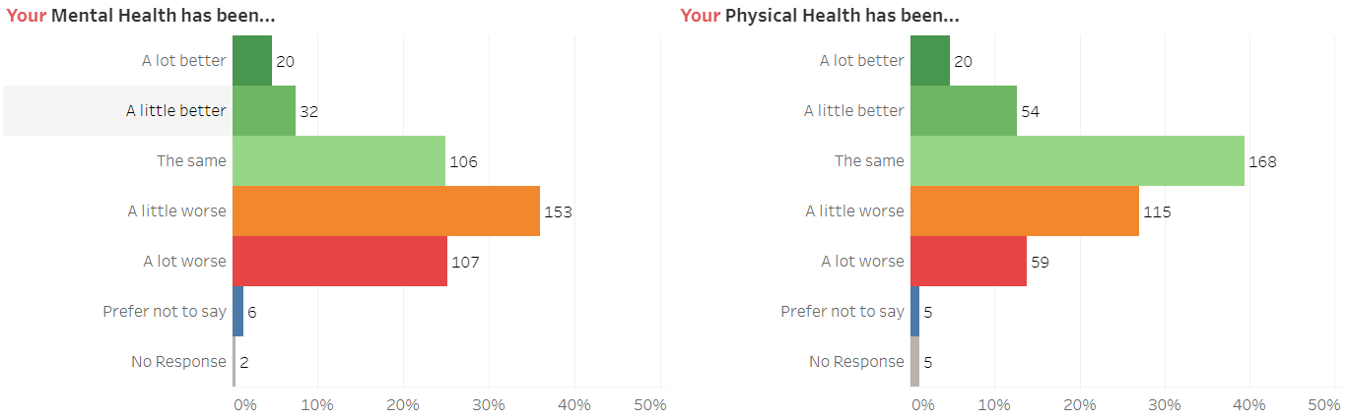

Respondents partners
Overall, the impact of lockdown had a positive impact on partners physical health and a mixed impact on mental health. Of those that replied
- 52% reported their partners mental health stayed the same or improved
- 48% described their mental health as becoming a little / a lot worse
For physical health, of those that replied
- 69% reported their partners physical health stayed the same or improved
- 31% described their partners physical health as becoming a little / a lot worse

Partners reported mental and physical health during lockdown
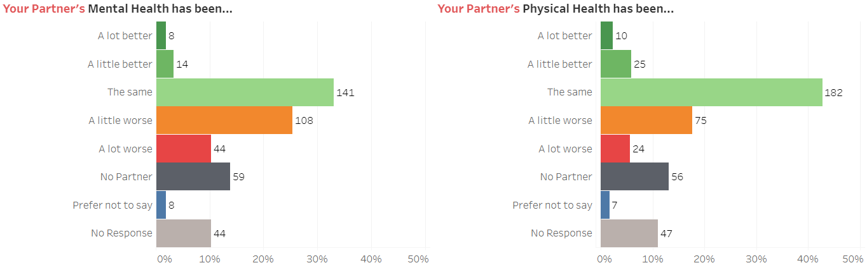

Non-disabled children
Overall, the impact of lockdown had a negative impact on the mental health of non-disabled children and a more positive impact on physical health. Of those that replied
- 42% reported their child / children with SEND’s mental health stayed the same or improved
- 58% described their mental health as becoming a little / a lot worse
For physical health, of those that replied
- 65% reported their partners physical health stayed the same or improved
- 35% described their partners physical health as becoming a little / a lot worse

Non-disabled children reported mental and physical health
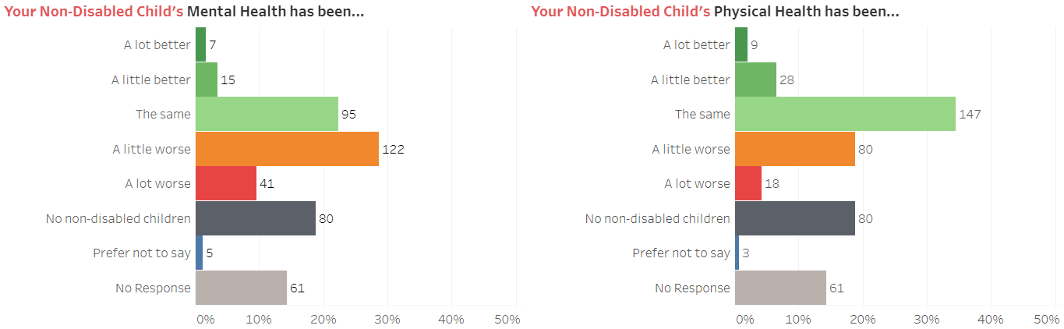

Seeking help
Respondents were asked where they sought help for health and wellbeing.

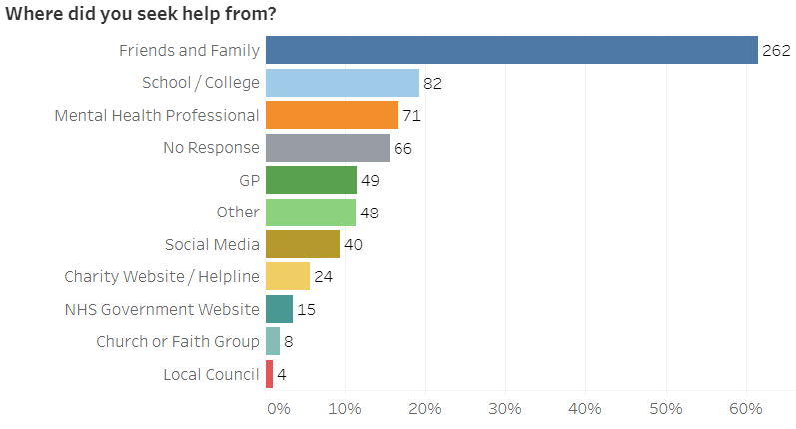
Family and friends was the most common source of support, with school / college and mental health professionals coming second and third.

Of the 48 respondents who selected ‘Other’, the following sources of support were provided, some respondents named multiple sources.

Support | Number of responses
Health professionals | Health Visitor (4) School Nurse (3)  Occupational Therapist (1) CYPS (5)  Physiotherapist (1) Crisis Team (1)  Adult mental health (1)
Private and voluntary support agencies | Calmer Therapy (2) Other parents (1)
Self help | Headspace app (1) Meditation app (1)  Books, audiobooks (1) Bike rides (1)
Online | Websites (1) Thrive (1)
Social care | Teen parenting course (1) Social Worker (2)  Hub Team (1)
Northumberland | 15 responses stated ‘Northumberland’ however it is not clear what service / support is meant
Elected members | Councillor (1)
Early years / School | Nursery (1) Sure Start (1)  SEN School Support Worker (1) School (2)
None | Did not seek help / need to seek help (25)  No help available (2)

“we’ve just muddled through together”

“we’ve managed the ups and downs between ourselves”

What have you found the hardest during lockdown? (407 replies)

Top three themes (% of 407 replies)
- Work and / or home schooling - 35%
- Lack of structure / routine – 14%
- Missing family / friends – 13%

Home-schooling was mentioned in a third of the responses with different aspects of home-schooling challenging for different families. 49 respondents shared that juggling working from home, and home schooling their children was difficult. 36 found home-schooling in itself hard, while 16 respondents cited the difficulties in home schooling more than one child with different ages and ability. Other difficulties encountered were keeping children entertained and occupied (13), motivating children to do school work (14), their child refusing to complete the work (8), accessing childcare (10) and the worry they had as parents and carers that their child might be falling behind in their school work (7). Many other challenges were noted that were particular to family circumstances or individual needs of children.

“trying to care for my children’s educational needs and well-being whilst simultaneously trying to fulfil my commitments at work has left me feeling overwhelmed and defeated”

“My son is feeling like the only time I have for him is to do schoolwork. If for any reason we can’t get through the work set (we ran out of printer paper this week) he gets anxious”

“Home schooling as my sons ability is poor and has a support assistant in with him in lessons. He didn’t like our way of teaching which ending up in melt downs and angry outburst. Every day was a battle to get any work done.”

A number of respondents (16) felt that the support offered by school did not meet their children’s learning needs or was too infrequent. Two parents cited the closure of their child’s special school as causing significant distress and upset to their family while one NHS worker whose child had an EHCP reported requesting a school place for their children and feeling ‘utterly let down’ when this was not offered. 3 parents described not having access to appropriate IT to be able to access or complete the homework on.

“The children have not been provided with much work from their school who basically said to enjoy spending time with them and do things like baking and gardening.”

“I feel very let down by the school, nobody rang to see how my son was coping for eight weeks, if we had been really struggling, I think contact and guidance from the school would have really helped.”

“Online learning has not really been differentiated so it has been tricky to complete some of the written tasks and keep motivation high when some of the tasks have been a bit beyond his capabilities.”

The restrictions about being able to leave the house, particularly at the beginning of lockdown was described by 27 respondents as having a negative impact on the physical and mental wellbeing of families and their children. 16 families described being stuck in the house and being overcrowded leading to family stress and others cited increased fighting between siblings.

“Nothing to keep children entertained, no parks, soft plays or swimming areas open.”

“Being stuck at home with nowhere to go, we don't have a garden so being inside was very difficult.”

“Having all the children in the house together as the house is very overcrowded”

58 respondents described a lack of, or a change to structure and routine as being one of the hardest things to manage during lockdown.

“lack of routine making children’s behaviours and sleeping patterns worse”

“the constant meltdowns as his routine is all wrong”

“trying to keep a routine going and get the children to do schoolwork”

54 respondents missed family and friends, with many describing missing hugs with family members, missing support they provided to the family (particularly from grandparents) and missing socialising with other people. 22 people described feeling alone and isolated as a result.

“not being able to see my parents and family”

“missing family support”

“feeling lost. Not part of society”

“Lack of social interaction with peers/family members also the feeling of being alone and isolation.”

Caring responsibilities and the impact that this had on parents was described by 36 families, with an additional 20 families describing a general lack of support. Some had children whose needs require full time care and supervision and described the impact this had on adult’s wellbeing. Some parents had their own physical or mental health issues to manage while caring for their children or had caring responsibilities with their own parents.

“Caring became 24/7 role requiring immense physical stamina and patience from parents - with no respite/break”

“Our relationship really suffered because we were carers 24/7 and we did not have the chance to rest.”

“The relentless of everyday and the removal of respite opportunities.”

14 families found shopping difficult, either trying to do this online or because of the difficulties with childcare and having to take their child with special educational needs with them. At the beginning of lockdown many supermarkets had policies of only allowing one person to shop at a time, which several respondents found hard with a child with a hidden disability and an absence of childcare. Others worried about their child’s lack of understanding of what was happening and the change in ‘rules’ around an everyday activity. 7 respondents reported money worries.

“Not being able to take my child to a shop etc due to not understanding restrictions and other peoples reactions.”

“I’ve had to take my SEN son with me as he needs 24/7 supervision therefore it’s been so challenging around shops, dealing with meltdowns, he runs therefore social distancing has been so stressful”

28 respondents shared their child’s behaviour had become worse with 18 sharing their child’s mental health had become worse. 9 families reported their child would not leave their house and, in a few cases,, leave their bedroom. 11 families found managing family anxiety about the coronavirus and 4 reported worries about family members who were shielding or being concerned for their child’s health. The role of social media and the constant reporting about the coronavirus, particularly at the beginning was reported as causing anxiety for 5 families, alongside families worrying their children were spending an increasing amount of time on screens (4). 7 respondents reported that medical / therapy appointments for members of their family or themselves had been cancelled and that their own mental health had become worse (7).
“The lack of professional help medically. Telephone app are ok but they do not allow them to see the child and the effects things have been”

“My daughter has pulled most of her hair out which is very worrying but could not get her the help she needed as some services were suspended.”

“His behaviour has deteriorated from attending a mainstream school and obtaining some good GCSEs next year, to throwing destructive temper tantrums that have really scared me and refusing to study”

“He has become increasingly aggressive, abusive and controlling.”

20 families described that their children with SEND did not understand what was happening and why the rules of society had changed, struggling for example, to explain why children could not see grandparents and what social distancing was. 11 respondents reported that their children missed seeing their friends, while some reported their child was happier in lockdown, with the pressures they experience of attending school taken away. 17 families described the impact on sleep patterns, either their own sleep or their children.

“I can’t always get her to do schoolwork and she misses her friends so much and being at school”

“The lack of respite during the day when they have very frequent bad nights has been mentally draining. Lack of sleep and then full days has been a huge problem.”

“He has very challenging behaviour and its draining. He’s a rubbish sleeper and we would spend the time he was at school catching up on missed sleep. we can no longer do that and its exhausting”

Significant family events were described by 9 families which included divorce, losing a job, birth, loss of a loved one, cancer diagnosis, their parent being admitted to hospital and domestic abuse.

9 respondents cited the positive side to being in lockdown such as enjoying more family time, receiving good support from school while 5 reported not experiencing any difficulties during this time.

What have you found positive during lockdown? (390 replies)

Top three themes (% of 390 replies)
- Increased family time - 49%
- More time outdoors – 9%
- Less stress and pressure – 8%

Just under half of replies (191) reported having increased family time was positive, with 24 stating that it had helped improve bonding and strengthen family and / or sibling relationships. Some replies gave specific examples of activities they had enjoyed – gardening (9), baking / cooking (11) and eating together (8), playing games (6). 37 families reported spending more time outside, with 18 describing enjoying long family walks. 9 families reported being able to save money.

“Spending lots of quality time together as a family. We will never get this time back.”

“The none disable child and the other young disable child have got on a lot better and they tolerate each other more.

“More time as a family baking, playing games and going out for walks together”

“This has been excellent for us all. Outside space has been important and we have made the most of this”

The slower pace of life was quoted by 17 respondents with an additional 12 citing generally decreased pressure within their lives. Not having to commute and better work life balance was reported by 11 respondents with 5 stating their mental health had improved. 9 families reported appreciating different aspects of their life more.

“Not as tired all the time Increased exercise - improved weight/fitness, which improves mood, self-esteem and wellbeing Work life balance so much improved”

“As I work full time & now work from home this has given us a chance to re-connect as a family at a slower pace.”

31 responses reported that stress was reduced by their child not having to attend school and 14 found home schooling positive with 7 reporting their child had made academic progress as a result. The opportunity to provide individual support to their child and understand more about what their child was learning about was described by 19 respondents. 7 families praised the support they had received from their child’s school. 7 respondents reported behaviour had improved and there were individual stories of skills gained eg toilet training, accepting being put to bed by a different parent.

“Mental health for both children improved significantly over this period to where my child stopped self-harming when school stopped.”

“Behaviours have been better and calmer home life without the stress of school and having to be sociable”

“My SEN child getting one to one time and help from me with reading and writing, he’s really come along in leaps and bounds”

“Having the opportunity to work on my son’s behaviour and being able to give him 1:1 support in his school work to improve his confidence”

To note, there were 36 respondents who indicated that very little or nothing had been positive about lockdown and 38 did not reply to this question.

Is there anything else you would like to tell us about the health and wellbeing of your family during lockdown? (142 replies)

Top three themes (% of 142 replies)
- Mental health reduced - 39%
- Home schooling – 28%
- Coped well – 13%

Themes were similar to those shared above for what respondents found hard during lockdown. Mental health was the largest theme with 48 responses. Respondents reporting a decrease in their mental health (29), worrying about returning to school (11) and general anxiety and stress around schoolwork (8). 11 reported their levels of physical activity had dropped while 6 reported that exercise had helped their wellbeing. A lack of support from school was described by 12 respondents while 5 cited a lack of medical support and 7 reported the national guidance on shielding was confusing.

Home-schooling was the second most common theme (40), with children missing friends (12), experiencing difficulty in completing schoolwork (10), lack of routine (7), motivating children and the increased use of electronic devices by children all being cited.

18 families described they felt they were coping well, with 10 enjoying the increased family time.

Health and wellbeing of your child / children with SEND

Overall, the impact of lockdown had a negative impact on the mental health of children and young people with SEND and a more positive impact on physical health. Of those that replied
- 40% reported their child’s mental health stayed the same or improved
- 60% described their child’s mental health as becoming a little / a lot worse
For physical health, of those that replied
- 58% reported their child’s physical health stayed the same or improved
- 42% described their child’s physical health as becoming a little / a lot worse

Children and young people with SEND reported mental and physical health
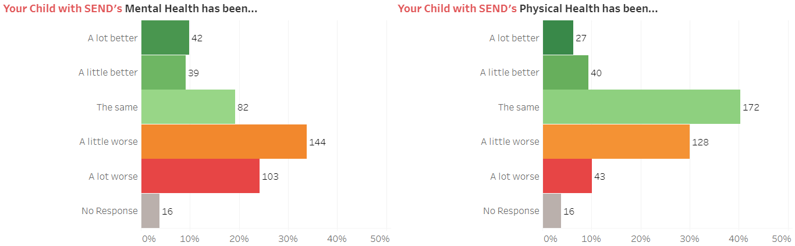

What has your child / children with SEND found the hardest to deal with during lockdown? (397 replies)

Top three themes (% of 397 replies)
- Missing family & friends - 45%
- Lack of structure and routine – 31%
- Not being able to go outside – 18%

Missing family, friends and social interaction was reported by 180 families. 29 families reported their child was missing school and 28 reported their child was isolated and lonely.

“Not being able to see friends and family has been hard as she struggles with interacting via screens. She has withdrawn from several friendships groups on what’s app as she can’t read the tone very well”

“Loss of contact with friends. He struggles to maintain his friendships in normal circumstances Being stuck in with his parents.”

“She found it hard to be apart from her grandma. She finds it hard to understand about the virus like how is it ok to see some people and not others”

Lack of routine and structure was described as affecting 124 children and young people, with 41 families describing the sudden change in circumstances difficult for their child to understand or cope with.

“My son couldn't cope with the big change to his routine. He also misses school so much. He cries whenever he sees the teacher videos on YouTube :(“

“Absence of familiar routines and people, consistency and familiarity are important to him and were severely disrupted leading to frustration/agitation”

Being able to go outside and visit places was reported by 73 families. 34 described not having access to usual support such as therapies, groups and activities was difficult for their child. 41 families reported that their children with SEND did not understand what was happening and why the rules of society had changed, struggling for example, to explain why children could not see family and friends and what social distancing was.

“She has found not going to her disability groups very hard and doesn’t fully understand the situation and why all this is happening”

“I am afraid my disable son may not reach his full potential due to this extended period of no therapies.”

Home schooling and schoolwork was described by 69 parents. Many mentioned the associated lack of routine caused by not being at school and the difficulties with getting their child to complete the work (36). 10 described the work they had received was either intermittent or too hard for their child to do, with 5 reporting their child found it hard to focus and concentrate on their work. 4 families missed the support of their child’s Learning Support Assistant or Teacher. 4 found the blurring of boundaries between home and school as difficult for their child to understand.

“Not seeing teacher or TA or having differentiated work that suit his learning style”

“Child has not been able to do much work and we are worried that our child will be far behind school peers upon return to school”

“He has struggled doing his schoolwork due to lack of concentration and he needs someone to prompt him but both parents key workers”

25 families reported the mental health of their child had become worse and 24 families reported their child had anxiety and worry related to the coronavirus. An additional 10 families described stress within the home due to sibling relationships and tensions around home schooling. 13 families described changes in sleeping patterns and routines.

“he has found it increasingly hard to deal with which in turn has made his behaviour really bad & challenging.”

“My child has struggled with leaving the house suffered very limited sleep sometimes none at all lost a lot of weight due to anxiety.”

“She has become very reclusive. Home schooling. As things have opened up, she has found busier places challenging.”

“He wont go out he has only just started to come down stairs, he is 14 and doesn’t get exercise which i worry about”

15 families reported that their child had not found anything difficult and was coping well.

“ Child has coped with lockdown brilliant. She missed her family but really was quite happy.”

“Can’t identify anything As a parent I am concerned about lack of socialisation but they aren't bothered”

What has your child / children with SEND found positive during lockdown? (349 replies)

Top three themes (% of 349 replies)
- Family time - 36%
- Not going to school – 11%
- Less stress and pressure – 10%

125 families reported that their children enjoyed spending time together as a family during lockdown, with 19 families reporting that their children had improved relationships with their siblings.

“being at home with mum”

“He has thrived staying home with me and relaxing.”

“Have created a stronger bond with their siblings”

39 families reported that not going to school was positive for their child, with 29 families reporting that their child responded well to home learning. 20 reported that their child enjoyed working at their own pace and doing their own thing. Of those that did go to school (9), the experience was positive overall, often due to reduced numbers and changes within the school day. 5 families commented positively on their children not having to wear school uniform which they found uncomfortable or had sensory issues with.

“She has found schoolwork much easier to do while being at home, less distracted.”

“Distance learning has been a huge positive for her, setting her own schedule and learning via technology has really helped to engage her.”

“Home school Being at home Being in their own rhythm”

35 families reported less stress and pressure within their daily lives and 19 families found the reduced social pressure on their children beneficial.

“no pressure to leave the house, the day has been more relaxed, no hurry to do anything.”

“No pressure to socialise and be someone they are not. Eldest has been so happy not to go to school and has found working at home much easier than in a classroom.”

“His behaviour and anxiety have been a lot better due to not being at school.”

Families reported a range of activities that their children enjoyed
- Gardening (9)
- Screen time – gaming / computer (16)
- Cooking / baking (11)
- Sleeping / lying in (13)
- Going for walks (13)
- Spending time outside (21)

“Learning new skills, cooking and independence skills around house.”

“Developing life skills such as baking, vegetable growing and cooking”

“Able to spend longer screen time, later night, not having to get up early”

There were 35 responses stating that lockdown had not been positive for their child.

Is there anything else you would like to tell us about the health and wellbeing of your child during lockdown? (139 replies)

Top three themes (% of 139 replies)
- Mental health decreased - 16%
- Mental health improved – 7%
- Little contact with school – 6%

Many responses were individual to children, young people and their circumstances though fell into three overarching areas of health, school and impact on the child.

57 responses referenced health services or wellbeing. 22 families reported the mental health and / or behaviour of their child had become worse, while 10 families reported it had improved during lockdown. 5 families described their child’s physical health had become worse with 5 concerned that their child wasn’t getting enough exercise. 4 reported the physical wellbeing of their child had improved. 5 families reported their child worried about the coronavirus. 3 cited a lack of medical

“ Her anxiety has got worse and hardly speaks now to me or any one else.”

“My youngest with ASD and dyspraxia has been calmer and happier not attending school, he is growing in height and his sleep and mental well-being have massively improved”

“Young adult awaiting surgery which has been postponed twice. Merely adds to the distress, anxiety & suffering constantly suffered”

36 responses discussed learning and school. 8 of these responses described a lack of contact from school and 6 described worrying about their children being ready / able to return to school. 5 responses talked about the challenge of working from home and home schooling and 3 families found schoolwork too hard or difficult to access online. 3 families felt that children should be able to attend school if they did not have an EHCP. Other responses were individual to children and their family circumstances.

“I feel as though we were given very little support by school for our son. 3 phone calls the whole time he was off school.”

“My child has struggled with having a working parent who also has to try and teach. Due to his ASD he struggles to see me as a teacher and focuses on parent this can lead to big behaviours!”

“I am concerned about how my child will cope with the return to normality, I think they would prefer to be on lockdown forever!”

“I find it very frustrating that my child has these needs but because he does not have a EHCP. He couldn’t attend school.”

18 responses were about children. 7 families reported that their child missed friends and family and 4 described the difficulties caused by their child’s lack of understanding of the coronavirus and the current rules.

“ The longer lock down has gone on though, the more they are missing school and friends”

“I worry more about the social aspect of lockdown, he has not seen or spoken to anyone outside the family since school finished.”

“Struggle with the lack of understanding as to why could not see grandparents (for routine, childcare and respite) and the negative impact this had on their behaviour.”

Health and social care support

Was your child receiving therapies or extra support from the Council, NHS or school before lockdown? (418 replies)

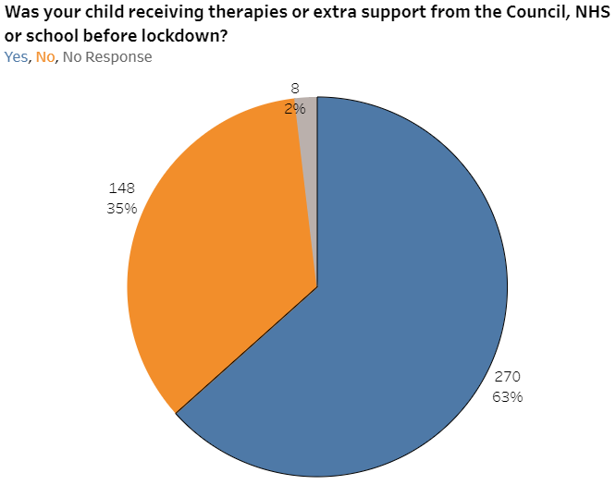

If yes, what happened to the support during lockdown? (268 replies)

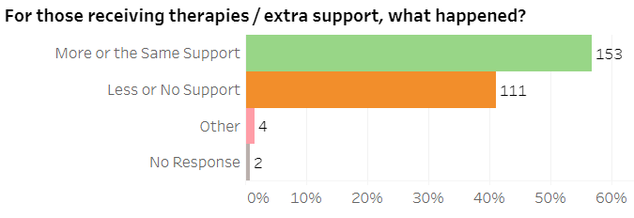
Of those who replied, 57% received more or the same level of support while 41% received less or no support. While 4 respondents selected ‘other’ from the options, 24 comments were made in the free text section. These related to phone calls being made to the parent from school (5), reports of individual services stopping eg play therapy, NHS appointments being postponed and circumstances individual to specific families eg people waiting for appointments to start up again or assessments to be completed.
If the support stopped, what impact did this have? (140 replies)

Top three themes (% of 140 replies)
- Services were paused / reduced - 44%
- Missed access to specific services – 34%
- Provided support themselves – 5%

Many responses (45) highlighted the negative impact that services stopping or reducing had on their child. The largest negative impacts were noted in children’s mental health (13), physical development (6), academic progress (11) and behaviour (12). In some cases, school was described as being a supportive factor (6) and in others concern was expressed that contact had been minimal (generic email, one phone call) or not at all (5).

“It has impacted on her mobility and general ability to move independently”

“My son has been more anxious and nervous, and this has made him a lot more aggressive and angrier. He is also sleeping less if at all at night”

“He was already behind, but I fear this will have caused more damage than he can deal with.

10 families described how support stopping made them or their child feel and 7 summed up the impact on their family in short phrases eg ‘very detrimental’, ‘huge negative impact’.

“Feeling totally adrift and now concerned the support for them will be gone post lockdown.”

“He feels abandoned, he has no one to turn to.”

“For the family, it was undertaking the roles of parent, carer, therapist etc without any support or relief. Who cares for the carers??”

7 families described putting their own arrangements in place to meet their child’s needs.

“support stopped for a while so as a parent was left to sort it only person who contacted me was school to make sure we were alright”

The most frequently named services that families felt their children were missing were Speech and Language Therapy (13), CYPS (6), Physiotherapy (6), OT (5) and social services including respite (7). 5 families described being on a diagnostic pathway for ASD or ADHD and this being placed on hold.

“We also haven't been having visits from the physiotherapists and have gone without a pair of orthotic boots for stretching one of my child's feet as the clinics were all cancelled. We also couldn't take delivery of a power wheelchair because of shielding.”

“Her medication needs reviewing and I’m not sure it is as effective as it was.”

“Cyps support mainly stopped, one online consultation.”

During the lockdown, have you needed to seek medical help for someone in the family? (414 replies)

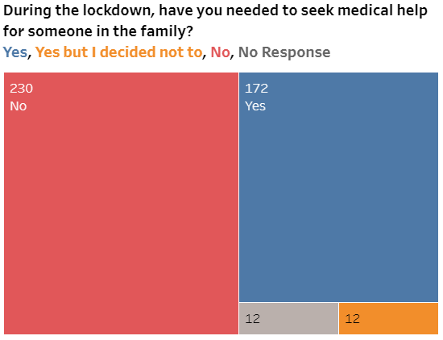
Of those that replied, 56% did not need to seek medical help during lockdown, while 41% did seek help and 3% needed to seek help but chose not to.

If yes, who did you seek advice for (185 replies)

Advice was sought for
- Child with SEND, 98 (23%)
- Respondent or their partner, 71, (17%)
- Non-disabled children 16, (4%)
- No response 241, (56%)

If you decided not to seek attention, why was this and what impact did it have (38 replies)

Many of the responses were specific to individual family circumstances. Respondents listed conditions they accessed medical support for including diabetes, epilepsy, kidney infection, broken bones, in growing toenail and receiving regular injections. The following were mentioned by 3 families
- Wanted a face to face appointment
- Felt others needed more help
- Sought respite and support from family members
- Were too scared / worried to visit hospital in case they caught the virus

With the following each being described by 2 families
- Unable to see a GP
- Child wouldn’t leave the house
- Treated the child themselves

“Did contact the minor injuries unit but was advised not to attend. Experienced severe pain and impaired mobility but had to keep going, am sure it has resulted in long-term damage to knee joint.”

“Didn’t want to burden the NHS. Exacerbated a simple problem.”

“Extremely limited access to GP service & not wanting to go to A&E in case of COVID infection.”

“Coz we would need to see someone in person as video call etc he will not do.”

“I thought GP’ appointments were not available for other problems.”

If you were waiting for a health or social care assessment when lockdown happened, what happened? (161 replies)

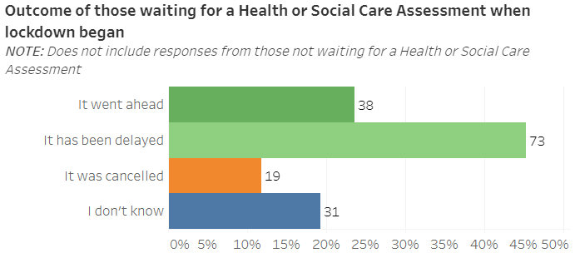

Assessments went ahead for 24% of those waiting one, 45% had their assessment delayed and 12 % had their assessment cancelled. 19% did not know what was happening with their assessment.

Is there anything else you would like to tell us about health and social care support during lockdown? (65 replies)

Top three themes (% of 65 replies)
- Negative impact - 35%
- Treatment delayed – 32%
- Received positive support – 27%

23 families described the overall impact on health and social care services as being negative.

“The NHS just appeared to stop apart from COVID and A&E. No work rounds were put in place.”

“There has been no support whatsoever”

16 families described receiving positive support.

“It has always been via phone call which was great. Means i never put anybody in my household in any danger and still got the things done that was needed”

“Early care worker from sure start was amazing we have a lady who i cannot praise enough.

21 families described how access to therapy / appointments / assessments had been delayed

“Due to the input being delayed it is beginning to have a physical impact on myself as not having aids put in place to assist with getting my son in and out of Bath and up and down stairs”

“My son was due an assessment for fitting - type behaviour. This has been delayed since early March.”

15 families reported they had received no support and 15 families discussed receiving support via phone calls or online sessions.

“None. All stopped.”

“We've been very lucky as all our appointments have gone ahead either in person or via video link.”

8 families described the positive support they had received from social services

“Our social worker from the children’s disabled team was excellent and really helped communication between other services, enabling him to return to school at around week 10 of lockdown.”

Education and learning

Support your child is receiving (400 replies)
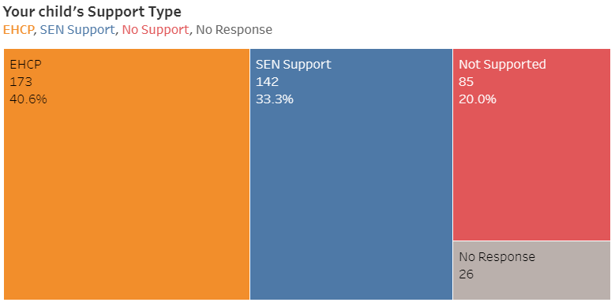

Children receiving support through an EHCP were the largest group of respondents at 40%, followed by those receiving support at SEN Support (33%) and 20% reported they were not yet receiving any support at school.

Where is your child educated? (418 replies)

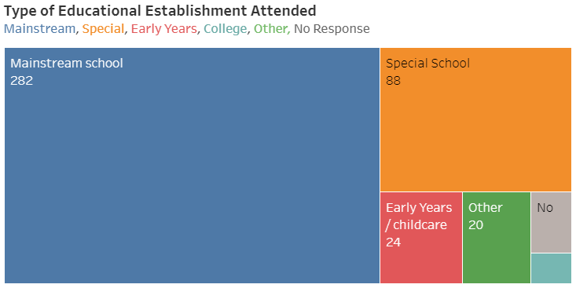

The majority of children (66%) were attending a mainstream school, while 21% attended a special school. 6% attended Early Years / Childcare, 2% did not respond and 3 children attended college (less than 1%). The following is a breakdown of the category ‘Other’
- No response – 4
- Attending Alternative Provision – 3
- Open to EOTAS (Education Other Than At School) – 2
- Home schooled – 2
- Currently not in school, waiting a placement -1
- Waiting to start special school – 1
- Online academy – 1
- More than one child attending mainstream / special – 1
- Specialist College – 1
- Expelled from school before the virus – 1
- Aged under 1 - 1
- Middle school – 1
- High school - 1

Are you a key worker or social worker? (421 replies)

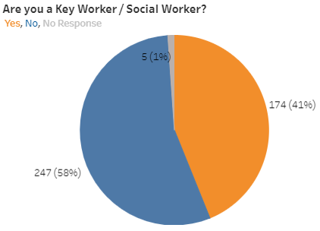
41% of respondents were key workers.

If your child was going through an assessment process for consideration of extra help with learning, how was communication about the process? (127 replies)
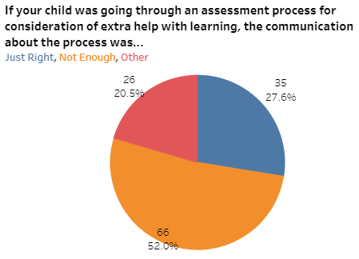

Just over half of the respondents felt that there was not enough communication about the process, with 28% reporting they felt communication was just right.

Of the 20 who replied ‘Other’, the following responses were received
- No response – 8
- Communication stopped – 4
- Not sure - 2
- Interviewed by phone – 2
- Communication via email – 1
- Communication was ok – 1
- Would like an EHCP – 1
- School – 1

‘It stopped and I have nowhere else to go’

‘I want an ehcp but the school don’t want one’

Did your child go to school, nursery or college during lockdown (409 replies)

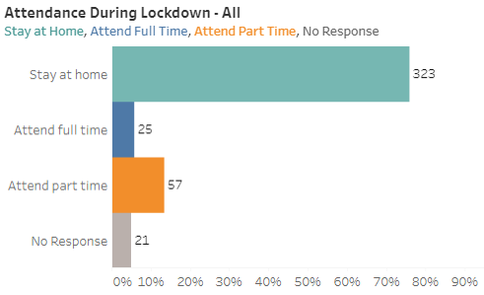

Of those that replied 79% of children and young people stayed at home, 6% attended full time and 14% attended part time.

Reasons why children stayed at home (328 replies)

Reason | Number | % of those that replied  (excluding no responses, rounded up/ down)
I am concerned about my child’s health at school or someone in our house is shielding | 111 | 34%
My child wanted to stay at home | 67 | 20%
The school formally risk assessed my child and advised they should not attend | 7 | 2%
The school formally advised that my child should not attend | 60 | 18%
The school were not able to provide suitable provision | 83 | 25%
No response - 98

The most common reason for staying at home was due to concern about their child’s health at school or because someone in the house was shielding. A quarter of those who responded reported that school was unable to provide suitable provision. In 20% of cases, the child had wanted to stay at home. Schools formally advised 18% not to attend school while 2% reported schools had formally carried out a risk assessment which detailed their child should not attend.

This information was analysed according to the age of children to determine whether the age was a contributory factor to attending school.
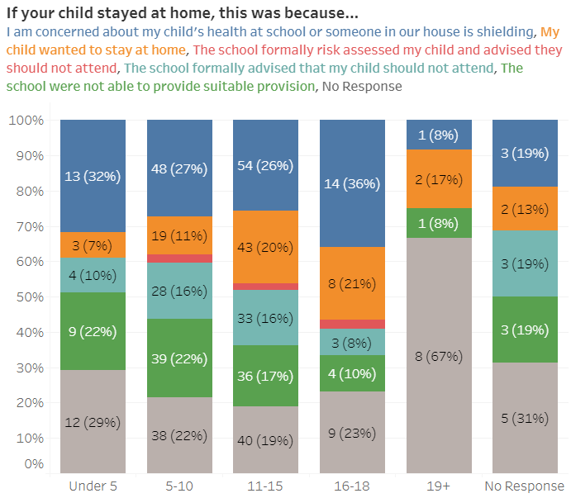
The percentage of children and young people who wanted to stay at home increased with age. The percentage of families who reported that school were not able to make suitable provision decreased with age.

Support received from school for those who were home schooled (316 replies)

Reason | Number | % of those that replied  (excluding no responses, rounded up/ down)
Good support for your child’s needs | 91 | 29%
Specific home learning support | 47 | 15%
Some specific home learning support but would have liked more | 76 | 24%
Support offered was not relevant to your child’s needs | 102 | 32%
No response - 110

29% reported receiving good support for their child’s needs from school, while 15% received specific learning support. 32% felt that support was not relevant to their child’s needs and 24% would have liked more support. A breakdown according to age is shown below.

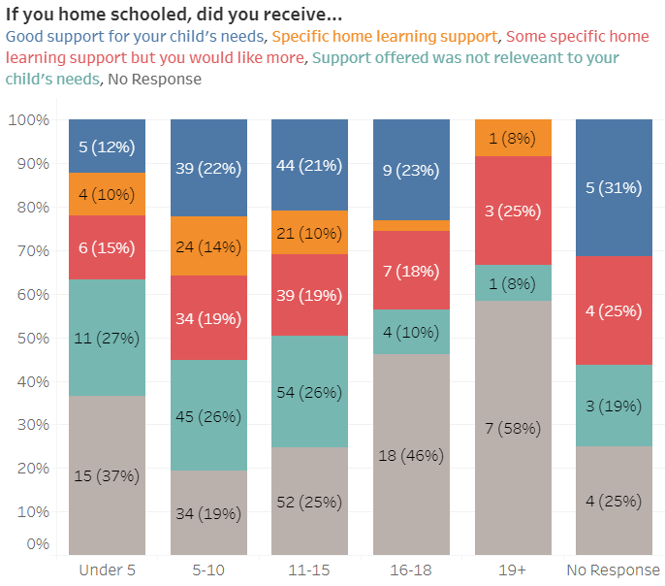
How much home schooling did you feel you were able to offer? (377 replies)

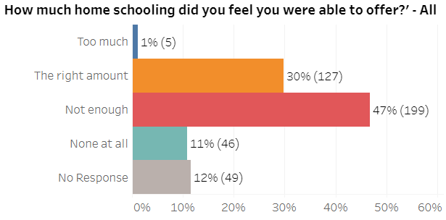
65% of the families that responded felt that they were unable to offer enough home schooling or weren’t able to offer any at all. A breakdown is provided of home schooling in relation to age below.

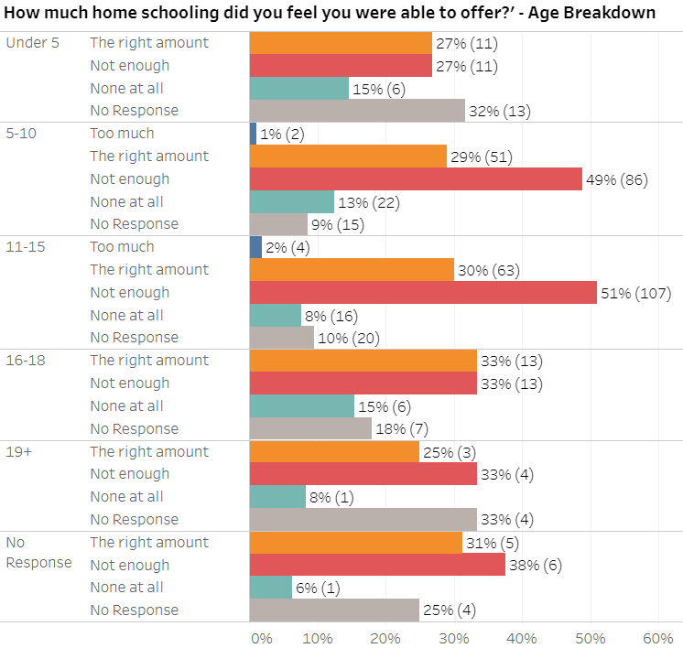

How do you feel about your child returning to school? (364 replies)

Top three themes (% of 364 replies)
- Confident / positive about return to school - 33%
- Expressed general anxiety / worry – 16%
- Worry about their child’s health and safety – 13%

122 families expressed feeling positive about their child’s return to school, using words such as ‘happy’, ‘pleased’ and ‘confident’. 32 families felt that their child was ready or needed to go back because they felt their child would benefit from the structure and routine of school, missed their friends and needed to socialise or needed to be taught by a teacher rather than themselves (or different combinations of all three). 22 families reported receiving very good support from school or stated they had trust in the arrangements school had in place.

“Feel apprehensive but confident school has procedures in place to safeguard both teacher and pupil safety”

“Happy as they need some social interaction both with teaching staff and fellow students. There is only so much you can learn from textbooks/online worksheets.”

“I am glad he is returning to school. He needs the routine and social interaction as he seems to be losing his social skills.”

45 families reported their child was attending school at the time they competed the survey. Comments were generally positive, however some parents reported that school attendance had been a necessity due to their personal circumstances.

“I'm worried but my daughter asked to go in for the last 3 weeks of term, I weighed up the risk of her diabetes but felt her mental health was a bigger risk and let her attend.”

“He is already back in school 2 days a week now. We as his parents were questioning if we had done the right thing but the moment, he got home from his first day back we knew we had. He was beaming, smiling & so happy and calm.”

“Home schooling was too much of a burden on the whole family and my son’s ability to deal with his anger proved problematic. In May I asked the school to take him.

A large number of families expressed worries about a range of different issues. 59 expressed general anxiety and worry at the thought of returning to school and 49 were concerned about how safe their child would be in school. Some were worried about their child catching the virus and then bringing it home as some families lived with elderly relatives or those who were shielding. A number felt mixed emotions, being both pleased their child was returning and yet anxious at the same time.

“I am worried about spreading in school and my child catching Covid 19 and spreading it to my elderly father with whom we are socially bubbling.”

“I am worried about how school will cope when he has a melt down and the impact it will have on social distancing, his safety, the safety of other pupils and staff.”

“I am glad but worried at the same time, her mental health has destabilised since march.”

“I am anxious because he requires 1:1 support for transferring between pieces of equipment, feeding, toileting and hand-over-hand for learning. He is prone to picking up bugs when at school anyway (which has not been a problem at home) so we are concerned he is at increased risk as he crawls, touches all surfaces, will not understand the instructions to keep his hands away from his face etc.”

33 families described being worried about their child settling back into the school routine and the fact that school would be different to when they left it before lockdown. 14 families reported their child had high levels of anxiety around returning to school.

“I am incredibly concerned how my child will access all of the support he needs in a safe, socially distanced way. It isn’t possible”

“I think my son will struggle following the new rules and likely to find the changes at school overwhelming and distressing”

“Anxious about how different it may be. Due to ASD change is a big deal and he doesn't always understand personal boundaries / social distancing.”

“A bit hesitant. Not because of covid but the increased anxiety he will experience.”

17 families were worried about their child transitioning into a new school or new class and felt there hadn’t been support put in place to help this. 12 had concerns that their child had fallen behind and 10 were worried that support would not be available for their child.

“My child is anxious about transition as she has not been able to visit her new school and we were advised before lockdown to ask for additional visits to the one standard visit.”

“Scared for their health as there on the shielding list. Scared they will get lost in the system as I feel they are now behind where they should be.”

“I am also worried he will be behind and that there will not be the resources needed for him to catch up.”

12 families reported they were not going to send their child into school or that they had concerns that their child would attend.
“ I am ok as long as his needs are met but the child just doesn’t want to go well refusing to go.”

“Don’t want him to go back until Covid is over.”

“He won't be returning to school. Risks too high for me.”

Is there anything else you would like to tell us about education and learning during lockdown? (157 replies)

Top three themes (% of 157 replies)
- Positive support from school - 15%
- Infrequent contact / support from school – 12%
- Work sent home not specific – 11%

Responses to this question mostly fell into two main categories, either responses about school or responses about home schooling. The following were the most common responses about schools
- Good communication and / or positive support from school (24)
- Lack of support and communication from school (19)
- Not enough work sent home or the work was too hard for their child with SEND (18)
- Wanted virtual lessons / contact (10)

“My child’s teachers were amazing always in contact with us either by email or phone. Passing on resources, challenges and message for his classmates.”

“I do feel like we were just left to get on with it, no home-schooling help was really provided from school and I had to make up all my own resources and attempt what I could”

“We’ve not been offered enough schoolwork and none of what was offered was SEND specific at all.”

“Requested online teaching e.g. Teams or Zoom but was rejected.”

The following were the most common responses about home schooling
- Child refused or very reluctant to work at home (12)
- Found home schooling hard (10)
- Very little home schooling carried out (9)
- Working from home and home schooling was difficult (8)
- Children made progress at home (6)

“My son does not understand school homework. He thinks schoolwork is for school and this caused many meltdowns.”

“we concentrated on the mental health and well-being of my SEN child instead of work as it was causing a lot of upset”

“As a single working parent, I didn’t have the time or resources to meet his educational needs”

Money and work

What happened to your household income during lockdown (423 replies)

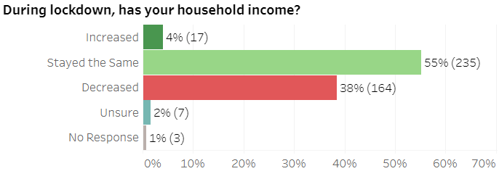
For the majority of families, household income remained the same, though 38% of families experienced a decrease in income.

If you are receiving benefits, have these

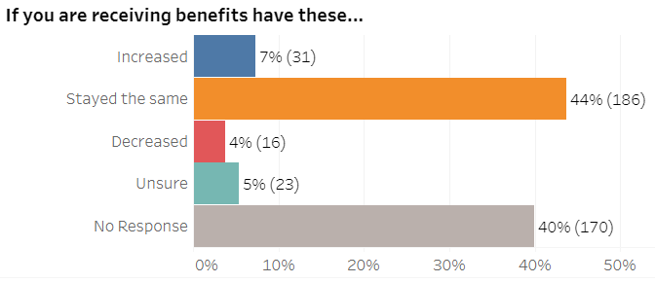

If your household income has dropped, what impact has this had? (110 replies)

Top three themes (% of 110 replies)
- Had to decrease spending - 39%
- Struggled financially – 27%
- Impacted on food shopping – 17%

30 families reported they struggled financially, while an additional 43 described how they had decreased their spending in order to manage financially. In some cases, this was due to the fact that there were fewer things to spend money on (e.g. decreased spending on petrol, visiting places), and in other cases it was because families reported actively ‘watching their pennies’. 4 families reported they were unable to afford any extras. 5 families had either taken a mortgage holiday or had not paid their mortgage and 3 families had sought financial support from their family, 3 had used savings and 3 had gone into debt.

“We just cut back a little more. As we were not going anywhere we saved in other areas e.g. petrol so that helped cushion the effects”

“We have really struggled and will be in debt for a long time”

“We had to stop the mortgage for 3 months to be able to stay on track with everything else”

“Worried about paying the rent, cutting down on food, managing to afford uniform for September. Getting a job for husband.”

6 families described running their own business and 5 reported difficulties in maintaining the viability of their business.

Food was mentioned in 19 responses
- Buying less food (6)
- Buying more food as more people at home to feed (5)
- Worry about providing food (2)
- Food shopping costing more (1)
- Debt because of food shopping (1)
- Child’s understanding of why food not the same (1)
- Gluten free food costing more (1)
- Only buying food (1)
- Used food bank (1)

“We have had to buy less food and be frugal with meals.”

“Cut down on food purchases by meal planning so as not to waste food.”

“we have had to buy more food to cover additional meals”

Employment of adults in the house

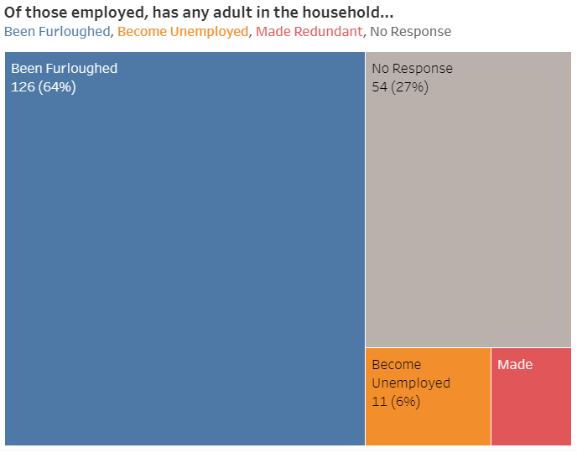

Is there anything else you would like to tell us about money and work during lockdown? (76 replies)

Many of the responses within this section described individual family and employment circumstances. Home schooling was reported to be a significant challenge when working from home (10), if employers weren’t supportive (3) or in one case, having to work from home at night as they could not home school during the day due to childcare.

“We are extremely fortunate in that we are both in our jobs with no furlough or other adverse impact, but keeping those jobs has ended up coming at a real cost to our child’s education and emotional wellbeing which makes us feel extremely sad and guilty”

“balancing the needs of our family with the demands of my employment, which has been particularly busy during lockdown, has been difficult. And children with oppositional behaviours can provide some interesting and unexpected "Zoom meeting" experiences.”

“there was a lot of overtime expected and less time to home school my child”

17 families described increased spending on everyday needs
- Buying educational equipment, activities for their children (7)
- Food costing more (4)
- Buying more food as more people at home to feed (3)
- Increased heating costs (2)
- Clothing (1)

“Food bills went up a lot as all the family in the house all day every day is expensive to feed.”

“I have also had to buy a lot of practical equipment as that is the only type of learning he will engage with.”

7 families reported stress caused by worrying about finances and future employment of family members. For those who had been furloughed there was a mixed picture, with 1 finding the scheme helpful and 3 reporting that they experienced a six-week delay in receiving any payment. Similarly, for those who were self-employed, 3 reported losing work and 1 found the government self-employment grant helpful.

While the provision of free school meals was reported as helpful by 3 family members, 5 respondents felt that the system was unfair as they experienced significant financial difficulties but were not eligible for the support.

7 families reported they were key workers which meant that financially their position remained the same and 2 reported saving money.

Thinking about the future

What three things would you like to see happen now in Northumberland to support children and young people with SEND? (284 replies)

Most common areas with 10 or more responses for the things that families feel need to happen now
- Extra staffing, resources, support and funding for schools (49)
- Increase support for mental health, anxiety needs etc in schools, provide counselling services in schools (29)
- Children to have a plan with support about how to catch up (28)
- Better, frequent communication about what is happening in school (17)
- More training to mainstream staff and SENCo’s around SEND (15)
- Extra activities for the holidays, weekends available locally (12)
- More support and advice available for parents about the SEND system and what support is available (11)

All responses
Parents and carers and returning to school
- Better, frequent communication about what is happening in school (17)
- More support and advice available for parents about the SEND system and what support is available (11)
- Good preparation and advice for return to school and what to expect (9)
- More advice from schools about how to help children learn (9)
- Support for parents who have children who refuse to go to school (2)
- Less pressure put on parents (2)
- More support around young people moving into adulthood
- More outreach from schools to support education of those whose families have someone shielding
- Access to sensory equipment
- Reassurance about how coronavirus will be managed
- Still send learning home
- Advocates for children

Support for families
- Listen to parents (7)
- More support for parents, carers and families (7)
- More support groups for parents / carers, drop ins, online support (7)
- Increased respite options, support for carers through direct payments (6)
- Phone line for parents if they need support (3)
- For children to have the equipment they need in their daily lives (3)
- Proactively ask families if they need help, don’t wait for a crisis (3)
- More support and advice for parents on dealing with issues at home (2)
- Consider offer of short breaks and whether it can be done safely (2)
- More support for siblings of SEND children (2)
- Respite for single parents
- More funding for respite, short breaks and overnight
- More flexibility to use funds to care for family’s needs specifically
- Carers website to make recruiting carers easier
- Someone to talk to
- Reopen support groups and networks
- Needs specific childcare
- Bring back young carers for siblings
- Continued support to learn sign language
Supporting schools
- Extra staffing, resources, support and funding for schools (49)
- Increase support for mental health, anxiety needs etc in schools, provide counselling services in schools (29)
- More training to mainstream staff and SENCo’s around SEND (15)
- Return to school and normality as soon as possible (4)
- Phased start to school (4)
- Flexi schooling, some time at home and some at school (4)
- Work with academies to support their understanding and support for children with SEND (3)
- Access to support for schools straight away (3)
- Smaller classes (2)
- Children with SEND to be welcomed by schools, more inclusivity (2)
- Support hubs to connect special and mainstream schools together
- Train teachers about ADHD and how to support children
- Share good practice from inclusive schools to those that aren’t
- Review how schools work and understand why some pupils had better mental health when not at school
- Needs of disabled children to be prioritised
Schools supporting children
- Children to have a plan with support about how to catch up (28)
- Return to the same levels of support available for SEND children as there were before lockdown (8)
- Review children to see if needs have changed during lockdown and provide extra where needed (8)
- More online teaching and support available (6)
- Specific support for mental health in the first few weeks of returning to school (7)
- Extra support for those children who are starting a new school in September, starting before school starts (7)
- School to deliver what is in the SEN Support Plan / EHCP (5)
- Personalised learning for children that is tailored to their needs, not generic (5)
- More help for those who don’t have an EHCP (2)
- Support for children who have social difficulties in returning to school (2)
- More rewards / acknowledgement for work being achieved
- Recognise dyslexia and provide consistent support
- Support group learning hubs for children
- Introduce ambassadors / advocates / learning mentor for children (3)
- To repeat a year in school to catch up
- Online support for children in small groups
- Schools to follow the graduated approach
- Support for behaviour
- More support earlier on
- Shorter waiting times for Portage
- Clear communication about how school is different, so pupils understand
- More regular direct contact with pupils to understand their needs (4)
- Home visits to start back up for Portage, continue with online music group
- Home learning was relevant to the class, not my son
- Safe transport to and from school

Moving into adulthood
- More support in 6th form, support drops off a cliff
- Wider post 16 provision
- More life skills / jobs skills / apprentice opportunities in the North
- Support Year 10s with the GCSEs

If lockdown was to happen again
- Review why services were discontinued to those with a Social Worker and / or an EHCP in lockdown
- Have a contingency plan for if lockdown happens again
- Access to learning in lockdown if you don’t have an EHCP
- Keep special schools like Priory open if there’s another lockdown
- For school not to close and offer nothing
- Make sure money in early years goes to the childcare provider who is giving the support
- More support for all children, not just those who have social workers

Types of educational provision
- Alternative educational provision and a support hub for girls with ASD (2)
- Provision is available to match need
- Develop provision for those at secondary who find mainstream hard, but specialist isn’t appropriate

For health services
- More face to face appointments (5)
- Improve support pre and post ASD / Asperger’s diagnosis for both parents and children (5)
- Closer working between CYPS and schools (4)
- Physio, OT and SLT support to be equitable to other parts of the country (2)
- Appointments to resume for ASD assessments who have been put on hold
- Being told about support available other than CYPS
- Reduce waiting times for physiotherapy, occupational therapy and equipment
- Online SLT sessions
- Catch up on therapies that should have been provided
- Make sure there is enough health care provision at 18+ so that those who still have needs don’t get discharged because of their age but get referred on
- Hospital appointments to start up again
- Health staff to be in schools so children don’t have to leave school to see them
- Find different ways of meeting physical / therapeutic needs when provision closed due to lockdown / social distancing
- Unable to access virtual mental health support as can’t afford technology
- Consistent appointments

In the community
- Extra activities for the holidays, weekends available locally (12)
- More social facilities in the community for SEND (6)
- Quiet safe spaces to go (5)
- More after school clubs (3)
- Businesses / clubs to have SEND only sessions (2)
- Safe youth clubs and more activities to do (2)
- More local play areas
- Support for charities already doing a good job eg Toby Henderson, Calmer Therapies
- Extra support for those with communication difficulties in the community
- Affordable groups nearby to help make friends and improve social interaction
- Northburn Community Centre to reopen as soon as possible
- More provision for young adults with disabilities
- More support for children outside of school
- Special school placements should be easier to obtain
- More facilities in Alnwick for teenage girls with SEND
- More help in North Northumberland
EHCP process
- Simpler quicker application process for an EHCP (6)
- Better communication through the process (2)
- Not to have to fight to get one (2)
- Provide a key worker / navigator to parents to help them with the EHCP process

Proposed improvement ideas
- A central contact centre for advice, support and signposting (3)
- Create ‘safe spaces’ – there is nowhere secure that parents can sit and let their child run around safely and parents can just have a rest. Create some MUGA’s (multi-use games area) tennis court style with astro turf and 6 foot fences (like the Astroturf football pitch at Northburn in Cramlington) which could be secured with a keycode style lock. I’d happily pay to book one for an hour so we could take a picnic and a ball and know that our kids could run around and not escape. Booking could be online. This would have been a lifesaver for us during lockdown and helped massively with mental health.
- Identity card to explain to others about hidden disability eg to shops that your child has SEND
- Discounted mind app / exercise voucher to support parents regaining mental health
Finally, families were asked ‘Is there anything else you would like to tell us?’ (65 replies)

Responses covered the following areas
- Impact of lockdown on transition between schools, classes
- Communication with parents and contact about home schooling being different across different schools
- Processes around SEND being difficult and stressful to navigate
- A feeling that no one cares about SEND, feeling abandoned
- Unhappiness with SEND assessment process and allocation of support
- Children not receiving support allocated to them in SATS year as given to other pupils
- Health and wellbeing of some children have improved and families can support education from home
- Wish to be involved in shaping SEND services
- CYPS should diagnose PDA
- Support needed for mental health of adults
- Nationally SEND system isn’t working
- Variable response of mainstream schools to SEND
- Support for ASD children and their parents in mainstream schools
- Good support from professionals – medical, educational, social care
- Lack of education in schools during lockdown
- Exhaustion in families who have children with complex needs, a lack of respite
- Their children don’t have SEND
- Expressing thanks to individual schools
- Worry over the future of children who refuse to home school
- Support is available when younger but appears to stop when aged 14-15
- Thanks for running the survey
- Overcrowding at home
- Request for online support groups
- Anger that a special school closed during lockdown
- More support needed for girls with ASD in Alnwick area
- Concern about secondary education and academies

