Music Partnership North
Northumberland

Policy for Child Protection
(Updated May 22)

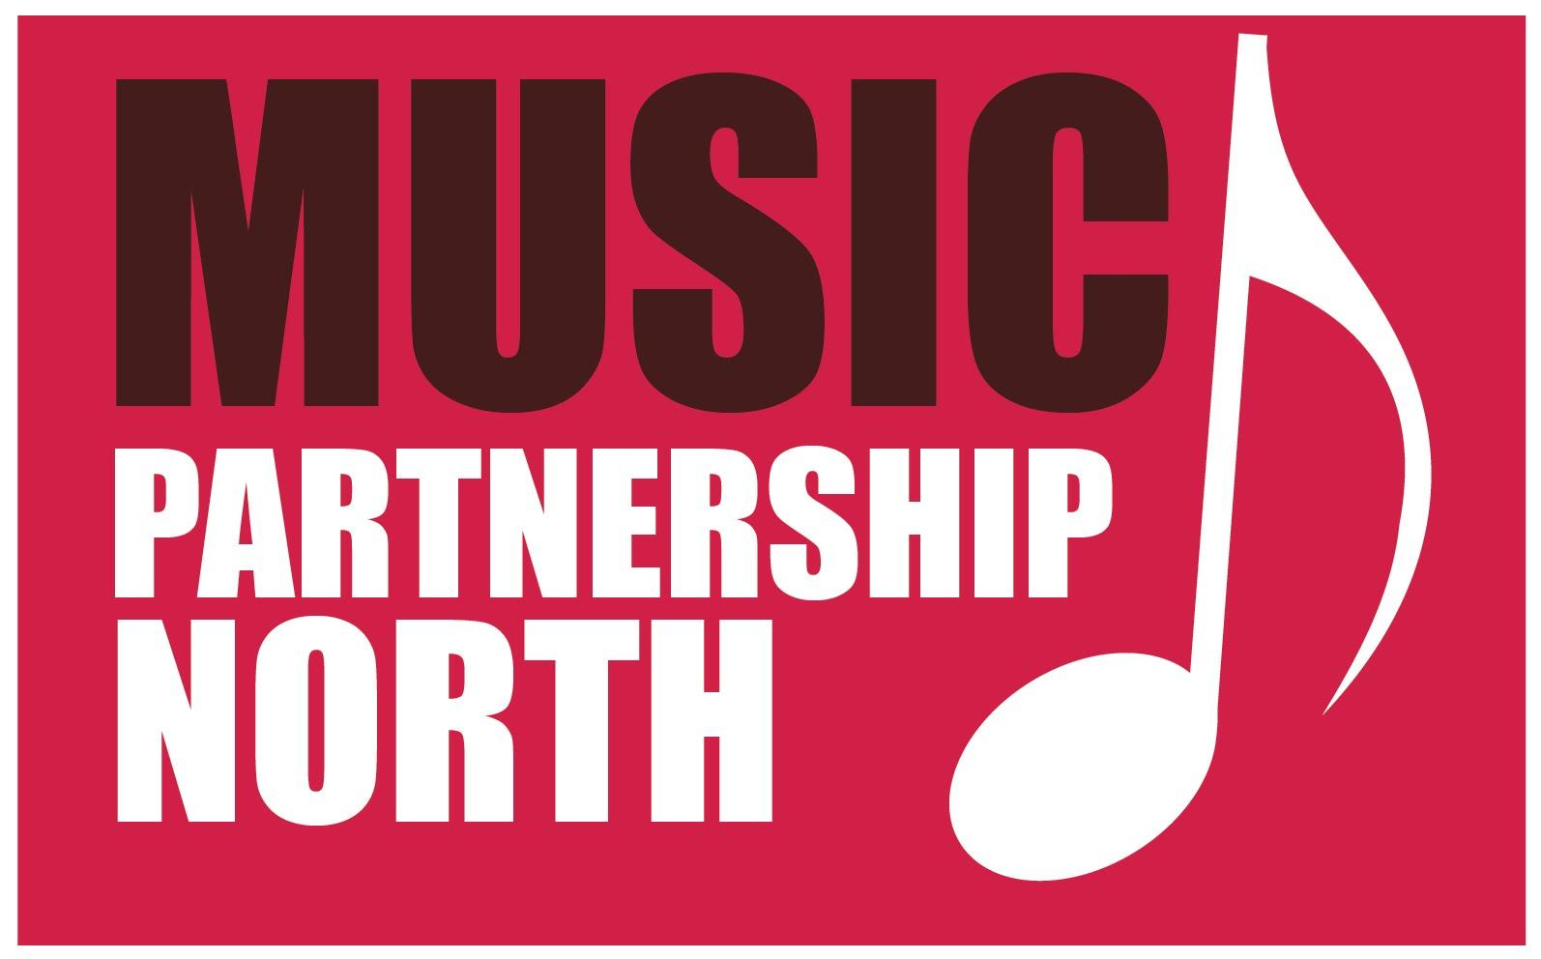

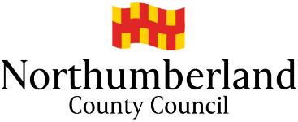
Safeguarding Children Policy

Music Partnership North - Northumberland (MPN) believes that pupils have a fundamental right to be protected from harm and to enjoy an environment that is safe, caring, happy and free from fear and abuse in order to learn. We also believe that all MPN staff working in schools have a right to personal support and guidance concerning the protection of pupils.

MPN is committed to protecting the rights of children enshrined in The Children’s Act 2004 (Section 11) and the papers “Working Together to Safeguard Children” and “Keeping Children Safe in Education”, September 2019. Safeguarding Children, as defined in “Working together to Safeguard Children”, is protecting children from maltreatment and preventing impairment of children’s health or development.

All MPN staff who come into contact with children and families in their everyday work, including people who do not have a specific role in relation to child protection, have a duty to safeguard and promote the welfare of children. This includes service users and their families and visitors to MPN premises and activities.

All MPN staff are trained in child protection during their induction process, this is then updated every three years.

This policy is part of the central Northumberland County Council Safeguarding policy which Music Partnership falls under. NCC policy can be seen by clicking here.

This policy outlines:
- What constitutes child abuse
- What you should do if you suspect a child is being abused

What constitutes child abuse?

- Child abuse occurs when children or young people under the age of 18 are hurt physically, emotionally or in some other way. Children can be abused in any section of society. Abuse occurs within all cultural, ethnic and religious communities. Children may be abused by family or friends, by professionals who are in a caring role or by strangers. All forms of abuse are wrong and have damaging effects on children and young people.

- There are four main areas of abuse:

Physical abuse includes hitting, kicking and punching and in serious cases may even lead to death

Emotional abuse includes degrading punishments, threats and withholding love and affection, which can undermine a child or young person’s confidence. All abuse involves some element of emotional mistreatment

Neglect occurs when basic needs such as food, warmth and medical care are not met

Sexual abuse includes all forms of sexual activity where children and young people are sexually exploited. This includes all forms of inappropriate touching, rape and/or oral sex. It also includes inappropriate touching or involvement with activities with which the child feels uncomfortable or which could be damaging such as watching pornographic materials.

What you should do if you suspect a child is being abused

- Everyone working for MPN has a responsibility to report their concerns to ensure all children and young people are safe. If you are concerned that a child is suffering harm or is likely to suffer harm from another person you have a responsibility to protect the child by reporting your concern immediately. The designated person at the school the child attends is the first point of contact.

- There are many forms of abuse and some are less clear than others, although this does not mean they are less harmful. You are expected to be vigilant to the possibility of abuse and where you are unsure to seek the advice of the designated person. What you see and know about a child is important and should be acted upon.

- In all cases of actual or suspected abuse outside of school hours or when the designated person is not available MPN staff have a duty to notify Northumberland County Council’s Onecall. One call brings together adult social care and healthcare staff from Northumbria Healthcare NHS Foundation Trust with Northumberland County Council staff from children’s services, and partners in Northumbria Police. Their priority is providing help at the earliest opportunity before the situation becomes more serious. If you have any concerns regarding a child contact Onecall on 01670 536400.

- Children’s Services staff will notify the police of any referral where a criminal offence may have been committed against a child.

- Allegations involving staff members will be referred to the Local Authority Designated Officer by Children’s Services and a strategy meeting called to consider the nature of the concerns. This strategy meeting will include representation from Northumbria police and will plan any child protection investigation.

- MPN staff will not be expected to undertake any investigation into a safeguarding concern. This remains the responsibility of Children’s Services who will become the responsible agency for coordinating intervention to protect a child once a referral has been made (see 5 above).

MPN staff are not allowed to contact pupils directly by mobile phone, email, Facebook or other networking sites. Contact should always be made to a parent/guardian or through the school.

MPN do not condone or support the use of Facebook, Twitter or other network sites to be used for uploading information or visual images of our ensembles as this may contravene child protection and copyright laws.

If you have any concerns regarding a child contact Onecall on
01670 536400

