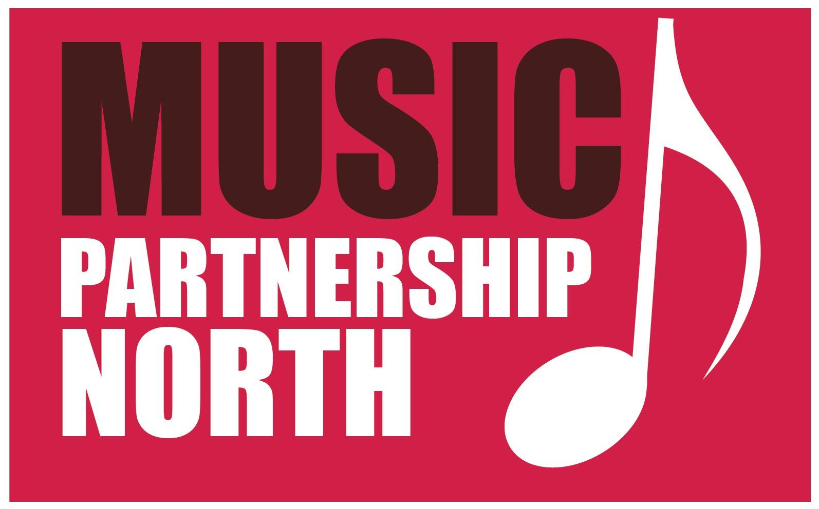
Music Partnership North
Northumberland

Off-Site Educational Visits
(Rehearsals, concerts, workshops etc)
Updated 10th Feb 2022

Information for Parents

Objectives

Pupils can derive positive educational benefits from taking part in off site rehearsals, workshops and concerts and their playing and progress on their instrument is enhanced from playing in an ensemble.

They have the opportunity to undergo experiences not available in the classroom and these activities help to develop a pupil's initiative skills while residential visits, in particular, encourage greater independence. Interpersonal and social skills are enhanced greatly through the manner in which music ensembles are organised and the ‘Office for Standards in Education’ (Ofsted) recognises the benefit that these ensembles offer to pupils of all standards. Experiences gained by pupils through attendance at these ensembles should not be seen as isolated opportunities but as a vital part a pupil's education.

Risk Assessment

The underlying basis of health and safety care is to control risks. This is effectively achieved through risk assessment. The sites that are used for our ensemble activities have been assessed and "reasonably and practicable", measures have been taken to avoid or reduce risks. Students will be made aware of the risks and how these risks are to be managed during rehearsals / concerts / workshops. If students are found in breach of the instructions and guidelines issued to them, and if staff deem that this breach is significant, parents will be contacted and requested to collect their child from the activity.

Parental Consent Form (SV5)

Music Partnership North - Northumberland (MPN) office must receive from parents either a completed SV5 form for residential visits and musical tours or confirmation of an online consent form for standard activities. This information will be held by the course leaders and a copy will be kept centrally for reference. Each course leader or nominated tutor will have a first aid kit available and the relevant training. If it is deemed necessary, the first aider will contact a parent/guardian according to the details on the consent form. In the case of an emergency, the relevant services will be called immediately, and parents/guardians contacted as soon as possible. Parents of pupils, who need specific medical equipment or medication at all times, should notify MPN of these requirements.

Pupils will not be allowed to attend a rehearsal without their medication. It is the parent’s responsibility to ensure the students have their medication with them and must inform us throughout the year of any changes to medication.

Pupil Behaviour

It is important that an atmosphere of respect, honesty, care and consideration is maintained at rehearsals, workshops and concerts, both for the staff, fellow students and the buildings. These qualities are encouraged and enhanced through the manner in which our activities are led by tutors trained to recognise and encourage positive behaviour. All pupils should behave in a manner in keeping with the above criteria, which is in line with schools’ behaviour policies. The safety of all pupils attending our rehearsals / workshops is our prime concern.

Examples of unacceptable behavior are:

- Use of obscene language towards or intentionally in the hearing of a member of staff or other
pupils
- Violence – deliberate physical aggression
- Defiance towards a member of staff
- Damage to or theft of property
- Indecency or behavior of a sexually implicit nature
- Possession of alcohol or drugs (NCC policy states that all their sites are designated as a no
smoking area)
- The carrying of any offensive weapon
- Bullying (in accordance with school policies)

The consequences for any infringement relating to the above types of behaviour will be the sending home of the person or persons involved. Parents will be expected to collect their child from where the visit is taking place. In such cases a student may be excluded from further ensemble experiences.

Supervision

Pupil to staff ratios is governed by NCC policy and the activity taking place. We always have a minimum of two members at any event and match male/female staff to each situation where possible or required.

Registration and Head Counts

Registration will take place at the beginning of all rehearsals or events. Head counts and registration of pupils take place regularly during all courses and residential visits. Any students leaving a rehearsal or event early must inform the course leader before they leave and must be collected by a guardian / parent. Any student arriving late to an event must inform the course leader as soon as they arrive.

For Health and Safety reasons, please come into the rehearsal room / performance area to collect your child after rehearsals / concerts rather than arranging to meet them elsewhere.

Clothing and Equipment

It is expected that all pupils attend with all the equipment they have been advised to bring, this information will have been relayed prior to the event through correspondence.

Dress at rehearsals is informal but must be appropriate to the activity. However, for all concerts we expect pupils to dress smartly according to the instructions given. Pupils who are improperly dressed may not be allowed to take part in a concert or event.

Data Protection

Please visit our website www.music.northumberland.gov.uk for more information relating to GDPR and how we handle your data.

Within the confines of normal auditions, rehearsal and concert procedures, every effort is made to ensure that activities are available and accessible to all who wish to participate, irrespective of special educational or medical needs, ethnic origin, gender, religion etc.

For further details and guidance please see the Ensembles Policy which is available online at the MPN website http://music.northumberland.gov.uk

