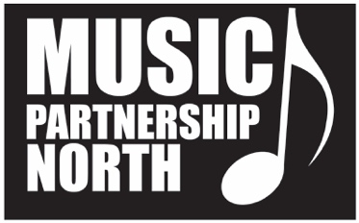

Music Partnership North is looking for a new Chair for its Music Education Hub Advisory Board.

Music Partnership North is made up of the local authority music services from Northumberland and Newcastle, with Sage Gateshead as a strategic partner.

The hub works collaboratively with key local, regional and national partners to ensure that all children and young people in our region have equal access to a rich variety of musical opportunities.

We are looking for an inspirational and motivated Chair of the Music Partnership North Advisory Board who will support the Hub with its mission, help us celebrate what we already do and support us to develop new opportunities for children & young people in our area.

The Chair of the Music Partnership North Advisory Board is a non-salaried position (reasonable travel expenses will be reimbursed) and would suit someone who has a strong background in business and/or education, and has the time to support the Hub to develop its role and remit.

For an informal chat about the post please call David Francis, Acting Lead Officer of Music Partnership North - Northumberland on 07818 011722 or email: david.francis@northumberland.gov.uk

If you would like to apply for this post please send your CV and a covering letter outlining how you meet the Qualities of the Chair (as outlined in the Job Description) and the knowledge, skills and experience you could bring to the role.

Please send your application to David Francis at david.francis@northumberland.gov.uk

Application Deadline: 28th February

Interviews: TBC

