10 THINGS TO DO ON RECEIPT OF A THREAT TO THE SAFETY OF YOUR SCHOOL

THREAT RECEIVED VIA EMAIL OR SOCIAL MEDIA
- DO NOT reply to, forward or delete the message
- If sent via email make a note of the the address of the sender
- If sent via social media make a note of the application used and the username/ID
- Dial 999 and follow police guidance, including advice about informing parents
- Preserve all web log files for your organisations to help the police investigation (as a guide, 7 days prior to the threat message and 48 hours after)

THREAT RECEIVED BY TELEPHONE
6. Stay calm, do not respond to any of the threats being made and record as much information as possible. If your school telephone system allows record the number of the caller making the threat. Dial 999 and follow police guidance, including advice about informing parents.

A FIREARMS OR WEAPONS ATTACK
7. Follow Government guidance as shown below
. 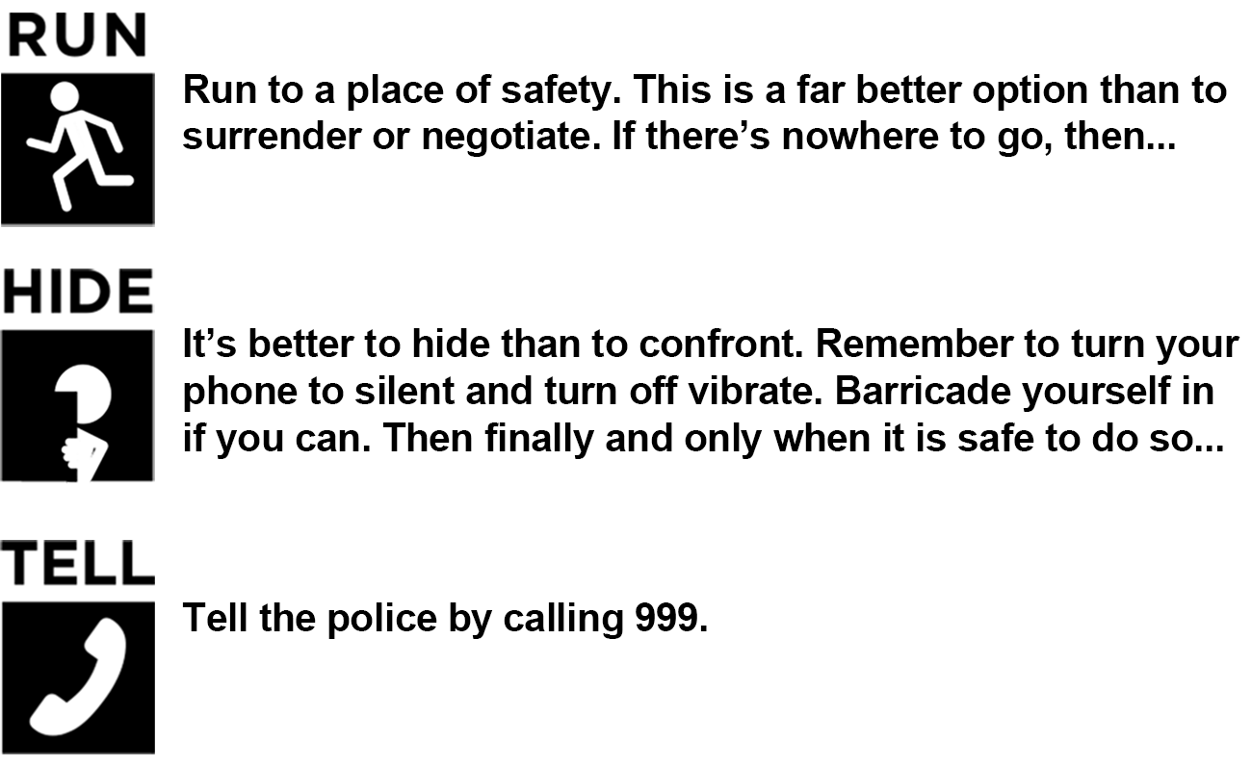
8. For all types of threat you must immediately inform the Director of Children’s Services - Cath McEvoy - 01670 624034. The DCS will initiate the appropriate procedures and ensure the correct agencies are informed including the LA communication team who will respond to any requests from the press.
9. Ensure your school contingency plan makes reference to such threats and the actions to be taken, remembering that the safety of the staff and pupils is paramount.
10. In ALL instances you should DIAL 999 before taking any further action.

Further details can be found on government websites
https://act.campaign.gov.uk/

https://www.gov.uk/government/publications/bomb-threats-guidance/procedures-for-handling-bomb-threats

