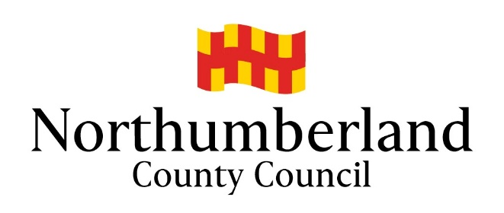

Children’s Safeguarding Unit - Update November 2020

Since 24 March 2020 the Safeguarding Unit has been managing all of our meetings virtually, initially via Google Hangout and more latterly through Teams.
We have had some positive feedback on how meetings have been managed and some frustrating technical issues. However overall, we have had better attendance from some professionals who would normally struggle to attend conferences - joining the meeting either for short periods of time or remaining joined for the whole of the meeting.
Child Protection Conferences
We are currently planning our conferences virtually for the foreseeable future. We are encouraging participants to join visually rather than via an audio link. We are also looking at ways to encourage parents/carers to join visually too.
Invites to Conferences
Initially invites to conferences remain the same. The social worker completes the invite list (meeting arranger) on day one of the Section 47 Investigation starting and reassigns this to the ICPC Bookings tray in ICS. Please remember the Social Worker or Team Manager should update the Safeguarding Unit on day four or five if the investigation is not progressing to an ICPC.
Safeguarding Admin prepares the invite letters that are sent by email to our partner agencies’ generic mailboxes - the invite letter includes the joining instructions for invitees. The calendar invites include the Social Worker, Conference Chair, Team Manager and our partner agencies receive the invites again via their generic mailbox - if the individual professional email address is known they will also be included in the calendar invite. Invites for parents are sent via post again with the joining instructions. The Conference Chair will contact parents in advance of the conference and discuss ways to join the meeting. However, to support the process the social worker should also discuss how parents might join the meeting when delivering the social work report. Social workers can also add professionals directly to the email invite - please inform the Safeguarding Admin if you have added anyone.
So long as we have the correct information, we aim to get invites for ICPC’s out within five working days and RCPC’s ten working days.

Reports for Conference
Given the mobility restrictions for professionals and parents, the Safeguarding Unit has agreed to collate all the professional reports for the conference and will share these with the all professionals the morning of the conference - again through the generic mailboxes. This includes all the reports we have received and the Social Work Report. Please let Safeguarding Admin know when the Social Work Report is completed and agreed so that it can be distributed. If the reports are not with the team by 9am they will not be able to be shared. It remains the responsibility for each professional to ensure the parents get copies of their own reports as soon as possible - one full working day for the Social work report (ICPC three for RCPCs) other professionals the agreed standards are three working days for both ICPC and RCPCs.
Once the conferences have taken place the minutes will be distributed in the same way within five working days for ICPCs and ten working days for RCP’s. It is still expected that the social worker will hand deliver the conference minutes and plan to parents.
Managing conferences in this way has demonstrated that we can be flexible in how the meetings are held and we have seen an increasing number of professionals attending conferences when previously they would have struggled - we have also had professionals join us for short periods of time to share their information.
If you have any queries about invites or reports please email: childprotection@northumberland.gov.uk
To discuss your attendance at or during a conference please contact the Conference Chair directly - their contact details are included on the invite.
Looked after Reviews
Looked after reviews are managed in a similar way to conferences. For the first review the social worker will share the invite list and we send out details and joining instructions for reviews via email or directly into a calendar invite if all the email addresses are known -again our invites are left open so social workers or other Northumberland staff can access the invite and add additional professionals/guests. Sometimes looked after reviews are held in as a series of meetings to support both full attendance of professionals and parents and at the request of the young person so they are not overwhelmed by too many people in attendance at their review. The invite will be explicit as to how the meeting is to be managed.
Aligning Reviews
We are attempting to align the annual review of a child’s EHCP with the child’s looked after review. We appreciate there will be an element of flexibility around this as we try to maintain a child led meeting for looked after reviews and we know that children struggle to have their meetings in school so consideration will be given to holding a series of meetings. Where possible the looked after review should not be arranged at a time which results in the child being absent from lessons/school.
Reports for Looked After Reviews
There remains an expectation that all professionals involved with looked after children should complete a report to consider the progress since the previous reviews. These reports should be shared three days prior to the looked after review wherever possible.
If you have any queries about invites or reports please email: LACadmin@northumberland.gov.uk
We are always looking at ways we can improve our service please feel free to contact me with any feedback jan.tilson@northumberland.gov.uk
I would like to take this opportunity to thank everyone for their support and effort over the past months.
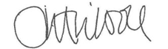
Jan Tilson
IRO Safeguarding Manager
01670 620293

