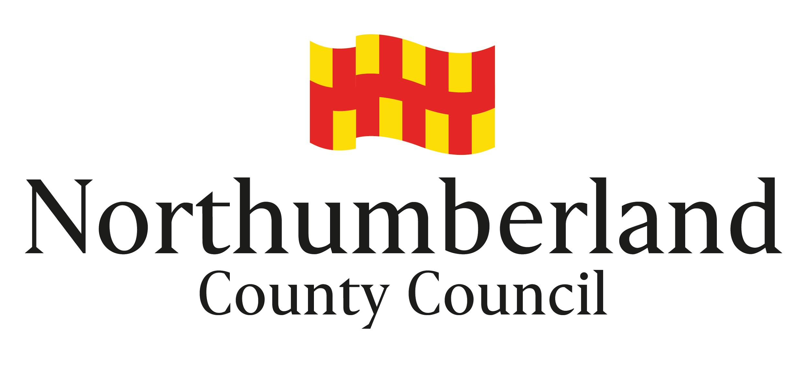

Guidance Notes for Applicants

POLICY FOR FUNDING SPORTS, PLAY AND RECREATION FACILITIES
VIA S106 HOUSING DEVELOPER CONTRIBUTIONS

Introduction
Northumberland County Council is keen to see the development and improvement of children’s play and sports facilities. S106 housing developer contributions are collected in a variety of ways based on historical supplementary planning documents produced prior to the Local Government Review. At the moment contributions can only be collected in the manner previously agreed through the planning process. In most of Northumberland, monies are collected based on individual agreements for a specific amount for a specifically agreed purpose. However, in the former Tynedale area, South East Northumberland and certain areas of North Northumberland, s106 monies are collected and may be pooled and spent over specific geographical areas on sports, play and recreation projects. NB: Different criteria for the spend of such pooled monies is applicable for each former district. Northumberland County Council will provide advice, assistance and support to Parish / Town Councils and other local groups and organisations seeking to carry out improvements. As part of this, the Council may, in appropriate circumstances, be able to assist in funding projects. This document sets out the policy and procedures that the Council will follow in considering funding such projects.

Who can apply for funding?
Applications for funding can be made by non-profit making / constituted organisations such as:
Parish / Town Councils
Community groups
Residents associations
Sports clubs (subject to the Council being satisfied with arrangements for community use)
Schools (subject to the Council being satisfied with arrangements for community use)
Council Departments

Individuals or businesses are not eligible for funding.

What can be funded?
This funding is for capital items only for children’s play areas or outdoor sports facilities plus indoor sports in certain areas as well as recreation facilities in areas of the North. The funding can be for new facilities or improvements to existing ones for example:
- New children’s play areas
- New sports pitches / areas
- New equipment in an existing play area
- Upgrading of facilities for outdoor sports such as changing rooms
- Specialised sports equipment eg cricket roller – NB: general grass cutting machinery is not eligible

Projects must be within specified locations in Northumberland and must be open to the general public. Where a local sports club or school is looking to develop or improve facilities, it would need to specify appropriate arrangements for wider community use.

Applications for funding need to demonstrate how they would address deficiencies in the amount, standard or distribution of facilities. They should normally be based on the improvements identified in the former Districts Strategic Documents and should be able to demonstrate local support for the project. Applications for sports projects should make it clear how the project will increase and/or sustain sports capacity.

Funding can be given towards the capital costs of new or improved facilities such as the installation of play equipment or a new changing room. Routine maintenance costs are not eligible. Eligible costs could include design fees, purchasing or securing the use of land and ground works in addition to the purchase and installation of equipment and other structures such as buildings, fences and lighting.

How much funding is available?
As funding comes via contributions from housing developers for specific areas, the level of funding available will depend upon the amounts collected at the time and also requests from other projects in the same area. This means that funding can be limited and in some areas there will be no funding available. The Council has limited resources to fund projects and will seek to use them to assist as many projects as possible. It will usually be one of a number of potential sources of funding.

How to apply for funding
An application form and supporting guidance notes to aid the completion of the application form are available on the Northumberland County Council website, www.northumberland.gov.uk on the ‘Funding for Sport and Play’ page The information provided on the application form will allow the s106 panel to consider and assess the need and benefits of the project and score the project against the evaluation criteria.

An application pack will include the following documentation:
- Application form
- Evaluation Criteria - things to consider when completing your application
- Additional notes to support completion of the application form
- Guidance Notes for Applicants

Advice can be given prior to an application being made.

Although each application will be considered on its merits, the amount of funding offered will depend, amongst other things, upon resources available at the time, competing demands from other projects and an assessment of the relative benefits of the project.

Conditions of funding
If it is decided to offer funding, this will be subject to a number of conditions. The project must not start, or be contractually committed, before a written offer of funding from the Council has been received, unless prior written consent is obtained. Payment will not be made until all of the following conditions are met:

- The project is complete and up to the required standard (inspection may be made by Council officers where required.
- The project has been delivered in line with the project details and costs presented in the application. An award from the Housing Developer Fund is made based on the project details and costs provided in the application and Northumberland County Council must be notified asap of any change to the project details and costs.
- Completed and signed claim documentation is submitted together with copy invoice(s) and evidence of payment to the contractor(s) in the form of a copy bank statement(s).
- Officers of the Council are satisfied that appropriate arrangements for the ongoing management and maintenance of the facility are in place, including inspection and insurance arrangements. These would include arrangements to ensure an adequate level of community use.
- There is security of tenure for the land and buildings concerned. This would normally be through evidence of ownership or a lease of 25 years when the application for funding was made.
- Officers of the Council are satisfied that the full cost of the project can be met and that the facility can be run viably thereafter.
- Subject to acknowledgement of the Housing Developer Fund contribution in all publicity.

If the facility which has received funding is disposed of or ceases to be used for the intended purpose within 25 years of payment being made, Northumberland County Council will be repaid in full.

