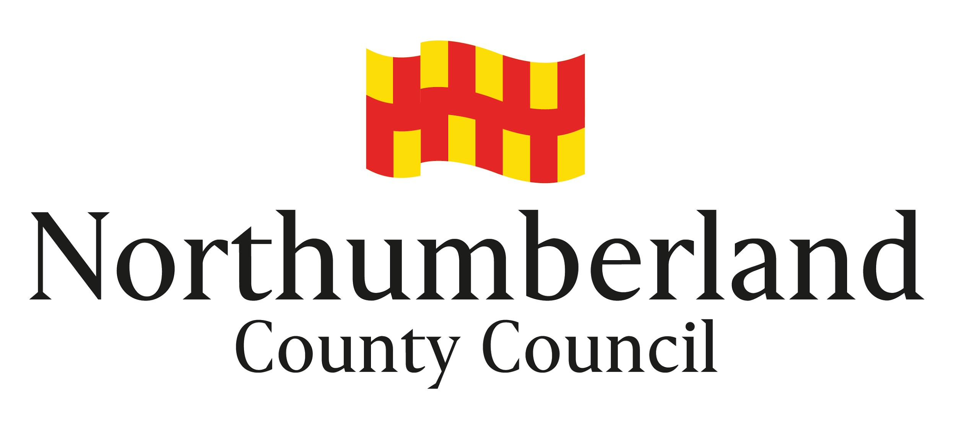

Guidance Notes for Applicants

POLICY FOR FUNDING SPORTS, PLAY AND RECREATION FACILITIES
VIA S106 HOUSING DEVELOPER CONTRIBUTIONS

Introduction
Northumberland County Council is keen to see the development and improvement of children’s play and sports facilities. S106 housing developer contributions are collected in a variety of ways based on historical supplementary planning documents produced prior to the Local Government Review. At the moment contributions can only be collected in the manner previously agreed through the planning process. In most of Northumberland, monies are collected based on individual agreements for a specific amount for a specifically agreed purpose. However, in the former Tynedale area, South East Northumberland and certain areas of North Northumberland, s106 monies are collected and may be pooled and spent over specific geographical areas on sports, play and recreation projects. NB: Different criteria for the spend of such pooled monies is applicable for each former district. Northumberland County Council will provide advice, assistance and support to Parish / Town Councils and other local groups and organisations seeking to carry out improvements. As part of this, the Council may, in appropriate circumstances, be able to assist in funding projects. This document sets out the policy and procedures that the Council will follow in considering funding such projects.

Who can apply for funding?
Applications for funding can be made by non-profit making / constituted organisations such as:
Parish / Town Councils
Community groups
Residents associations
Sports clubs (subject to the Council being satisfied with arrangements for community use)
Schools (subject to the Council being satisfied with arrangements for community use)
Council Departments

Individuals or businesses are not eligible for funding.

What can be funded?
This funding is for capital items only for children’s play areas or outdoor sports facilities plus indoor sports in certain areas as well as recreation facilities in areas of the North. The funding can be for new facilities or improvements to existing ones for example:
- New children’s play areas
- New sports pitches / areas
- New equipment in an existing play area
- Upgrading of facilities for outdoor sports such as changing rooms
- Specialised sports equipment eg cricket roller – NB: general grass cutting machinery is not eligible

Projects must be within specified locations in Northumberland and must be open to the general public. Where a local sports club or school is looking to develop or improve facilities, it would need to specify appropriate arrangements for wider community use.

Applications for funding need to demonstrate how they would address deficiencies in the amount, standard or distribution of facilities. They should normally be based on the improvements identified in the former Districts Strategic Documents and should be able to demonstrate local support for the project. Applications for sports projects should make it clear how the project will increase and/or sustain sports capacity.

Funding can be given towards the capital costs of new or improved facilities such as the installation of play equipment or a new changing room. Routine maintenance costs are not eligible. Eligible costs could include design fees, purchasing or securing the use of land and ground works in addition to the purchase and installation of equipment and other structures such as buildings, fences and lighting.

How much funding is available?
As funding comes via contributions from housing developers for specific areas, the level of funding available will depend upon the amounts collected at the time and also requests from other projects in the same area. This means that funding can be limited and in some areas there will be no funding available. The Council has limited resources to fund projects and will seek to use them to assist as many projects as possible. It will usually be one of a number of potential sources of funding.

How to apply for funding
An application form and supporting guidance notes to aid the completion of the application form are available on the Northumberland County Council website, www.northumberland.gov.uk on the ‘Funding for Sport and Play’ page The information provided on the application form will allow the s106 panel to consider and assess the need and benefits of the project and score the project against the evaluation criteria.

An application pack will include the following documentation:
- Application form
- Evaluation Criteria - things to consider when completing your application
- Additional notes to support completion of the application form
- Guidance Notes for Applicants

Advice can be given prior to an application being made.

Although each application will be considered on its merits, the amount of funding offered will depend, amongst other things, upon resources available at the time, competing demands from other projects and an assessment of the relative benefits of the project.

Conditions of funding
If it is decided to offer funding, this will be subject the standard terms and conditions and possibly additional conditions of grant. The project must not start, or be contractually committed, before a written offer of funding from the Council has been received, unless prior written consent is obtained. Payment will not be made until all the conditions of grant have been met.

