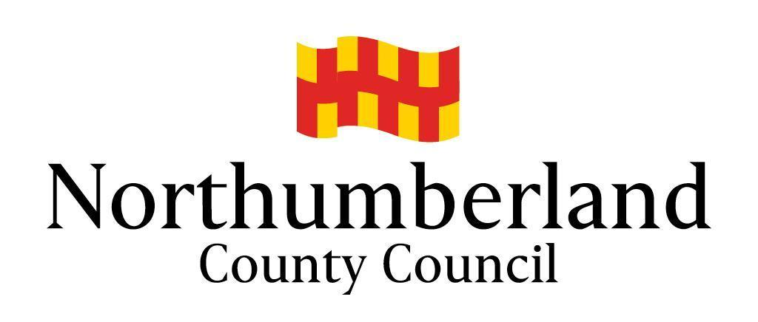

Community Chest Scheme
Uniformed Youth Groups Fund

SCHEDULE OF EXPENDITURE

Please list all items of expenditure (add rows or continue on another sheet if required). If you can recover the Value Added Tax (VAT) you must only show the net amount.

Items of expenditure (include all costs of the project) | Cost
Total

Please list any additional sources of funding towards your project. Please note that match funding is not required for expenditure up to £1,000.

All sources of funding | Current Status  (secured or pending) | Amount
Total

Amount that you are requesting (must not exceed £10,000)

NAME: …………………………….………………………… DATE: ………………….…………….

General Data Protection Regulation 2018 Privacy Statement
Northumberland County Council is the sole owner of the information collected by us. The information collected will enable us to ​correctly process your request regarding a Uniformed Youth Groups Fund application. We will not provide your personal information to any other external organisation or individual unless it is lawful to do so, eg the prevention and/or detection of crime; where sharing is covered by a data sharing agreement or Service Level Agreement (SLA); or where you have provided explicit consent to do so. However, we will need to share your information with certain departments of this Council where necessary for the Council’s law enforcement functions, eg licensing, planning enforcement, trading standards and food safety, etc. If this is the case we are not required to, and will not, seek your consent to do so. The Council’s Privacy Notice can be found on the Council’s website and at Customer Information Centres.

