Event Fund 2019  Application Form | 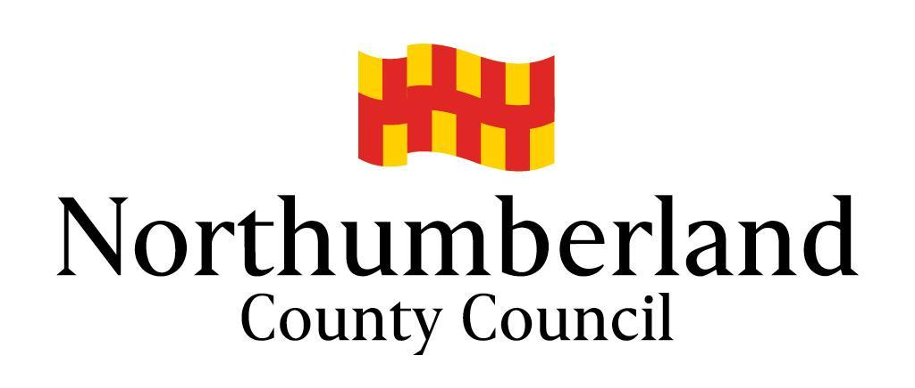
ABOUT YOUR GROUP/ORGANISATION

Applicant | Group/Organisation/Accountable Body
Name: | Name:
Address:  Post code: | Address:  Post code:
Tel: | Tel:
Email: | Email:
Position: | Web:
Please give a brief description of your group/organisation.
What is the status of your group/organisation? (Tick all that apply)
⃞ Registered Charity Charity Number: ……………………………………
⃞ Community Group ⃞ Voluntary Organisation ⃞ Town/Parish Council
⃞ Other, please specify: ……………………………………………………………………………………

ABOUT YOUR EVENT

Please describe the event that you plan to use your grant for.
Who will be the main beneficiaries of the event? Please give numbers, ages, etc.
Where will the project/activity take place?
Event start date |  | Estimated end date

ABOUT YOUR GRANT

Please state how much money you need for your event and what it will be used for. If you can recover the Value Added Tax (VAT) you must only show the net amount. If you are including volunteer time this must be entered in both expenditure and funding.

Items of expenditure (include all costs of the project) | Cost
Total

Please list all contributions towards your costs, including any cash, grants, volunteered time, donations, and your own resources. This must amount to not less than 25% of eligible expenditure (those items eligible for funding). The 75% maximum may be applied item by item.

All sources of funding | Current Status  (secured or pending) | Amount
Total

Amount that you are requesting (must not exceed 75% of eligible costs)

I confirm that to the best of my knowledge and belief that all the information provided is true and correct. I understand that Northumberland County Council reserves the right to recover all or part of any grant award in the event of non-compliance with the terms of the grant.

I confirm that all relevant documentation has been provided and that the group/organisation is adequately covered for all liabilities from the running of the event.

I accept that Northumberland County Council, its partners, agents or employees are not liable for any costs, losses or damages incurred as a direct result of the event.

SIGNATURE: …………………………….…… NAME (Please print): ………………….…………….

DATE: …………………………………………..
General Data Protection Regulation 2018 Privacy Statement
Northumberland County Council is the sole owner of the information collected by us. The information collected will enable us to ​correctly process your request regarding a Community Asset Transfer. We will not provide your personal information to any other external organisation or individual unless it is lawful to do so, eg the prevention and/or detection of crime; where sharing is covered by a data sharing agreement or Service Level Agreement (SLA); or where you have provided explicit consent to do so. However, we will need to share your information with certain departments of this Council where necessary for the Council’s law enforcement functions, eg licensing, planning enforcement, trading standards and food safety, etc. If this is the case we are not required to, and will not, seek your consent to do so. The Council’s Privacy Notice can be found on the Council’s website and at Customer Information Centres.

