Community Chest Scheme 2020  Guidance | 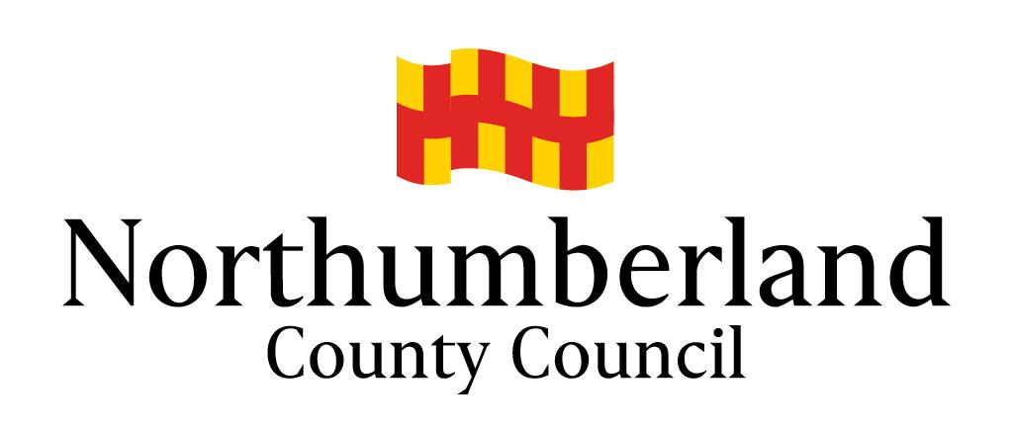
The aim of the Community Chest Scheme is to support community groups and organisations to deliver activities which contribute to achieving the Council’s ambition for Northumberland.

High priority will be given to projects that enhance the environment, strengthen communities, and which promote health and wellbeing. Particular emphasis is given to initiatives that will help groups to be sustainable in the longer term, are of value to a local area, and are not able to secure mainstream funding from the Council or other sources.

Who can apply?

The scheme is open to any voluntary, community or not for profit group or organisation (including charities) that is based in or serves the communities of Northumberland.

Parish Councils may apply in 2020 for capital costs relating to projects that help communities recover from the impact of the Covid-19 pandemic, including public realm works that compliment the Council’s Cultural Fund. Such costs will be eligible up to 100% up to a maximum of £5,000.00. The panel will take into consideration the ability of the councils to manage such costs within their existing precept and reserves, therefore preference will inevitably be given to smaller councils.

Who cannot apply?

- Schools
- Businesses and other for profit organisations

What can be applied for?

The Scheme largely funds capital items, such as the purchase of equipment, materials, building refurbishment, and one of hire costs. A list of successful projects from a previous year is available on the Council’s website: www.northumberland.gov.uk

What cannot be applied for?

The scheme will not fund the following:

- Core running costs, including premises | - Social excursions
- Wages, salaries, expenses or professional fees | - Religious or political activity
- Goods and services already purchased | - Food and hospitality
- Personal attire, such as sports kits, uniforms | - Loan repayments
- Feasibility studies or pre project costs | - Annual or repeat funding
- Advertising and marketing | - Funding for other grant schemes
- Fundraising and prize-giving | - Consumables
- Tourism/visitors | - Parish Allotment Sites

How much can be applied for?

The Scheme can provide grants of up to 75% of eligible costs up to a maximum of £5,000; however, the average grant is £2,500. Please note that projects that specifically help the community to recover from the impact of the Covid-19 pandemic may apply for up to 100% but the limit remains £5,000.00. The grant is paid up front and must be spent within 12 months of notification of award. Costs that are not eligible for funding will not be included in calculating the grant amount. Any other sources of funding or support from the Council will be taken into consideration when deciding the amount offered by the Scheme.

When can applications be made?

There are two deadlines within the current year, although applications can be submitted at any time. The grant panel will meet within 6 weeks of the deadline. In 2020, applications will be considered by a Grants Panel in 2 Rounds until all funds are allocated:

 | Deadline | Panel Meeting by
Round 1 | 2nd October 2020 | 13th November 2020
Round 2 | 15th January 2021 | 26th February 2021

All applications are considered in chronological order of receipt date. Once all funds are allocated in an Area the Scheme will cease in that Area.

How are decisions made?

The Scheme is divided into five geographical areas based on the Council’s Local Area Councils (LACs), namely:

- Ashington & Blyth
- Castle Morpeth
- Cramlington, Bedlington & Seaton Valley
- North Northumberland
- Tynedale

Each LAC appoints a subcommittee of elected members to act as a Grant Panel to decide the allocation of the grants. Each has a budget which equals £0.94 per head of population.

There will be no separate budget allocation for Countywide projects in 2020.

Administration and advice to applicants is provided by the Community Regeneration Team, who will comment on draft applications and provide additional support if required.

Applications must be submitted on the approved forms, and must be accompanied by a constitution or Articles of Association, recent bank statements from all accounts, and most recent annual accounts. If your constitution does not include a commitment to equality of opportunity, you will need to submit an equality statement approved by your organisation. Additional information should be provided to support the application if appropriate e.g. business plan, child safeguarding policy, photographs, quotes, etc. Parish Council need only supply their most recent annual accounts and budget for the current year.

What is the process for assessing applications?

Once we have received your application form, together with supporting documents, it will be appraised by a member of the Community Regeneration team. They may contact you if they feel that changes need to be made, if important supporting documents or information is missing, or to inform you that your request is ineligible in whole or in part. Your application will then be considered by the grant panel in order of receipt. They are solely responsible for the decision to support and the level of support to be awarded. Their decision is final.

What do the grant panels look for in an application?

- A clear rationale and evidence of need;
- All funding is accounted for, including match funding;
- Multiple quotes or other evidence that best value has been considered;
- A clear exit strategy or plan for forward sustainability.

How will the decision be notified?

All applicants will be contacted by a Community Regeneration Officer in writing. If successful, an Acceptance Form and Bank Details Form will be enclosed, together with a statement of conditions and a Completion Form which should be returned once the project is completed (no later than 12 months after award). No payment will be made until all relevant paperwork has been submitted. Payments will be made in advance via BACS transfer.

Applications that do not succeed may be resubmitted at a subsequent round but must use a new application form. Applications will only be carried over from one round to the next at the discretion of the grant panel. All issues raised in respect of a rejected application must be addressed in resubmission.

How do I get an application form?

Application forms are available on the Council’s website:

https://www.northumberland.gov.uk/Councillors/Community-Chest.aspx

If you require further advice, please contact the Community Regeneration Team:

Iain Hedley, Community Regeneration Officer
communitychest@northumberland.gov.uk
07747 473 687

COMMUNITY CHEST SCHEME 2020

Terms and Conditions

- The project must not start, or be contractually committed, before the grant offer date.

- All projects, or expenditure, must be completed within 12 months of notification of award. In exceptional circumstances, an extension may be granted.

- Best value must always be demonstrated by the Grant Recipient when purchasing items. The Council may ask for this evidence to be supplied, e.g. competitive quotations, screenshots from websites, etc.

- The Grant Recipient must submit a monitoring form when the project is completed. Copies of invoices and receipts must be submitted with this form. Failure to do so may prevent further funding from the Council.

- The applicant must have security of tenure on any facility to be grant aided either by ownership of the freehold or by means of a lease that has at least five years duration when the application is made.

- Unless otherwise agreed, any unspent grant must be returned to the Council.

- If the grant aided project is disposed of, or ceases to be used for the purpose the grant is given, the Council reserves the right to reclaim all or part of the grant.

- Grant Recipients must ensure all relevant permissions and licences are obtained before they apply.

- All liabilities for the project remain with the Grant Recipient and are not the responsibility of the Council, its partners, agents or employees.

- The Grant Recipient must ensure that all publicity relating to the project fully acknowledges the Council.

- If the Grant Recipient can recover VAT, then VAT must not be included in the project costs.

- The Grant Recipient must demonstrate a commitment to equality of opportunity.

- Any equipment purchased with the grant must remain the property of the organisation and must be available for more than one member to use.

- The Council is subject to the requirements of the Freedom of Information Act 2000 (FOIA) and the Environmental Information Regulations 2004 (EIR). The Grant Recipient shall provide all necessary assistance and cooperation which is reasonably requested by the Council for the purposes of complying with their obligations under the FOIA and EIR.

- The Grant Recipient shall comply with all relevant UK and EU data protection legislation in delivering their obligations under this Agreement. The Council may use any information or data provided by the Grant Recipient or collected during the course of the Agreement for the purposes of management, control and evaluation and may share this with other UK and EU public bodies (or their authorised representatives or auditors) for the purposes of monitoring, evaluation and administering State Funds and monitoring EU Regulations.

