Community Chest 2018  Completion report | 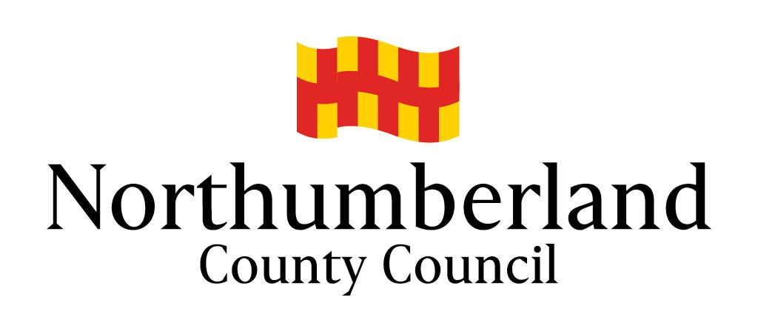

This report, with evidence of spend (receipts, etc), must be completed and returned within 12 months of the offer of the grant funding. Failure to do so will prevent consideration of future funding applications.

Project Title:
Name of Group/Organisation:
Project Start Date: | Project End Date:
What has the project achieved so far?
For example, did you achieve what you intended to, were there any unexpected benefits? (Please enclose photographs, press cuttings and any other relevant material where possible)
Which of the following parts of the community have benefited from the project?
Children and Young People, Older People, People with Disabilities, New Group Members Please give numbers and information about how they were included or involved.
How many local people were involved in helping to run the project and what help did they provide?

Items of expenditure (include all costs of the project) | Amount
Volunteer time:
Total

All sources of funding | Amount
NCC Community Chest Scheme
Volunteer time:
Total funding (must be the same as total costs)

Declaration
I declare that the managing committee of the organisation that received the grant has endorsed this monitoring report and that the information it contains is accurate to the best of my knowledge.

SIGNATURE: …………………………….…… NAME (print): ………………….…….…………….

POSITION: ……………………………………. DATE: ………………………………………………

Return to: Community Chest Scheme, Community Regeneration Team, Planning & Economy, Northumberland County Council, County Hall, Morpeth NE61 2EF.

Email: communitychest@northumberland.gov.uk

Feedback
Please let us know if you have any comments about your experience of the Community Chest Scheme, including any suggestions as to how it may be improved.

