Queen’s Platinum Jubilee  Fund 2022  Application Form | 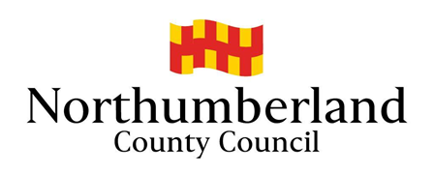

Applicant | Group/Organisation
Name: | Name:
Address:  Post code: | Address:  Post code:
Tel: | Tel:
Email: | Email:
Position: | Web:
Please give a brief description of your group/organisation.
What is the status of your group/organisation? (Tick all that apply)
⃞ Local Charity Charity Number: ………………………………… ⃞ Social Enterprise
⃞ Constituted Voluntary and Community Organisation ⃞ School ⃞ Parish Council
⃞ Other, please specify: ……………………………………………………………………………………
Please describe the project/activities that you plan to use your grant for.
Who will be the main beneficiaries of the activity/project? Please give numbers, ages.
When and where will the project/activity take place?

Please state how much money you need for your project and what it will be used for. If you can recover the Value Added Tax (VAT) you must only show the net amount.

Items of expenditure (include all costs of the project) | Cost
Total

Please list all contributions towards your costs, including any cash, grants, donations, and your own resources.

All sources of funding | Current Status  (secured or pending) | Amount
Total

Amount that you are requesting

I confirm that to the best of my knowledge and belief that all the information provided is true and correct. I understand that Northumberland County Council reserves the right to recover all or part of any grant award in the event of non-compliance with the terms of the grant.

I confirm that all relevant documentation has been provided and that the group/organisation is adequately covered for all liabilities from the running of the activity/project.

I accept that Northumberland County Council, its partners, agents or employees are not liable for any costs, losses or damages incurred as a direct result of the activity or project taking place.

SIGNATURE: …………………………….…… NAME (Please print): ………………….…………….

DATE: …………………………………………..

General Data Protection Regulation 2018 Privacy Statement
Northumberland County Council is the sole owner of the information collected by us. The information collected will enable us to ​correctly process your request regarding a Queen’s Platinum Jubilee Fund application. We will not provide your personal information to any other external organisation or individual unless it is lawful to do so, eg the prevention and/or detection of crime; where sharing is covered by a data sharing agreement or Service Level Agreement (SLA); or where you have provided explicit consent to do so. However, we will need to share your information with certain departments of this Council where necessary for the Council’s law enforcement functions, eg licensing, planning enforcement, trading standards and food safety, etc. If this is the case we are not required to, and will not, seek your consent to do so. The Council’s Privacy Notice can be found on the Council’s website and at Customer Information Centres.

