Risk Assessment Form (RA1)
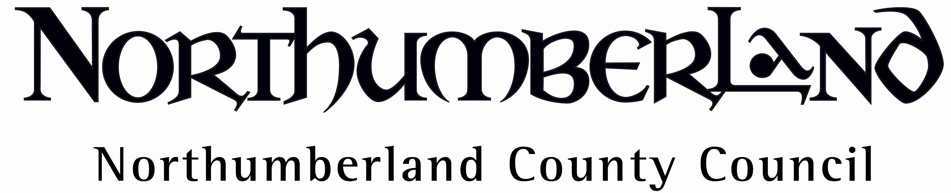

Department: All | Service: |  | Reference:
Activity: Use of electric microwave ovens. |  | Site: Non industrial kitchen
People at Risk: Employees. |  | Additional Information:
Name of Person Completing form ………...…..Job Title:……………….………………..............Date:……..…… |  |  |  | Review Date:…………..…

Risk Evaluation

Hazard | Risk | Initial Rating  (L, M, H,) | Existing Control Measures | Final Rating  (L, M, H,) | Additional Action Required (action by whom and completion date)
Switching on. | Electric shock.  Moving and handling injury. | M | Dry hands prior to operating switch.  Do not site high or low locations to avoid unnecessary bending and stretching.  Do not switch on when empty.  The microwave is inspected annually as part of portable appliance testing regime.
Hot food and containers. | Burns.  Scalds. | M | Puncture cling film and be aware of steam when removing.  Use protective cloths or gloves.  Do not use tinfoil or metallic containers. When possible leave containers to cool prior to removal.
Incorrect use of equipment or cooking procedure. This could lead to overheating or undercooking food. | Scalds and burns.  Food poisoning.  Electric arcing.  Fire. | M | Follow manufacturer’s recommended heating times for particular oven.  Stir as required. Check if food is thoroughly cooked.  Never put sealed containers or metal implements into a microwave.  Foods containing alcohol should not be heated in a microwave oven.  A fire extinguisher should be sited nearby.
Superheated liquids | Burns.  Scalds. | M | Do not heat pure liquids such as water. It is preferable to use a kettle for that purpose. If unavoidable, stir vigorously prior to heating and leave container to stand before continuing stirring. |  | Note! Microwaved water and other liquids do not always bubble when heated
Spillage of food & liquids. | Burns, scalds.  Slips, trips and falls.  Food poisoning | M | Cover food during heating.  Mop up and dry spills immediately both inside & outside oven.  A cleaning regime needs to be in place.  Sensible clothing & footwear should be worn.
Defective equipment. | Burns | M | A thorough cleaning regime needs to be in place.  Air vents at side and rear should not be obstructed.  Do not use if door does not close or if the interlock switch has broken. |  | Replacement of oven should be considered if showing signs of wear & tear. The low cost of replacement units may make repair uneconomical.

