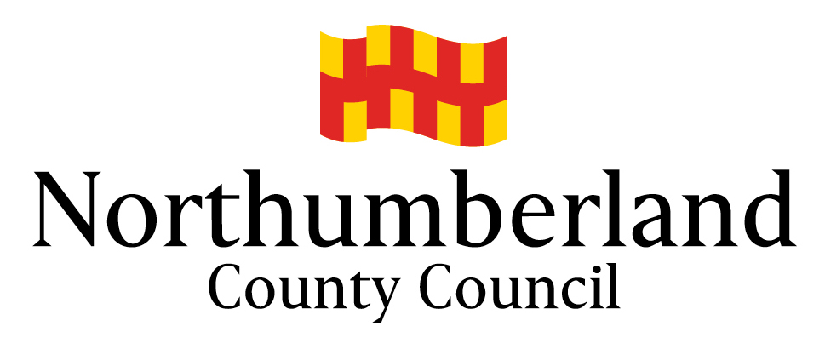

**Managing a Minibus – The Legal Requirements**

**Contents**

Introduction 1

Section 19 - The Main Points 1

Section 19 Permit Legislation 2

Minibus Drivers 3

*What is a Minibus?* 3

*Employees* 3

*Volunteer Drivers* 4

*Drivers of Permit Vehicles* 4

Duty of Care – Responsibilities 5

Conclusion 5

Contact Points 6

Appendix 6

# Introduction

Northumberland County Council (NCC) has produced this Advice Note on Section 19 (S19) permits to help educational establishments and charitable groups understand their roles and responsibilities when operating transport under the Local Transport Act 2008.

The above legislation made changes to the issuing and use of S19 permits. There are many organisations defined as a designated body that can issue permits to minibus owners and operators. In the main, the duty for issuing them rests with the Driver and Vehicle Standards Agency (DVSA). Though NCC is a designated body, it no longer issues S19 permits. Organisations that issue permits now have additional legal duties to ensure that applicants comply with the law before an operator is issued with a S19 permit and that, once it is issued, the recipient operates properly.

# Section 19 - The Main Points

S19 Permits can only be issued to organisations operating without a view to profit that are concerned with:

* Education
* Religion
* Social Welfare
* Recreation
* Other activities for the benefit of the local community.

The permit does not entitle the vehicle to carry passengers who are members of the general public. It must not be used with a view to profit. Category D1 (101) (not for hire or reward) licence holders are entitled to drive minibuses under a S19 permit that are operated for hire or reward in strict accordance with the S19 permit conditions.

The permit must be displayed in any minibus that is being used. It provides exemption from legislation that applies to commercial transport operators and their qualified drivers, and allows for some payment (not for profit) by passengers either directly or indirectly towards the running costs of the vehicle.

Further information can be obtained by using the links to the DVSA documents below.

# Section 19 Permit Legislation

The changes made to the S19 permit system have transferred more duties to the issuing body, in that it needs to be assured that the status of applicants is appropriate for S19 use and that they can operate vehicles safely.

In light of these changes, NCC strongly recommends that all S19 permit holders read and comply with the following documents:

* *Section 19 and 22 permits: not for profit passenger transport.* This was published by DVSA and can be accessed [here](https://www.gov.uk/government/publications/section-19-and-22-permits-not-for-profit-passenger-transport/section-19-and-22-permits-not-for-profit-passenger-transport)
* *Guide to maintaining roadworthiness – Commercial goods and passenger carrying vehicles*. This was published by DVSA and can be obtained [here](http://www.dft.gov.uk/vosa/repository/Maintaining_roadworthiness_PCV_1110.pdf)

These documents explain the legal responsibilities of permit holders when providing transport to passengers for any kind of payment (cash or kind) which gives a person a right to be carried on the vehicle on a ‘not for profit basis’.

Before issuing a permit to an operator DVSA, or other designated bodies, will need to be assured that the operator is undertaking the vehicle safety and maintenance checks. Once issued, the permit is not transferable to other organisations. It must be emphasised that the operator must not allow an organisation that does not have its own permit to use the minibus until such time as that body has obtained one.

When applying for a S19 permit it would be beneficial to request additional permits as a permit would be required for any extra hired minibuses that may be required in addition to an operator’s usual fleet. It is the responsibility of the person hiring the minibus to ensure he/she is operating all minibuses within the terms and conditions of the S19 permit; it is not the responsibility of the company hiring out the minibus to provide a S19 permit.

# Minibus Drivers

# *What is a Minibus?*

A minibus is a motor vehicle with between 9 and 16 passenger seats – the driver’s seat does not count for these purposes. It is described as a category D1 vehicle by the Driving Vehicle Licencing Authority (DVLA).

# *Employees*

In August 2013 the Department for Education (DfE), the Department for Transport (DfT) and the Association of Chief Police Officers (ACPO) jointly produced guidance on driver licence entitlement for those persons who drive a school minibus; however, the guidance is also relevant to charitable groups.  This guidance note seeks to clarify their interpretation of licensing requirements for driving a minibus.  In consequence, NCC has reviewed its policy and recent guidance the interpretation of licensing requirements for driving a minibus have changed. Members of staff who drive a minibus must have either:

* A Category D1 (101) minibus entitlement, together with a current MiDAS qualification. (Adult Services staff may undertake an in-house theoretical test and practical instead of MiDAS)
* A PCV category D or D1 entitlement. Because D1 training content and assessment exceeds that of MiDAS, once a driver has D1 on their licence, there would only be a requirement to undertake an additional MiDAS certification in certain cases. MiDAS should be considered in the following circumstances:
* If a driver only drives a mini bus occasionally. Experienced drivers who drive a minibus on a regular basis would not be required to undertake this.
* If the mini bus being driven has a tail lift or where disabled passengers are being transported. This is because MiDAS provides additional training in this aspect which is not covered in D1 training.
* If, following an assessment, it is deemed that MiDAS training is required, a driver would only need to undertake their first MiDAS certification 4 years after the date of passing their D1. This would be issued following an assessment of their competence by a MiDAS Driver Assessor Trainer. There would then be a requirement to renew this every 4 years.

Previously, staff with a Category B car licence (without D1 entitlement) - namely those who passed their driving tests after 1 January 1997 - were able to drive a minibus. This was made possible by an exemption gained for volunteer drivers who complied with specific conditions set out under the Minibus Section 19 permit.

The concession, obtained from the European Commission was intended for drivers volunteering to work for charities; it was not intended to cover staff driving a minibus. In consequence, it now transpires that employed members of staff who drive a minibus in the course of their work may not be identified as volunteers in law and thus require a D1 licence.

Drivers who passed their car test after 1 January 1997 who undertake minibus driving duties within their scope of paid employment must hold a full D1 (as above)

# *Volunteer Drivers*

Volunteer drivers who passed their driving tests after 1 January 1997 can continue to drive minibuses where the Section 19 exemption above applies, however, the vehicles they are driving must weigh less than 3.5 tons GVW or MAM or 4.25 tons GVW or MAM if fitted with accessible equipment. To drive minibuses weighing in excess of these weights, the driver will need to hold a full D1 licence, as defined above.

FOR FURTHER ADVICE ON TEACHERS PLEASE REFER TO “SCHOOL MINIBUS ADVICE AND GUIDANCE”

# *Drivers of Permit Vehicles*

The government has produced a useful document entitled ‘vehicles you can drive’ which identifies the vehicles that people are legally qualified to drive; it can be accessed [here](https://www.gov.uk/vehicles-you-can-drive).

Driving a small bus requires additional skills in order to handle the vehicle safely and specialist driver training courses are recommended. The Community Transport Association UK (CTA) promotes and administers a nationally recognised standard for the assessment and training of minibus drivers, which is known as MiDAS. This is a membership-based scheme that has been designed to enhance minibus driving standards and promote the safer operation of these vehicles. Member organisations range from small voluntary bodies operating one vehicle, to local authorities operating large fleets of minibuses, as well as schools, colleges and universities. MiDAS provides theoretical training and an on-road driving assessment for all minibus drivers. It is NCC’s policy that when undertaking Council business with passengers aboard all drivers must have passed the appropriate MiDAS course before they can drive a minibus.

*PLEASE NOTE*

*Because D1 training content and assessment exceeds that of MiDAS, once a driver passes their D1 they would need to undertake their first MiDAS certification training 4 years after the date of passing their D1. NCC drivers must, then, continue to hold a current MiDAS certification as detailed below.*

Regular refresher training is a significant element of MiDAS and in order to retain their MiDAS Certificate, drivers must attend refresher training every four years. MiDAS operates a ‘cascade’ approach. The CTA has appointed a number of training agents who provide training for minibus Driver Assessor/Trainers (DATs) nominated from member organisations. Once trained, a DAT can then assess the competence of other minibus drivers, and provide them with training on how to use a minibus safely.

DATs can also offer a course to those drivers who transport passengers with disabilities, particularly those who use wheelchairs.

Several individuals and organisations offer MIDAS courses suited to the education sector or Community Transport Operators. Those wishing to have their staff trained should satisfy themselves that the trainer is suitably qualified before using their services.

A selection of MiDAS Driver Assessor Trainers is provided in the appendix.

# Duty of Care – Responsibilities

A ‘duty of care’ is a [legal](http://en.wikipedia.org/wiki/Law) [obligation](http://en.wikipedia.org/wiki/Obligation) imposed on an organisation or individual requiring that they adhere to a   
[standard](http://en.wikipedia.org/wiki/Standard_of_care) of   
[reasonable](http://en.wikipedia.org/wiki/Reasonable_person) care while performing any acts that could foreseeably affect others.

It is the S19 permit holder’s responsibility to know who is travelling on their vehicle and this requires that personal details, including age, name, address and emergency contacts are recorded. Such information would be invaluable in the unfortunate case of accident or emergency. In addition, this information is essential to enable the S19 permit holder to prepare the vehicle and driver for any special needs or mobility difficulties that may be encountered. This means that such details must be obtained so that adjustments can be made to the vehicle prior to the journey.

# Conclusion

Schools, voluntary groups, community groups, colleges and other bodies providing transport and must comply with information bulleted below:

* Obtain a S19 permit and observe the permit regulations, including reading and complying with the documents cited in this guide
* Consider all the facts contained in this document before operating a minibus service
* Operate community transport with a duty of care towards every passenger
* Join MiDAS and maintain driver certification as required by NCC policy
* Have registration and booking systems which can demonstrate clearly the eligibility of their service users to travel, having taken full account of the factors contained in this document.

It may be of benefit to voluntary and community groups, schools, colleges and other bodies providing transport to become members of the Community Transport Association and have access to that organisation’s ‘advice leaflets’:

# Appendix

Please note that the contact details provided below are correct at the time of publication. The contacts are provided as guidance only. Those wishing to engage the services of training providers should satisfy themselves that the trainer is suitably qualified before using his/her services.

**Information:**

Iain Young

Fleet Transport

[Iain.Young@northumberland.gov.uk](mailto:Ian.Young@northumberland.gov.uk)

Mobile 07825403084

Karen Savage

Compliance Officer, Local Services

[Karen.Savage@northumberland.gov.uk](mailto:Karen.Savage@northumberland.gov.uk)

01670 62233