Health and Safety Inspection/Audit
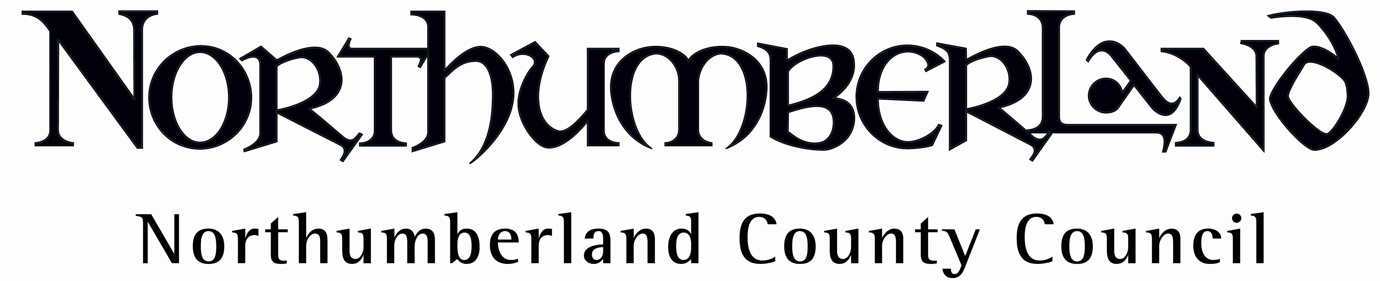
Guidance for Headteachers

Inspection Goals

The process of inspection/audit is intended to assist Headteachers and Governing bodies to discharge their responsibilities in ensuring adequate arrangements are in place to manage health and safety within a school. It also provides an opportunity, in the long term, for the County Council to collate information so that resources can be effectively targeted in the areas of greatest need.

How Long Will It Take?

This will depend on the size and type of school being inspected and the level of risk involved. Some inspections involving smaller First Schools may take three to four hours, inspections at larger High Schools may take several days. The estimated time will be discussed when the appointment is made.

What Will Be Covered?

As well as a visual inspection of the school building and grounds, an audit of the management systems in place to provide a safe and healthy environment will be included. There will be an element of the inspection that refer to property issues, however, the Property Services Help Desk remains the appropriate contact for reporting defects in buildings (where this service is covered by SLA). In some cases, particular issues may require more detailed advice and a separate meeting may need to be arranged in addition to the general inspection.

What Sort of Preparation Should Be Necessary?

In order to maximise the benefit of the inspection the following documentation should be available, where applicable;

- School Local Health and Safety Policy
- Risk assessments
- Safe working procedures
- COSHH risk assessments and Safety Data Sheets
- Fire Log Book – including fire risk assessment, testing records and fire drill records
- Policy on Supporting Pupils with Medical Conditions – including a sample of parental consent forms, care plans etc.
- Asbestos survey
- Contractor documentation – “Contractors Induction Pack” (if available), sample of completed HSC1/N1 forms
- Inspection Records e.g. portable electrical equipment, hoists, ladders
- Water hygiene records, including flushing log (where applicable)
- Health and safety training plan and training records
- Any other statutory required records.
- Emergency Plan

In addition, it would be a good idea to discuss any current safety concerns with staff members prior to the inspection so that they may be raised during the course of the inspection.

Who Should Be Involved?

The inspection should normally be carried out with the Headteacher. If this is delegated to other members of staff, a period of time should be set aside at the beginning and end of the inspection to discuss the safety management issues with the Headteacher (approximately 1 hour should be set aside at the end of the day). In Middle and High schools it may also be necessary for departmental heads to be available to discuss their specialist areas. The inspectors will also need to meet with the Caretaker and Kitchen Manager

Trade union Safety Representatives and Safety Co-ordinators (where appropriate) should be made aware that the inspection is scheduled and should be involved in the inspection if possible.

What Happens After The Inspection?

A written report, which includes an action plan, will be sent via email to the Head following the inspection. If any dangerous activities or processes are discovered which require immediate action, this will be fed back verbally to the Head on the day of the inspection and confirmed via email within one working day. To comply with the team’s internal audit protocols appropriate monitoring of the above Action Plan will be carried out.

The Corporate Health and Safety Team are always available to advise on any aspect of the content of the report.

