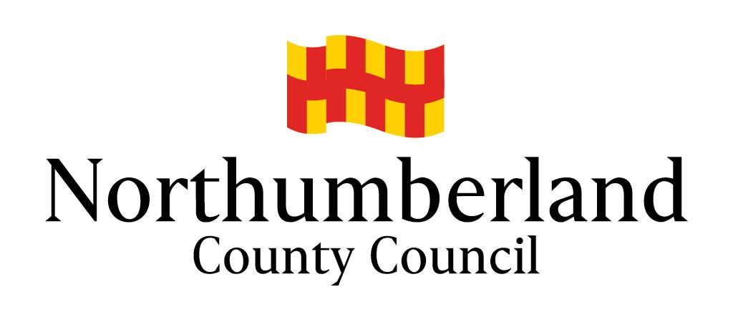

Policy Statement on Health and Safety at Work

August 2021
Statement of Policy on Health and Safety at Work
Northumberland County Council

Health and Safety at Work Act 1974

Our statement of general policy is to:

- ensure the health, safety and welfare of all persons at work.

- protect visitors, contractors and the general public who attend our premises/sites or who are affected by our undertakings, from risks to their health and safety which may arise from such activities.

- provide the necessary resources to comply with the Health and Safety at Work Act and all associated legislation concerning health, safety and welfare.

- identify hazards and provide adequate control of the risks arising from our work activities.

- provide and maintain safe plant and equipment.

- ensure the safe use, handling, storage, transport and disposal of materials and substances.

- provide information, instruction and supervision for employees.

- ensure that all employees are competent to do their tasks, and to give them adequate training.

- maintain safe and healthy working conditions and ensure that the means of access to and egress from workplaces are safe.

- consult with our employees on matters affecting their health and safety.

- prevent accidents and cases of work-related ill health.

- monitor health and safety performance on a regular basis.

- provide appropriate personal protective equipment, where necessary.

- bring the approved Corporate Health and Safety Policy Manual to the attention of all employees and, where necessary, other persons affected by County Council activities. Health and Safety Policies will be reviewed and revised as necessary.

Organisation

The Chief Executive has overall responsibility for all matters relating to the health, safety and welfare of every person employed by the County Council and for ensuring that members of the public who may be affected by any of its activities are not thereby exposed to risks to their health or safety.

In turn, the Executive Directors indicated below are responsible for all matters relating to health, safety and welfare within their respective services:

- Chief Executive
- Executive Director of HR and OD and Deputy Chief Executive
- Executive Director of Finance (section 151 Officer)
- Executive Director of Adults & Children’s Services
- Executive Director of Place
- Executive Director of Regeneration, Commercial & Economy

All Service Directors and Heads of Service are responsible for ensuring that adequate health and safety management arrangements are in place within their area of responsibility.

The Council has appointed Rick O’Farrell - Executive Director of Place, as Health and Safety Champion. This role has special responsibility for promoting health and safety and has been established to ensure that a high-level health and safety profile is maintained by senior leadership. It does not remove any primary responsibilities from the Chief Executive and the other Executive Directors. An Elected Member, Paul Scott, has also been nominated as the Member Health and Safety Champion.

All employees have a duty to exercise personal care and responsibility towards themselves and others, and to cooperate with the County Council in the execution of this policy. Further information on roles and responsibilities of staff at all levels can be found in “Section D - Organisation” of the Corporate Health and Safety Manual.

Arrangements

The Council will take all reasonable steps to meet its responsibilities through appropriate and effective arrangements.

Safety policies, risk assessments and safe working procedures will specify health and safety arrangements in sufficient detail to enable individual employees to promote safe and healthy working practices.

The Council is committed to the maintenance of high standards of workplace health and safety. The Executive Team receive a monthly performance dashboard report to monitor the health and safety performance of the organisation to ensure that targets are met. The Heads of Service annual health and safety audit is used to monitor service health and safety strategic arrangements, the results of which are reported to Executive Team.

Further detailed information on the Council’s health and safety arrangements is provided in the Council’s Corporate Health and Safety Policy Manual.
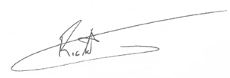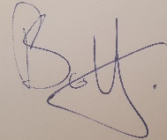

Daljit Lally  Chief Executive | Rick O’Farrell  Health & Safety Champion | Councillor Paul Scott  Member Health & Safety Champion

Date: 11 August 2021

