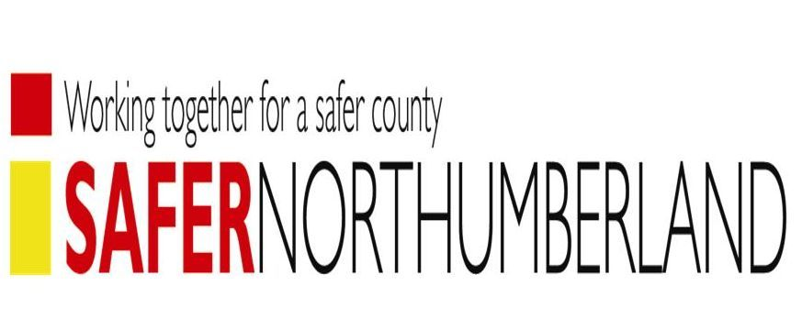
Report to: Safer Northumberland Partnership Board

Date: 24 March 2016

Subject: Extract of Home Office Letter ( 23/9/15) in relation to Northumberland Domestic Homicide Review

Reference: SNP/DHR/1/2013 - Julia

Report Author: Allan Brown, Domestic Abuse / Sexual Violence Policy Officer
Allan.brown@northumberland.gcsx.gov.uk

