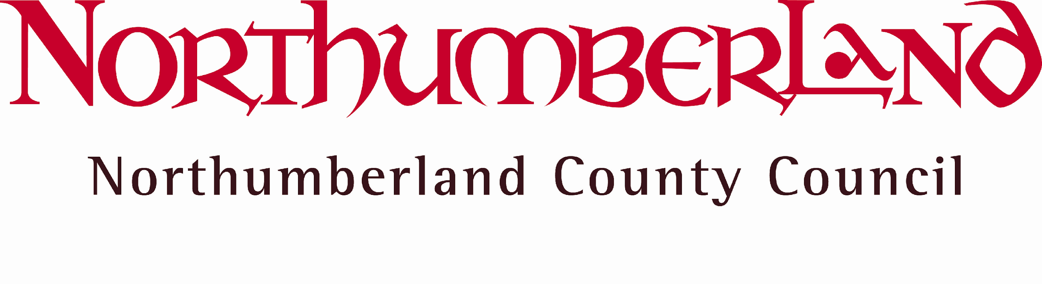
County Hall Morpeth Northumberland NE61 2EF
Web: www.northumberland.gov.uk

The Occupier | Our Ref: |  | 2017/075
 | Your Ref:
 | Contact: |  | Andy Walker
 | Direct Line: |  | 01670 620420
 | E-mail: |  | Highways programme@northumberland.gov.uk
 |  |  | Wednesday 8th November 2017
Dear Sir/Madam

Proposed – Introduction of a ‘No Through Road’ restriction
Lysdon Avenue, New Hartley

At the request of a resident and with the support of County Councillor, Dungworth, the County Council is proposing the introduction of a ‘no through road’ restriction on a section of Lysdon Avenue, New Hartley on safety grounds.

I am therefore writing in accordance with Regulation 5 of the Local Authorities Traffic Orders (Procedure) (England and Wales) Regulations 1998 (as amended) to formally ask for your comments on the proposal to introduce a ‘no through road’ restriction at Lysdon Avenue, New Hartley as shown on the attached plan.

The County Council is seeking your views on the proposals and a freepost response form is attached to facilitate the consultation process.

Regrettably, it is not possible to reply to individual comments, but you may wish to note that comments may be included in a Decision Report, to the Executive Director of Local Services and may be available for public inspection. The closing date for any comments you may wish to make is Friday 1st December 2017. If you wish to respond to this consultation online, please visit the web address http://trafficconsult.northumberland.gov.uk/.

I thank you for your assistance in this matter.

Yours faithfully

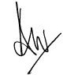

Andy Walker
Technical Assistant (Members Small Schemes)

