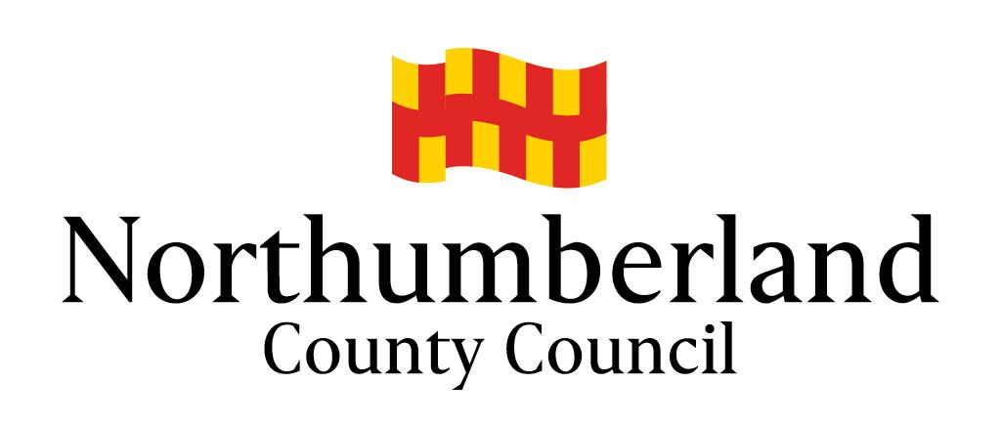  COMMENTS FORM | For official use only:  Consultee ID:  Agent ID:  Date received:  Date acknowledged:  Date processed:
Northumberland Local Plan
Draft Plan Regulation 18 Consultation (July 2018)

We are inviting comments on the draft Local Plan and this form should be used to make comments in response to this consultation.

The consultation period begins on Wednesday 4 July 2018 and ends at 5pm on Wednesday 15 August 2018.

Comments can also be submitted online using our interactive website at http://northumberland-consult.limehouse.co.uk/portal/planning/localplan/reg18. We would prefer for comments to be submitted in this way as it saves us time and reduces our costs.

An electronic version of the representation form can also be found on this website and paper copies of the form are available from us on request.

Please note:
- Responses must include your name and address.
- Your comments cannot be treated as confidential. By completing this form you agree to your details being shared and your name and comment (but not your address or other personal details) being made available for public viewing.
- It is recommended that groups that share a common view send a single response rather than multiple copies of the same response. Please attach a list of the contact details of each person who supports the comments, including their names and addresses.
- Completed comment forms can be returned to us via email to PlanningStrategy@northumberland.gov.uk or by post to Planning Policy, Northumberland County Council, County Hall, Morpeth, NE61 2EF.
- Completed forms should be received by us no later than 5pm on 15 August 2018

Section 1 – Your details
 | - Personal details | - Agent details (if applicable)
Title
Name
Organisation / group
Address 1
Address 2
Address 3
Address 4
Postcode
Telephone number
Email address

If you are replying on behalf of a group, how many people does it represent (Only complete where applicable, see point 3 above)
Section 2 – Your comments

To which part of the draft Local Plan do your comments relate? Please state the policy number, paragraph number or figure number.
What is the nature of your comments? [tick as appropriate]
General comment |  |  | Support |  |  | Objection
Provide your comments below:
Expand this box as necessary or attach additional sheets. If attaching additional sheets, please clearly mark these with the consultation question that the representation relates to and your name.

To which part of the draft Local Plan do your comments relate? Please state the policy number, paragraph number or figure number.
What is the nature of your comments? [tick as appropriate]
General comment |  |  | Support |  |  | Objection
Provide your comments below:
Expand this box as necessary or attach additional sheets. If attaching additional sheets, please clearly mark these with the consultation question that the representation relates to and your name.
To which part of the draft Local Plan do your comments relate? Please state the policy number, paragraph number or figure number.
What is the nature of your comments? [tick as appropriate]
General comment |  |  | Support |  |  | Objection
Provide your comments below:
Expand this box as necessary or attach additional sheets. If attaching additional sheets, please clearly mark these with the consultation question that the representation relates to and your name.

To which part of the draft Local Plan do your comments relate? Please state the policy number, paragraph number or figure number.
What is the nature of your comments? [tick as appropriate]
General comment |  |  | Support |  |  | Objection
Provide your comments below:
Expand this box as necessary or attach additional sheets. If attaching additional sheets, please clearly mark these with the consultation question that the representation relates to and your name.

To which part of the draft Local Plan do your comments relate? Please state the policy number, paragraph number or figure number.
What is the nature of your comments? [tick as appropriate]
General comment |  |  | Support |  |  | Objection
Provide your comments below:
Expand this box as necessary or attach additional sheets. If attaching additional sheets, please clearly mark these with the consultation question that the representation relates to and your name.

To which part of the draft Local Plan do your comments relate? Please state the policy number, paragraph number or figure number.
What is the nature of your comments? [tick as appropriate]
General comment |  |  | Support |  |  | Objection
Provide your comments below:
Expand this box as necessary or attach additional sheets. If attaching additional sheets, please clearly mark these with the consultation question that the representation relates to and your name.

To which part of the draft Local Plan do your comments relate? Please state the policy number, paragraph number or figure number.
What is the nature of your comments? [tick as appropriate]
General comment |  |  | Support |  |  | Objection
Provide your comments below:
Expand this box as necessary or attach additional sheets. If attaching additional sheets, please clearly mark these with the consultation question that the representation relates to and your name.

To which part of the draft Local Plan do your comments relate? Please state the policy number, paragraph number or figure number.
What is the nature of your comments? [tick as appropriate]
General comment |  |  | Support |  |  | Objection
Provide your comments below:
Expand this box as necessary or attach additional sheets. If attaching additional sheets, please clearly mark these with the consultation question that the representation relates to and your name.

Section 3 – Declaration

How we will use your personal information
The personal information you provide on this form will be processed in accordance with the requirements of the Data Protection Act 2018. The information you provide will only be used for the purposes of the preparation of the Local Plan as required by the Planning and Compulsory Purchase Act 2004, and may be used by the Council to contact you if necessary regarding your submission. Your name, organisation and comments will be made available for public inspection when displaying and reporting the outcome of the statutory consultation stage, and cannot be treated as confidential. You will not be asked for any unnecessary information, and in order to protect personal data, we will not publish signatures, telephone numbers, addresses or email addresses on the internet.

Your details will be kept until the Local Plan is adopted plus a further five years to evidence that a fair and transparent process has been followed. Processing is kept to a minimum and data will only be processed in accordance with the law. When other agencies are involved in Local Plan Preparation, we may need to share details about you to enable us to work together for your benefit. Information will only be shared with third parties if they have genuine and lawful need for it. Information shared on this basis will not be reused for any other purpose. We will take all reasonable precautions to protect your personal data from accidental or deliberate loss or unauthorised disclosure.

Please sign and date this form. Forms signed electronically will be accepted.
Declaration:
By completing and signing this form, I agree to my name, organisation and representations being made available for public inspection on the internet.

Signature: |  |  | Date:

We would also like to retain your contact details on our database to keep you informed of future Local Plan consultations and updates.

Yes, please add me to your database
No, I do not wish to be added to your database

A copy of our privacy notice is available on our website - www.northumberland.gov.uk/localplan

