Public Notice

Town and Country Planning Act 1990, (Section 61G)
The Neighbourhood Planning (General) Regulations 2012 (Regulation 6)

NOTICE OF CONSULTATION ON APPLICATION FOR DESIGNATION OF A NEIGHBOURHOOD AREA

Northumberland County Council hereby gives notice that Wooler Parish Council has submitted an application for the designation of a ‘Neighbourhood Area’ under Regulation 6 of The Neighbourhood Planning (General) Regulations 2012.

Wooler Parish Council is a ‘Relevant Body’ for the purposes of Section 61G of the Town and Country Planning Act 1990 and is therefore qualified to undertake neighbourhood planning. The proposed Neighbourhood Area covers the whole of Wooler Civil Parish area as shown on the map below.

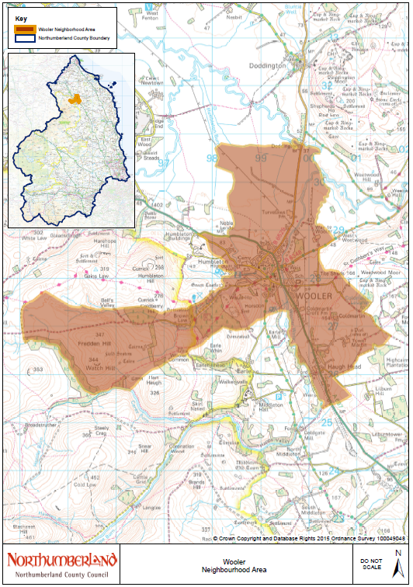

The application including the proposed boundary and supporting statement submitted to Northumberland County Council can be viewed on the council’s website at www.northumberland.gov.uk or in person at Wooler Library, Cheviot Centre, Padgepool Place, Wooler, NE71 6BL; Berwick Library, Walkergate, Berwick-Upon-Tweed, TD15 1DB; Council Offices Wallace Green, Berwick-upon-Tweed, Northumberland TD15 1ED; and County Hall, Morpeth, NE61 2EF during normal opening hours.

If you wish to make representations on the proposed neighbourhood area, these must be made by email or letter. Representations must be received by the County Council on or before Friday 20 November 2015.

Please address any comments to: David English, Communities and Infrastructure Team, Northumberland County Council, County Hall, Morpeth, Northumberland, NE61 2EF. Email: David.English@northumberland.gov.uk Tel: 01670 623619

