Application to Modify or Discharge Section 106 Planning Obligation

The Town and Country Planning (Modification and Discharge of Planning Obligations) Regulations 1992

Office Use Only
Reference Number
Received Date
If returning by post please send to:
Development Management,
Northumberland County Council,
County Hall, Morpeth, NE61 2EF

Email Address: Planning@northumberland.gov.uk
Telephone: 01670 627040

Complete the form in block capitals using black ink.

The fee for this application is £316 (plus normal legal fees).

Please supply a copy of the Official Title Plan of Land Registry to which the land and S106 agreement relates.

- Your details

Name:
Address:
Post Code:
Email Address:
Contact Number:

2. Agent details if applicable

Name:
Address:
Post Code:
Email Address:
Contact Number:

3. Full postal address of the site to which the obligation relates:

Development Site Address:

4. Nature of the applicant’s interest in the land:

5. Please provide sufficient information to enable us to identify the planning obligation (Planning Reference numbers, date of agreement etc.)

Planning Application Reference Number:
Date of Agreement:

6. What reason(s) do you have for applying for the modification or discharge of the obligation?

Checklist: Please tick

A 1 x Original form completed, signed and dated Certificate A,B,or C as applicable
B 1 x Copy of a map identifying the land to which the obligation relates
C 1 x Copy of such other information as you consider relevant to the determination of the application
D 1 x Copy - supply the latest version of the official copies of land registry
Please note, A title plan and title register, dated within the last 3 months, will be required by our legal department if and when a new agreement is to be drawn up.
E 1 x Served or published a Notice of application on interested parties
F 1 x Fee of £316

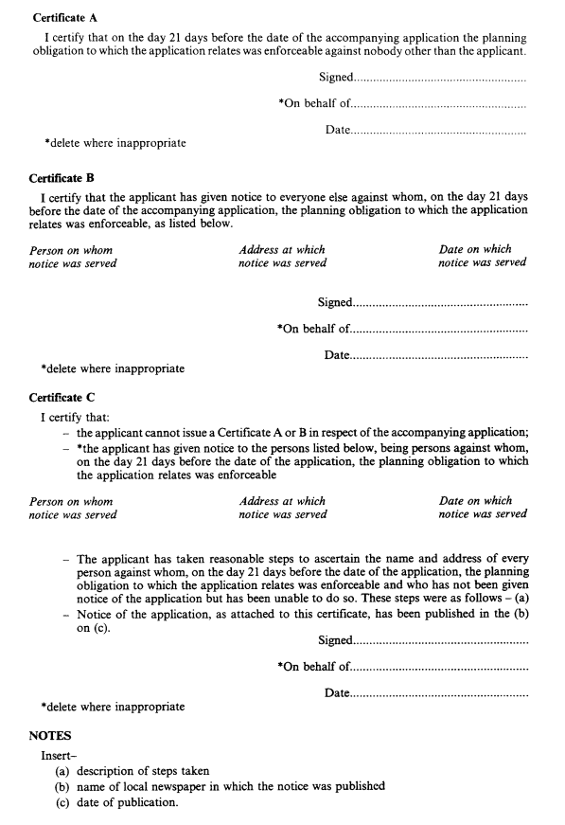
Regulation 5(2)

NOTICE OF AN APPLICATION TO MODIFY OR DISCHARGE A PLANNING OBLIGATION UNDER SECTION 106A OF THE TOWN AND COUNTRY PLANNING ACT 1990
