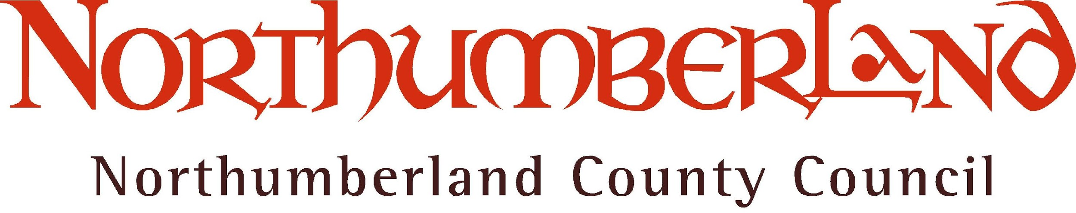

Tender for Licence to trade from a car park operated by Northumberland County Council (“the Council”)

Proposed Licence period: 01 April 2017 to 31 March 2020

Tender Return
- A Tender is hereby submitted for a Licence to be granted to permit trading from the car park indicated in the Schedule to this return in consideration of the annual sums set out in the Schedule during the period 01 April 2017 to 31 March 2020.
- I understand that if the Tender is accepted by the Council, I will be required to enter into a formal Licence Agreement with the Council and will be subject to the terms and conditions of such Licence.
- I understand that if the Tender is accepted by the Council, I will be required to hold a Street Trading Consent for each location.
- This Tender is submitted by:
Full name and title of applicant:
Name of company or trading name (if appropriate):
Address:
Postcode:
Telephone numbers:
Work:
Home:
Mobile:
E-mail address
5 I wish to tender to trade from the car parks indicated in consideration of the annual sums specified:

 |  | Annual period/tender sum (£)
Location | Articles to be traded | 01/04/17- 31/03/18 | 01/04/18- 31/03/19 | 01/04/19- 31/03/20
Links Road Car Park, Bamburgh | Ices, confectionery and soft drinks only
Beadnell Car Park (Main Parking Area), Beadnell | Ices, confectionery and soft drinks only
Beadnell Car Park (Main Parking Area), Beadnell | Hot and cold food and drinks and confectionery only (NO ices)
Castlegate Short Stay Car Park, Berwick | Ices, confectionery and soft drinks only
Greens Haven/Sandy Beach Car Park (Magdelene Fields), Berwick | Ices, confectionery and soft drinks only
Craster Quarry Car Park, Craster | Ices, confectionery and soft drinks only
Craster Quarry Car Park, Craster | Hot and cold food and drinks and confectionery only (NO ices)
Chare Ends Car Park, Holy Island | Ices, confectionery and soft drinks only
Chare Ends Car Park, Holy Island | Fresh fish and shellfish only
Low Newton Car Park, Low Newton-by-the-Sea | Ices, hot and cold food and drinks and confectionery
Newton Steads Car Park, High Newton-by-the-Sea | Ices, hot and cold food and drinks and confectionery
Cowhaugh Car Park, Rothbury | Ices, confectionery and soft drinks only
Old Station Yard Car Park, Seahouses | Ices, confectionery and soft drinks only
South Greenwich Road Car Park, Spittal | Ices, confectionery and soft drinks only

6 I enclose a detailed Risk Assessment for both the public and staff with this Tender:
- Risk assessment for public
- Risk assessment for staff

Signed: | [applicant’s signature]
Dated:

The completed Tender and accompanying documentation must be returned by 12 noon on Friday 3 February 2017 to:

Democratic Services
Northumberland County Council
County Hall
Morpeth
Northumberland
NE61 2EF

The envelope should be clearly marked in the top left hand corner ‘Tender for Trading in NCC car parks’.

