F

**Northumberland County Council**

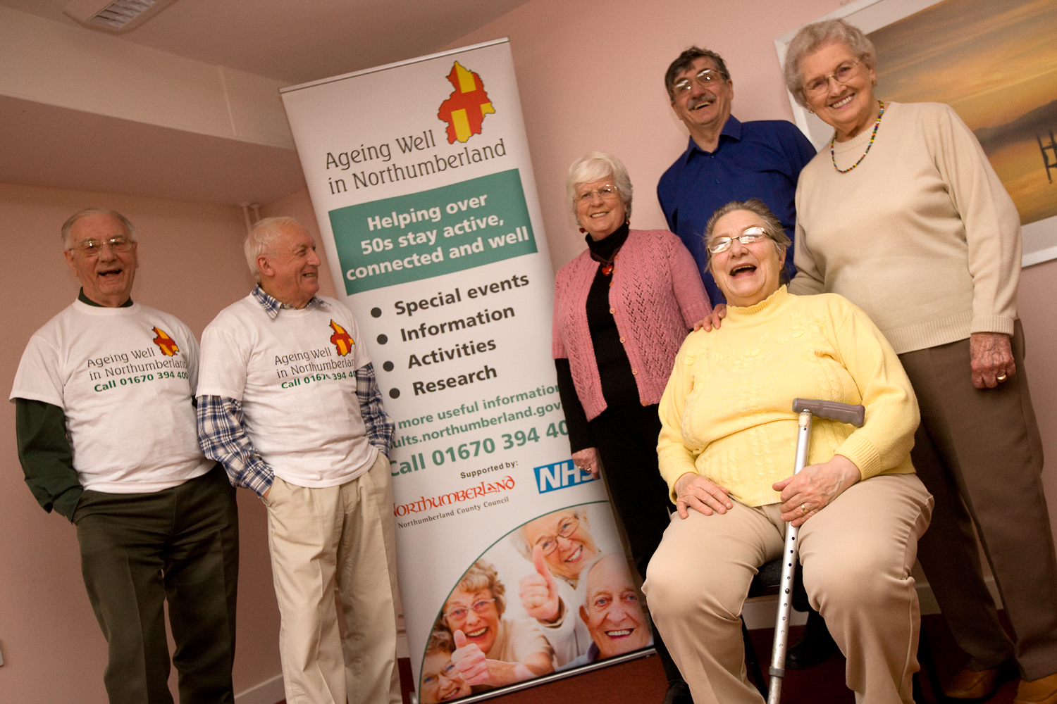

**Market Position Statement for older people**

**Where do we want to go?**

Older people are part of what makes Northumberland a distinctive place to live.

The quality of life our communities offer people of all ages is one of the reasons people choose to live here, work here, holiday here and remain here.

Northumberland offers a range of varied and stimulating work, leisure and learning opportunities which are now being taken up by increasing numbers of people. Its towns and villages provide attractive housing options for older people in locations served by a range of community facilities which support a long and active independent life.

We want older people - and where relevant their carers - to have full access to the life of the county and as part of this we want to make the most of their contribution to our communities.

We will encourage organisations providing services to older people to:

* work to build upon the potential that older people have
* help build their knowledge, interests and connections
* support other local businesses and services to become more welcoming and accessible to older people
* encourage organisations with a record of best practice to look at marketing directly to people with their own revenue and clear ideas of what they’d like to purchase.

The council wants to work with all these businesses and interested parties to influence them and support them to make this vision a reality. Money has never been tighter – and the pressure to get the best out of what we do have has never been more urgent.

It is a journey we would like you to make with us

**Working in partnership**

The work of the county’s older people – and their carers - through *Ageing Well in Northumberland* has received national recognition.

There are a range of partnership arrangements:

* The Older People’s Partnership Board
* Meetings with providers and commissioners to discuss and agree the operation of the annual round of monitoring arrangements and further issues brought to the table by the council and service providers
* Carers Northumberland
* Older People’s Forums
* Opportunities for Older People (a networking group).

This Market Position Statement will build on a dialogue with providers and businesses in the county, and others considering coming here, so that

* we agree what good support looks like
* we make best use of natural supports and daily community opportunities
* we design and deliver services that match what people want
* the commissioners and providers of services have a shared understanding of the local market
* the council is clear about its priorities for commissioning and how it sees the future, and has shared this with providers.

**Standard 5:** Helping me to make choices: I get help to make my own decisions and about how I live my life and how I am supported. If that is not possible, decisions are made with the help of my carers and/or and advocate.

**Standard 6:** Involving and caring about relatives and friend who support me: The role of any family member or friend providing unpaid care and support of me is promoted, valued and recognised.

**Standard 7:** Information about me and my support: I receive and understand information about my care and support. I know that it is kept confidential, and used to get my support right and to do the best for me.

**Standard 8**: Managing and paying for my support: I choose how I am supported, and all the things are in place that can help me manage my support, in a way that suits me; I am charged a reasonable cost and only for services that I need.

Our quality standards describe what a good service looks like for individuals and the people supporting them. They offer a framework which providers can use to show their strengths and describe their unique contribution. The eight standards also set out the minimum needed to make things work well:

**Standard 1**: Getting my support right: I get the best support possible, which helps me take control and fulfil my personal goals and dreams; I am listened to and involved in my care and treatment.

**Standard 2**: Having the right people to work me: I have a good and positive experience of people involved in my treatment and support.

**Standard 3:** Helping me to feel safe and take responsibility: I feel safe and an equal citizen with the same rights and responsibilities as other people and get the right support to enable me to take part in my community as much as possible.

**Standard 4:** Helping me to keep healthy and feel good: I choose how to be healthy. I have the information and advice I need to feel empowered

and make the right choices for me.

**How will we know when we get there?**

*Our ambitions for service outcomes in Northumberland*

The Care Act….

…sets out the vision for a reformed care and support system:

* “The Government supports the diverse range of care providers that currently offer care and support, including user and carer led organisations, small and micro enterprises and social enterprises.”
* “A local authority must promote the efficient and effective operation of a market in services for meeting care and support needs with a view to ensuring that any person in its area wishing to access services in the market has a variety of providers to choose from who…provide   
  a variety of services.”

Northumberland’s Commissioning Plan for Older People with a disability or illness 2012-15

This plan sets out our shared intentions for the older persons services which we commission to:

* promote independence and the use of ordinary, everyday services
* increase personalisation, individual choice and service users’ control
* improve service quality.

It is available at **http://tinyurl.com/qgtc7cu**.



This Market Position Statement

* gives information and analysis which describes what people and services look like now
* flags the changes to the sort of care and support we think that people will want to increase independence, choice and control
* sets out how we plan to work with the market and how we will discourage poor practice
* helps businesses understand the future environment for their work and decide how to grow in future.

It will be useful for everyone involved with older persons services: people using the services, their carers and those providing them; people who receive public funding and people who fund services themselves.

***Existing providers already delivering services in Northumberland*** can use it to help plan any changes which might be necessary and shape their services in future.

***Other local businesses, including voluntary and community organisations*** can learn about future opportunities and what would enable them to build on their knowledge of local needs to develop new activities and services.

***Social care providers and organisations not currently active in Northumberland*** can find opportunities to use the strengths and skills they have gained elsewhere to benefit local people and develop their business.

***People interested in local business development and social enterprise*** can speculate about new opportunities in the market and tell us what would help them to come into social care markets and offer innovative services.

***People (and carers) who purchase services either from their own resources or useing a personal budget/Direct Payment*** will get an overview of what is available and the different models of provision.

Page | 3

**THE CARE ACT IN BRIEF**

The Care Act 2014 is the most important statutory change in social care for two decades. It confirms much of the existing law and introduces a number of new features:

* A council duty to provide preventative services
* A council duty to promote integration with health
* A council duty to provide information on care and support
* A council duty to oversee the social care market and promote variety and quality
* A duty to co-operate with councils when asked
* New statutory eligibility criteria
* A social care costs cap for individuals
* A council duty to meet carers’ needs
* A duty to arrange advocacy where needed
* A new local authority responsibility for the social care of prisoners.

The scale and complexity of the changes means that it is difficult to plan ahead, particularly as changes to finance will not become clear for some months.

**What is happening nationally?**

Adult social care is changing radically. Important messages about how this transformation affects services include:

* Older people are being given more control and choice over the support they need.
* Funding for services will be affected by implementation of the reforms introduced by the Care Act in 2016.
* People now have the opportunity to have a personal budget. They can use this to design a personal package of care and support that meets their individual needs. They will be able to choose services from a range of providers. This could include a mix of traditional and mainstream services.
* Some people will also be funding their own care needs in the future and consequently will want direct discussions with service providers.
* The aim is to give older people the same opportunities and responsibilities, aspirations and life chances as other people. This is about making sure older people are involved in, and in control of, decisions made about their lives; have greater access to housing provision, health, education, leisure and transport opportunities; and can participate in family and community life.
* There is a key shift from caring to enabling and developing independence.



**Key messages from older people**

Older people and their carers tell us it is a priority to stay living in the communities where they live now, often in their own home.

Making their own decisions about their daily lives is very important. They want to stay connected to, and feel involved in a network of different kinds of relationships - friends, family and their communities.

If they need it they would like easy access to information, help and advice.

They tell us it is important that:

* They are supported to maintain as much independence as they can
* Staff supporting them have the skills and knowledge to communicate with them, maintain their dignity and support personal choice.
* There is good communication between care providers, health and other statutory services the individual and families

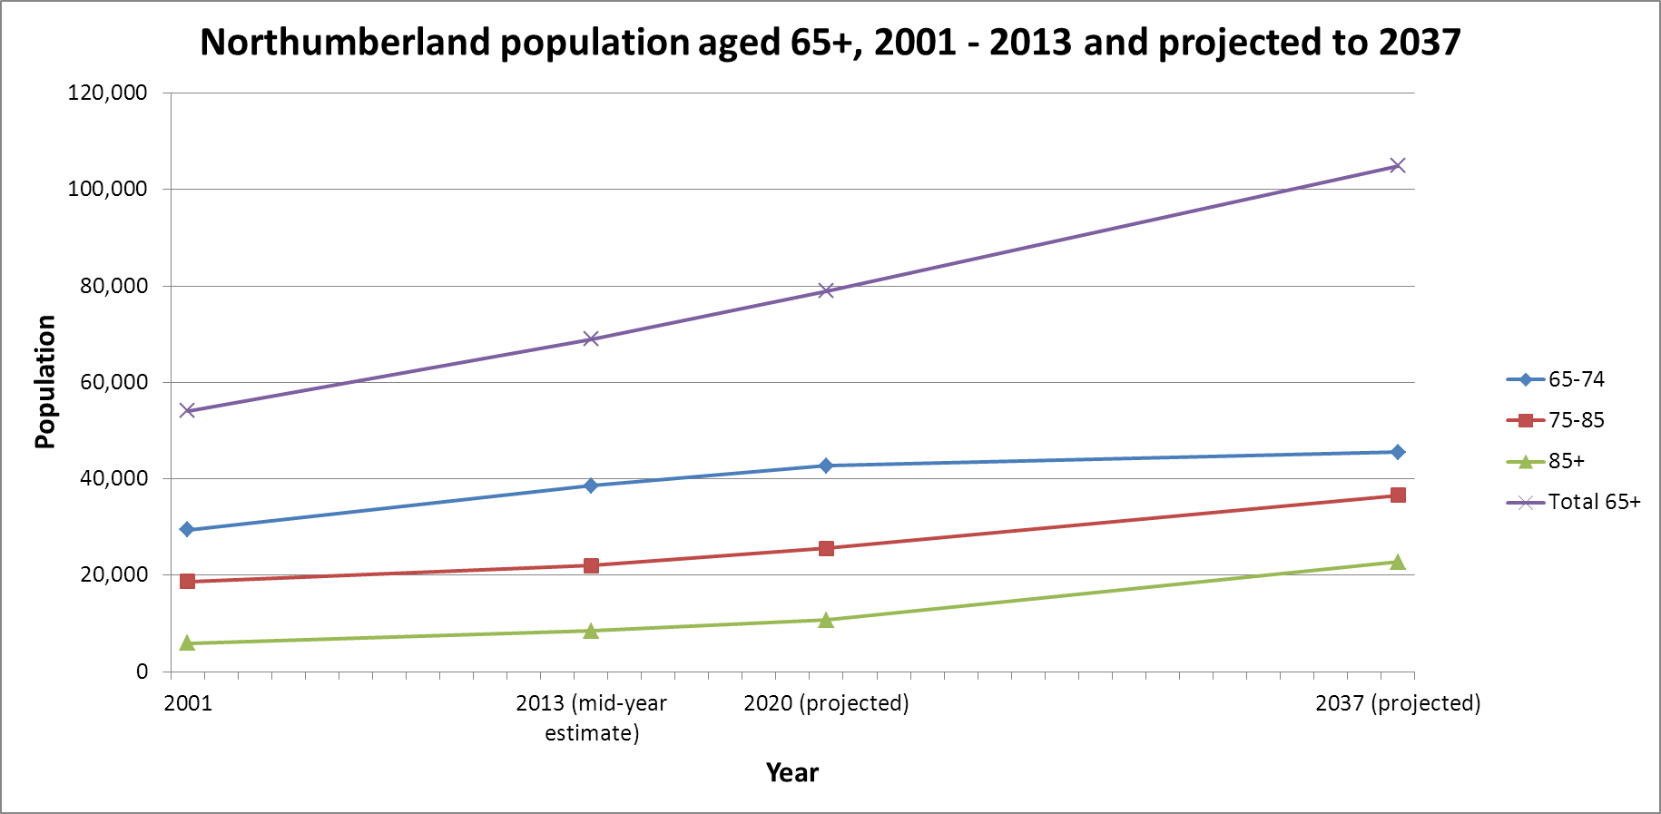

What do older people and their carers say about services?

In the most recent survey of the people who use adult social care services (the Adult Social Care survey 2013-14):

* 94% of people who expressed a view were satisfied with the care and support they received
* 79% of those people who expressed a view felt they had control over their daily life
* 87% felt those services make them feel safer and more secure.

What do older people and their carers say about their quality of life?

In the Adult Social Care Survey 2013/14 carried out in Northumberland, some 60% of older people rated their quality of life as either so good it could not be better, very good or good.

**We are living longer**

The average UK life expectancy is now 82 for women and 78 for men. 100 years ago, UK life expectancy was only 54 for women and 50 for men. A baby born today has a 26% chance of seeing its 100th birthday. In Northumberland the average life expectancy is 80.9 for women and 77.3 for men.

Across the North East there are some examples of innovative work to improve the provision of appropriate housing for people with dementia; this includes private, public and charitable sectors initiatives. However, there is a need to share these innovative practices and work with providers to implement them across Northumberland.

**Key points**

* The population over 65 is expected to increase significantly, rising to over 100,000 by 2037.
* Within this overall increase the numbers of “younger old” are estimated to increase less quickly after 2020.
* 75 – 85 year olds will increase relatively steadily over the period – an overall percentage change of around 2/3rds
* The increase in the “older” group, those over 85 will increase most steeply, rising to over 20,000 during this period – a percentage change of over 150%.

**Older people in Northumberland 2001 - 2037**

**Older people in Northumberland 2001 - 2037**

**Demanding Times:** older people receiving services in Northumberland

|  |  |  |  |
| --- | --- | --- | --- |
| **Older people receiving care services** | | | |
| **Age range** | **At 31/03/2014** | **2020 projected** | **% change** |
|
| 65-74 | 992 | 1096 | 10.5 |
| 75-84 | 1810 | 2101 | 16.1 |
| 85+ | 2205 | 2809 | 27.4 |
|  | **5007** | **5728** | **14.4** |

The increasing age of the population in Northumberland is predicted to mean increases in the demand for social care and support from older people.

Using the information we currently hold on the number of older people receiving social care services, and the predicted trends based on information in the latest census, it is possible to estimate future number of older people receiving social care and support (see the charts left and below).

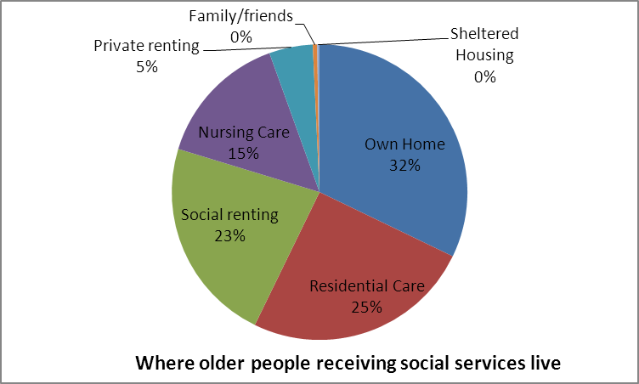

**Living in the community**

Nearly 1,500 older people who receive a social care service own their own home or have a home as part of a shared ownership scheme. Over 1,000 rent from social landlords, while over 200 have private landlords. Only around a quarter of those receiving support live in residential care.

Where older people receiving social care live

Of the 1800 older people receiving social care services in 2014, the majority (55%) live in the community. Of these, most live in their own home, though a significant proportion rent, mostly from social landlords. 5% live in private rented accommodation. This is illustrated in the chart below.

The key challenges and opportunities providers describe to us:

Implementation of personal budgets makes economies of scale more difficult to achieve, more costly back office functions, and less security due to limited block contracts. We need to market our services to individuals rather than just to commissioners which requires a different set of skills.

The shift in expectation from caring for people to enabling and developing independence means that staff need to have a different attitude and behave in different ways to improve outcomes for people. This has implications for workforce recruitment and training.

The pressure to reduce segregation and involve people in the community means a reduction in traditional day services and residential homes. There is a need to facilitate an increase in alternative housing, access to mainstream leisure, education and employment services but it can be difficult to know how to or where to start.

There is not always enough detailed understanding of other agencies, how they work and potential opportunities for networking and collaboration.

**Key points**

* Older people will form an increasing proportion of our population and demand for support and care services will continue to rise significantly in the coming years.
* Estimates of current need indicate that the Council is purchasing approx. 40% of the total amount of social care that is needed to support older people in Northumberland – the remainder is, therefore, likely to be purchased directly by people funding their own care, or being delivered by informal carers.
* As people age, the incidence of dementia will increase and services therefore need to be appropriate to meet these changing needs.
* Generally people are entering services much later in life and consequently with more complex needs.
* Early intervention and prevention is key to helping people age well and live life to the full.
* Increasingly people will seek out solutions which help them to live independently in line with their chosen lifestyle.
* Technology can support people with dementia to live in their own homes. The council is keen to work with providers who can maximise opportunities for the appropriate use of technology to support people to live in their own homes.

**Dementia: what the numbers tell us**

Our ageing population will have a significant impact on the lifestyle of many people in Northumberland and the challenge is to ensure that we plan to meet both current and future needs.

There are now around 69,000 residents over 65 in Northumberland - 11,000 more than you would expect on average. In the Berwick upon Tweed area by 2030 around two-in-five will be described as an older person, compared to one-in-five nationally.

Because dementia is mainly associated with ageing, this means that the condition will have a more significant impact in our county than in other parts of the county. 4,400 people are currently likely to have dementia, and this is predicted to rise to around 8,500 people by 2030.

Northumberland has the highest expected increase in the number of people living with dementia in the North East

Northumberland has the lowest rate of formal diagnosis of dementia across the North East (48%)

There are 31 Home Care Providers – 20 of them provide services for people with dementia.

(For further information please see the Northumberland Dementia Strategy)

**LOCAL SERVICES ENJOYED BY PEOPLE WITH DEMENTIA**

The **Blooming Well programmes** are designed for people in the early stages of dementia and provide activities to help maintain cognitive functioning, stimulate memories and conversations and reduce social isolation. Sessions offer a wide range of gardening activities in a peaceful environment. People are given the opportunity to develop new skills and rekindle old ones. Activities help to support independence and allow people to connect with nature. Carers can also benefit from the programmes and enjoy meeting other carers, forming friendships and swapping ideas.

**Chrysalis** is a volunteer led organisation in Hexham, that brings together people with dementia, families, friends, professionals and volunteers to undertake activities from sport and singing to arts and crafts and general socialising.

**Dementia cafés** provide people with dementia and their carers with the opportunity to socialise and share experiences with others in an inviting and supportive environment. Dementia cafés often provide a form of entertainment along with the opportunity to access information that can help a person to live well with dementia. There are Dementia Café’s in a number of town across Northumberland.

**Drivers for Change**: is a dementia friendly bus transport in Northumberland which aims to train bus drivers to deal with passengers with dementia and their carers and to increase awareness of the needs of passengers with dementia and how they can be supported using public transport. It uses a `train the trainer’ model - works regionally to train providers from Arriva, Go North East, Stagecoach, Capital4 and Adapt and is also providing mentoring to support cascading training out to drivers.

**Dementia and older people’s forums** provide an opportunity for people with dementia and their carers to express their thoughts and opinions on issues and services that affect them and a mechanism to inform and shape the development of services and policy. Dementia forums run at Alnwick, Bedlington, Blyth, Hexham. Older people’s forums, open to people with memory problems, were, as of May 2014, running in Ashington, Berwick, Hexham

Northumberland has developed a Carers Health and Wellbeing Checklist, which includes useful information for those caring for someone with dementia

**Useful help**

There are also many places in our county offering help with things that you might not be able to do for yourself or that you need some help with – not all of them charge, and many are not expensive….

* **Training for carers on keeping yourself safe**
* **Training for younger carers looking after grandparents**
* **Handyperson work/Home repairs**
* **Moving house/downsizing**
* **Managing your finances, benefits advice**
* **Homecare/residential care issues**
* **Shopping/cultural visits for rural areas**
* **Coping with deaf blindness**
* **Toilet facilities in town centres**
* **Keeping warm and well in winter**
* **Keeping your home safe from fire, burglary**
* **Clinic café health briefing**
* **Managing sight and hearing loss**
* **Digital skills, Learning to use an IPAD, superfast broadband**
* **Befriending**
* **Community Transport.**

THE ‘TO DO’ LIST - Activities involving older people in Northumberland

Northumberland is a place where people of all ages can find a variety of different things to do. If you look hard enough, it’s usually possible to find something that will interest you, somewhere near where you are. For example….

* **Men’s skills sharing**
* **Starting your own business**
* **Skydiving**
* **Men’s fitness**
* **Dance, Tai Chi, Zumba, yoga, Pilates**
* **Grandparenting**
* **Gardening, community gardening, natural crafts, allotments**
* **Going with someone to the cinema**
* **Parties for people over 100**
* **Sensory Garden**
* **Singing for people with dementia and carers**
* **Art, pottery, photography**
* **Walking**
* **Rookie golf classes**
* **Lipreading, sign language**
* **Exotic pets**
* **1940s reminiscence.**

**THE TOP SUPPLY ISSUES**

1. There is an **oversupply of residential care homes** with fewer people needing that model of provision – this includes services for people with dementia
2. Providers continue to look to build large new care homes despite the continuing reductions in placements and oversupply
3. The rural west and north of the County present substantial challenges to providers supporting people in their own homes because of geography and access issues especially in inclement weather
4. Commissioned Home Care is provided by contracted preferred providers with no expectation to expand the market during the life of the contract
5. There is an acknowledgement that Northumberland’s Home Care providers rates are higher than other neighbouring Local Authority areas
6. There is a need to improve **progression pathways** through highly staffed services, and to proactively plan for people’s support needs reducing as they enable their move towards greater independence.
7. The best providers are able to **adapt the support** they offer as people’s needs change, to accompany them on a journey changing plans to keep pace as people develop new skills and their independence grows.
8. There is a need to increase the use of **assistive technology** to support people to live safely in ordinary settings.
9. There are too few examples of social enterprises or micro businesses

**Projected spending on services for older people**

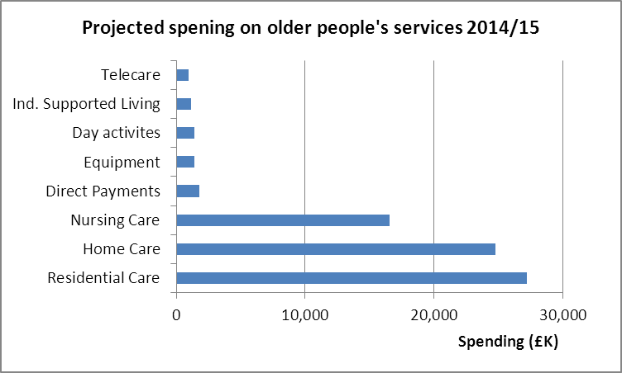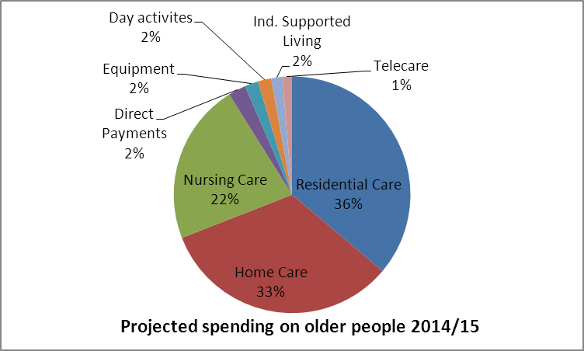

The current and future level of (Council) resources

* The largest areas of spending are residential, home and nursing care
* Spending on direct payments is increasing: spending on day activities reduced significantly in recent years
* The total of available resources has reduced this year and is unlikely to increase in the foreseeable future
* The largest areas will be under pressure to identify reductions.

How will the Council help the market and support work on our priorities?

In Northumberland the market for traditional services such as residential care, domiciliary care (including supported living services) and day care is strong, of high quality and offers value for money in most circumstances.

However, these services are mostly based on traditional models of delivery, relying on the Council to commission these services directly on behalf of customers. The supply of residential care services for older people including those with dementia currently outstrips demand and the council is keen to manage this to prevent it from continuing.

We want to build on current changes to the way services are commissioned and delivered to make sure that the customer is effectively and fully in control of their lives and the services they wish to use. Services must flex and adjust constantly to people’s moves towards greater independence.

To support these transformational changes we wish to encourage innovation and the development of best practice in service delivery, in particular with local third sector organisations.

We want to promote opportunities for older people, their families, care managers and health and social care providers to come together to understand mutual needs for growth and development, recognising that services should be designed and delivered jointly by users and providers working in collaboration.

We are also interested in improving information about providers, to help suppliers to advertise the services they offer, and customers to access information on different types of services available to them.

We want to support providers to market their opportunities directly to self-funders.

**Services for self-funders – a key role for the market**

We know there is a need for services for people who choose to arrange their own support or who do not meet our eligibility criteria for support. We are looking for imaginative collaboration between providers, service users and other stakeholders to provide for self-funders, for example:

* Access to social and leisure opportunities alongside other citizens
* Personal skills training to support continuing independence such as
  + Meal preparation
  + cooking
  + mobility
  + self-advocacy
* Access to employment and voluntary opportunities
* Support to obtain and maintain appropriate accommodation within social housing and the private sector
* Support to carers and family members.

**Want to find out more? Key contact details for further discussion….**

For further discussion you and your organisation can book a personal appointment to discuss how we can work with you.

Arrange an appointment through the Social Care contracts team by email on

* contracts@northumberland.gov.uk
* or telephone 01670 622437.

**Service development opportunities**

We want what we offer to be *individual* rather than institutional – personal as well as *specialised*.

**Your community, your life**

* **New ways of taking part** in recreational, social and leisure activities in the local community – e.g. for older people, people with dementia or with complex needs and for people who pay for services themselves.
* **“Bespoke” daytime activities** – catering for people who choose different things to do from the clubs and activities traditionally on offer. Now people have their own budgets they can be pooled to make this possible.
* **New respite opportunities –** some older people or their carers may wish to take breaks away, stay in a hotel, stay with another family, or have assistants to stay in their home rather than go to traditional residential respite placements.

**Your wellbeing, your choice**

* **Supporting health needs:**  full health means tackling isolation and taking part in the local community as well as finding practical ways of managing weight and exercising.
* **Personal support** – Personal skills training e.g. transport training personal hygiene, cooking and budgeting etc.
* **Back office services** – people may wish to employ a personal assistant to help them manage their support package and finances. They may need support recruiting, employing and training people or help with job descriptions, payroll and criminal record bureau checks.

Example MPS