REPORTING ON TOXIC STRESS FACTORS

A list of open cases was extracted from ICS on 9th December 2015. Separately, a list of all child and family assessments undertaken since March 2014 was produced, and then refined to produce a list of cases where either of the parental toxic quadri were identified.
The two lists were then matched, and split by the type of case (child in need or child protection) to produce the numbers / percentage of cases where each toxic quadri was a factor.
Figure 1- CIN Quadri
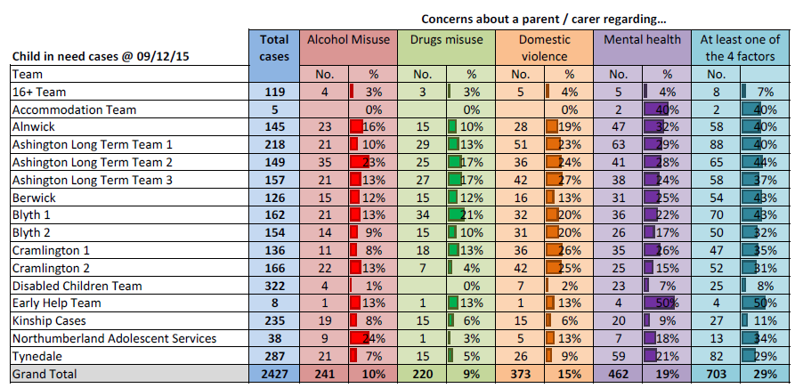
Figure 2 - CP Quadri
