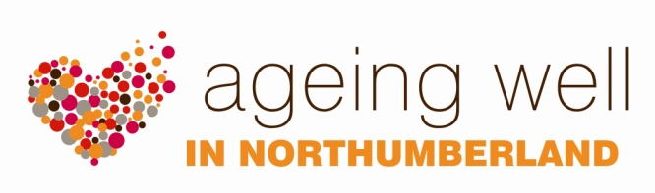
EVENTS

LOCAL EVENTS

Ageing Well events are opportunities for local communities to work together, to share information about activities in the area and to encourage individuals in the community to get involved. This helps people to stay connected, avoid social isolation and to promote their health and wellbeing. Ageing Well encourages local people to work with local and national organisations to plan an event. It is local knowledge which can make these events really useful, interactive and successful. Two Ageing Well events which are held at a variety of locations in Northumberland are Stepping into Spring and the Winter Warmer events.

Stepping into Spring event

Stepping into Spring events happen in local communities in the months leading up to summer. They are about encouraging local people to access groups and activities that promote being active, getting involved, and having fun. Health messages may be linked to outdoor activity health and safety.

Winter Warmer event

Winter Warmer events happen in local communities in the months leading up to the winter time. They are designed to remind older people about the importance of staying safe, well, and warm when the temperature outside is really cold and conditions can be hazardous. They are also an opportunity to promote information to people about slips, trips, falls, and the importance of flu vaccinations.

How can Ageing Well help?

If you would like to get involved with organising an event we can:

- Discuss your ideas for an event with you and if needed, allocate an Ageing Well representative to offer guidance and support in the planning stages and/or at the event.

- Support your event by providing a display of health improvement information and, where capacity allows, a health trainer for 1:1 health advice.

- In some circumstances offer a small amount of funding.

- Provide Ageing Well promotional materials and templates.

- Allow use of the Ageing Well branding. We would expect the event to be inclusive and open to all older people in the community.

For a successful and well attended event, we recommend that local groups and organisations who are invited to support the event (to share their information with participants and to network), are not charged for taking part.

We would also recommend that for all events, appropriate risk assessments are carried out and documented, in order to ensure that relevant health and safety issues have been considered.

When holding an event it is useful (for example to support the planning of any future events), to gather information about the number of people who attended and to ask them for their feedback about your event. It would also be very helpful if this feedback was communicated to the Involvement and Service Development Team, in order to support the continuation and development of Ageing Well activity in Northumberland.

EVENT TOOLKIT

We have developed an event toolkit to help anyone who is interested in organising a local Ageing Well event (see pages 17 – 34 of this pack):

(1) Let’s get started.
(2) Planning the event.
(3) On the day.

Checklist 1: Choosing a venue.
Template 1: Risk assessment for events.
Checklist 2: Quick checklist for events.

Template 2: Example of an event poster (Stepping into Spring)
Template 3: Example of an event poster (Winter Warmer)
Checklist 3: Creating a welcoming environment.

Template 4: Registration sheet.
Template 5: Evaluation sheet (short version).
Template 6: Evaluation sheet (long version).

This toolkit includes several templates, the use of which is optional. They can be changed to suit your needs and can be downloaded from www.northumberland.gov.uk/ageingwell

Want to know more?
Please contact the Involvement & Service Development Team on 01670 629000.

