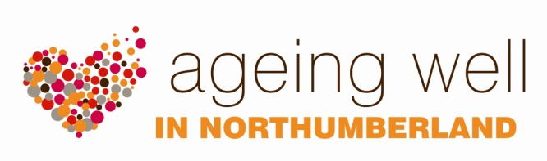

RESOURCES

AGEING WELL PROJECT DEVELOPMENTS

The Ageing Well team may be able to offer support for new projects that have the potential to help people stay connected, active and well through the development of local activities. Several examples of such developments are listed below.

Ageing Well Hens

Two organisations have received support from the Ageing Well team to set up a “Cooping Well” project. This project offers older people in the community an opportunity to get together, share their hen keeping skills, have fun, and take an active part in looking after the hens. This also has the potential for rewarding intergenerational activity.

Supported Walks

The Ageing Well team can put you in touch with organisations and volunteers in the county who provide supported walks for older people and people with dementia. We can also help you set up your own walking group and explore ways of ensuring the group is accessible to the needs of vulnerable members of your community.

Craft and Activity Groups

The Ageing Well team have contact with lots of partner organisations who provide a variety of different art and craft activities. We can help you develop new ideas and put you in touch with other groups in your local community who can give you their expert advice on projects they have successfully developed.

If you have a good idea, or are interested in developing an activity in your area, give us a call.

Want to know more?
Please contact the Involvement & Service Development Team on 01670 629000

