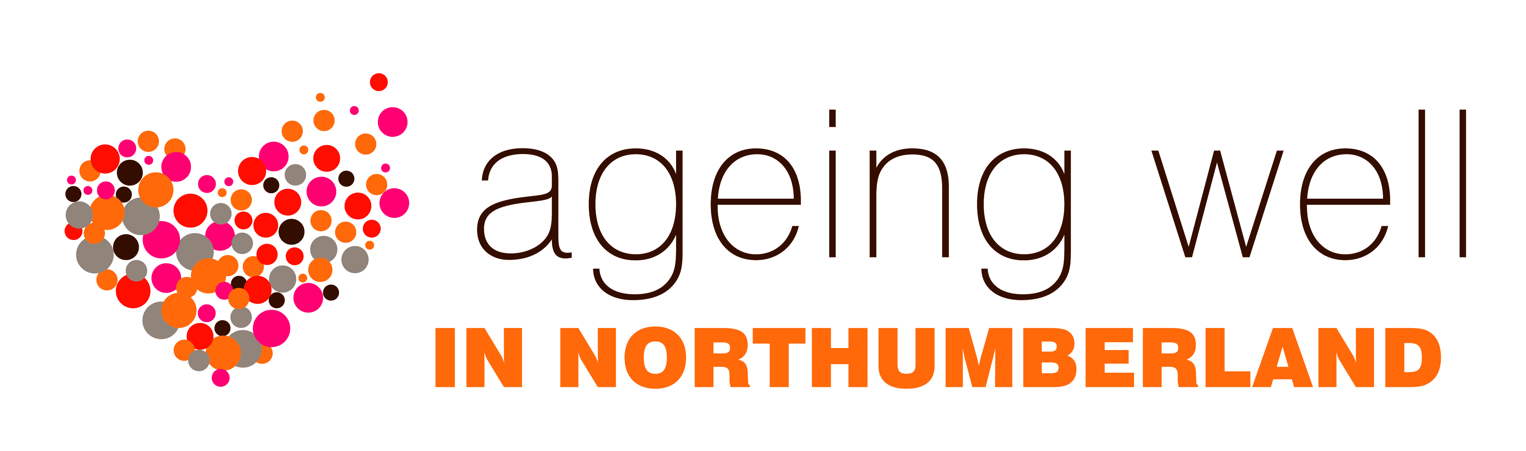
TRAINING

SPECIALIST HEALTH IMPROVEMENT SERVICE

The Ageing Well Allies training (see p.37 of this pack) offers an all-round introduction to many of the topics listed below. Should individuals wish to access more in-depth training, this is available free of charge from the Specialist Health Improvement Service.

The Specialist Health Improvement Service in Northumberland focuses on providing specialist health promotion support and training to local organisations and individuals, in order to reduce health inequalities and improve the health and wellbeing of those living and working within the county.

You can find out more about the training opportunities that are available by ringing 01670 811972, or by visiting this webpage: https://www.northumbria.nhs.uk/our-services/healthy-living/

The 2016/17 programme includes:

General Health Improvement Awareness / Prevention Training
- Basic Drug Awareness
- Cancer Prevention/Awareness Sessions
- Child Safety & Accident Prevention Training
- Dementia Awareness Training
- Every contact a health promoting contact
- Falls Prevention Training
- Health Champion Training
- RSPH Understanding Health Improvement
- Smoke Free Families – Reducing Exposure of second hand smoke
- Smoking Cessation Brief Advice Training

Healthy Weight
- Healthy Weight in Adults Brief Intervention
- Healthy Weight in Children & Young People Brief Intervention
- Maternal Obesity – Supporting women to achieve a healthy weight

Mental Health
- Basic Suicide Awareness Training
- Mental Health First Aid
- Youth Mental Health First Aid

Want to know more?
For more information please contact Kay Yeo, Health Improvement Practitioner Specialist on 01670 629000 or email kay.yeo@ncht.nhs.uk

