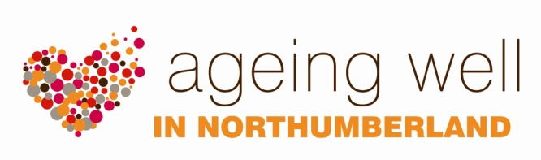

TRAINING

PRACTICAL DEMENTIA AWARENESS TRAINING

This two hour practical dementia awareness training session of will be of value to anyone who wants more information about dementia, or who is working with people who have dementia. The session can be requested by any group, community or professional. It is delivered locally by our Health Improvement Practitioner Specialist. There is no charge for this training.

By the end of the session, the participants will have achieved the following learning outcomes:

- A general understanding of what dementia is and the main diseases causing dementia.

- Understand how dementia affects everyday living.

- Practical measures that may be taken to help people live well with dementia.

Training methods:

- Real life experiences (DVD’s).

- Interactive discussion.

- Hand-out material about practical ideas and strategies that carers/workers can try to use to support individuals.

- Information and advice about activities that can help people with dementia to enjoy relaxation time.

- Visual examples of aids which can be purchased to support individuals living in the community, to help people to stay independent for longer.

Want to know more?
For more information please contact Kay Yeo, Health improvement Specialist on 01670 629000 or email kay.yeo@ncht.nhs.uk

